­­edgar6_check

15 September, 2021

Table of Contents

Global trends and totals 9

CO2, CH4, N2O emissions 9

Fgas emissions 9

All gases (GWPs applied) 10

IPCC 1996 sector trends 11

AFOLU sectors 11

Buildings sectors 23

Energy systems sectors 26

Industry sectors 45

Transport sectors 75

Country trends 81

Afghanistan 82

Albania 83

Algeria 84

American Samoa 85

Angola 86

Anguilla 87

Antigua and Barbuda 88

Argentina 89

Armenia 90

Aruba 91

Australia 92

Austria 93

Azerbaijan 94

Bahamas, The 95

Bahrain 96

Bangladesh 97

Barbados 98

Belarus 99

Belgium 100

Belize 101

Benin 102

Bermuda 103

Bhutan 104

Bolivia 105

Bosnia and Herzegovina 106

Botswana 107

Bouvet Island 108

Brazil 109

British Virgin Islands 110

Brunei Darussalam 111

Bulgaria 112

Burkina Faso 113

Burundi 114

Cabo Verde 115

Cambodia 116

Cameroon 117

Canada 118

Cayman Islands 119

Central African Republic 120

Chad 121

Chile 122

China 123

Christmas Island 124

Cocos (Keeling) Islands 125

Colombia 126

Comoros 127

Congo, Dem. Rep. 128

Congo, Rep. 129

Cook Islands 130

Costa Rica 131

Côte d’Ivoire 132

Croatia 133

Cuba 134

Cyprus 135

Czech Republic 136

Denmark 137

Djibouti 138

Dominica 139

Dominican Republic 140

Ecuador 141

Egypt, Arab Rep. 142

El Salvador 143

Equatorial Guinea 144

Eritrea 145

Estonia 146

Ethiopia 147

Falkland Islands (Malvinas) 148

Faroe Islands 149

Fiji 150

Finland 151

France 152

French Guiana 153

French Polynesia 154

French Southern Territories 155

Gabon 156

Gambia, The 157

Georgia 158

Germany 159

Ghana 160

Gibraltar 161

Greece 162

Greenland 163

Grenada 164

Guadeloupe 165

Guam 166

Guatemala 167

Guinea 168

Guinea-Bissau 169

Guyana 170

Haiti 171

Heard Island and McDonald Islands 172

Honduras 173

Hong Kong SAR, China 174

Hungary 175

Iceland 176

India 177

Indonesia 178

Int. Aviation 179

Int. Shipping 180

Iran, Islamic Rep. 181

Iraq 182

Ireland 183

Israel 184

Italy 185

Jamaica 186

Japan 187

Jordan 188

Kazakhstan 189

Kenya 190

Kiribati 191

Korea, Dem. People’s Rep. 192

Korea, Rep. 193

Kuwait 194

Kyrgyz Republic 195

Lao PDR 196

Latvia 197

Lebanon 198

Lesotho 199

Liberia 200

Libya 201

Lithuania 202

Luxembourg 203

Macao SAR, China 204

Macedonia, FYR 205

Madagascar 206

Malawi 207

Malaysia 208

Maldives 209

Mali 210

Malta 211

Marshall Islands 212

Martinique 213

Mauritania 214

Mauritius 215

Mayotte 216

Mexico 217

Micronesia, Fed. Sts. 218

Moldova 219

Mongolia 220

Montserrat 221

Morocco 222

Mozambique 223

Myanmar 224

Namibia 225

Nauru 226

Nepal 227

Netherlands 228

Netherlands Antilles 229

New Caledonia 230

New Zealand 231

Nicaragua 232

Niger 233

Nigeria 234

Niue 235

Norfolk Island 236

Northern Mariana Islands 237

Norway 238

Oman 239

Pakistan 240

Palau 241

Panama 242

Papua New Guinea 243

Paraguay 244

Peru 245

Philippines 246

Pitcairn 247

Poland 248

Portugal 249

Puerto Rico 250

Qatar 251

Réunion 252

Romania 253

Russian Federation 254

Rwanda 255

Saint Helena, Ascension and Tristan da Cunha 256

Saint Pierre and Miquelon 257

Samoa 258

São Tomé and Principe 259

Saudi Arabia 260

Senegal 261

Serbia and Montenegro 262

Seychelles 263

Sierra Leone 264

Singapore 265

Slovak Republic 266

Slovenia 267

Solomon Islands 268

Somalia 269

South Africa 270

South Georgia and the South Sandwich Islands 271

Spain 272

Sri Lanka 273

St. Kitts and Nevis 274

St. Lucia 275

St. Vincent and the Grenadines 276

Sudan 277

Suriname 278

Swaziland 279

Sweden 280

Switzerland 281

Syrian Arab Republic 282

Taiwan, China 283

Tajikistan 284

Tanzania 285

Thailand 286

Timor-Leste 287

Togo 288

Tokelau 289

Tonga 290

Trinidad and Tobago 291

Tunisia 292

Turkey 293

Turkmenistan 294

Turks and Caicos Islands 295

Tuvalu 296

Uganda 297

Ukraine 298

United Arab Emirates 299

United Kingdom 300

United States 301

United States Minor Outlying Islands 302

Uruguay 303

Uzbekistan 304

Vanuatu 305

Venezuela, RB 306

Vietnam 307

Virgin Islands (U.S.) 308

Wallis and Futuna 309

Western Sahara 310

Yemen, Rep. 311

Zambia 312

Zimbabwe 313

# Global trends and totals

### CO2, CH4, N2O emissions

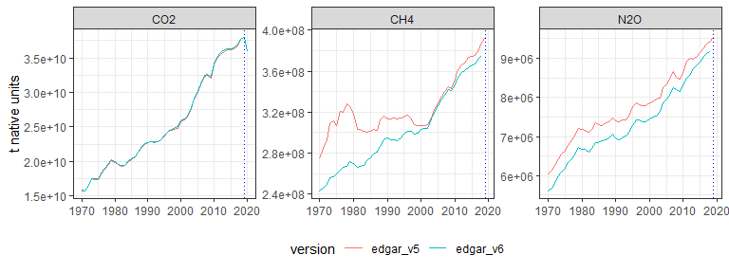

### Fgas emissions

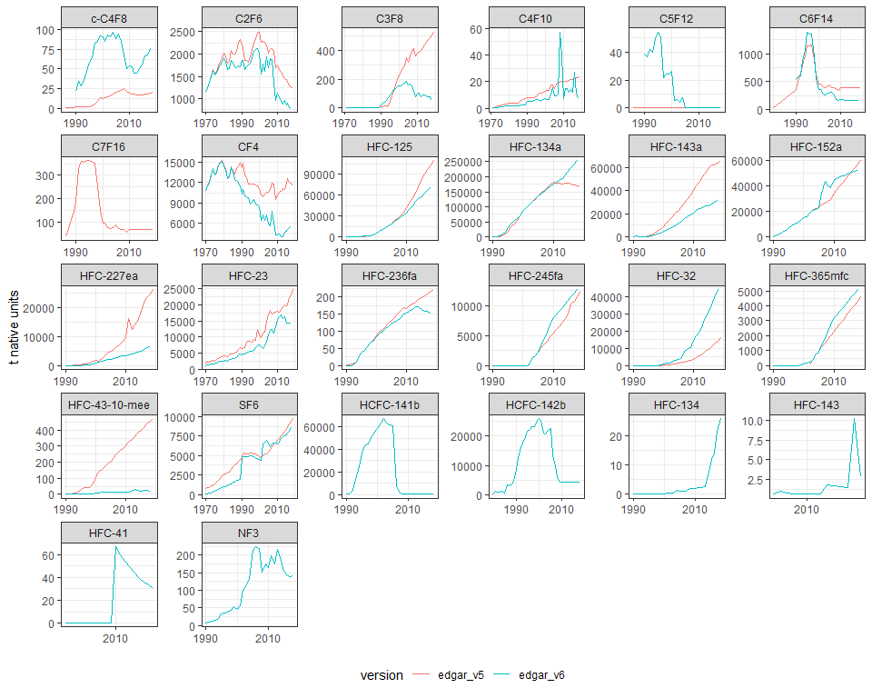

### All gases (GWPs applied)

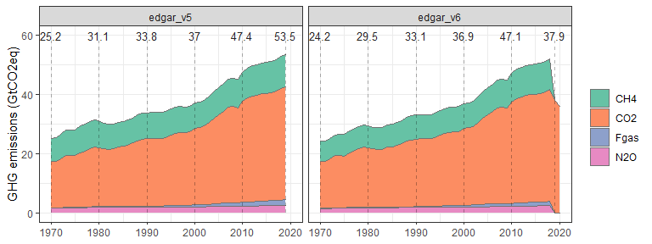

# IPCC 1996 sector trends

### AFOLU sectors

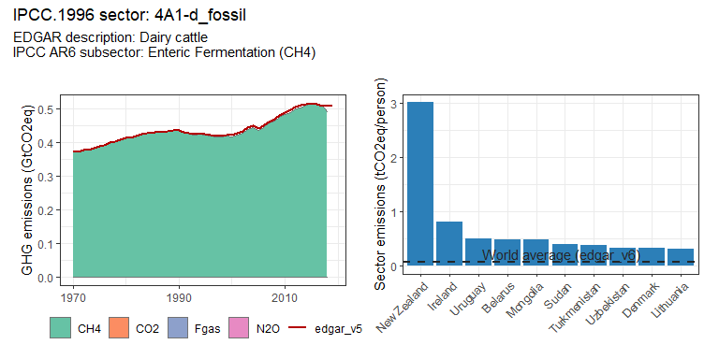 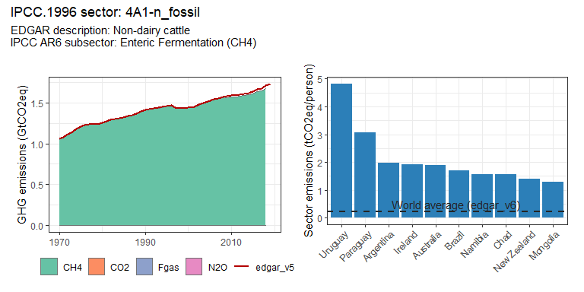 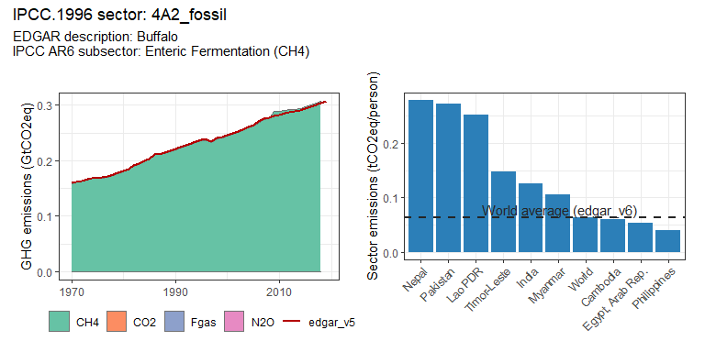 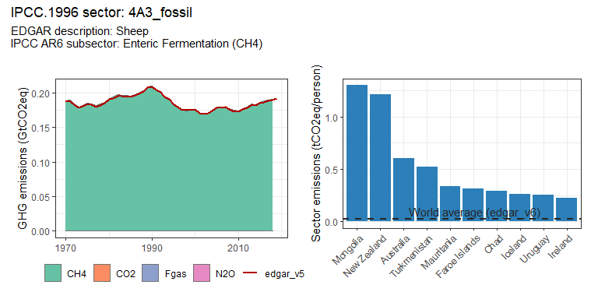 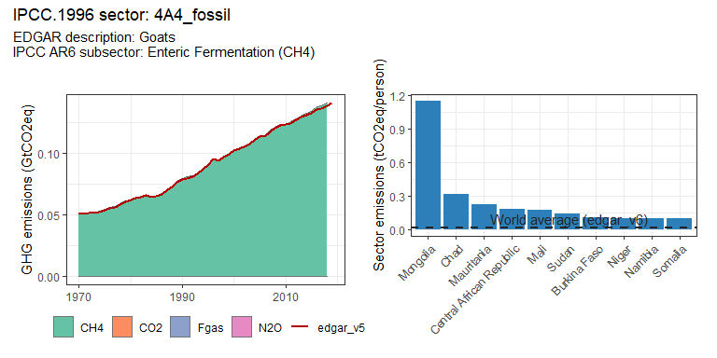 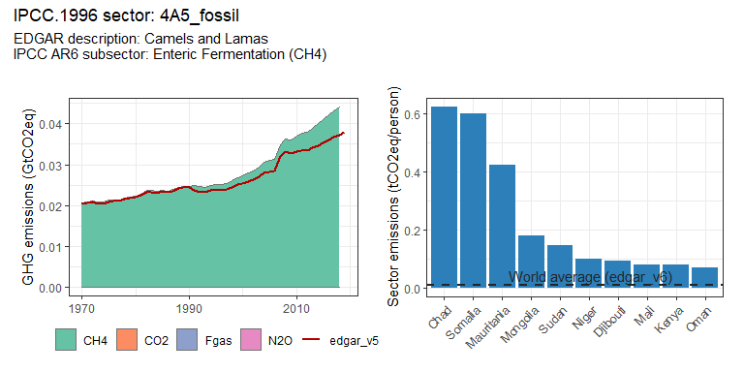 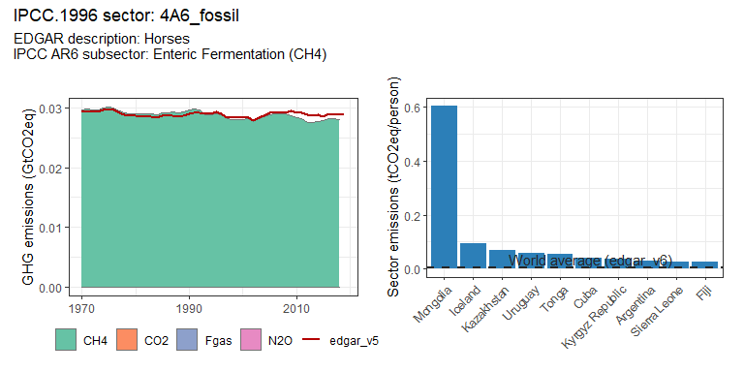 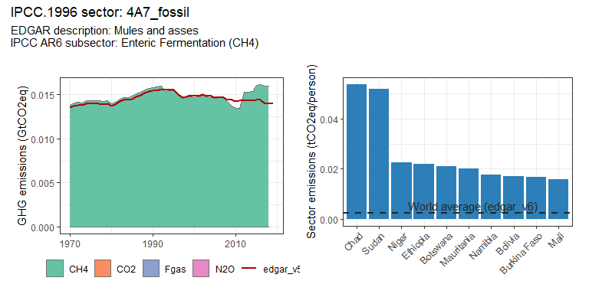 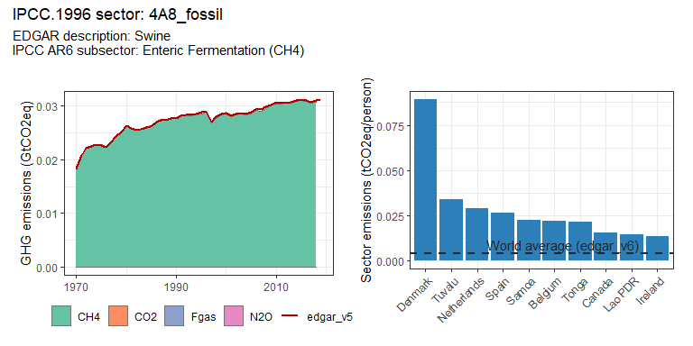 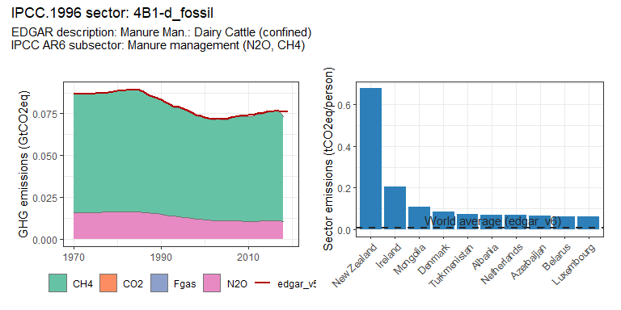 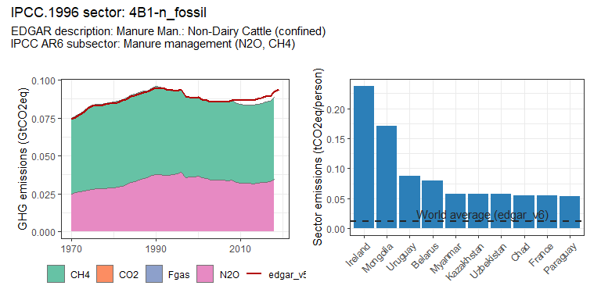 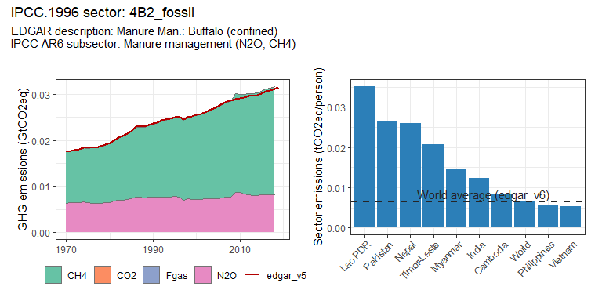 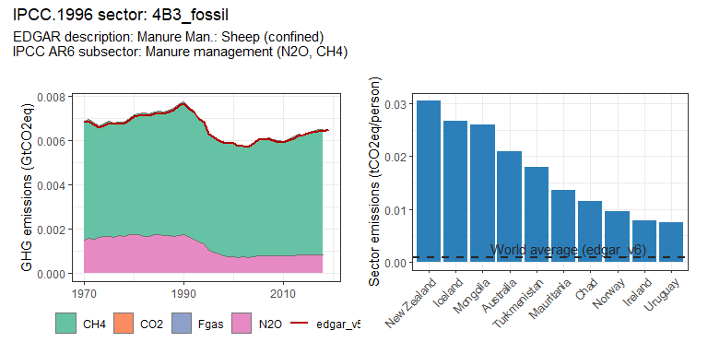 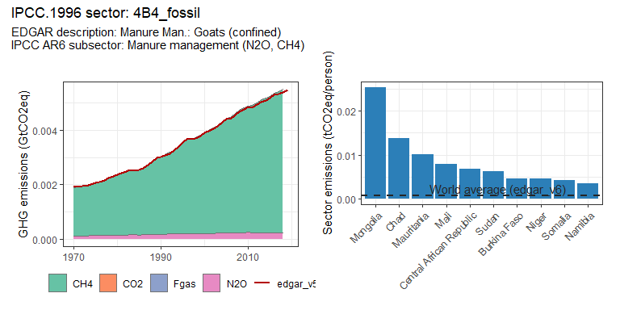 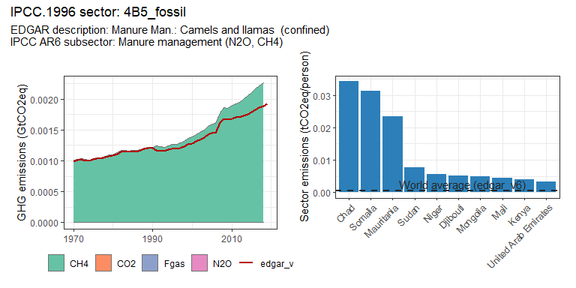 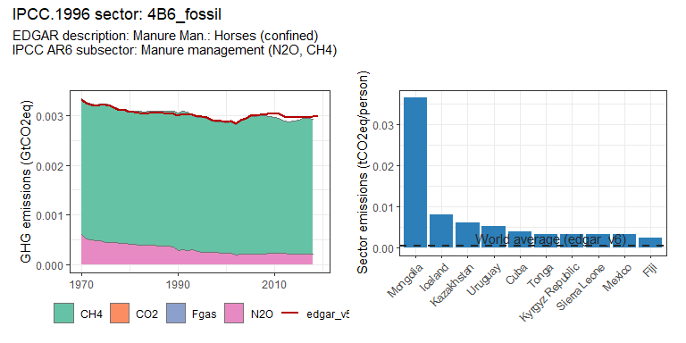 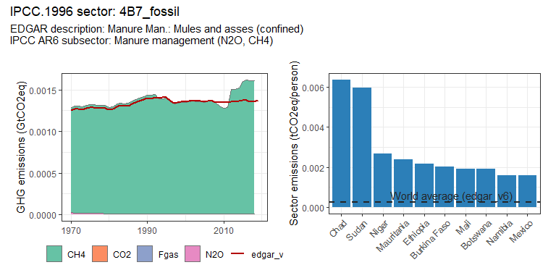 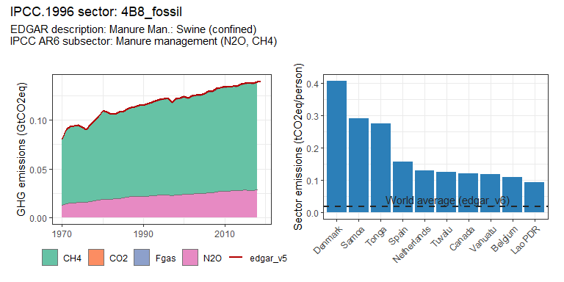 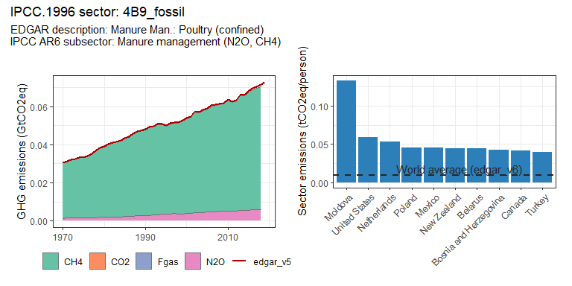 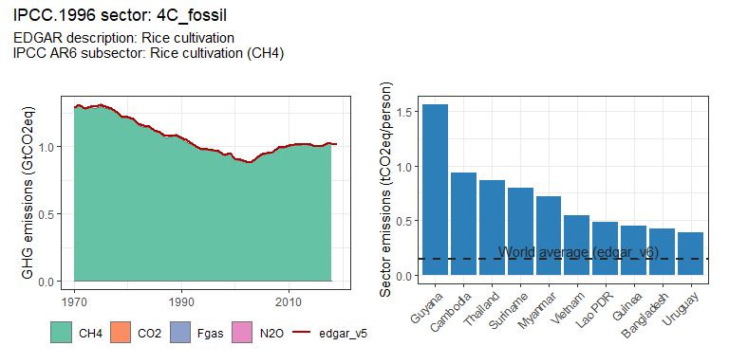 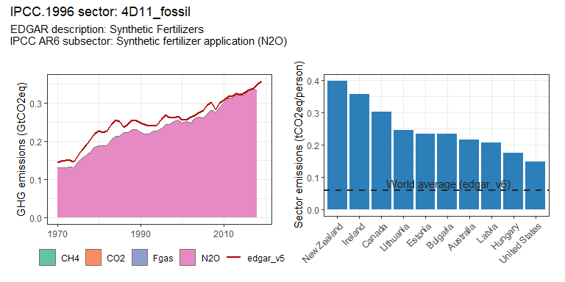 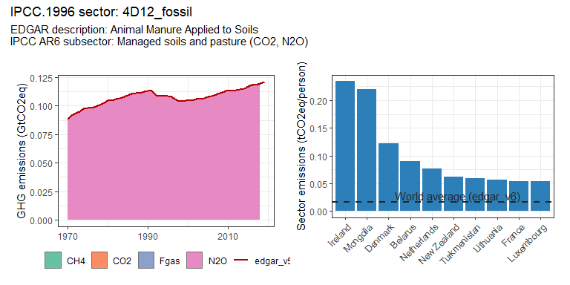 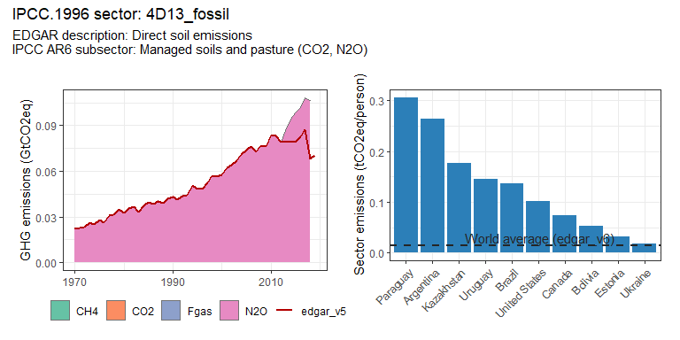 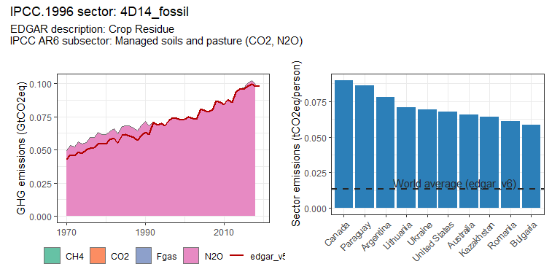 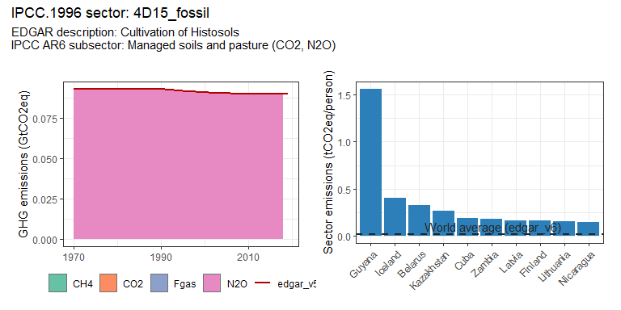 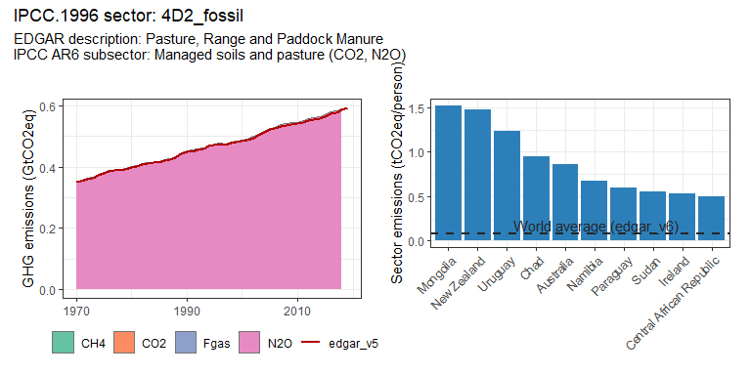 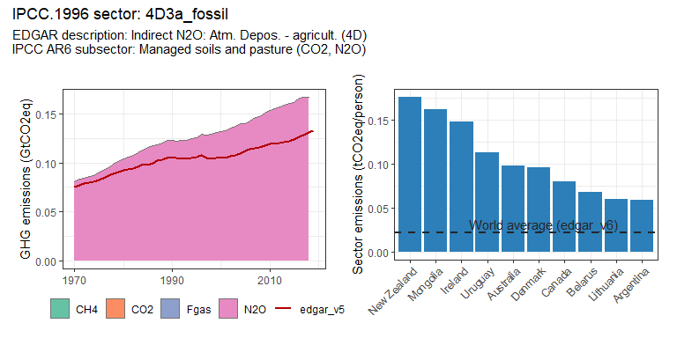 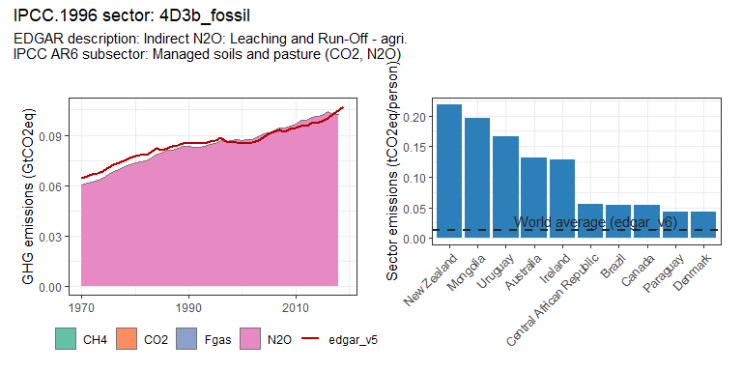 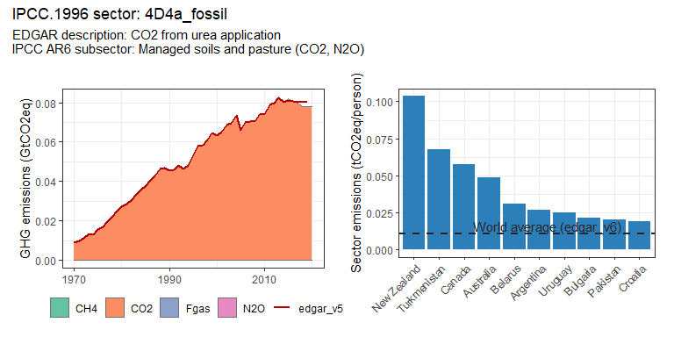 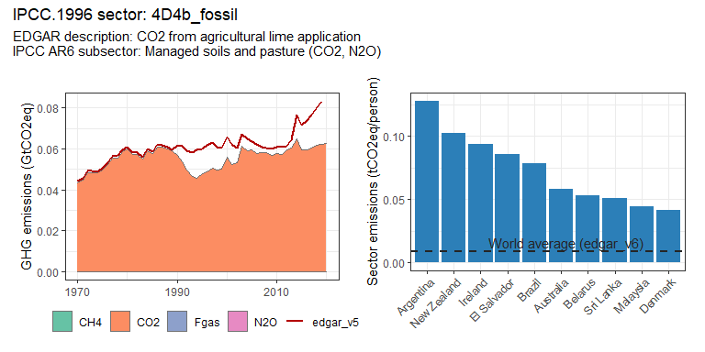 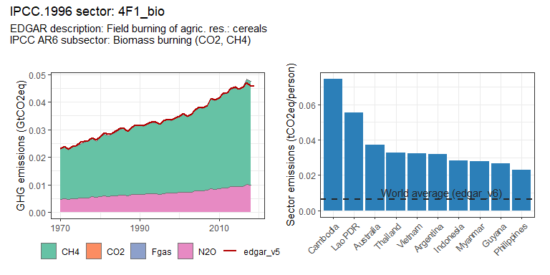 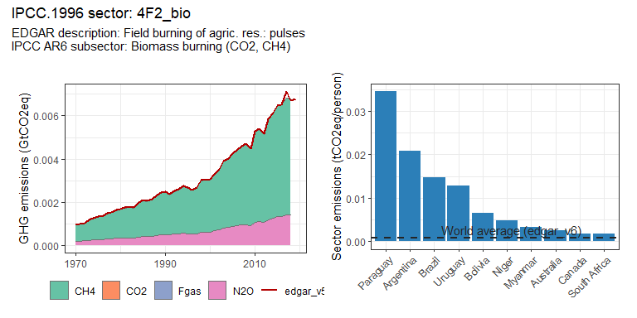 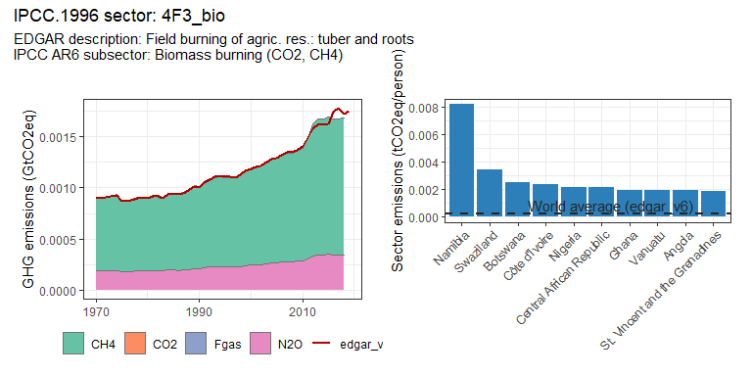 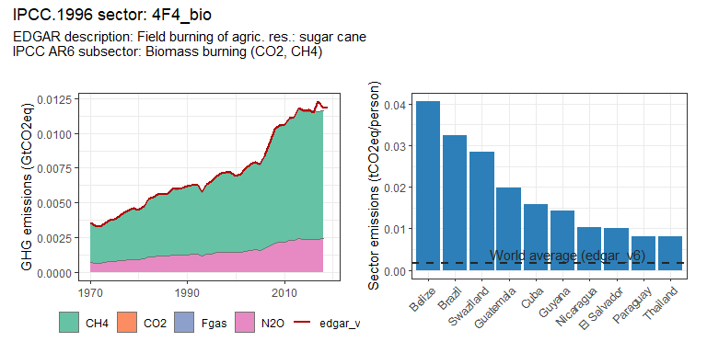 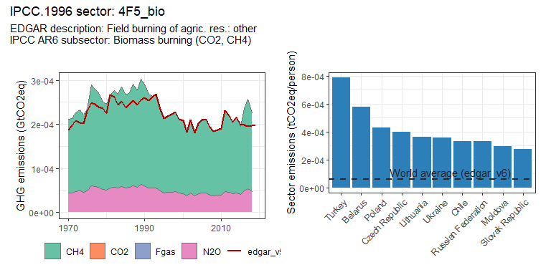

### Buildings sectors

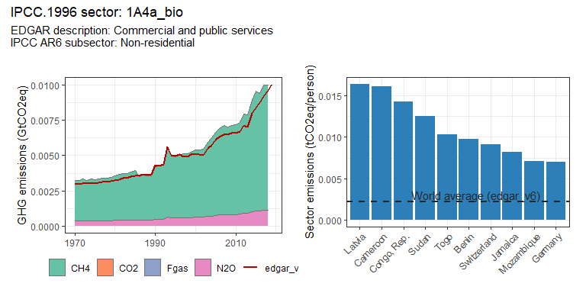 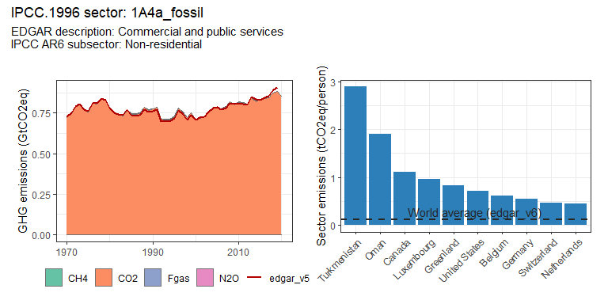 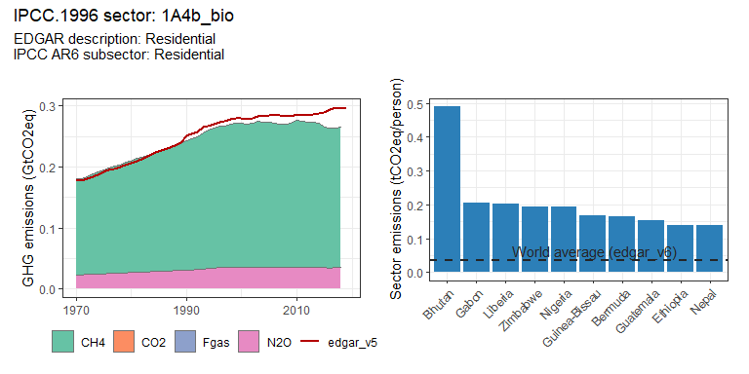 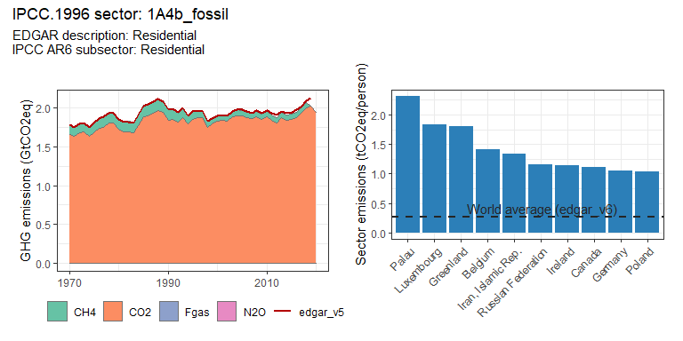 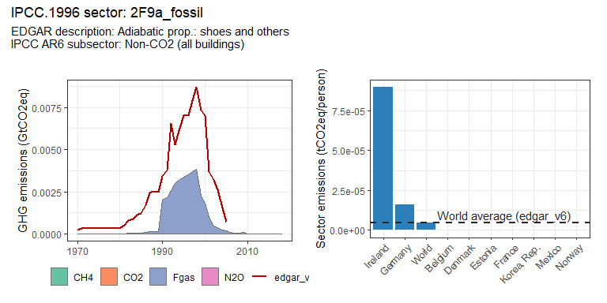 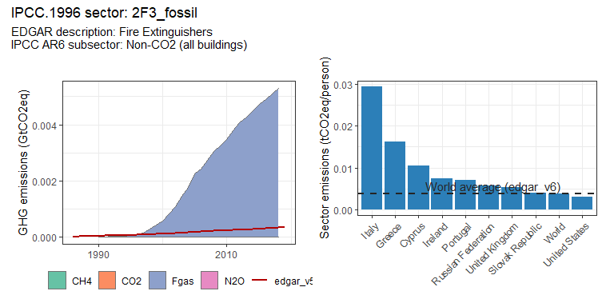 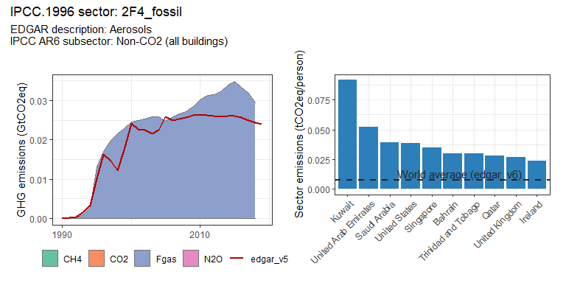 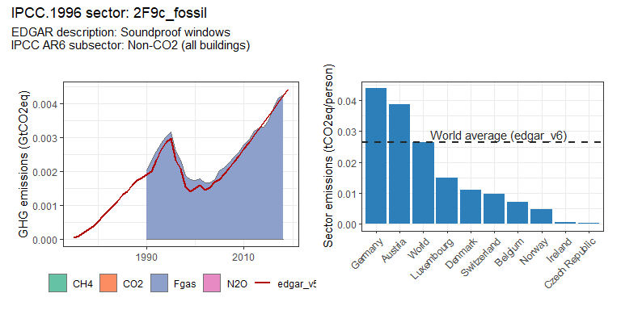

### Energy systems sectors

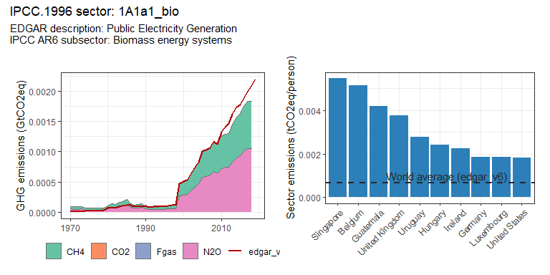 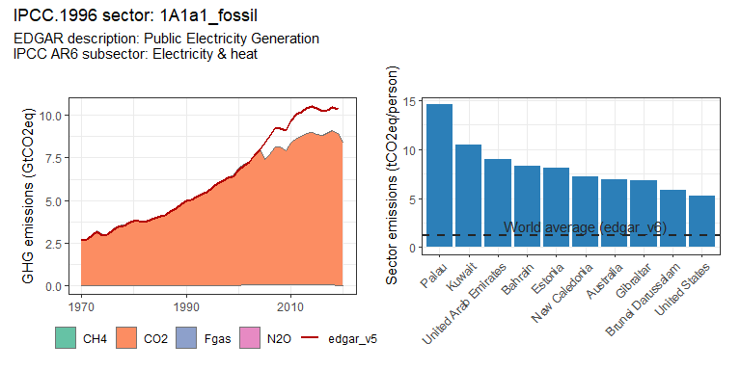 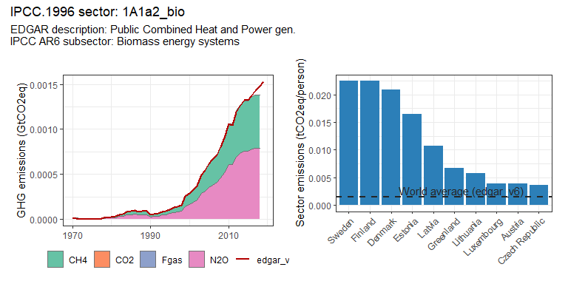 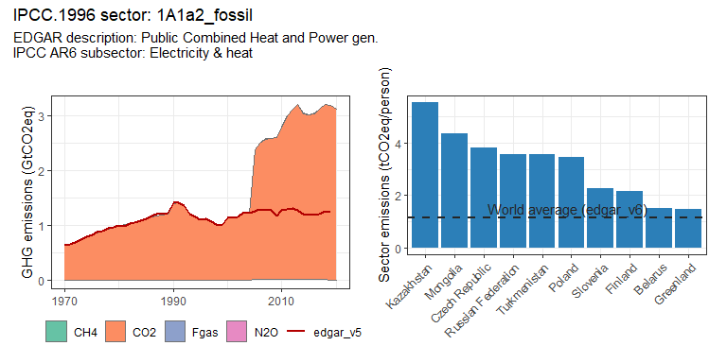 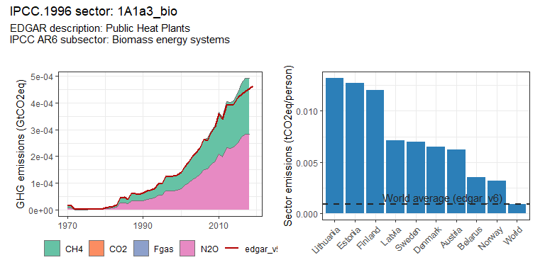 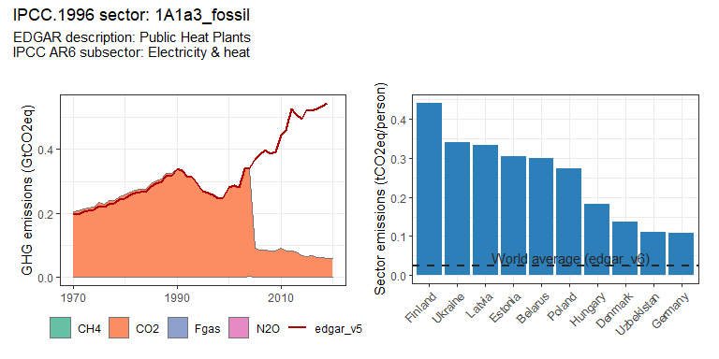 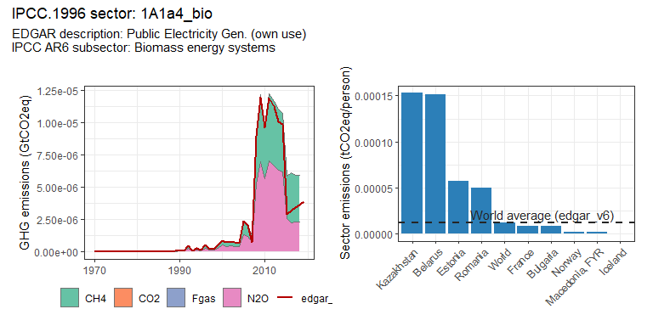 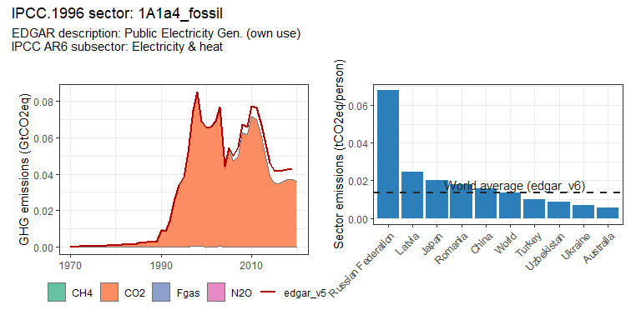 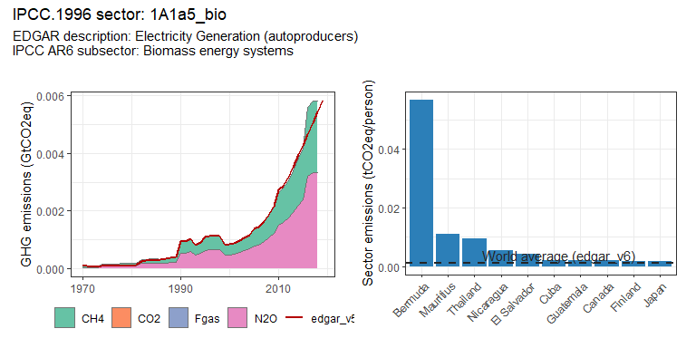 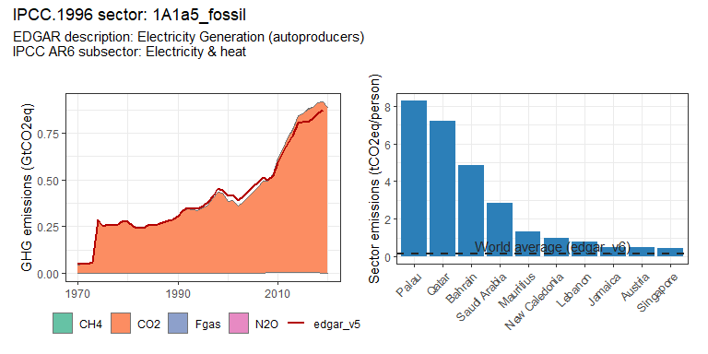 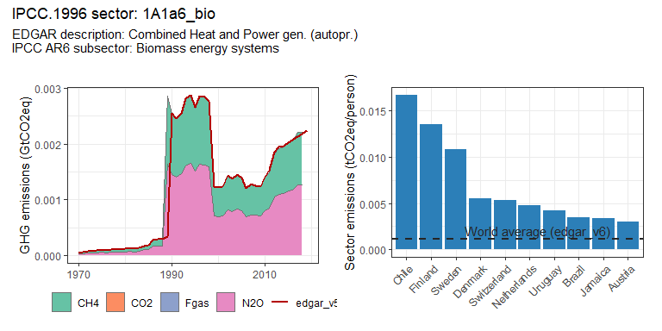 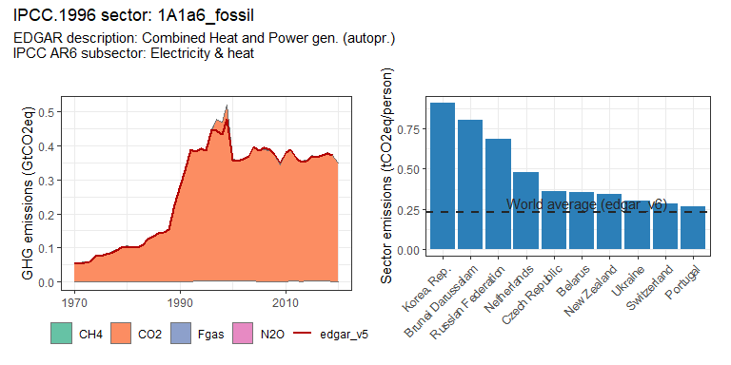 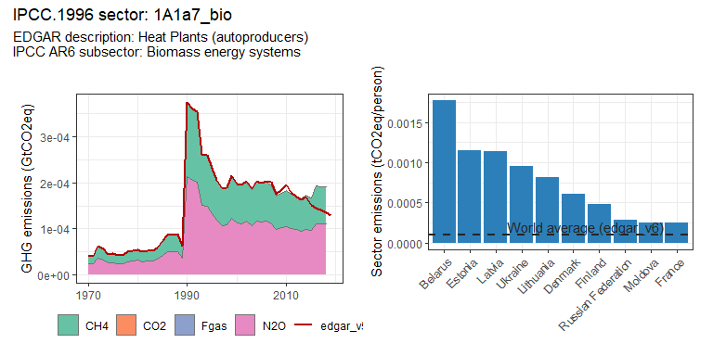 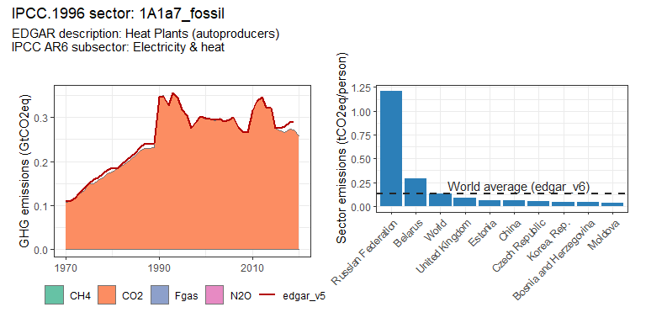 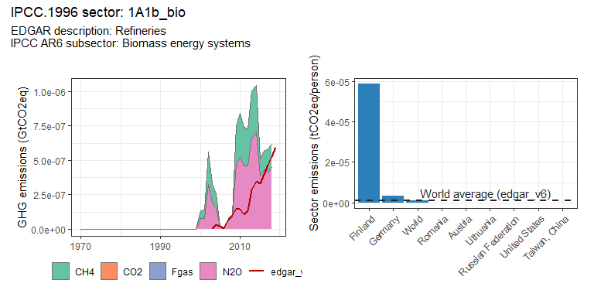 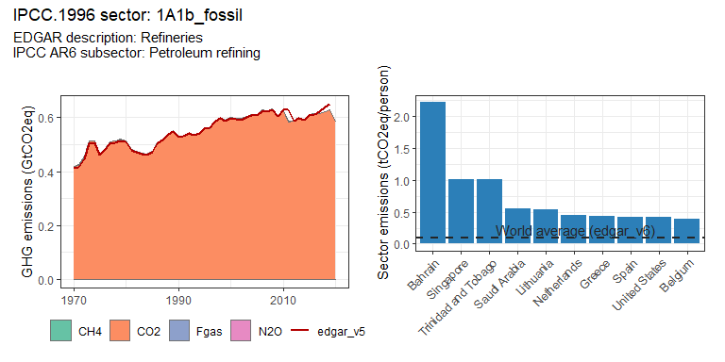 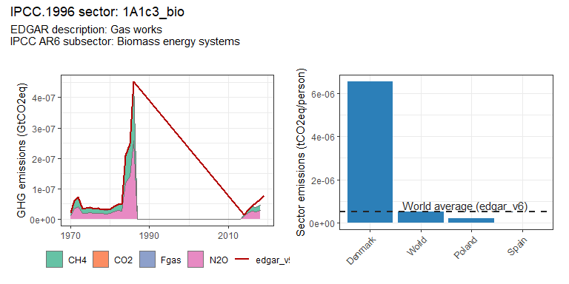 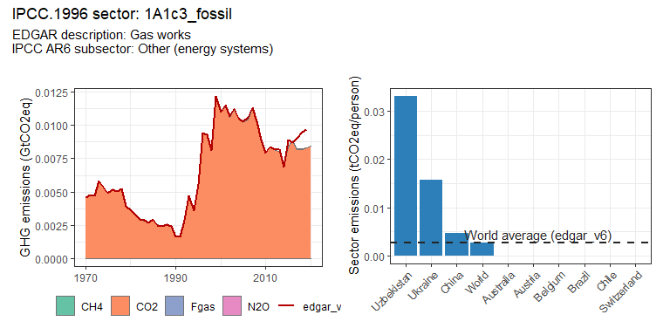 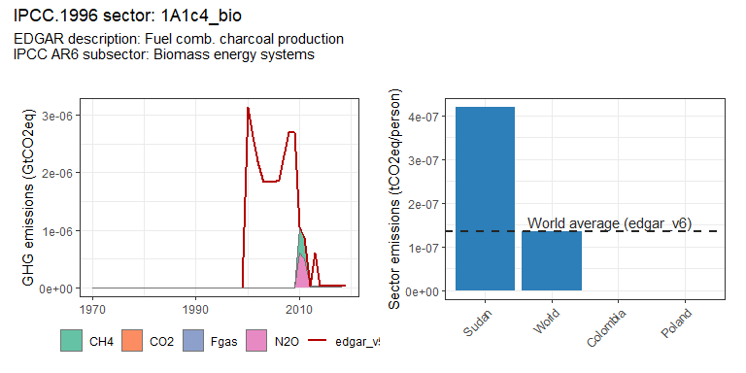 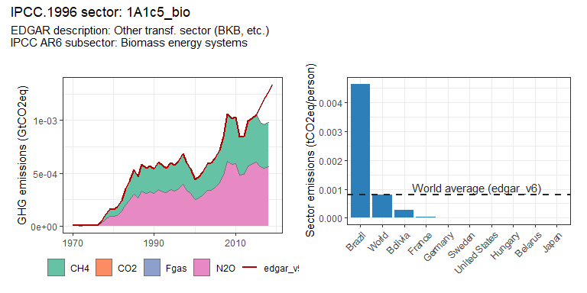 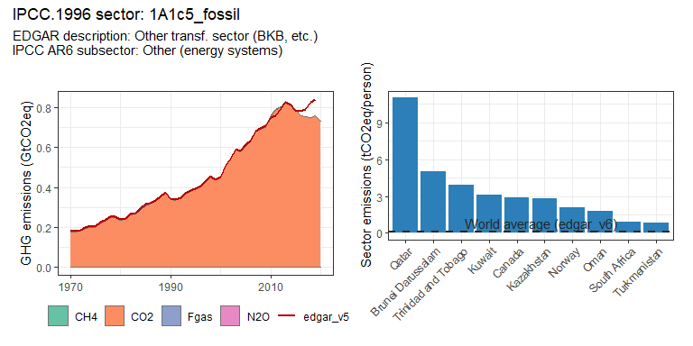 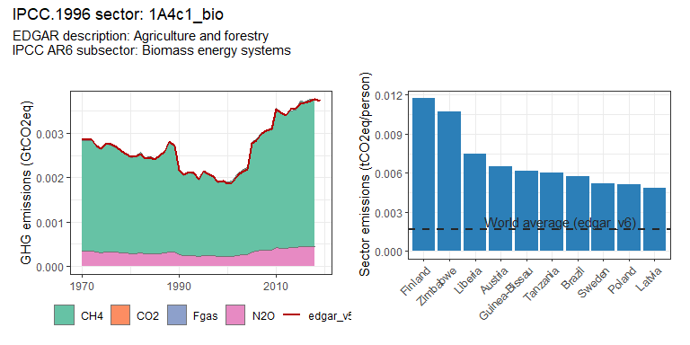 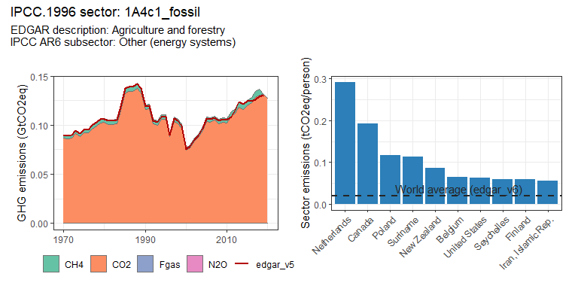 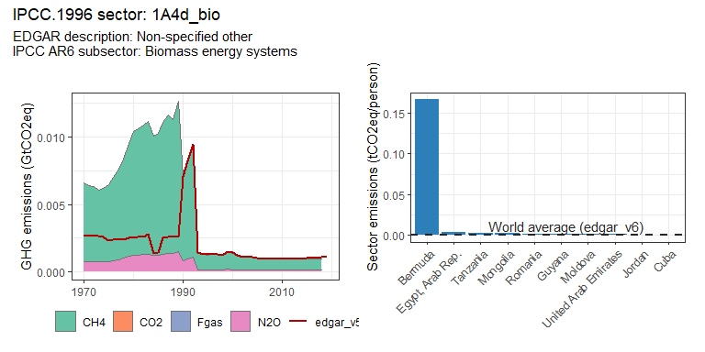 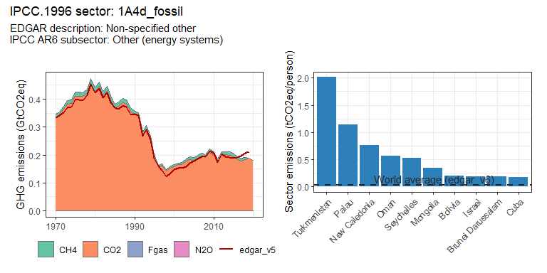 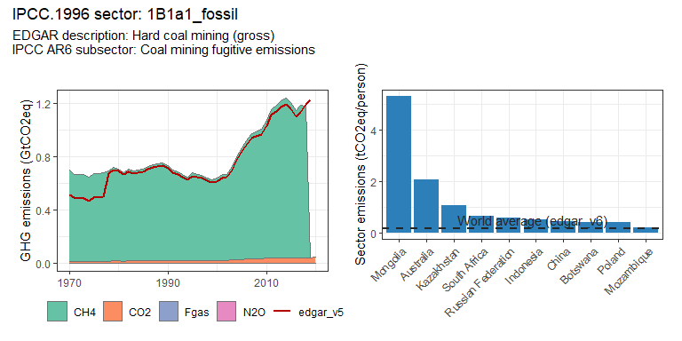 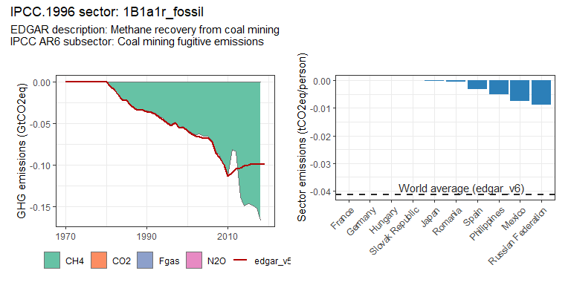 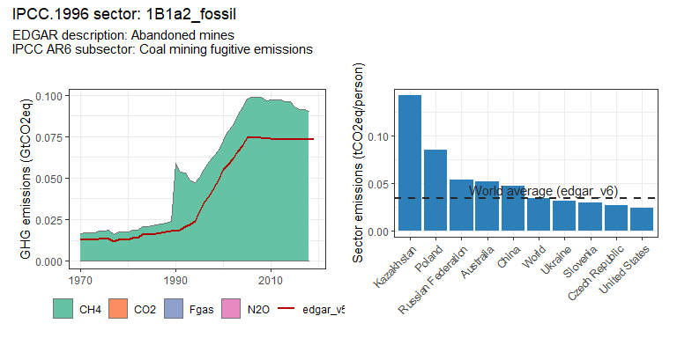 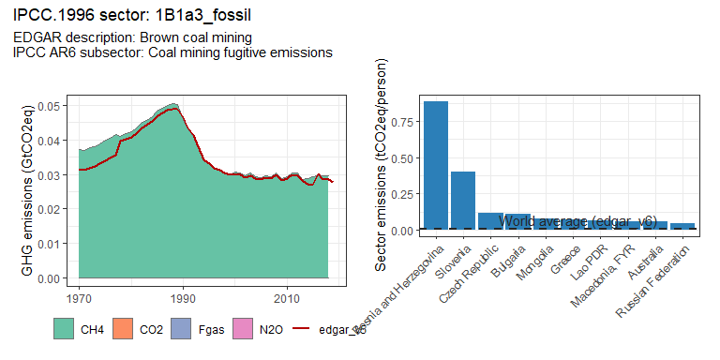 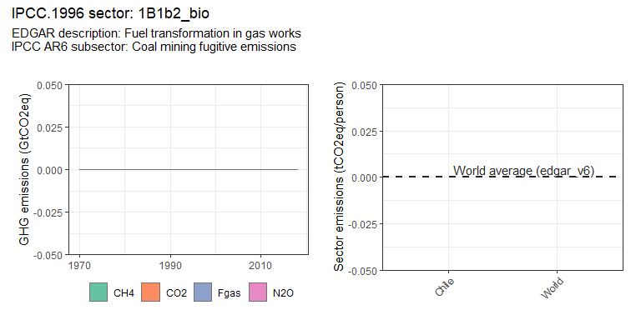 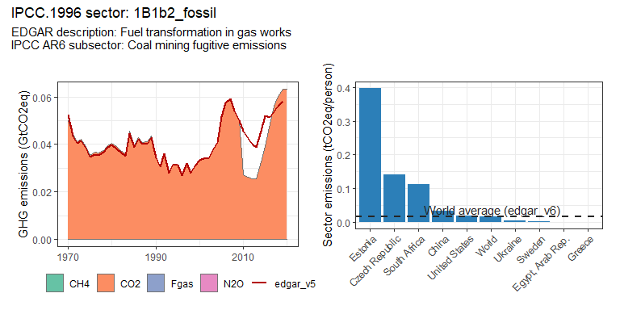 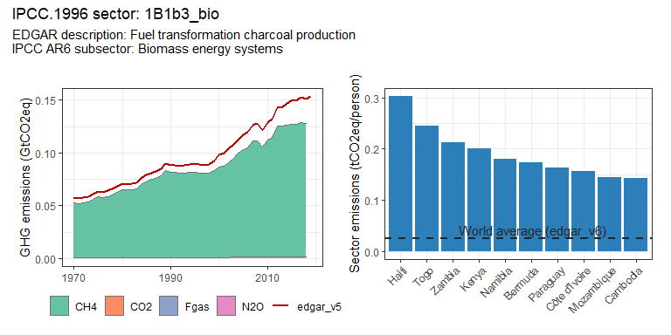 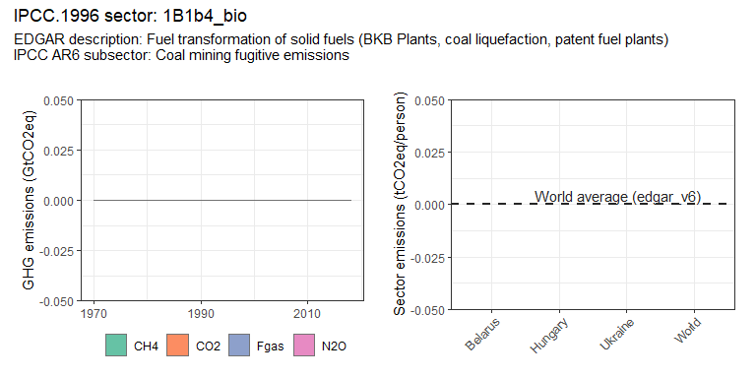 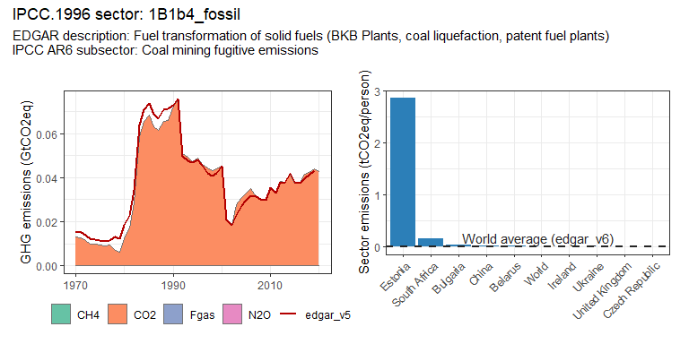 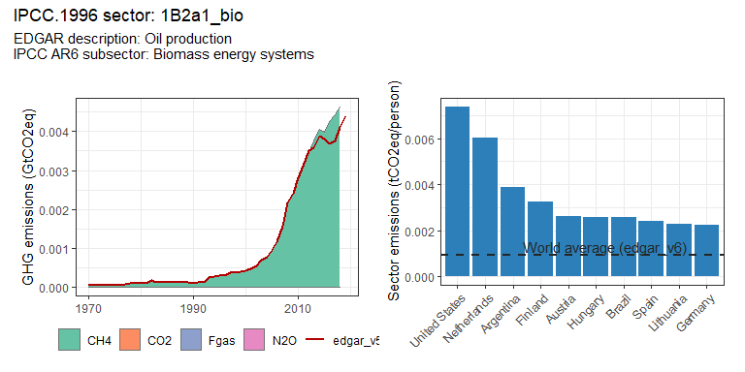 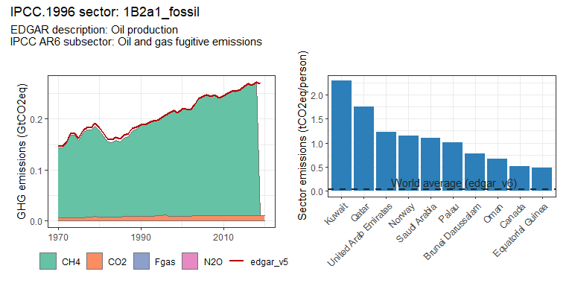 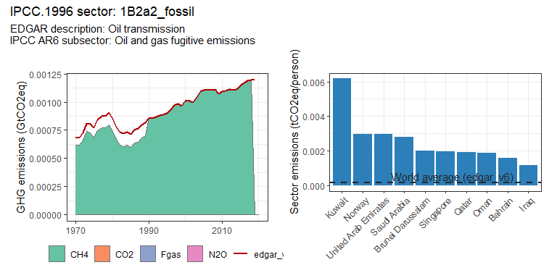 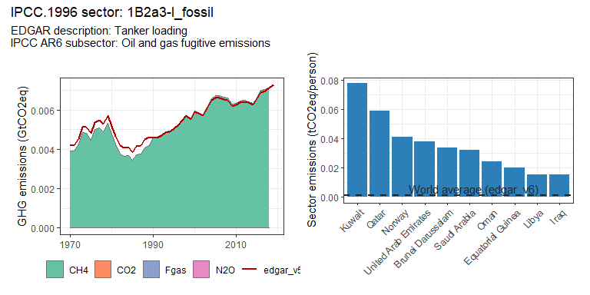 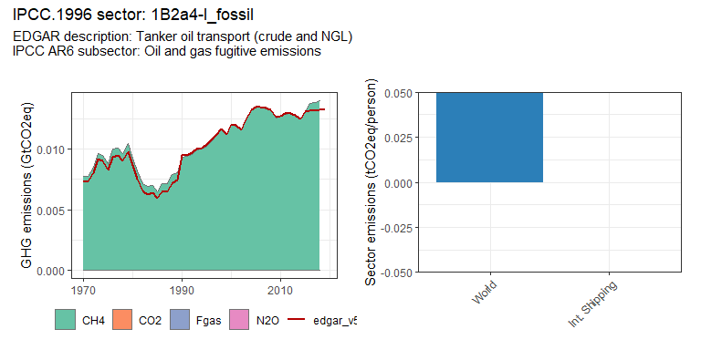 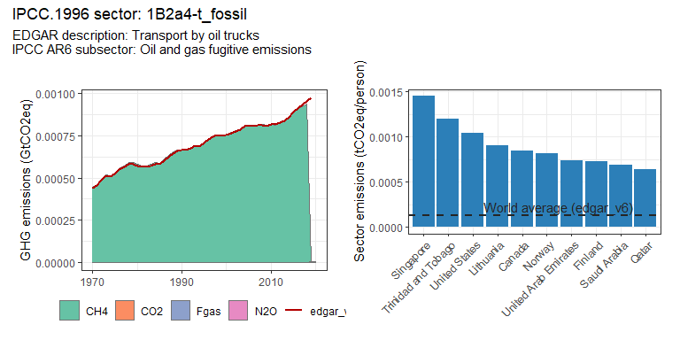 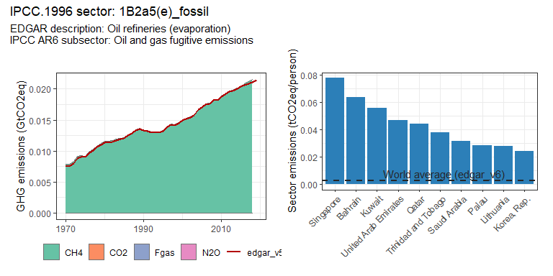 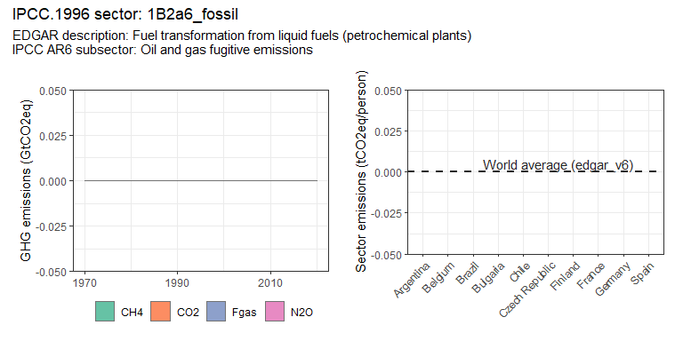 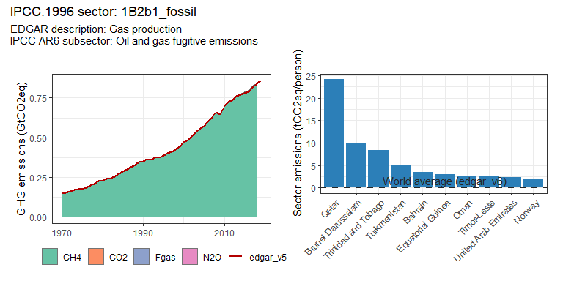 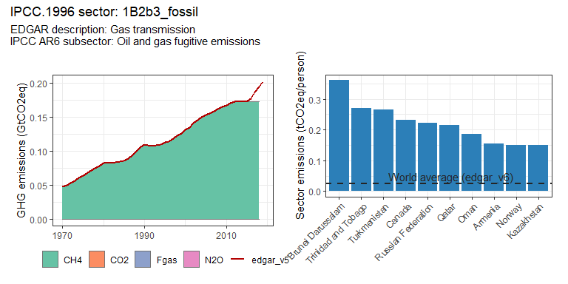 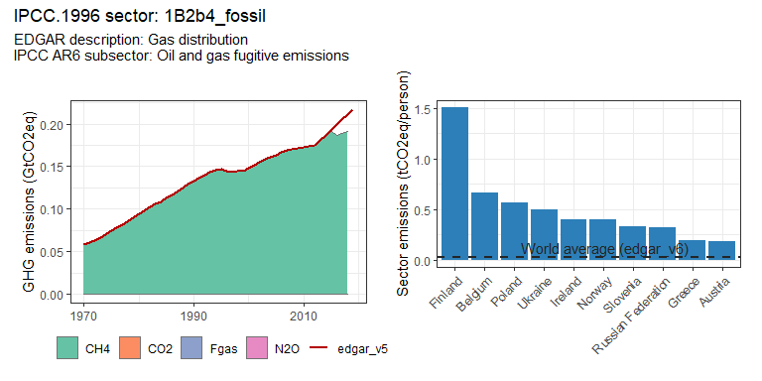 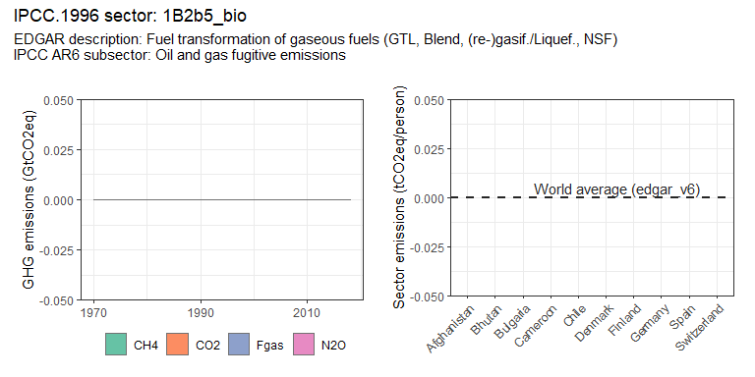 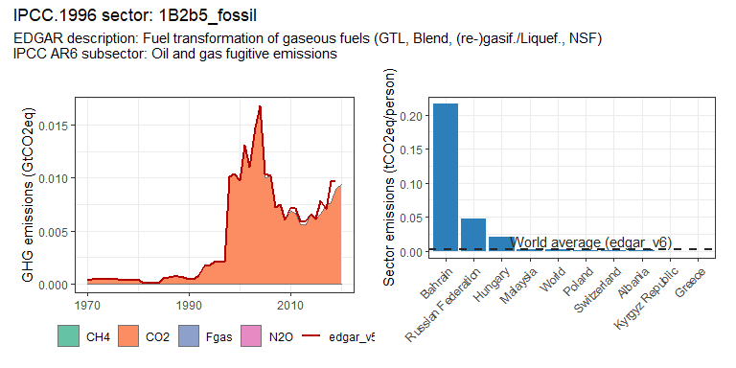 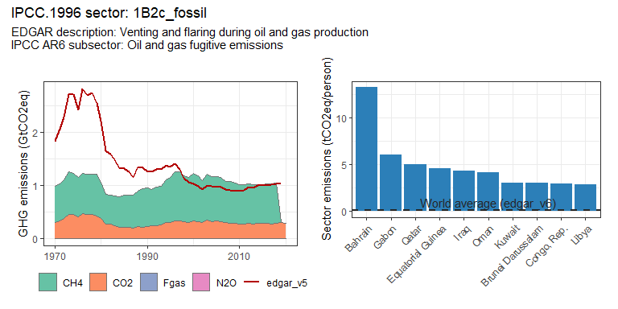 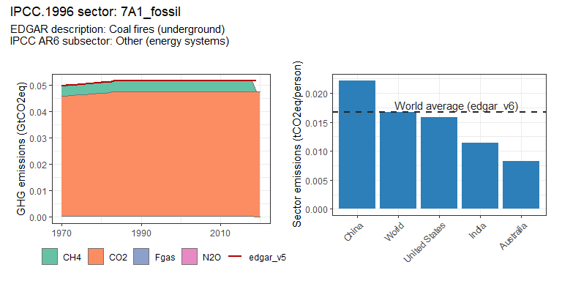

## geom_path: Each group consists of only one observation. Do you need to adjust  
## the group aesthetic?

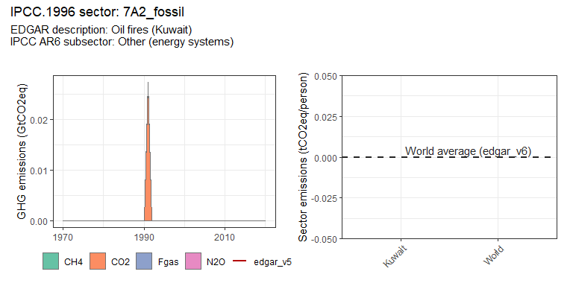 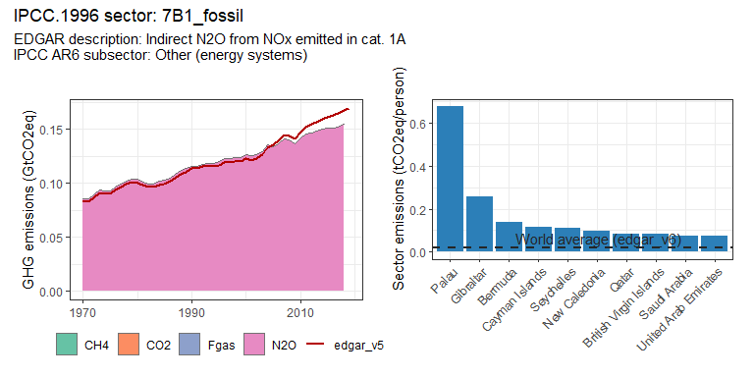 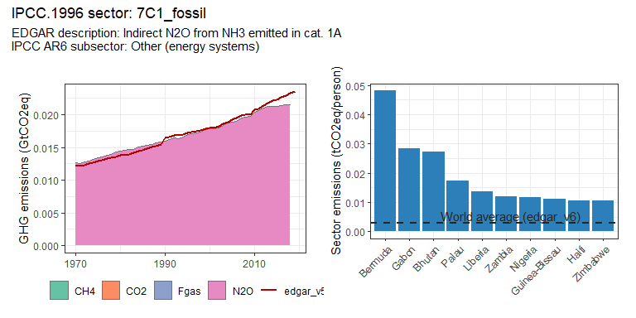 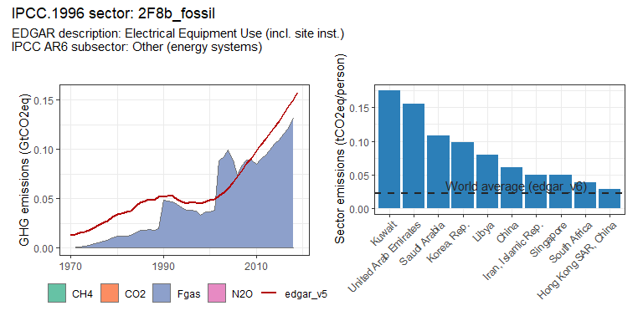

### Industry sectors

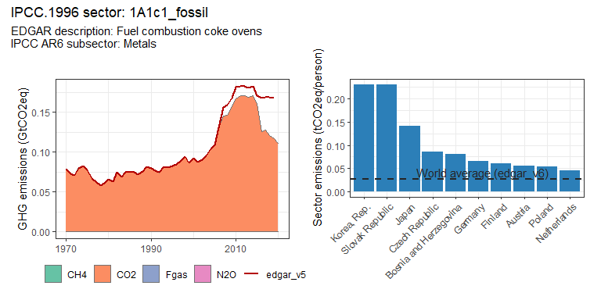 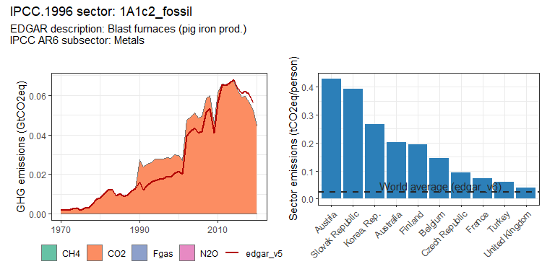 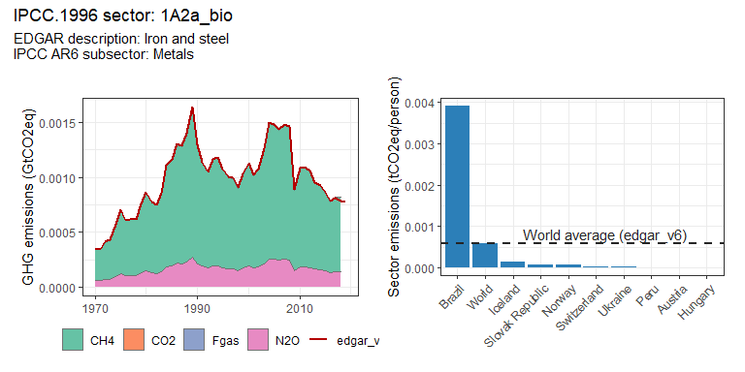 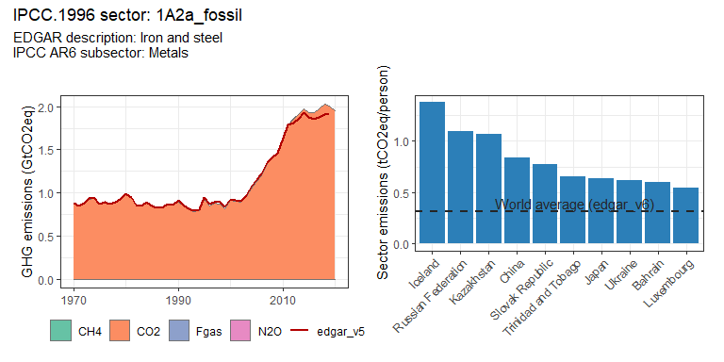 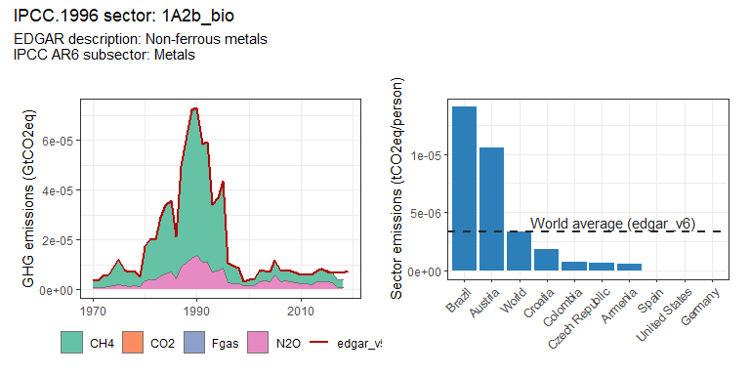 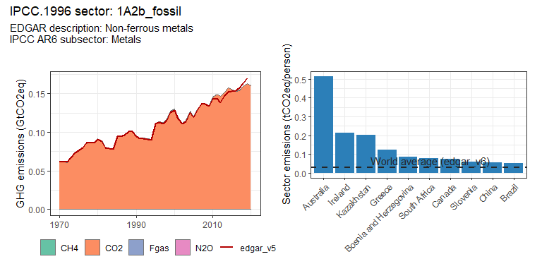 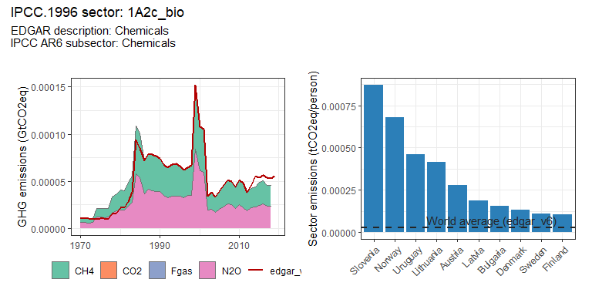 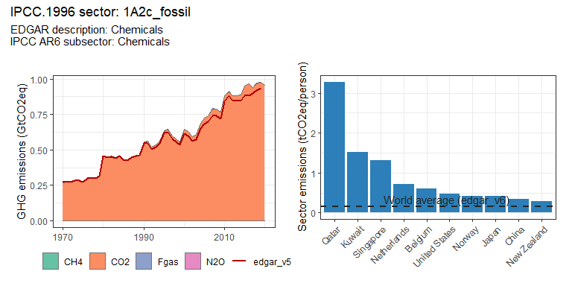 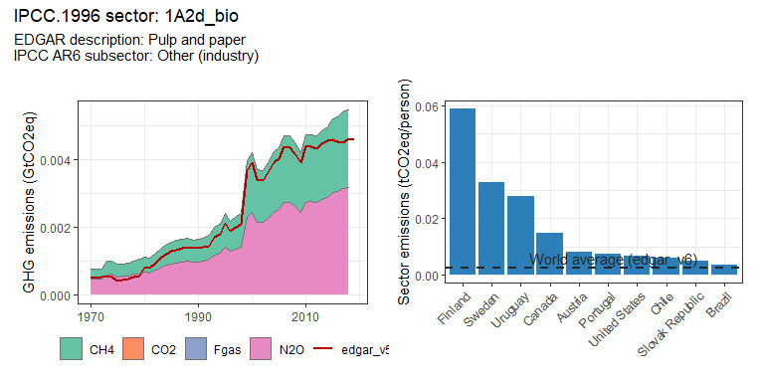 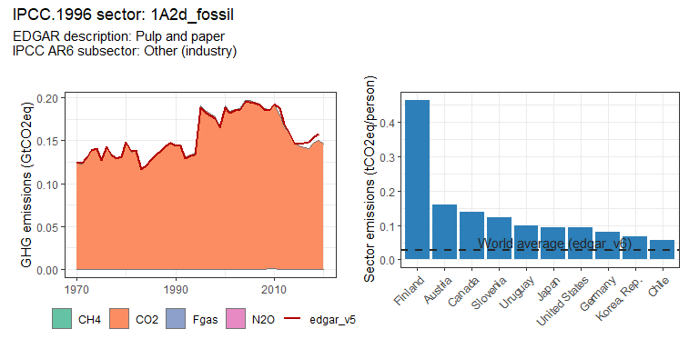 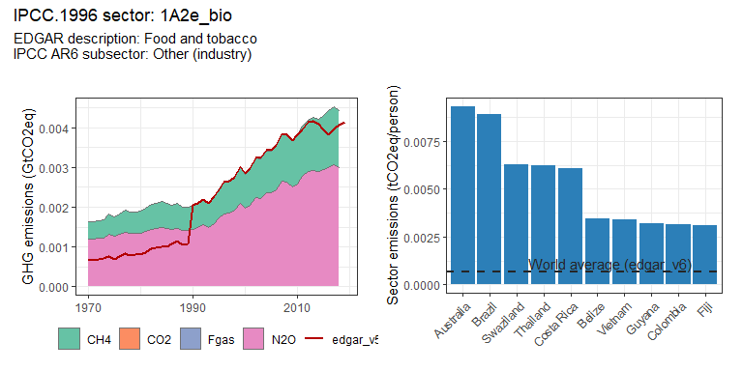 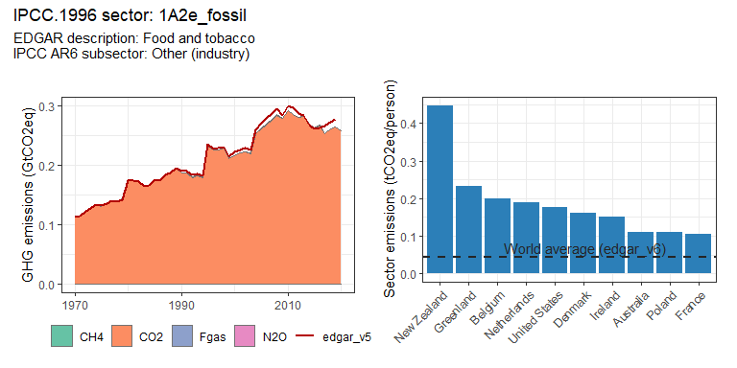 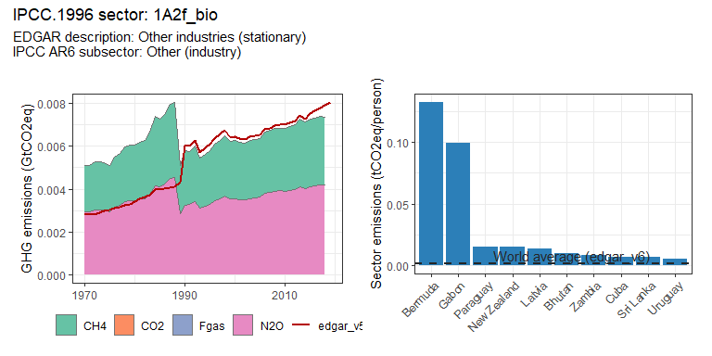 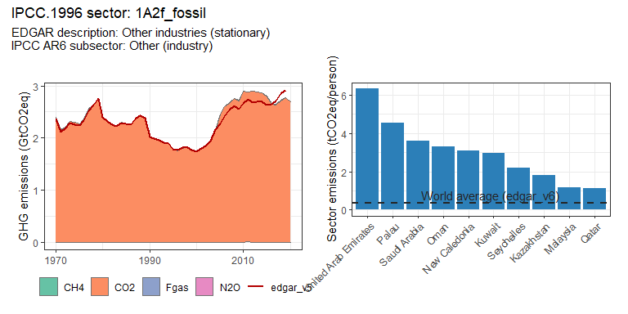 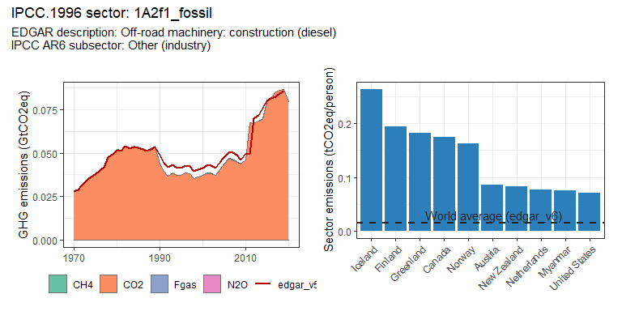 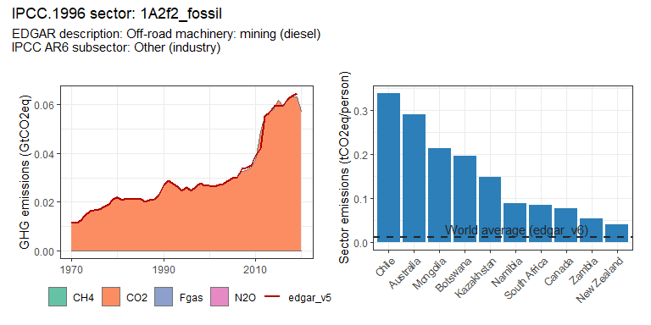 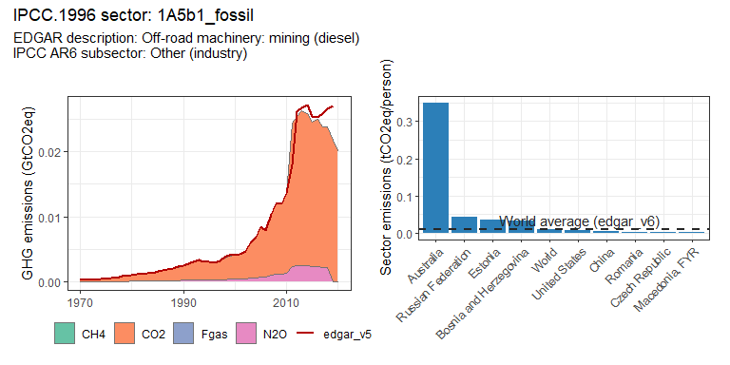 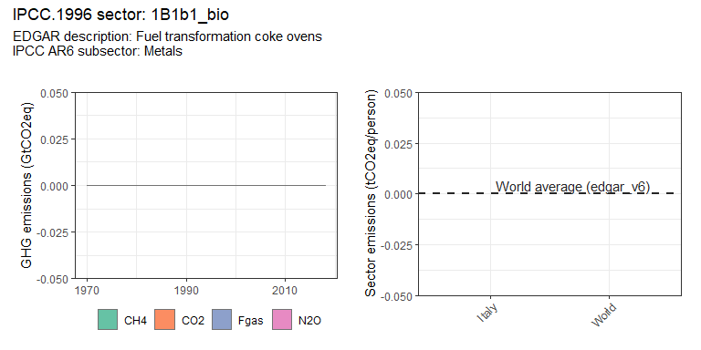 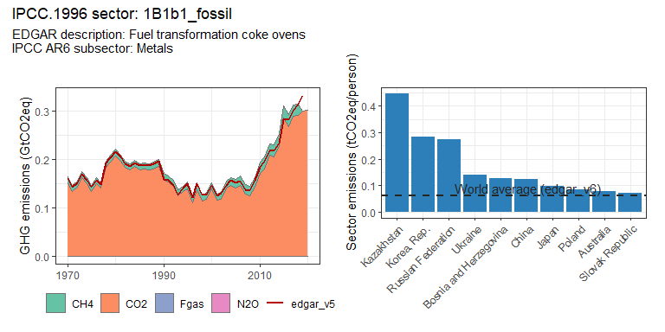 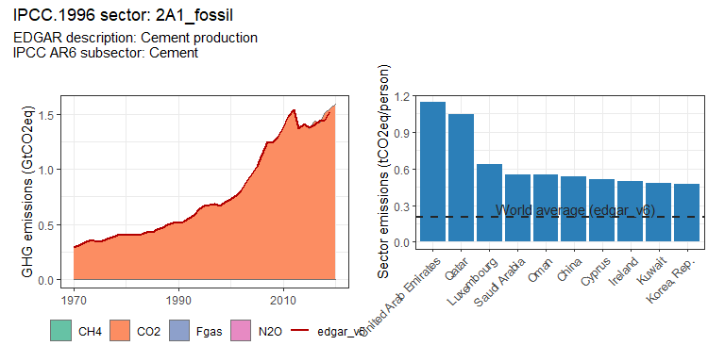 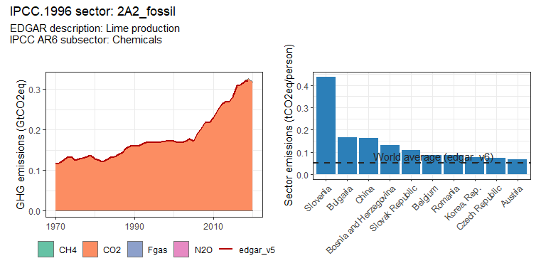 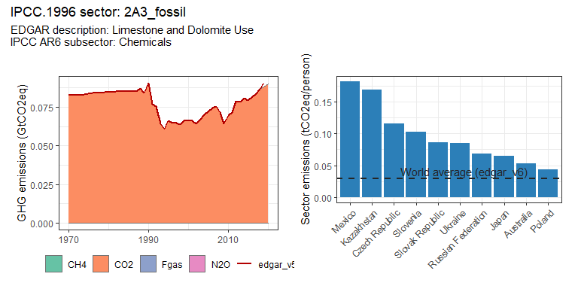 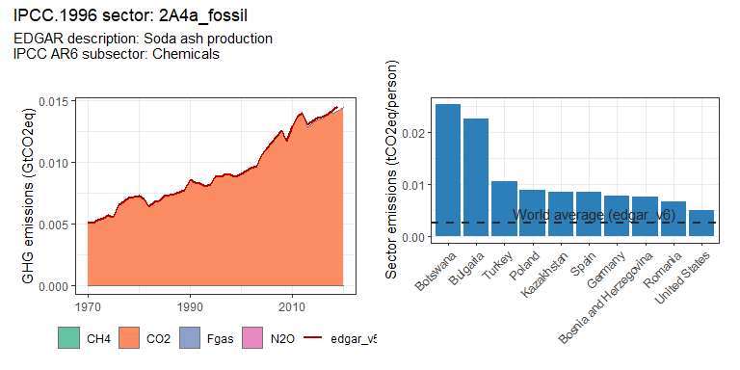 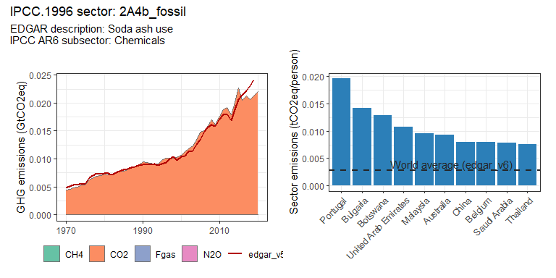 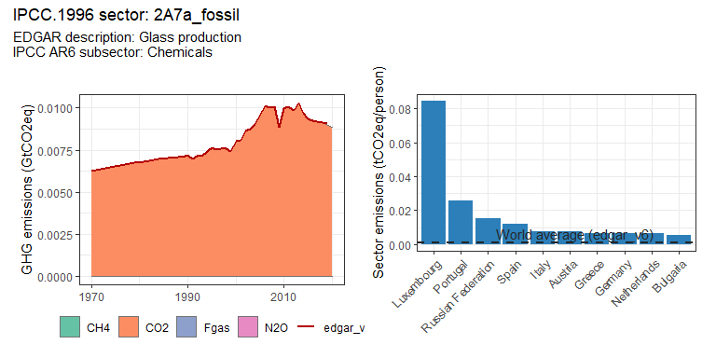 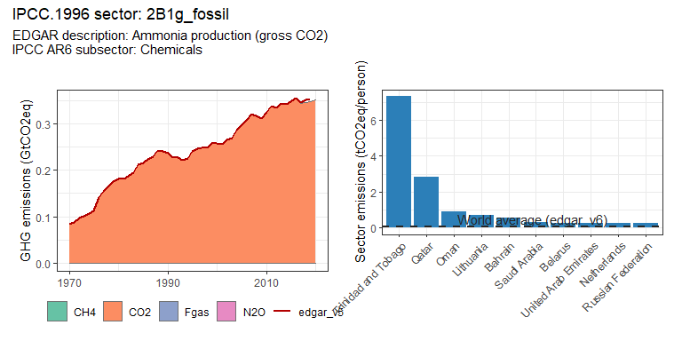 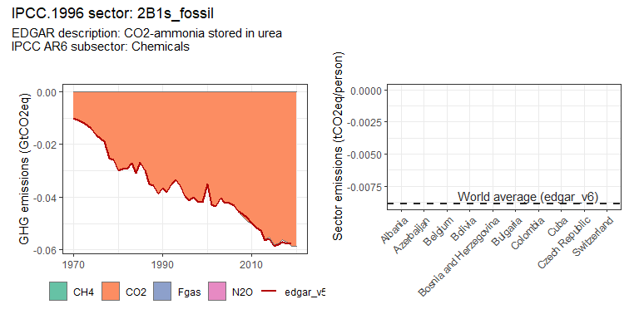 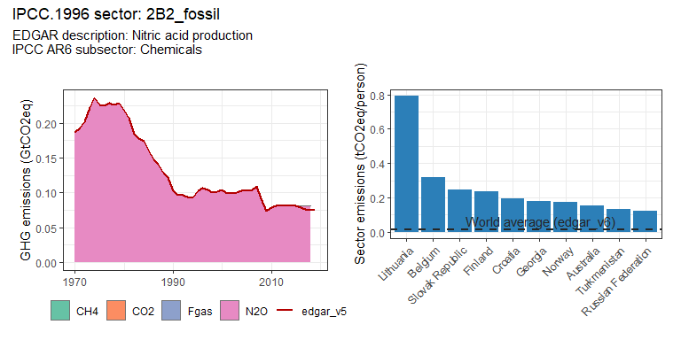 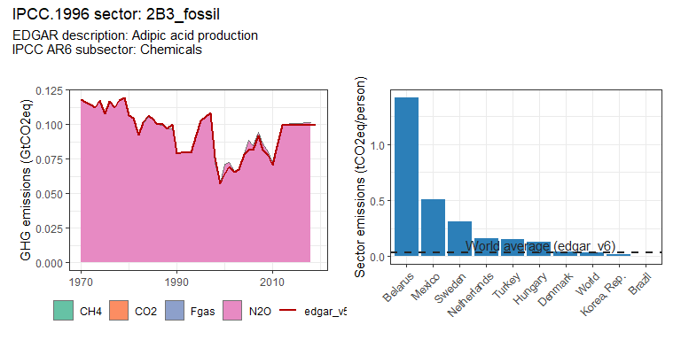 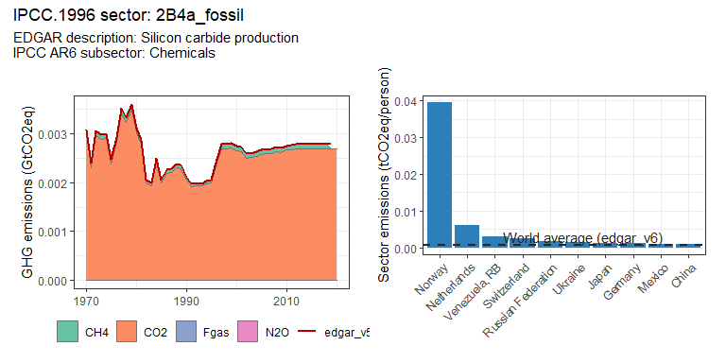 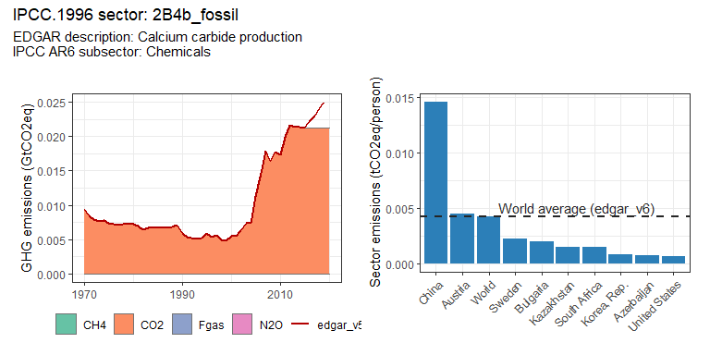 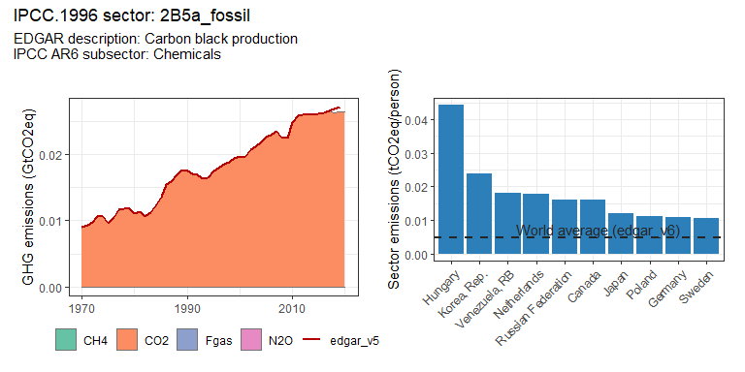 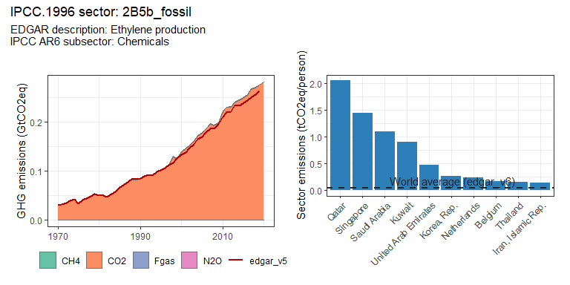 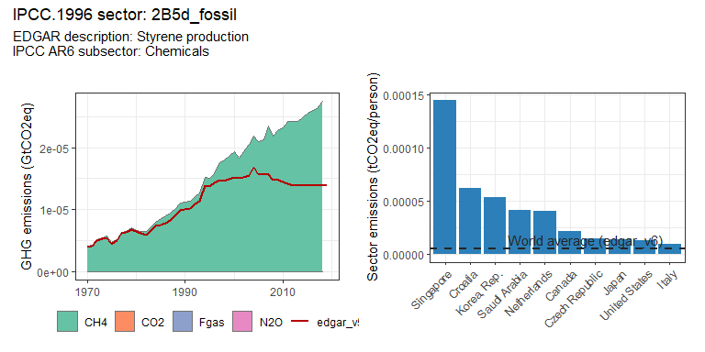 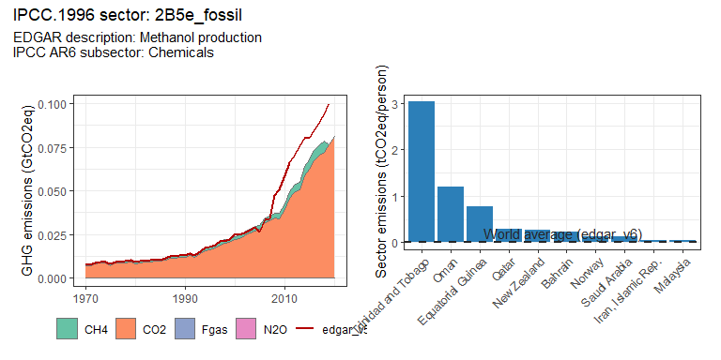 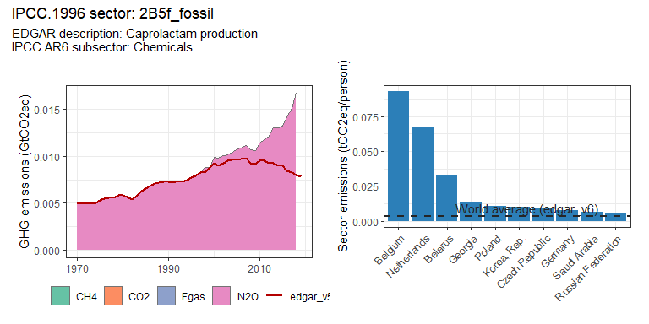 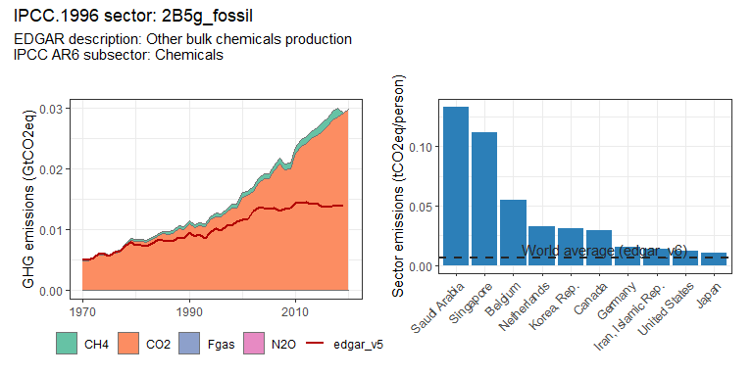 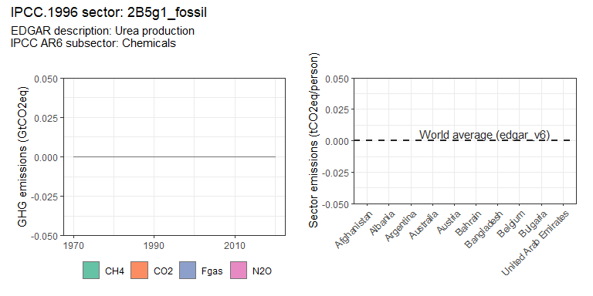 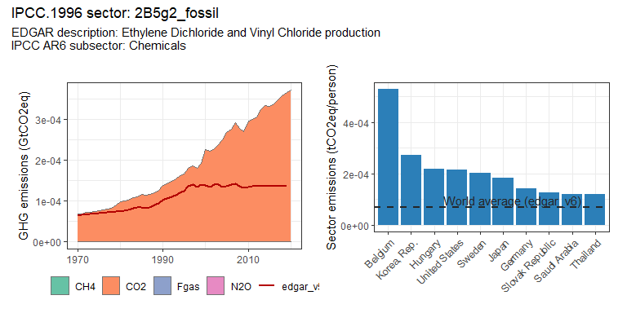 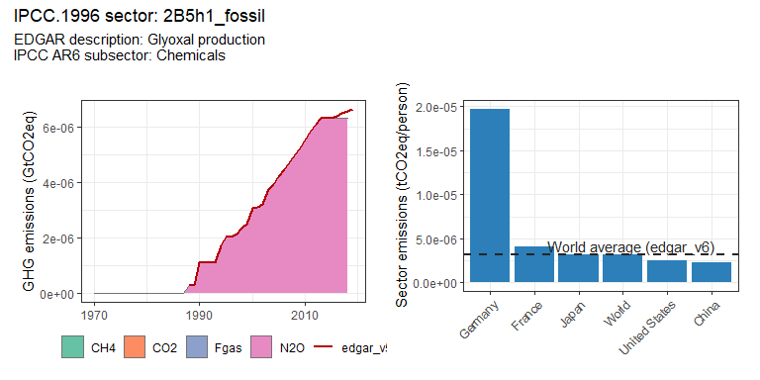 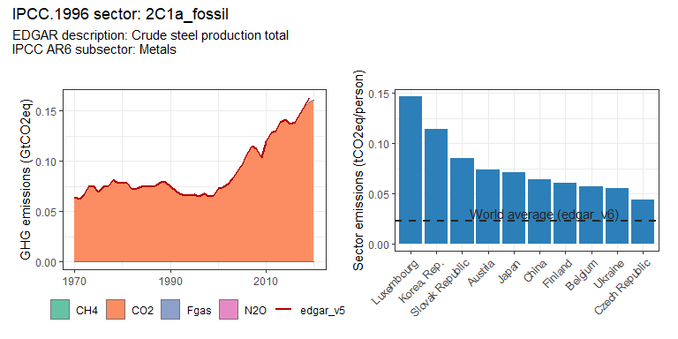 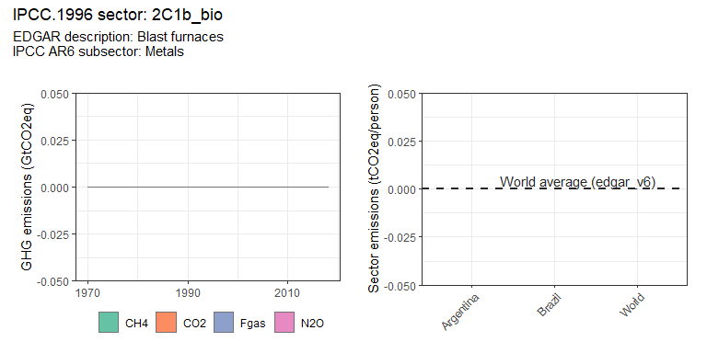 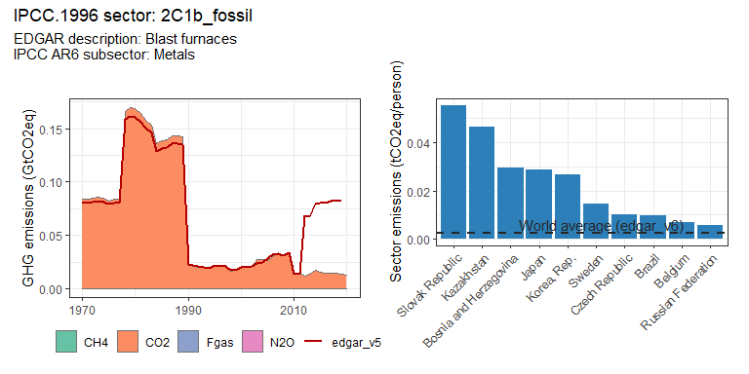 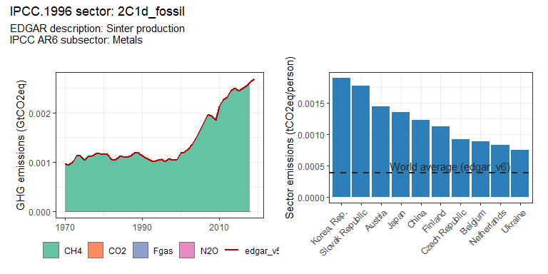 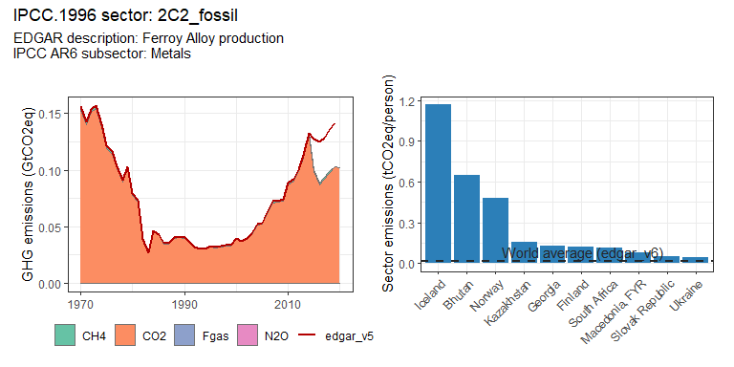 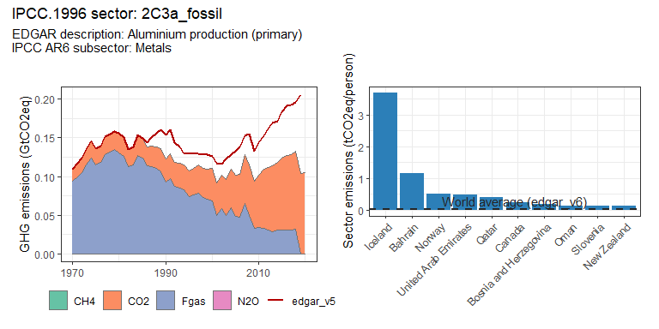 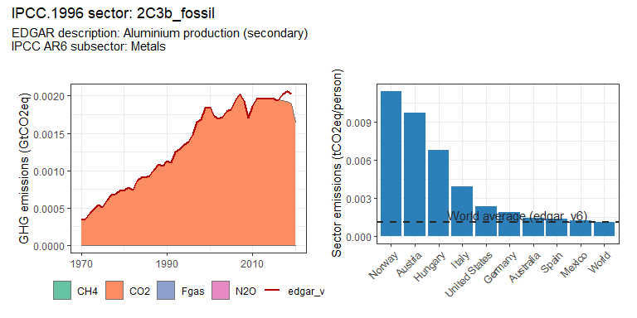 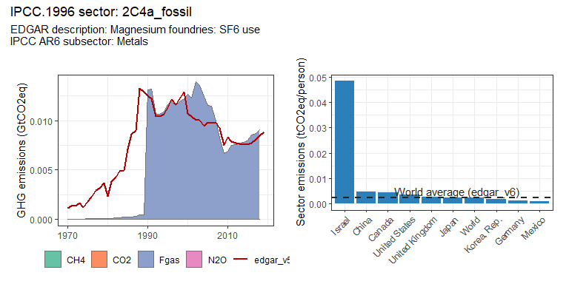 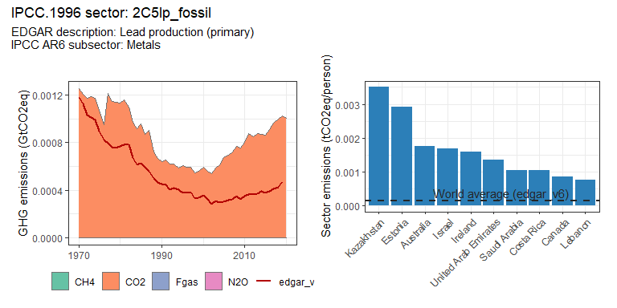 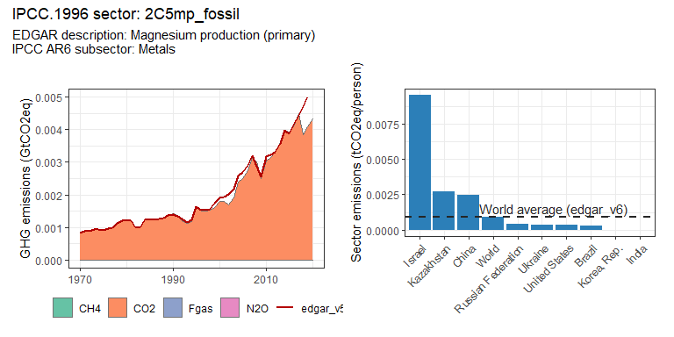 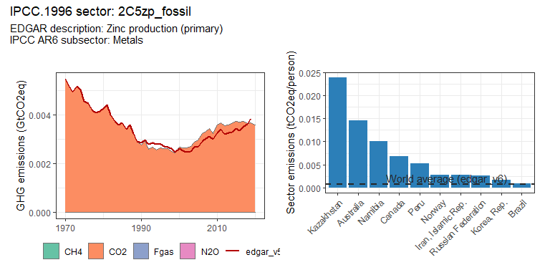 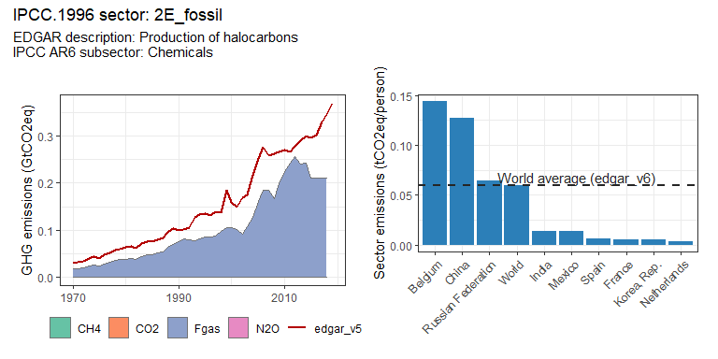 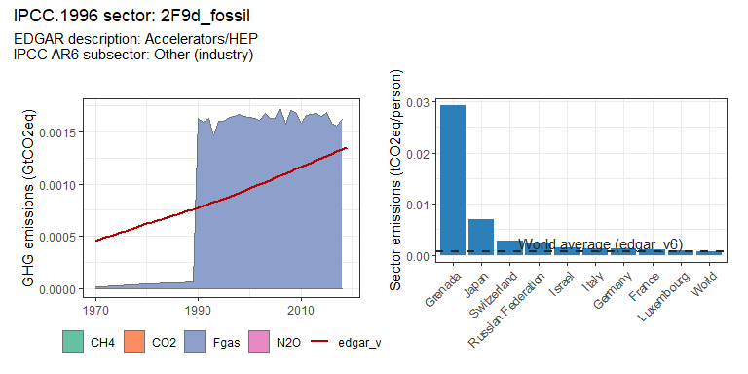 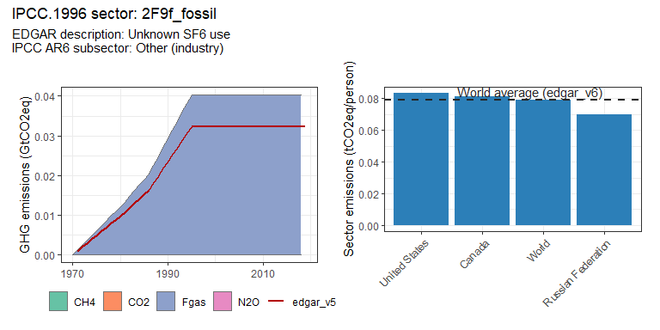 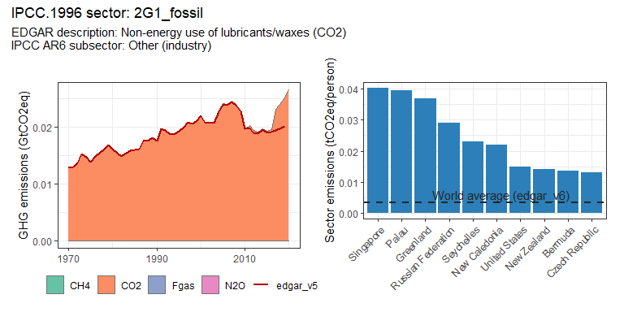 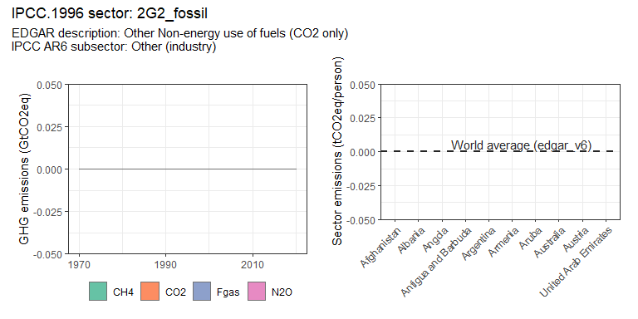 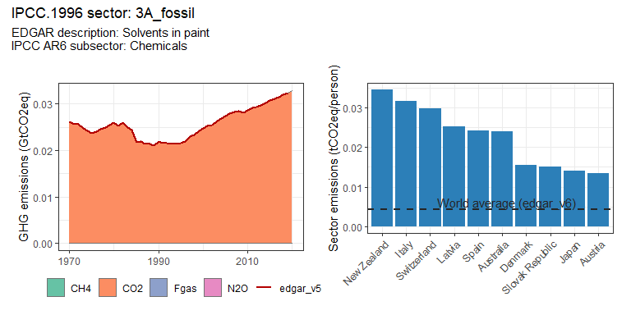 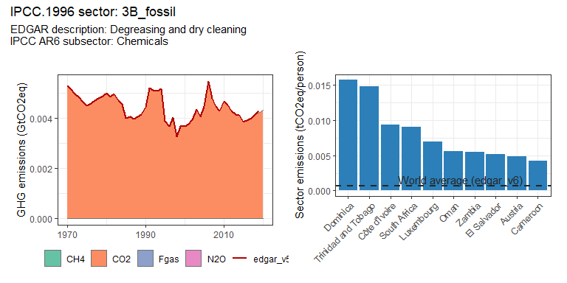 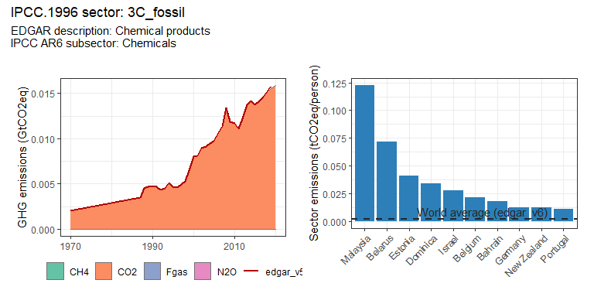 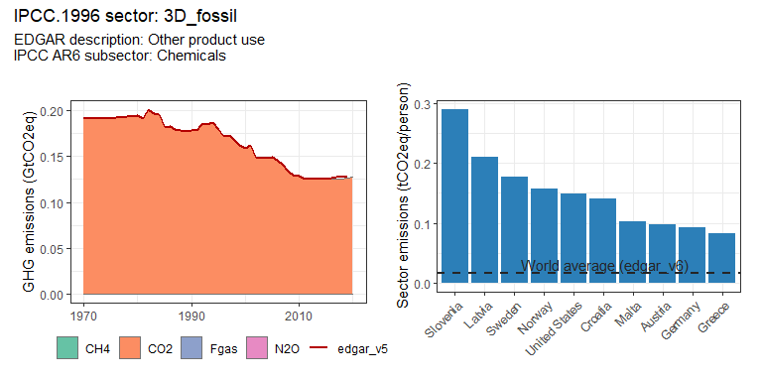 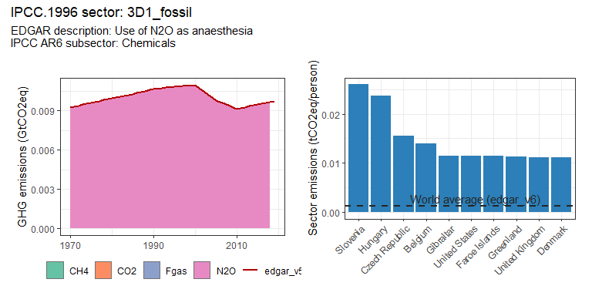 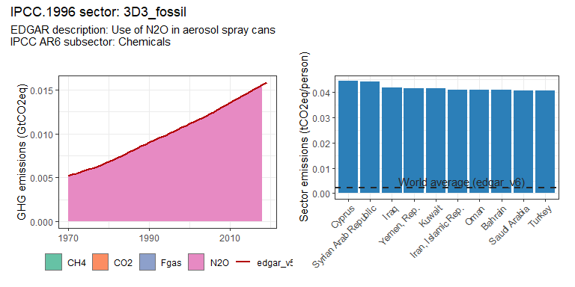 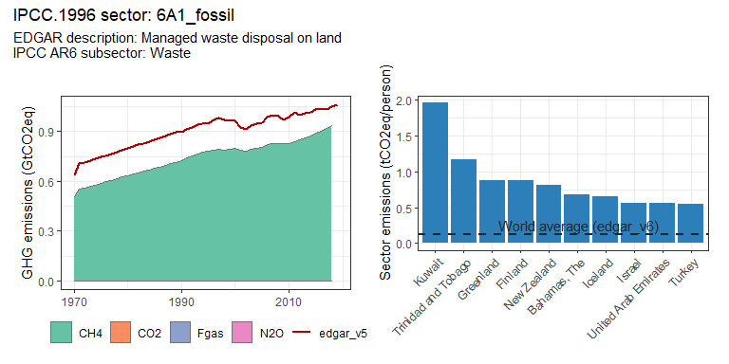 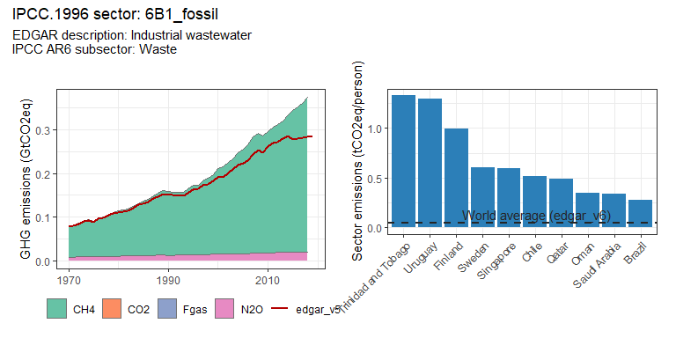 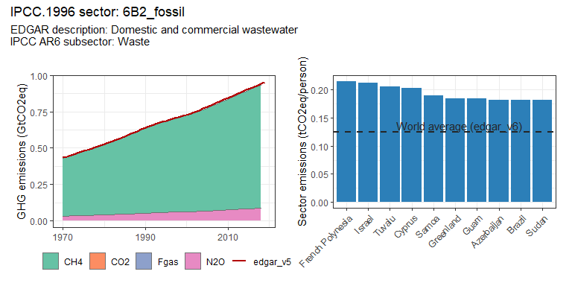 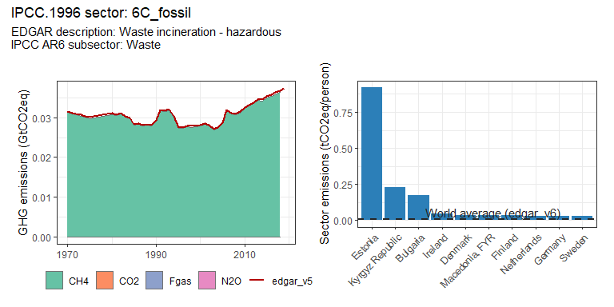 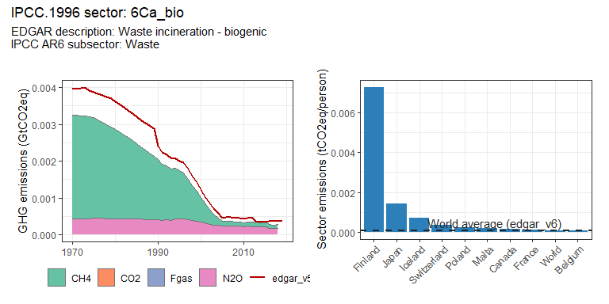 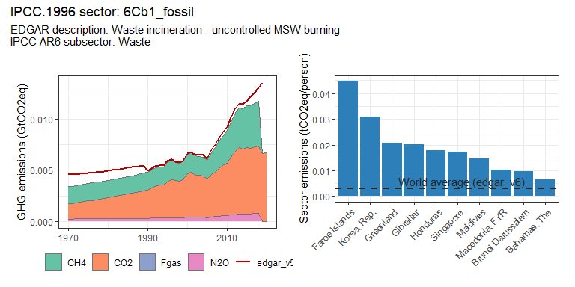 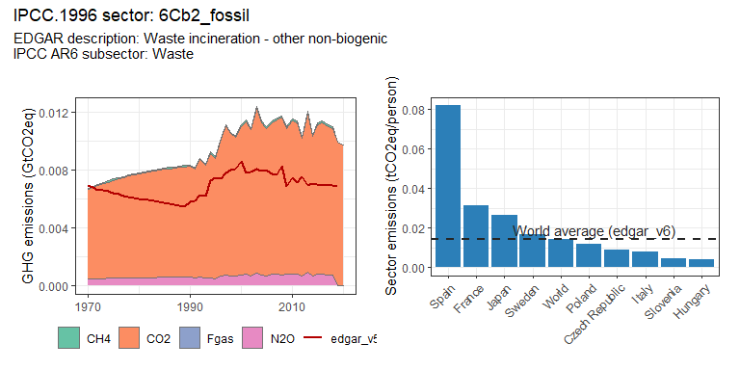 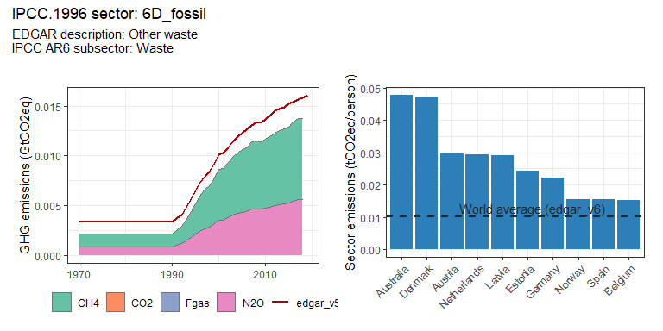 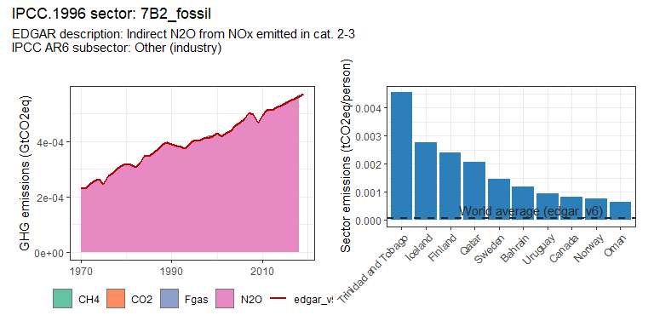 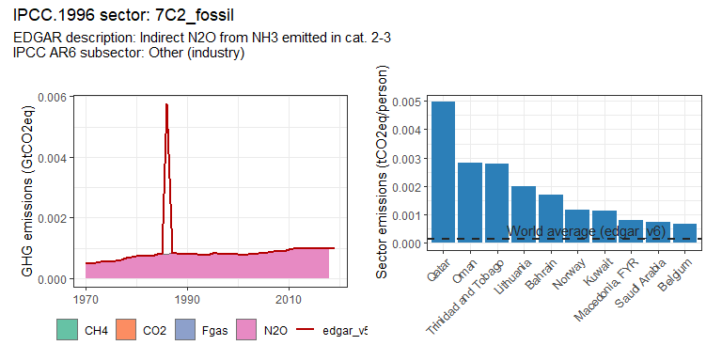 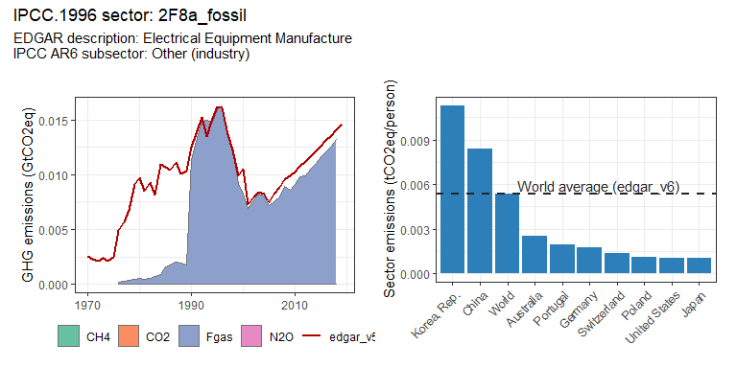 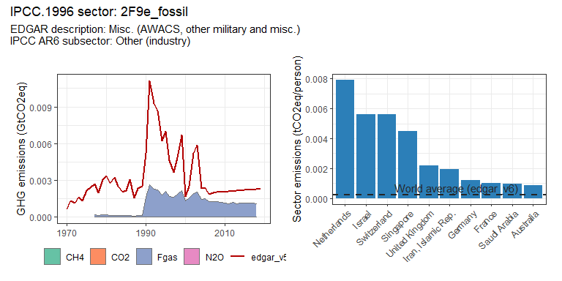 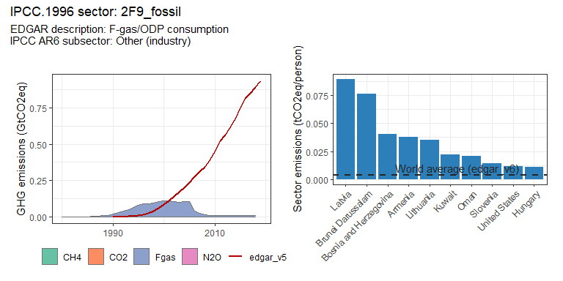 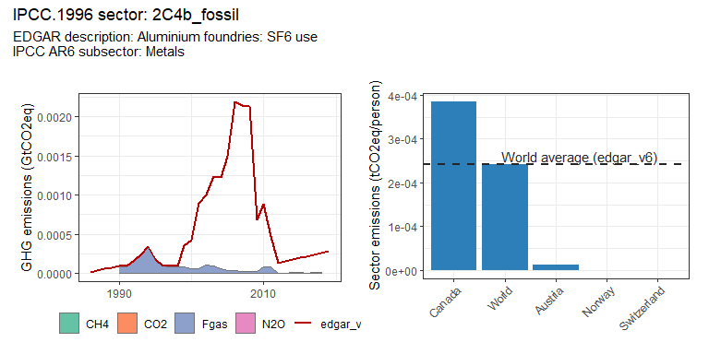 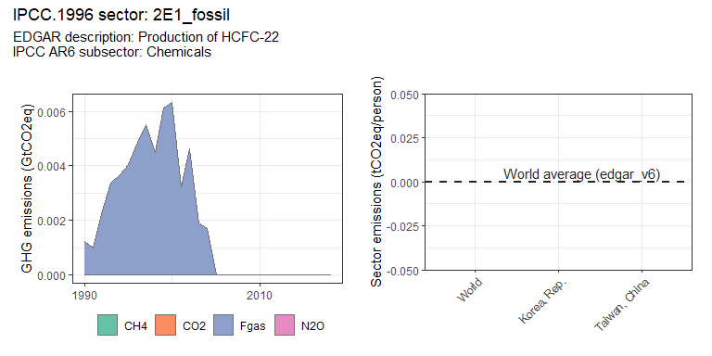 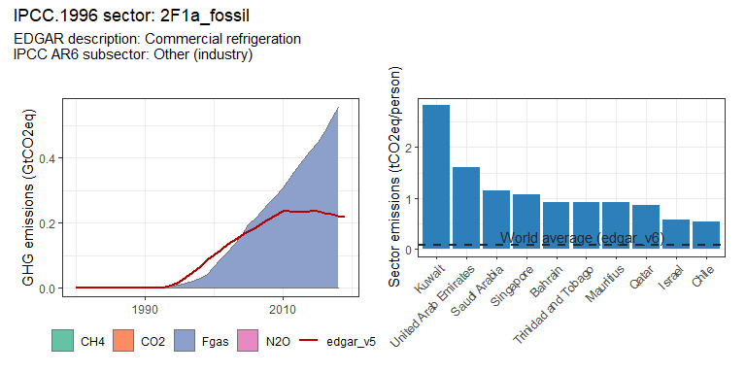 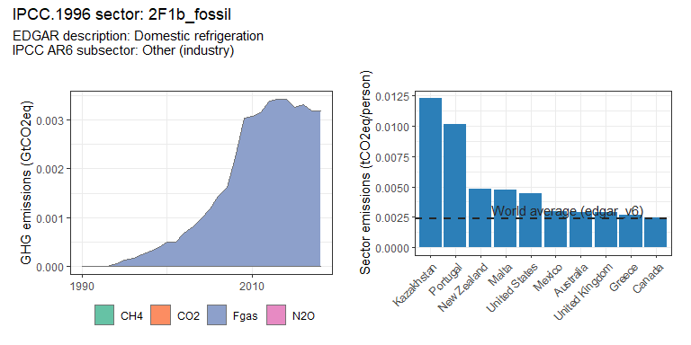 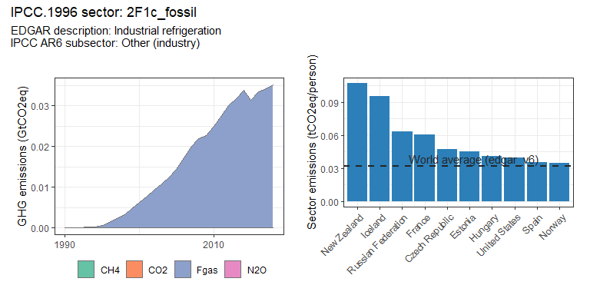 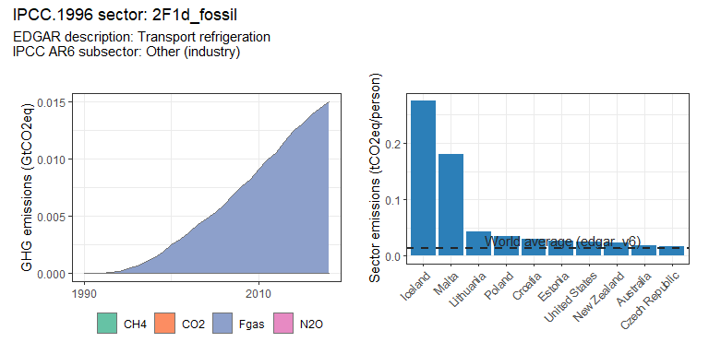 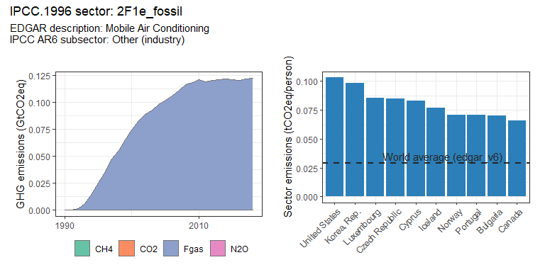 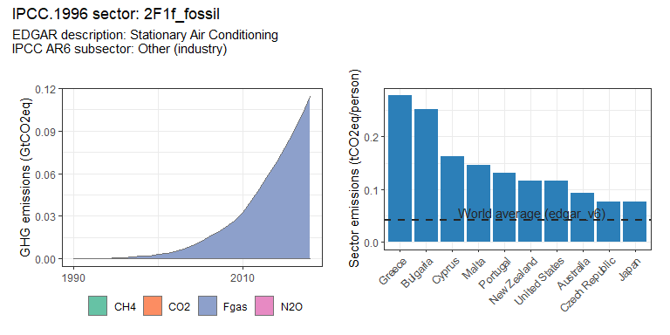 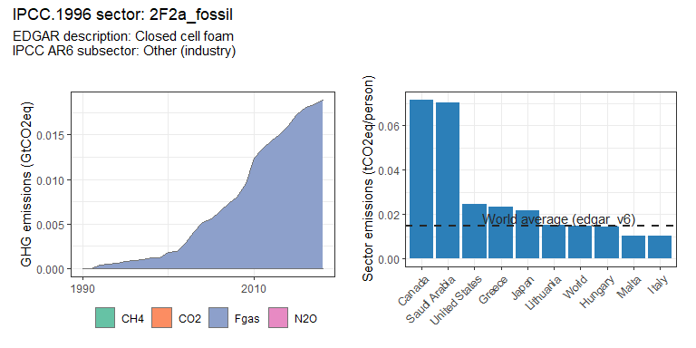 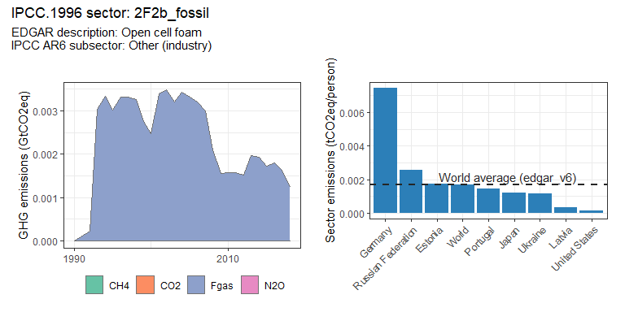 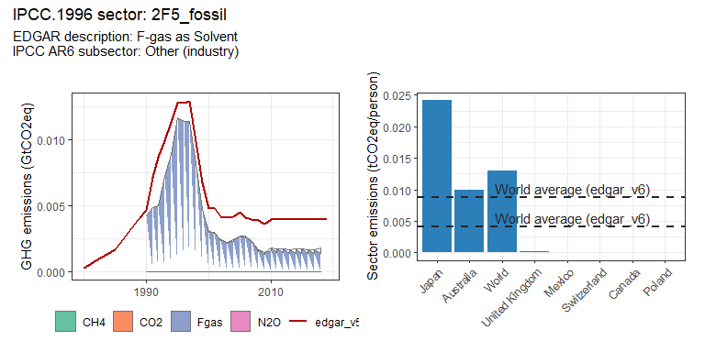 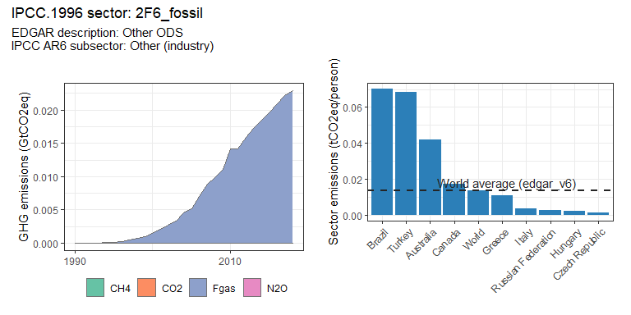 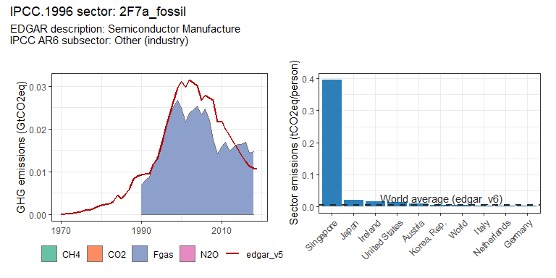 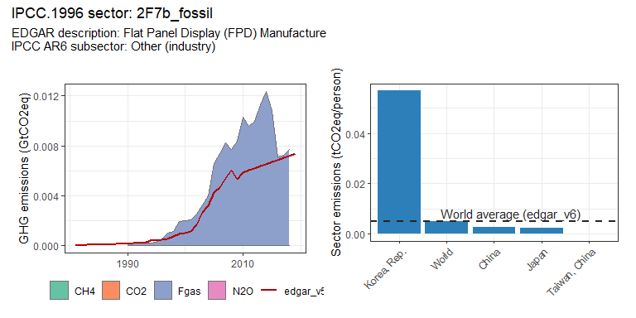 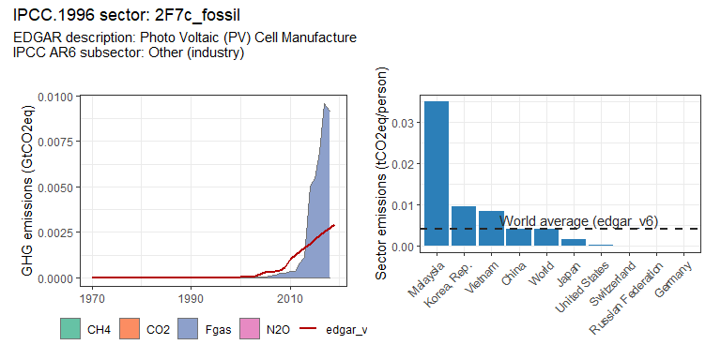

### Transport sectors

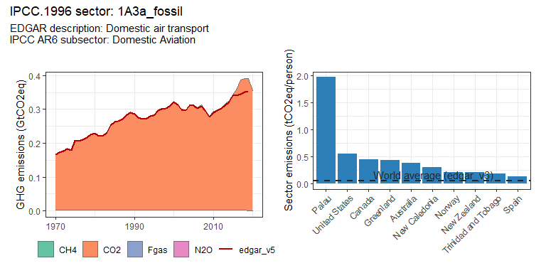 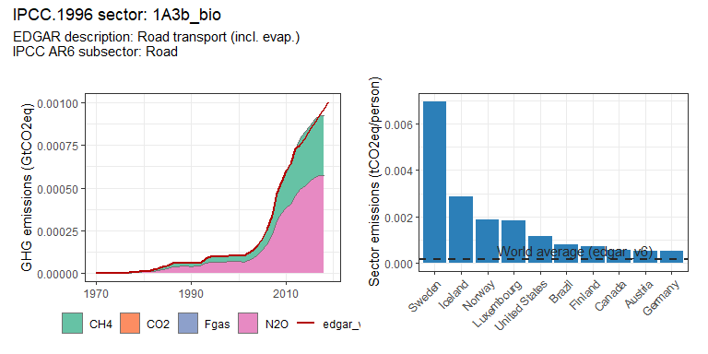 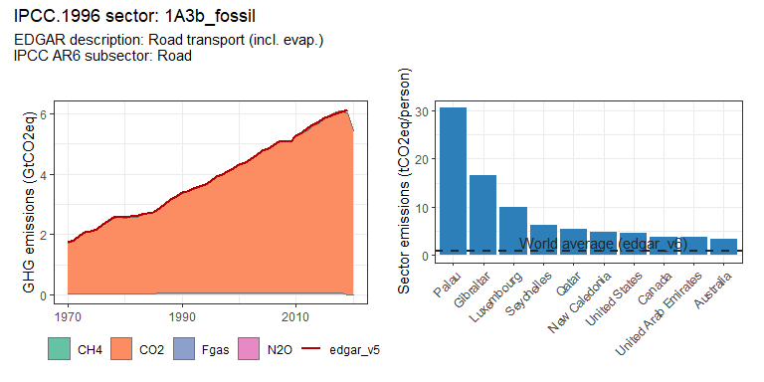 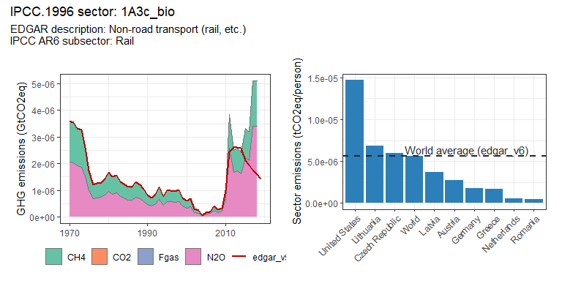 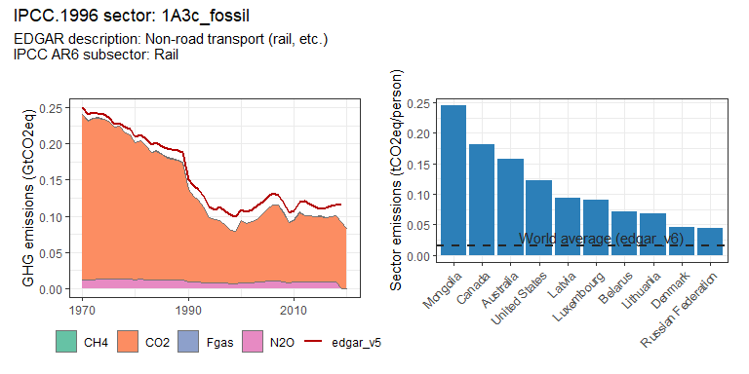 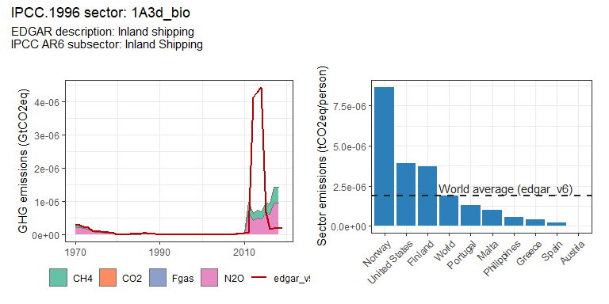 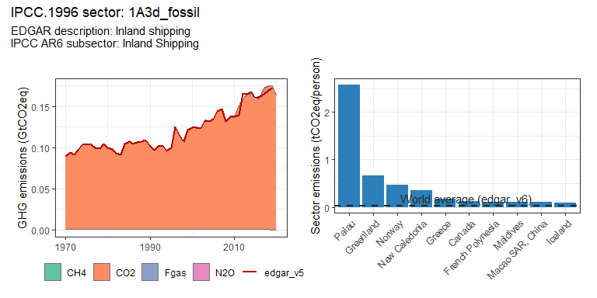 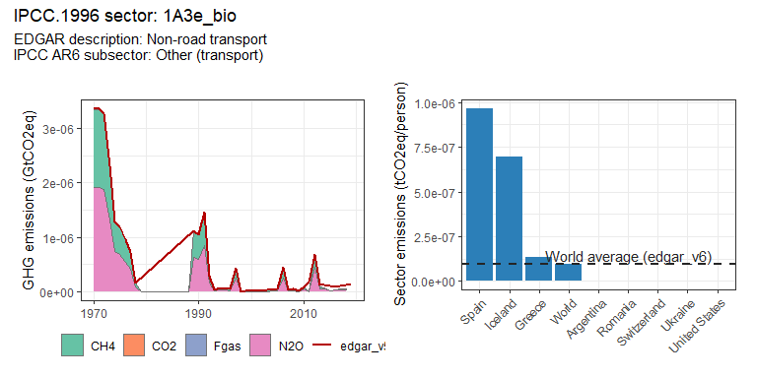 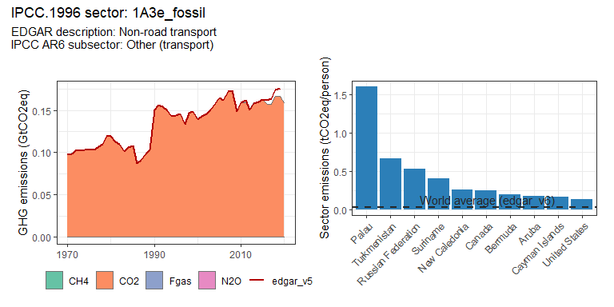 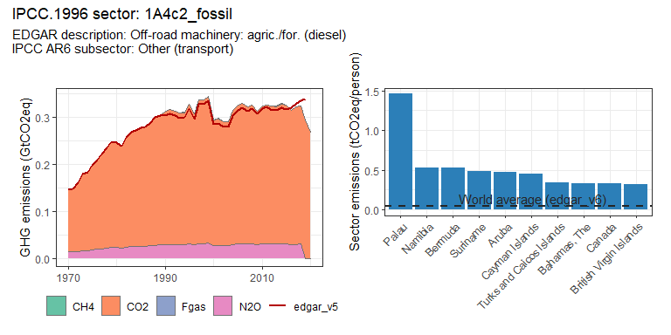 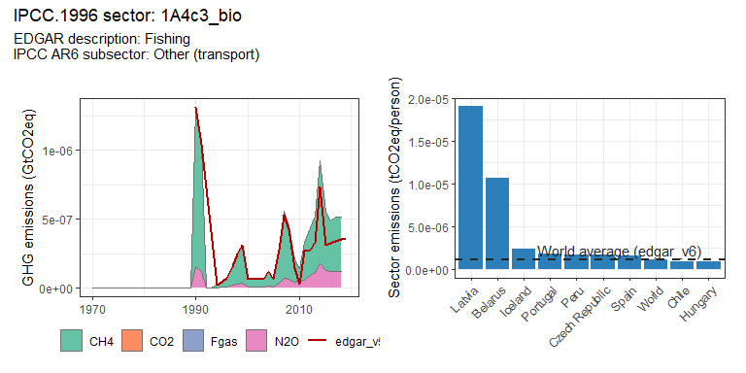 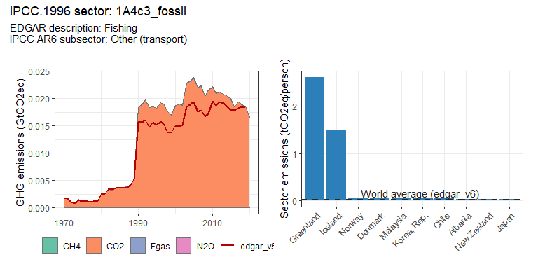 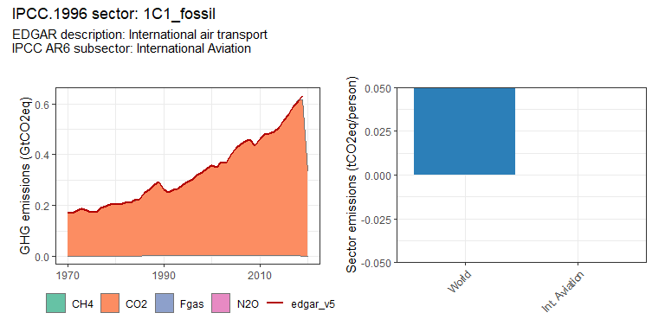 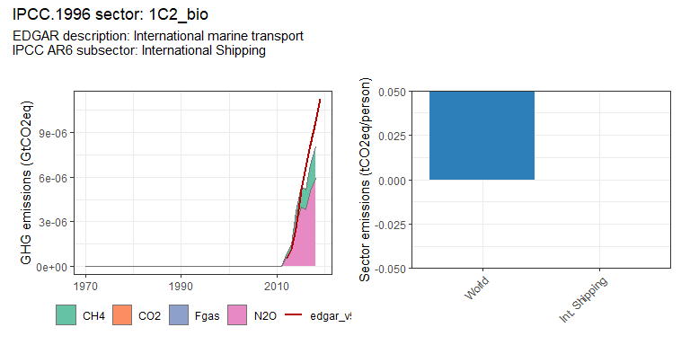 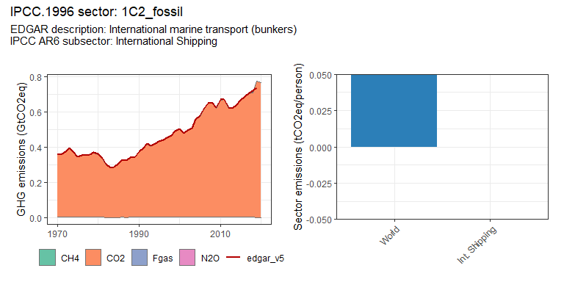 # Region trends

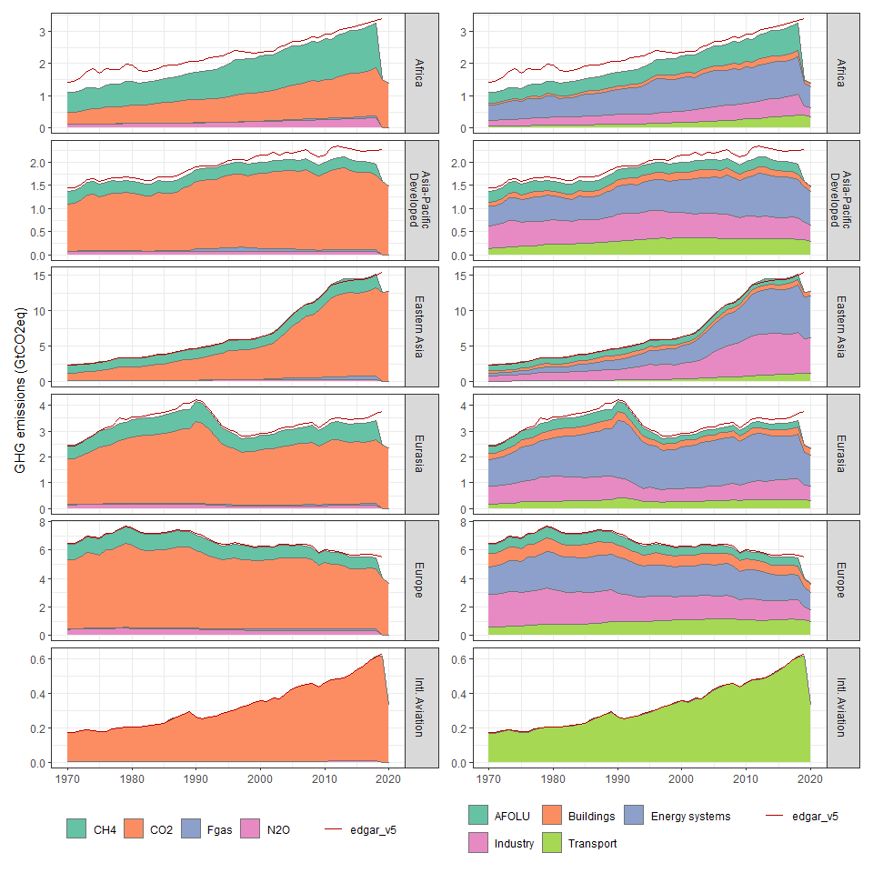 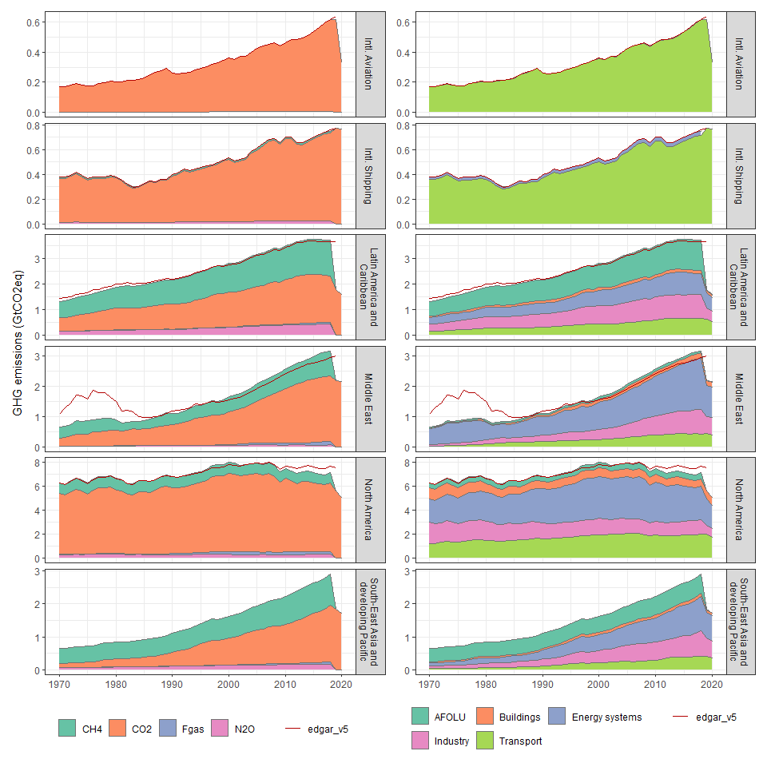

# Country trends

### Afghanistan

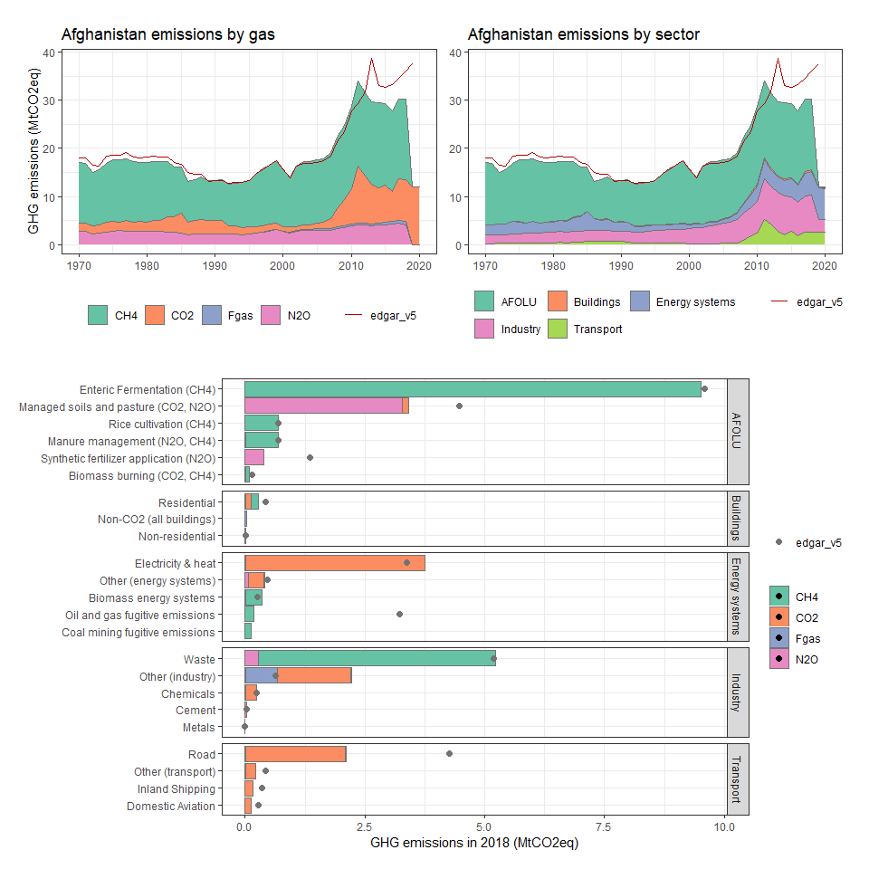

### Albania

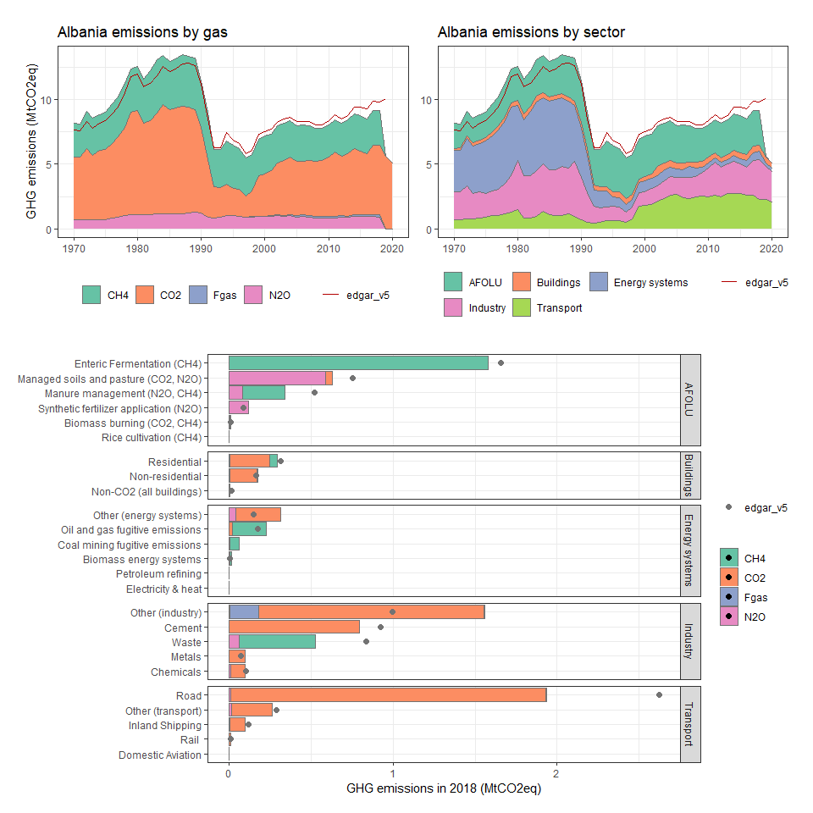

### Algeria

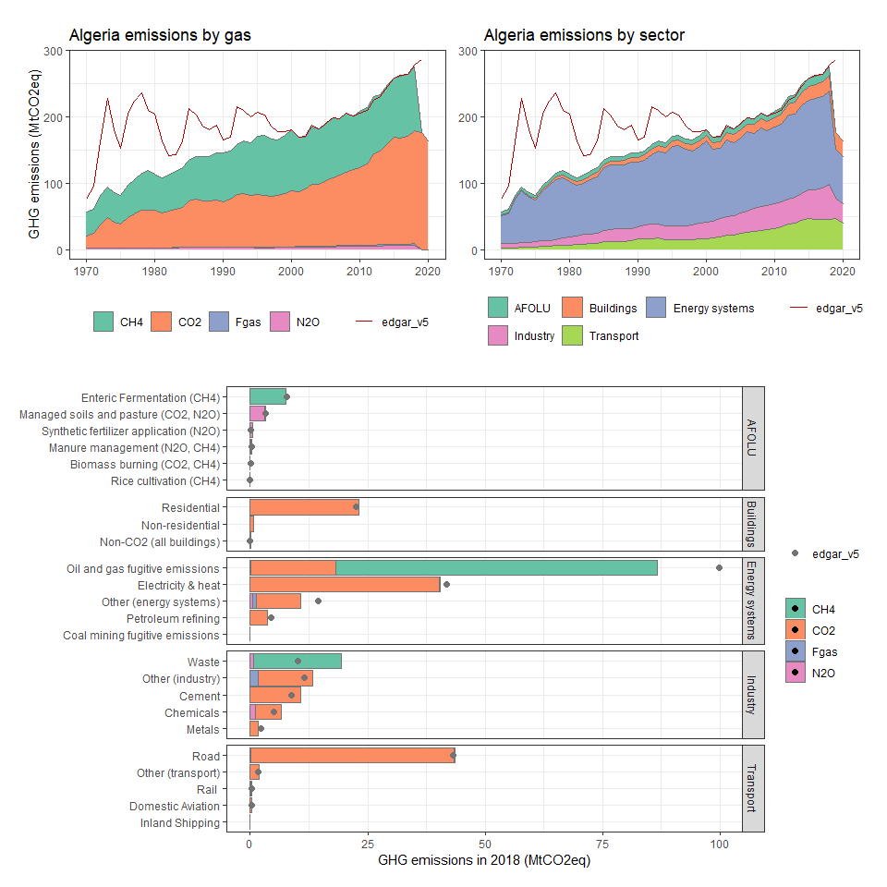

### American Samoa

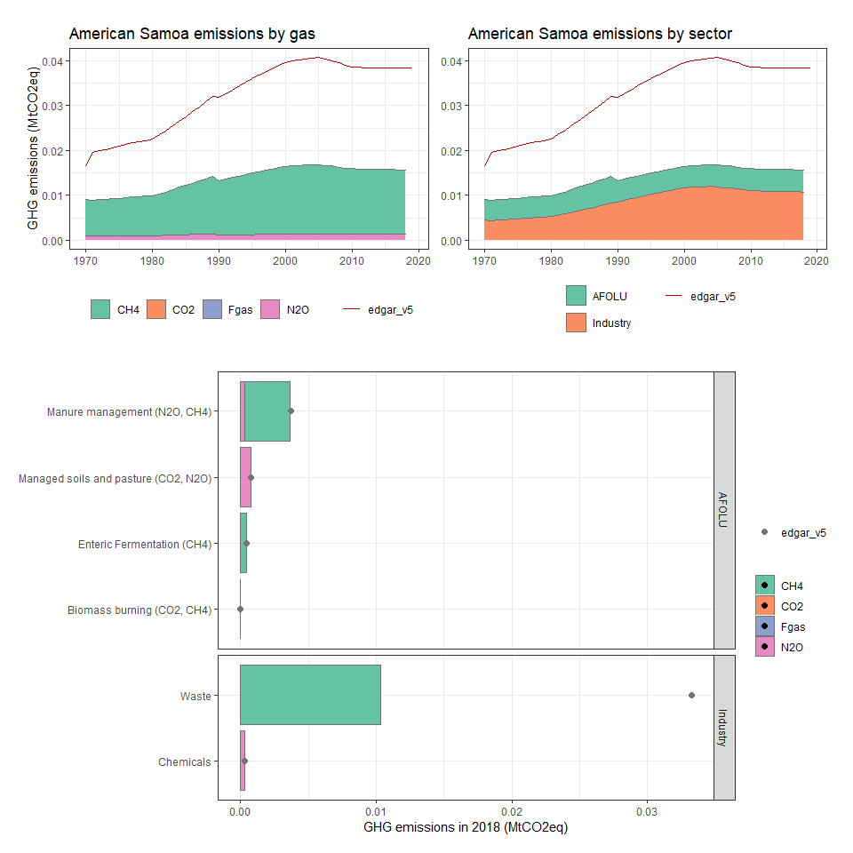

### Angola

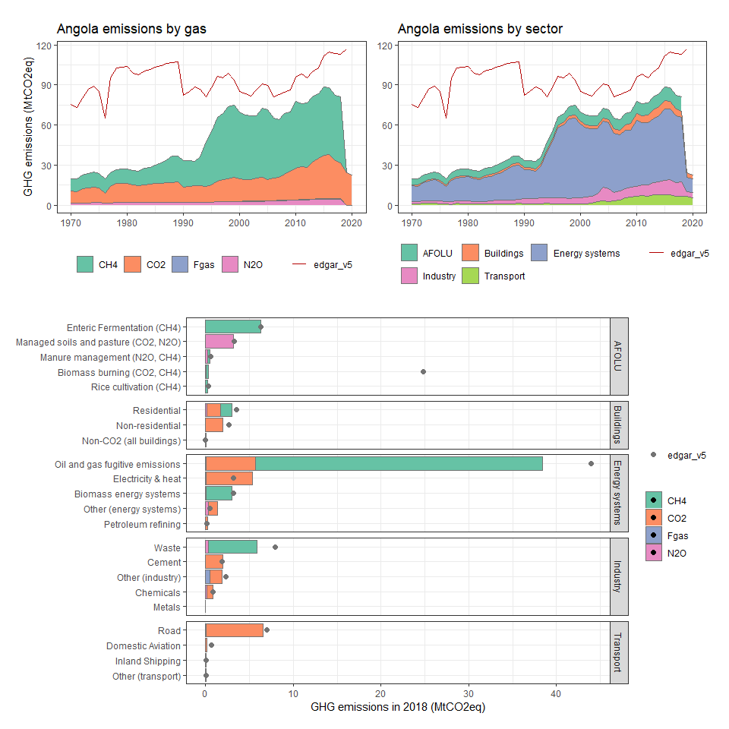

### Anguilla

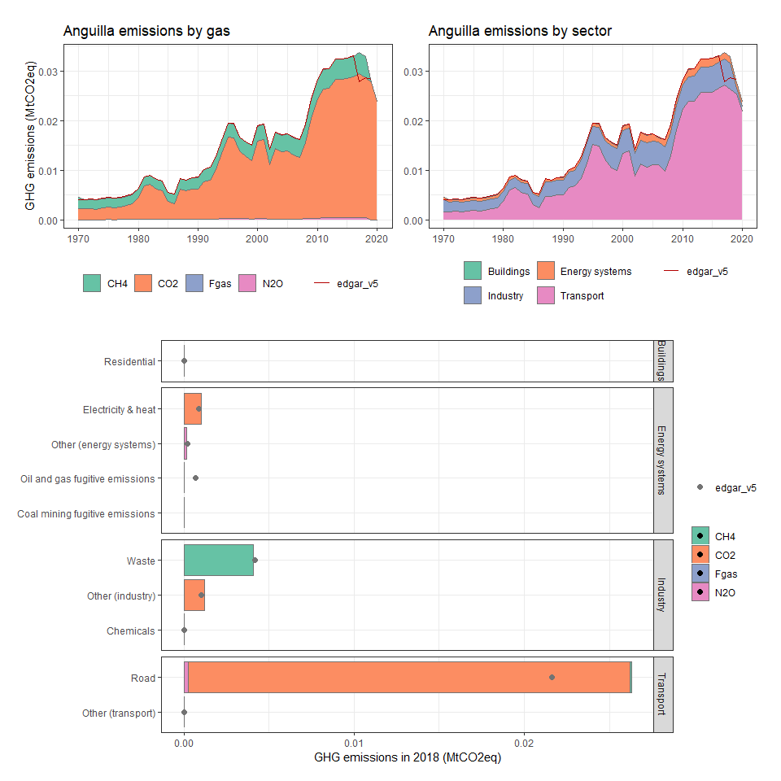

### Antigua and Barbuda

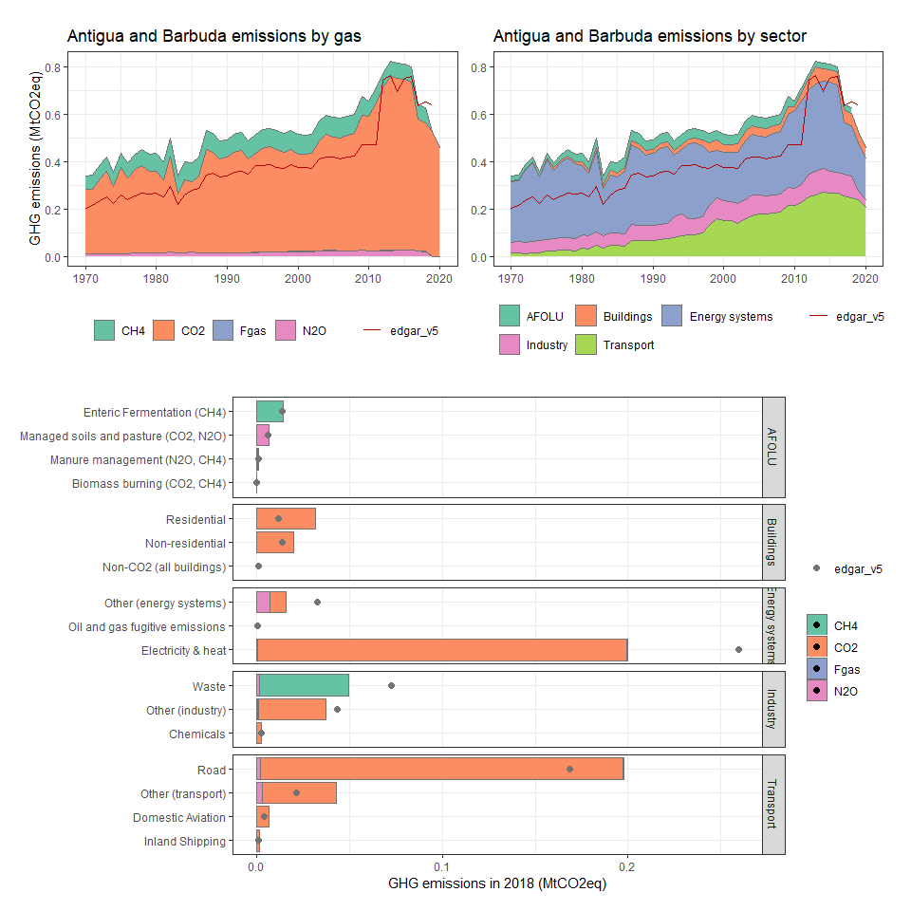

### Argentina

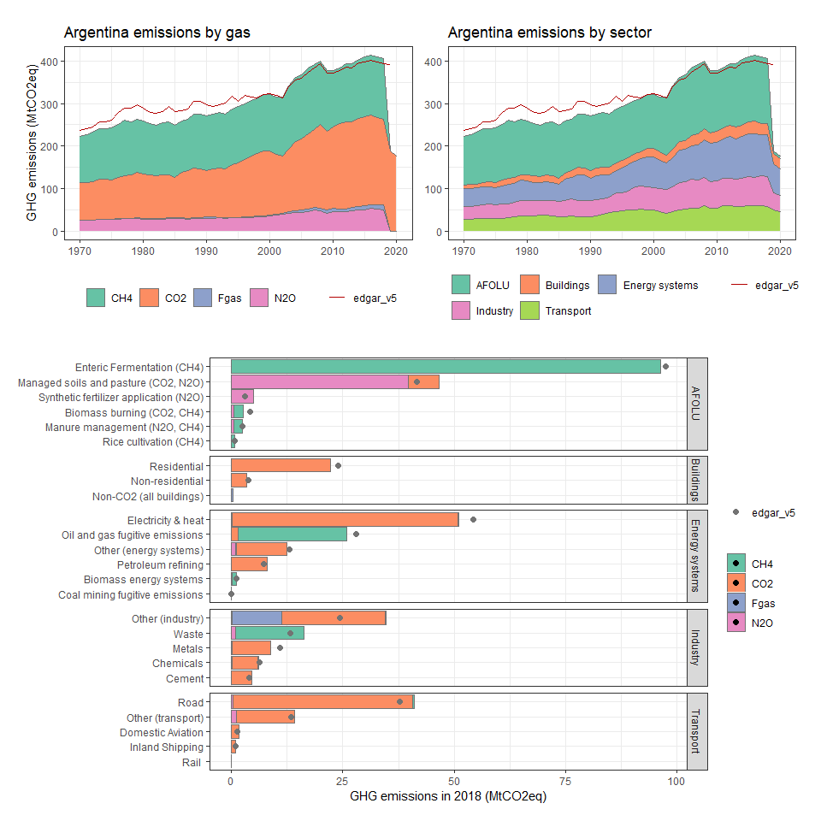

### Armenia

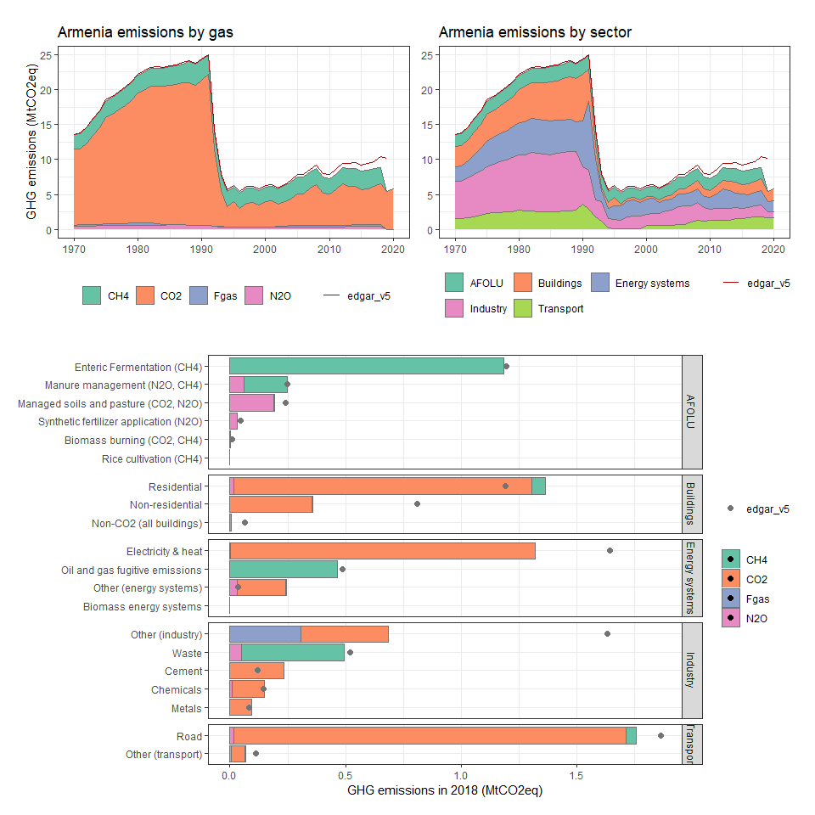

### Aruba

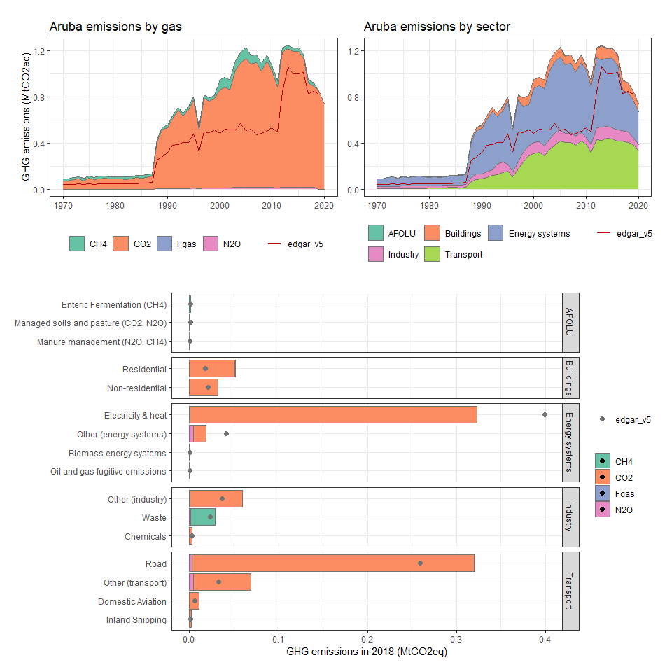

### Australia

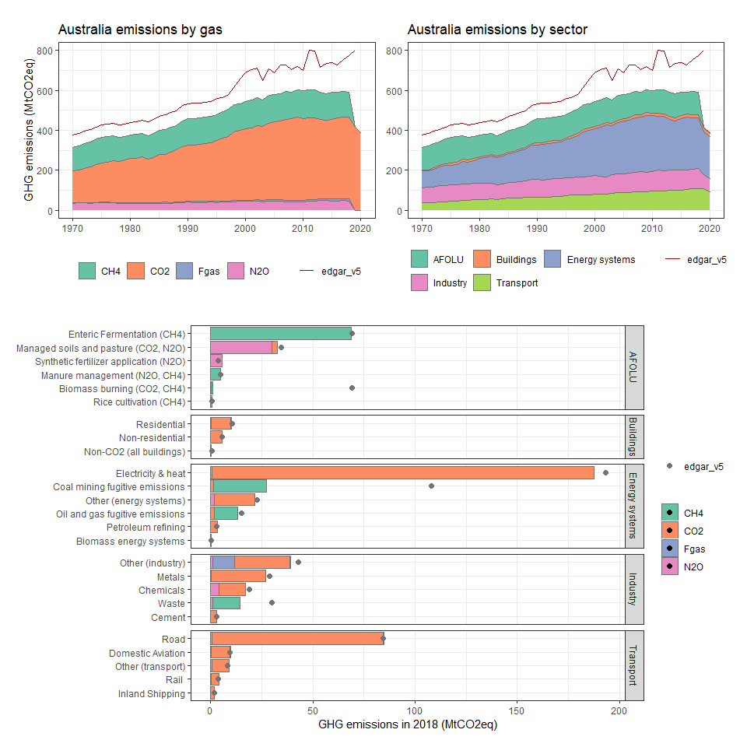

### Austria

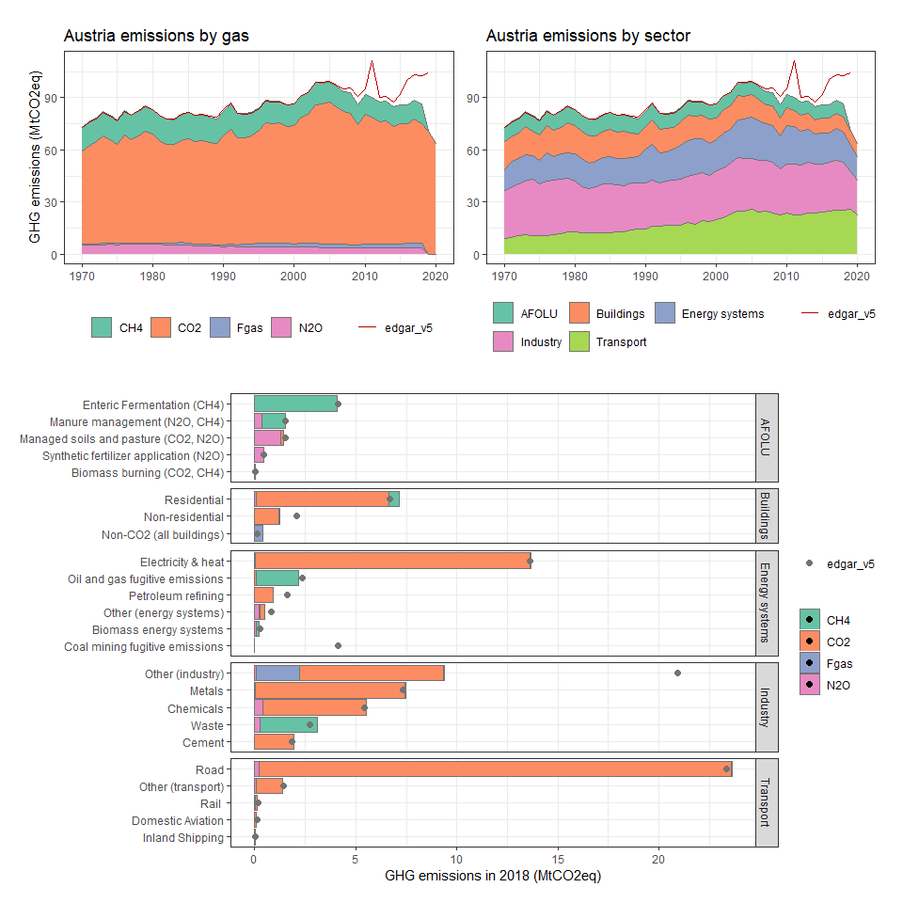

### Azerbaijan

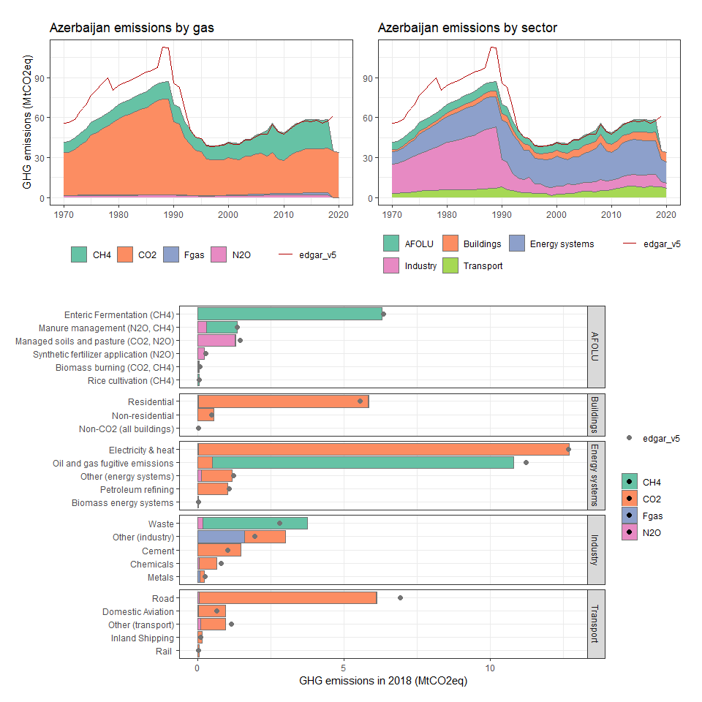

### Bahamas, The

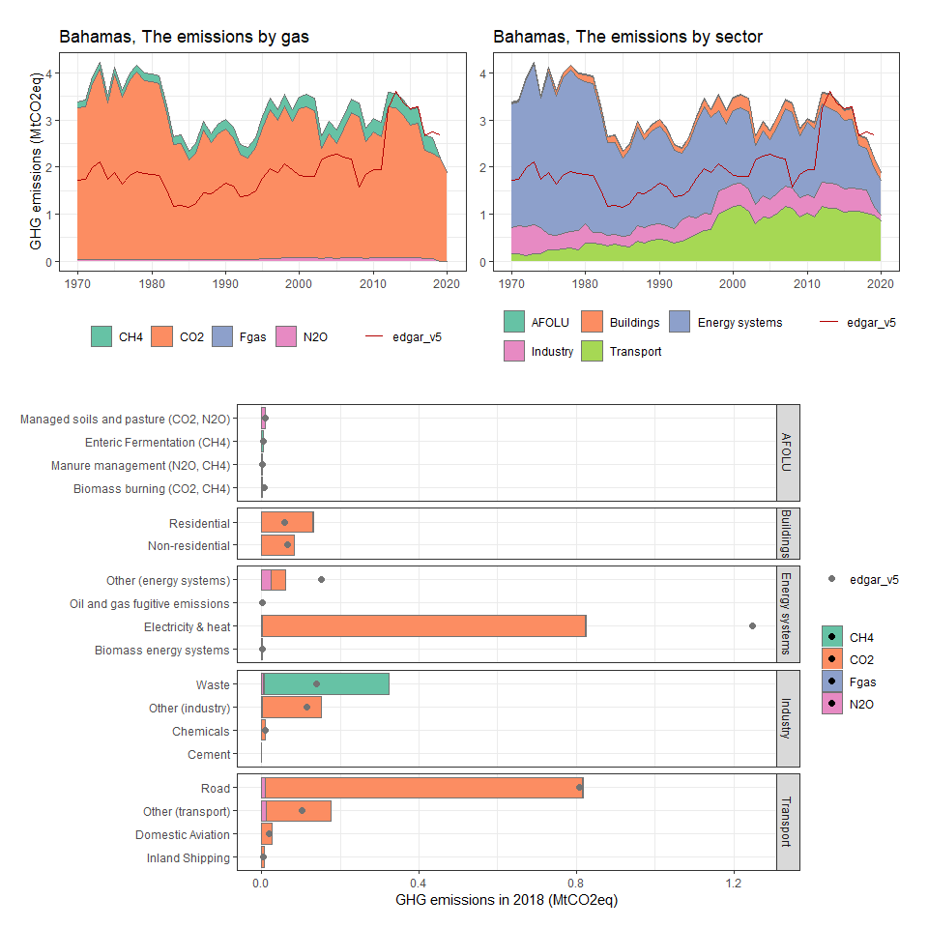

### Bahrain

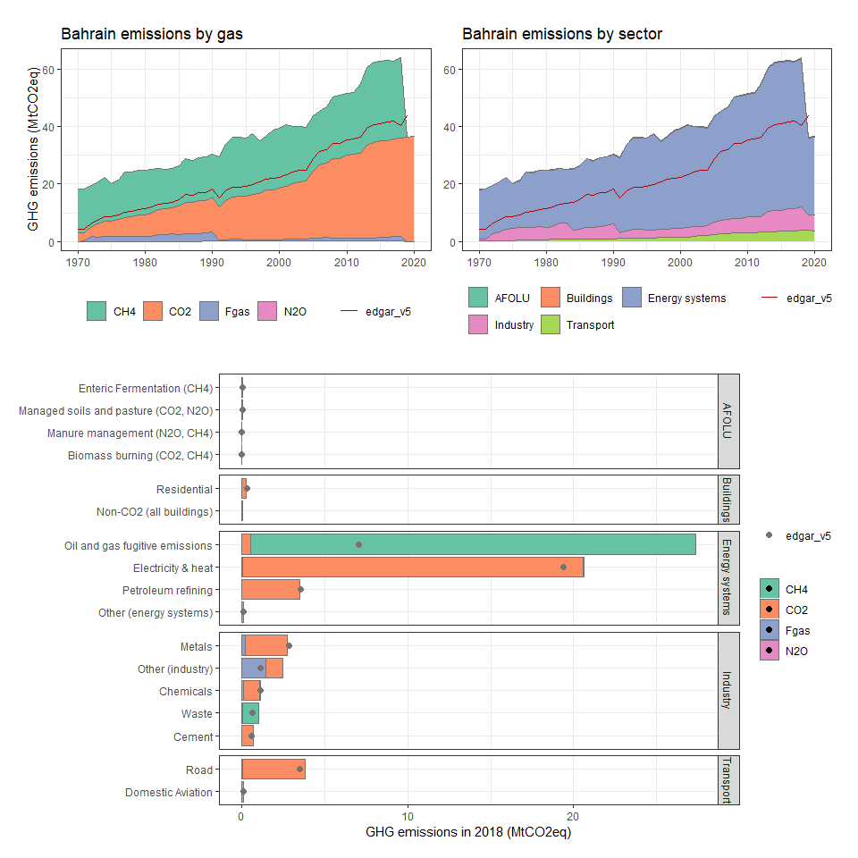

### Bangladesh

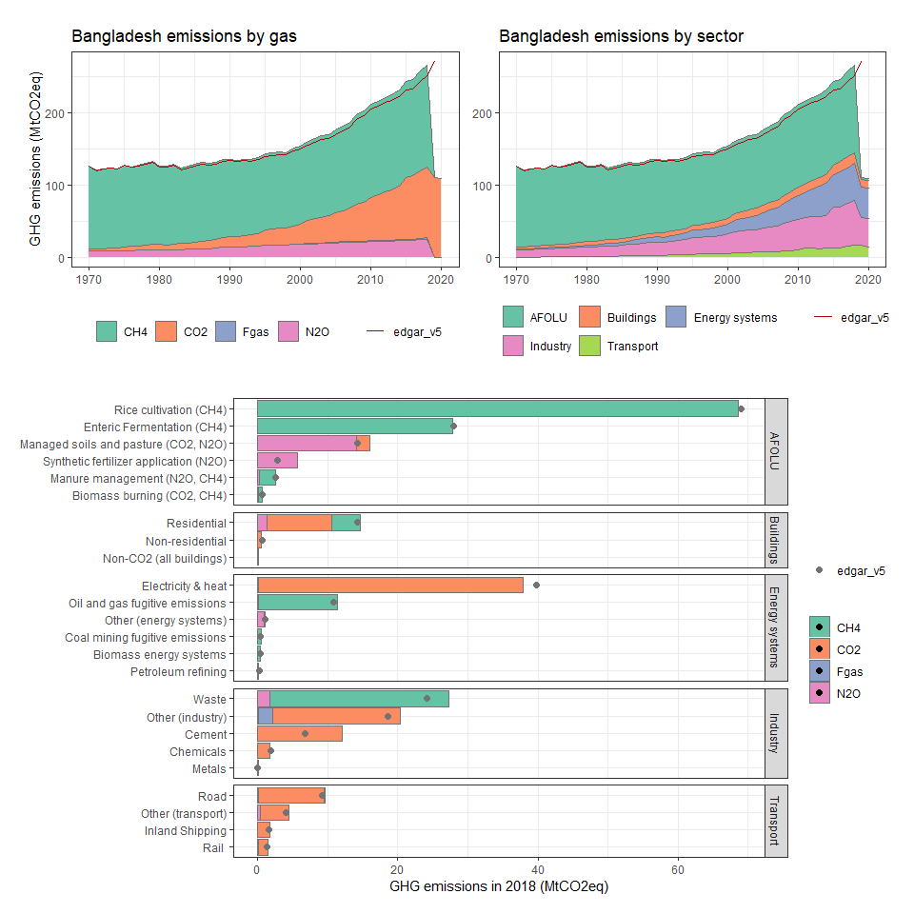

### Barbados

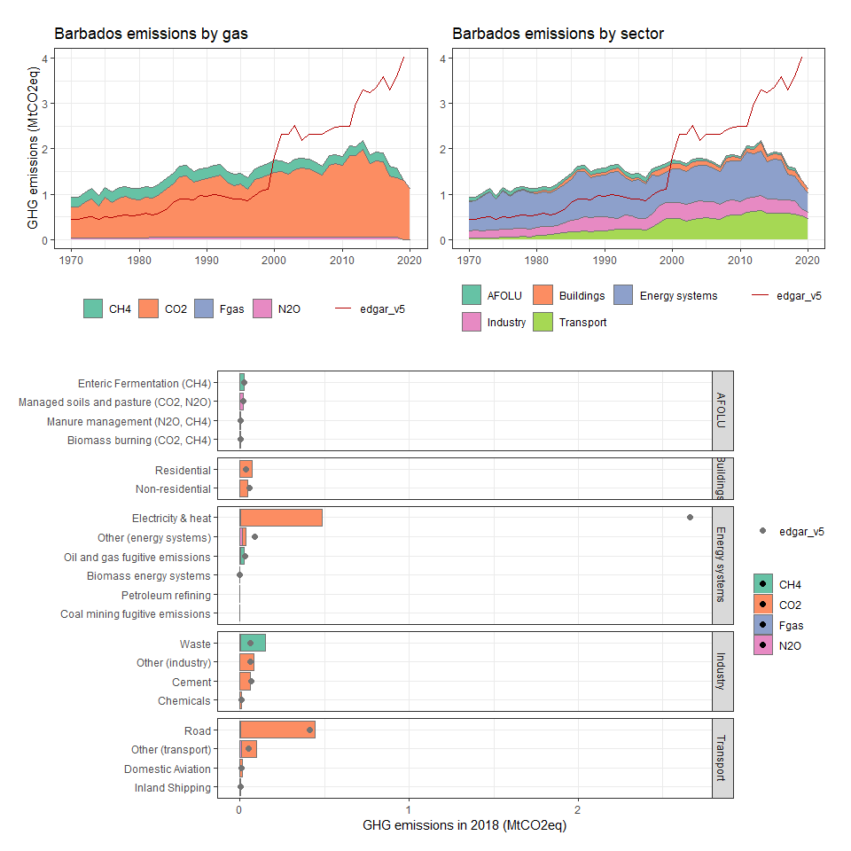

### Belarus

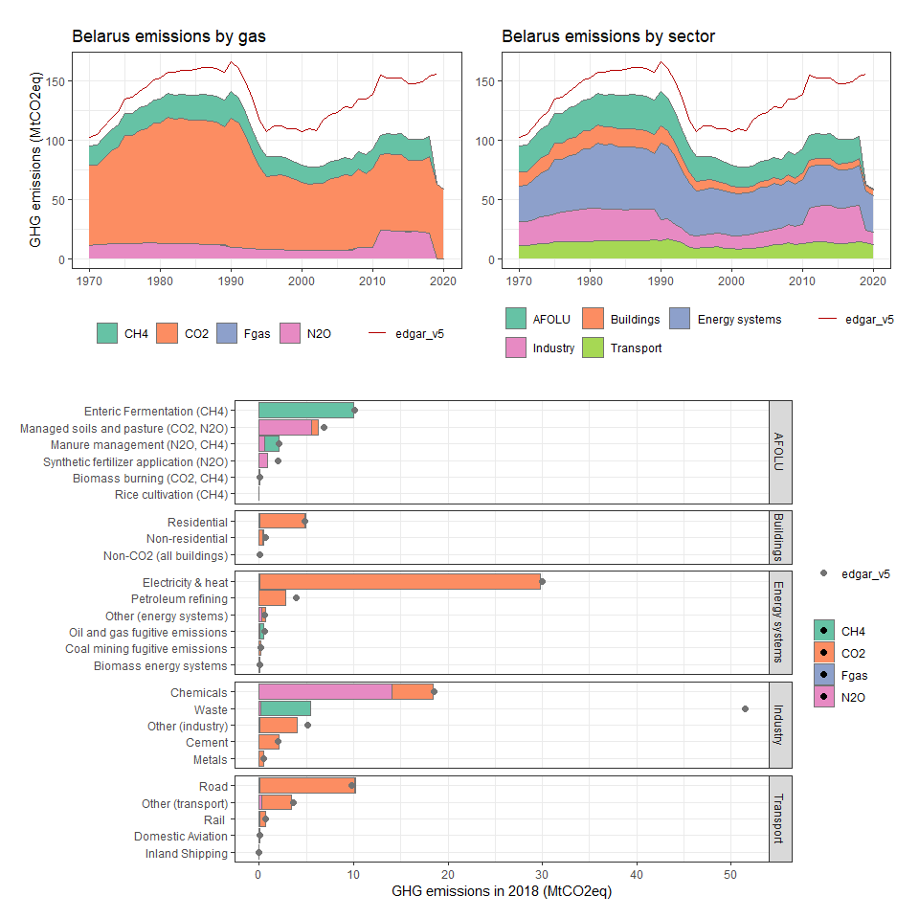

### Belgium

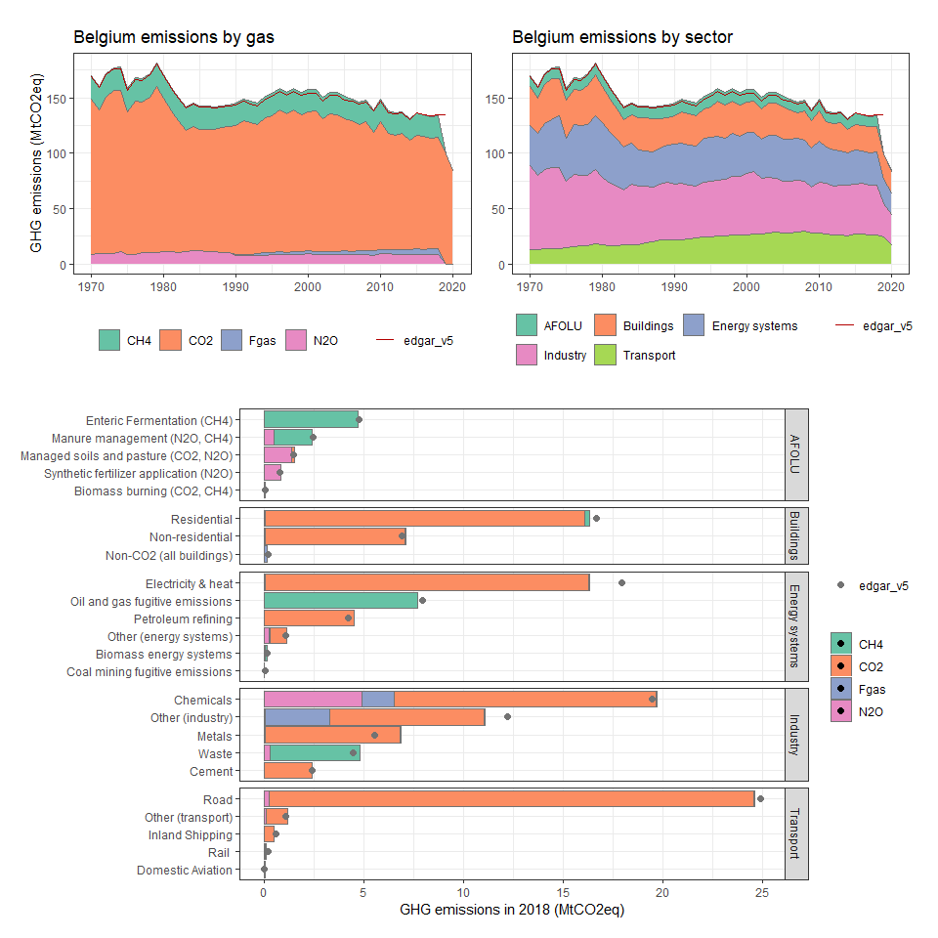

### Belize

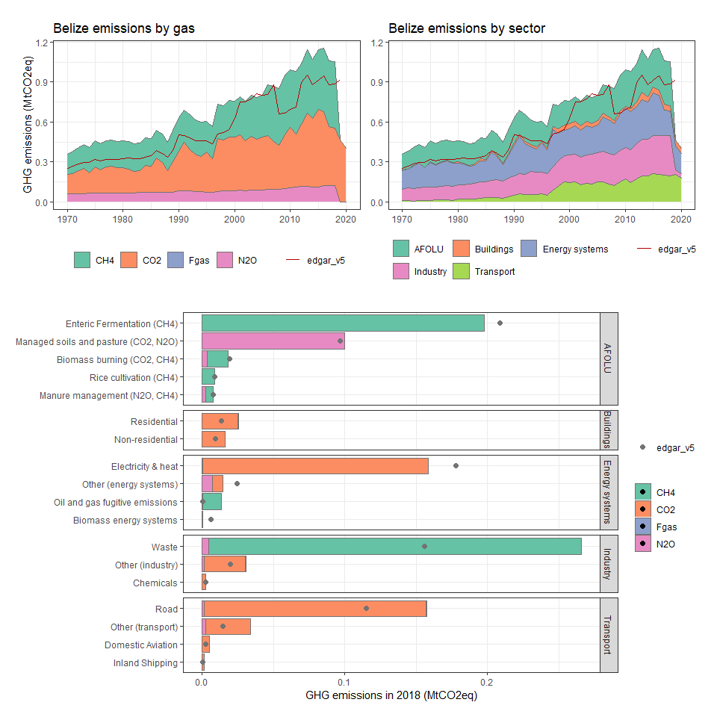

### Benin

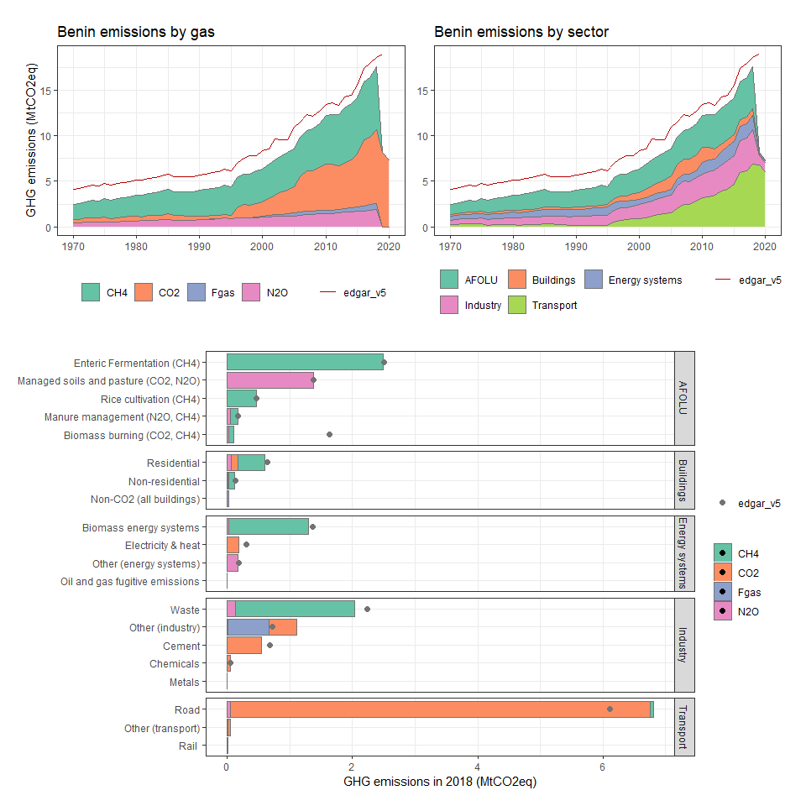

### Bermuda

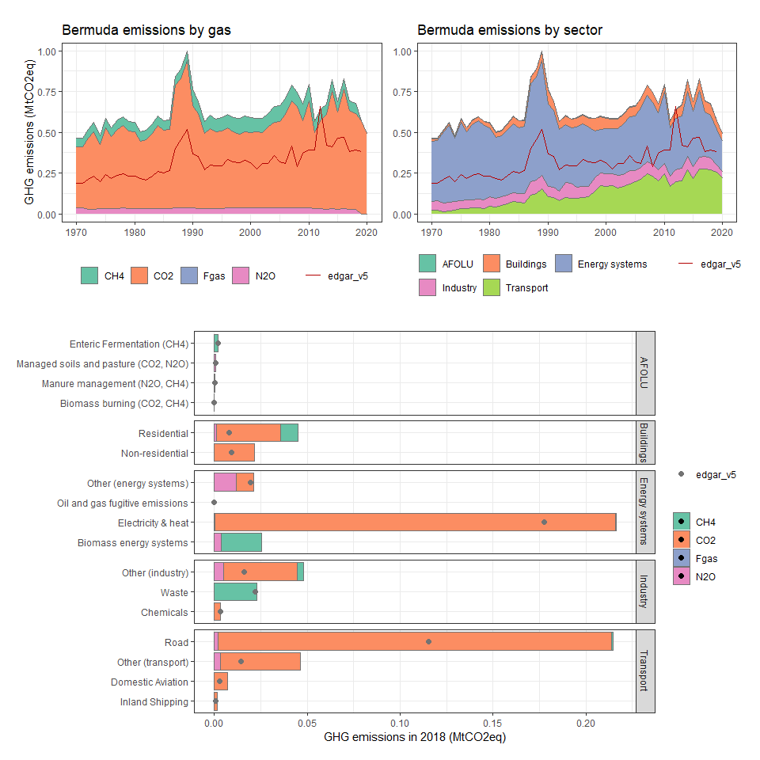

### Bhutan

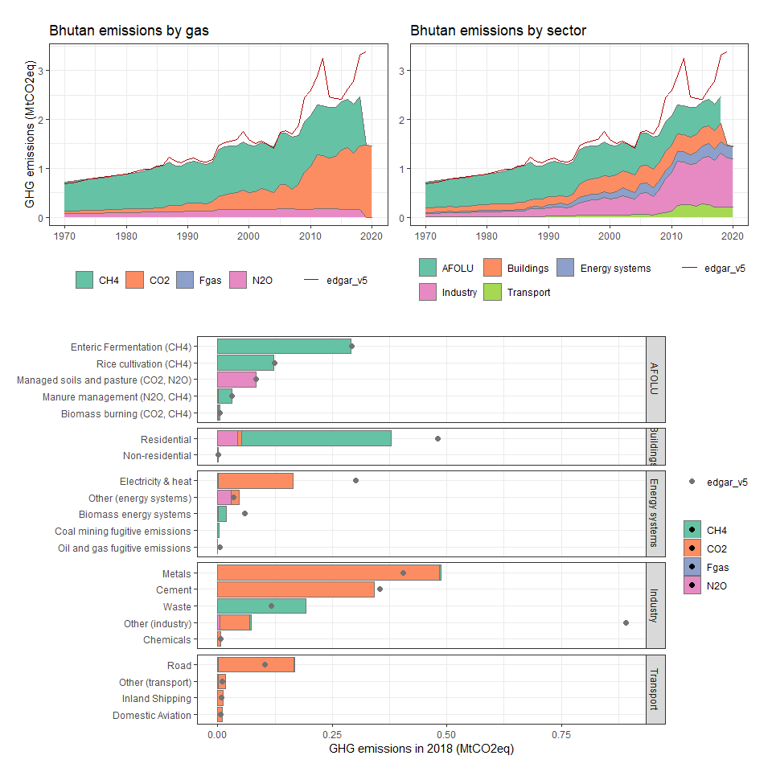

### Bolivia

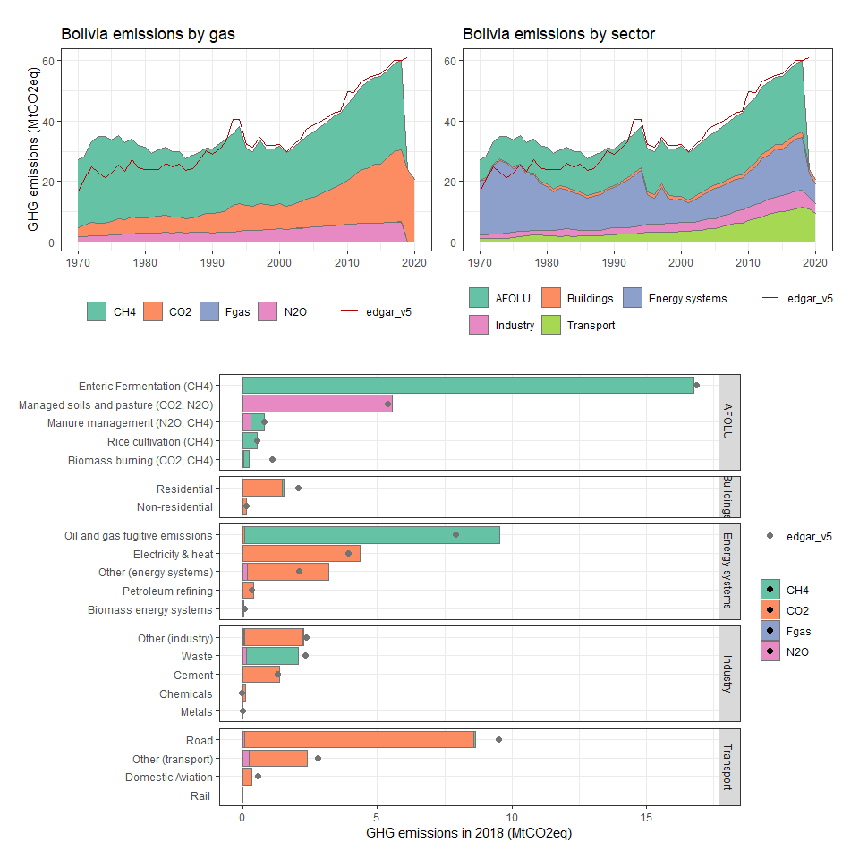

### Bosnia and Herzegovina

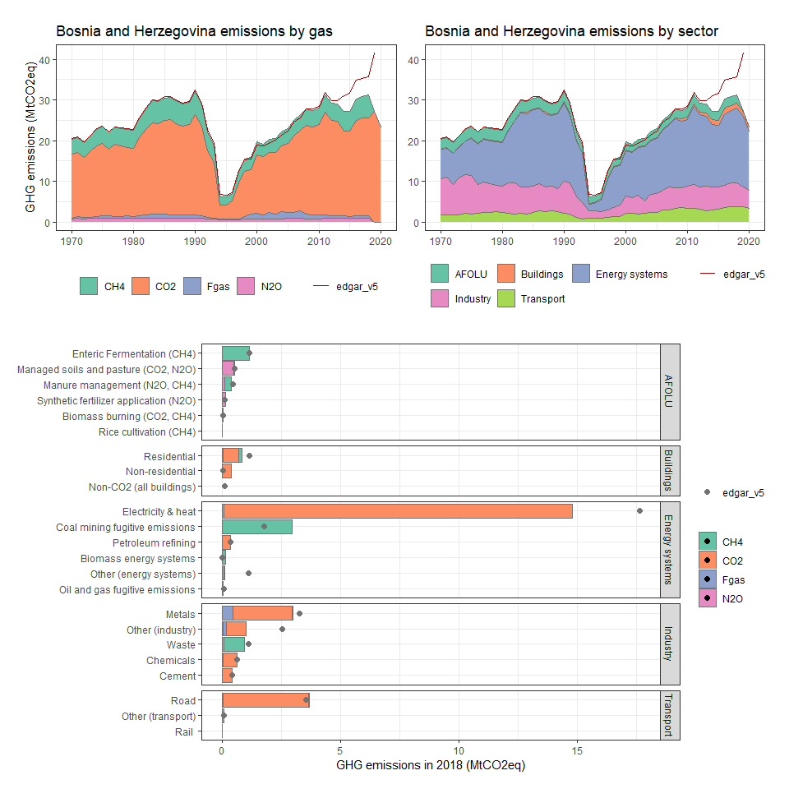

### Botswana

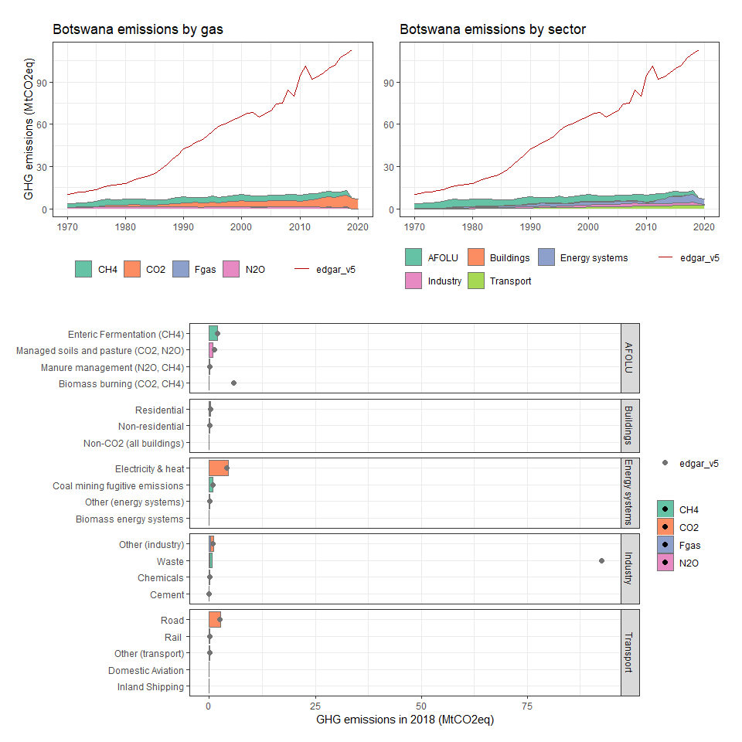

### Bouvet Island

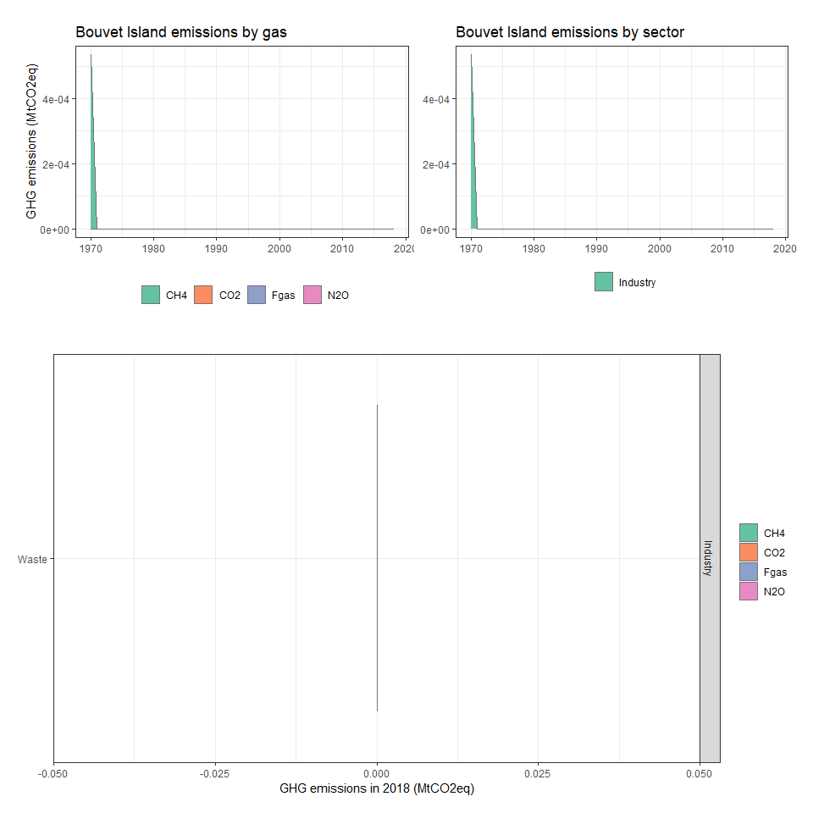

### Brazil

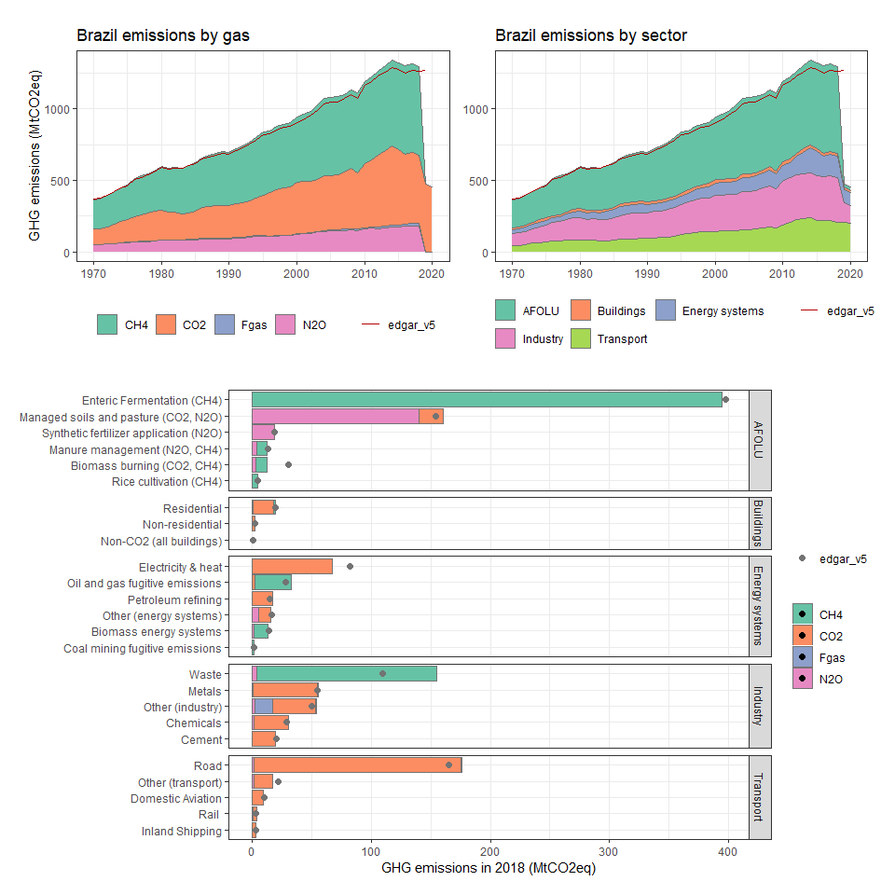

### British Virgin Islands

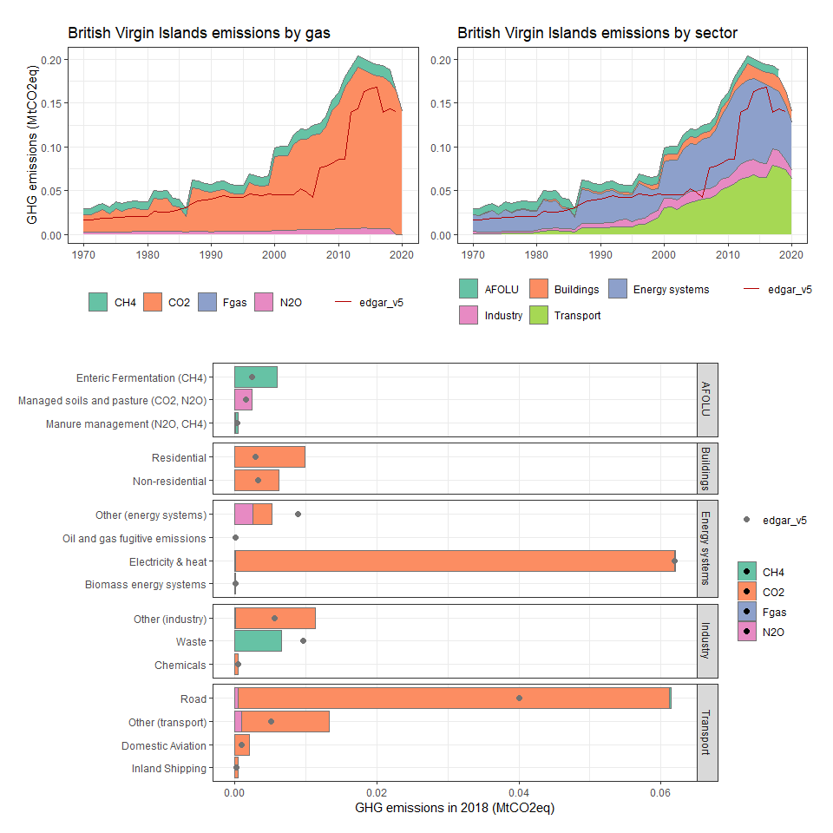

### Brunei Darussalam

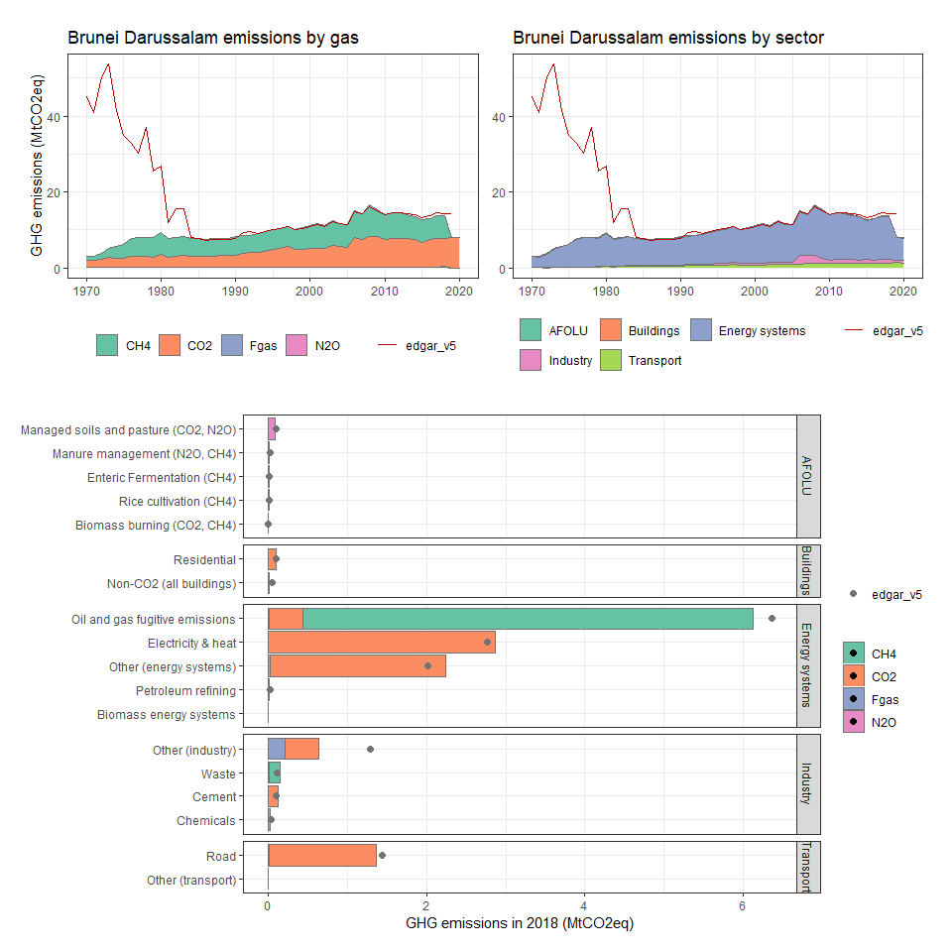

### Bulgaria

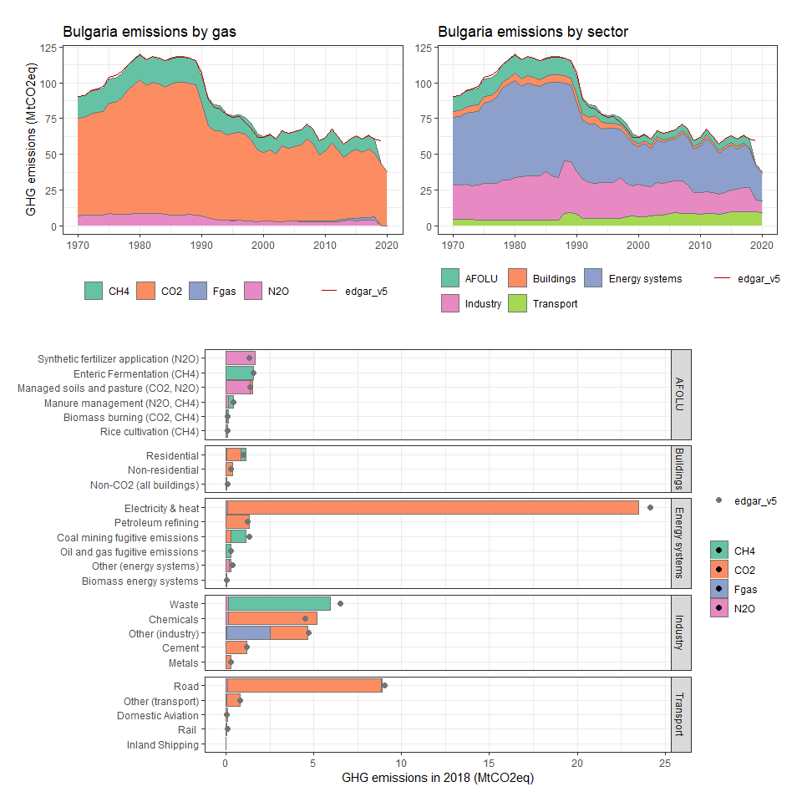

### Burkina Faso

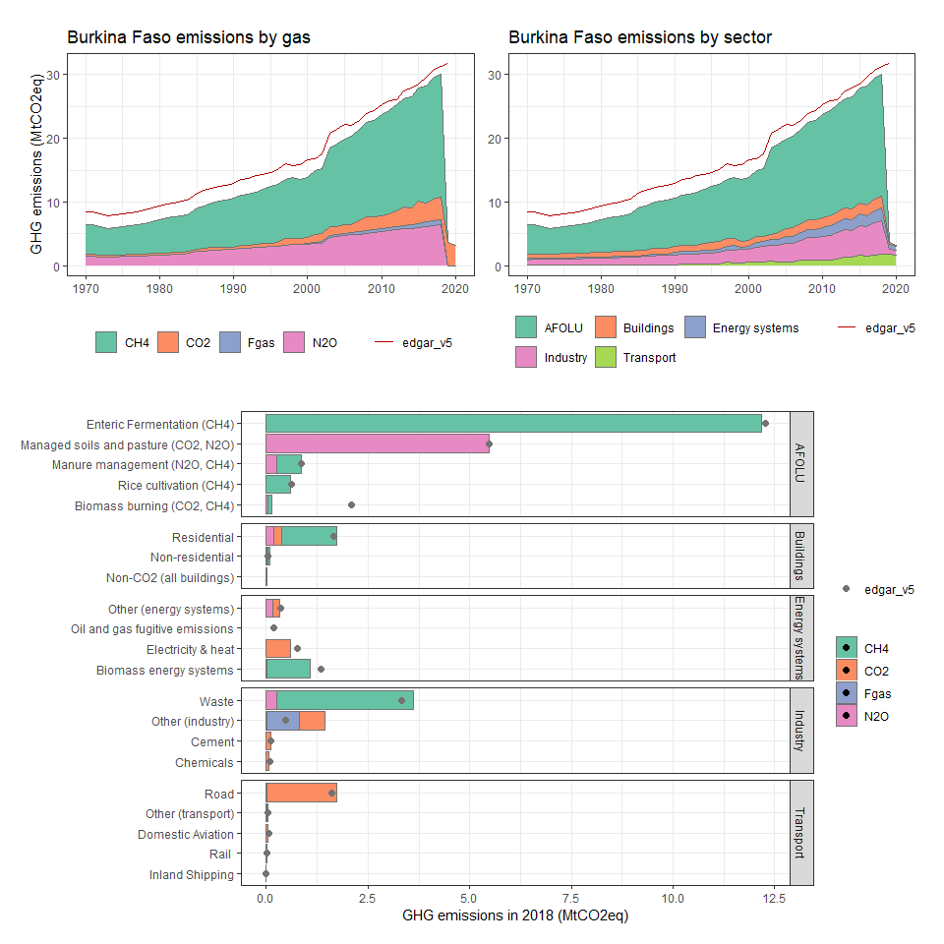

### Burundi

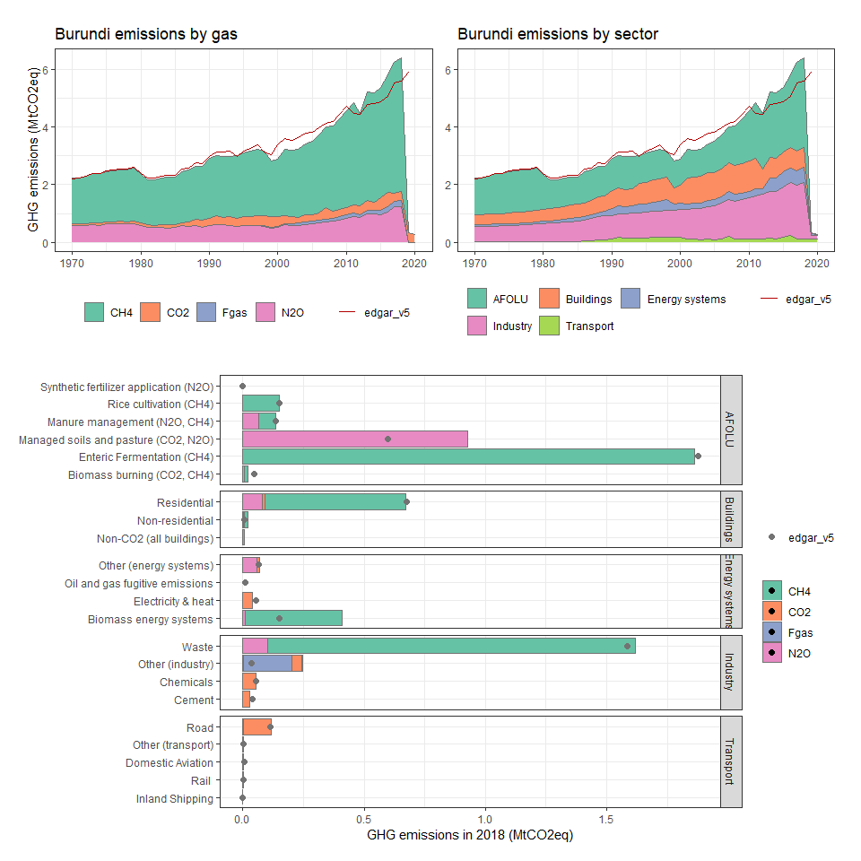

### Cabo Verde

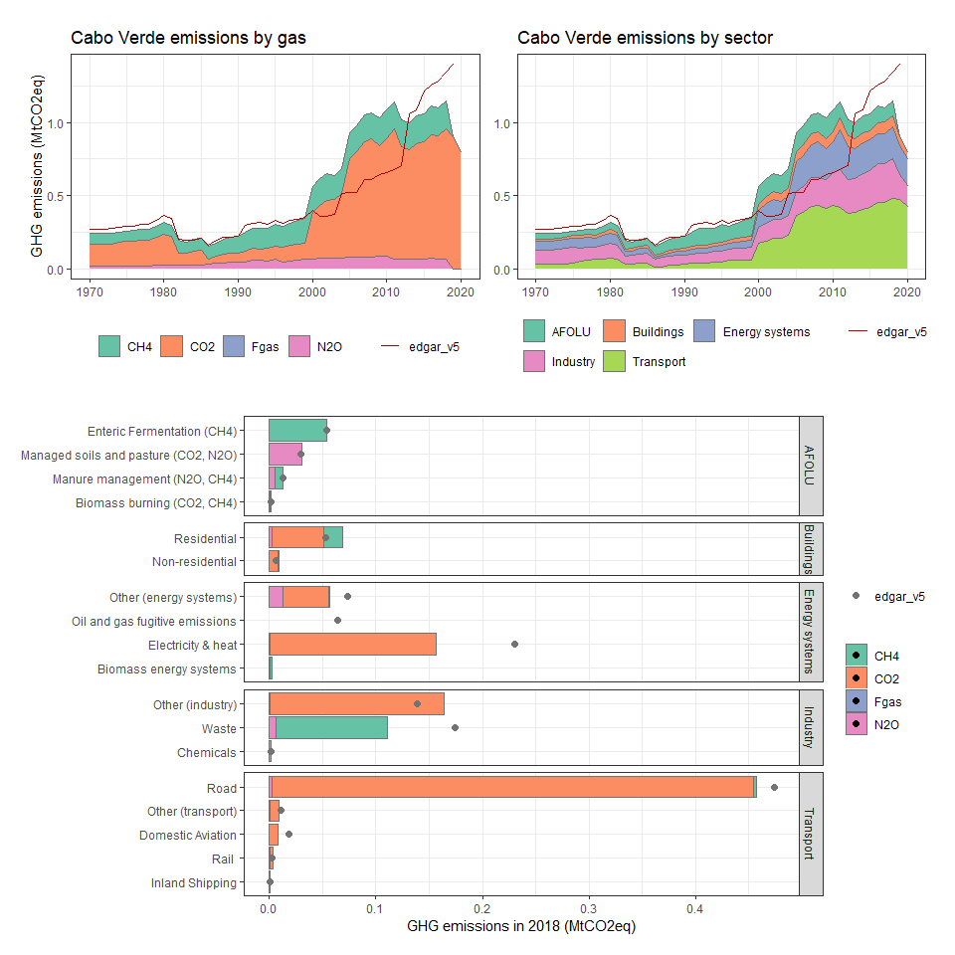

### Cambodia

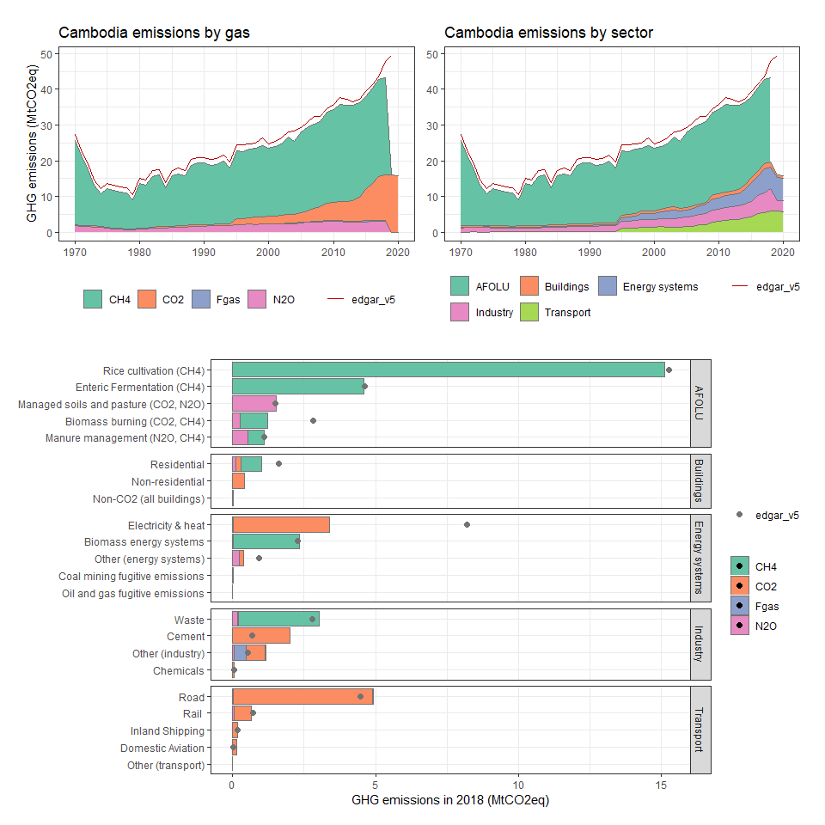

### Cameroon

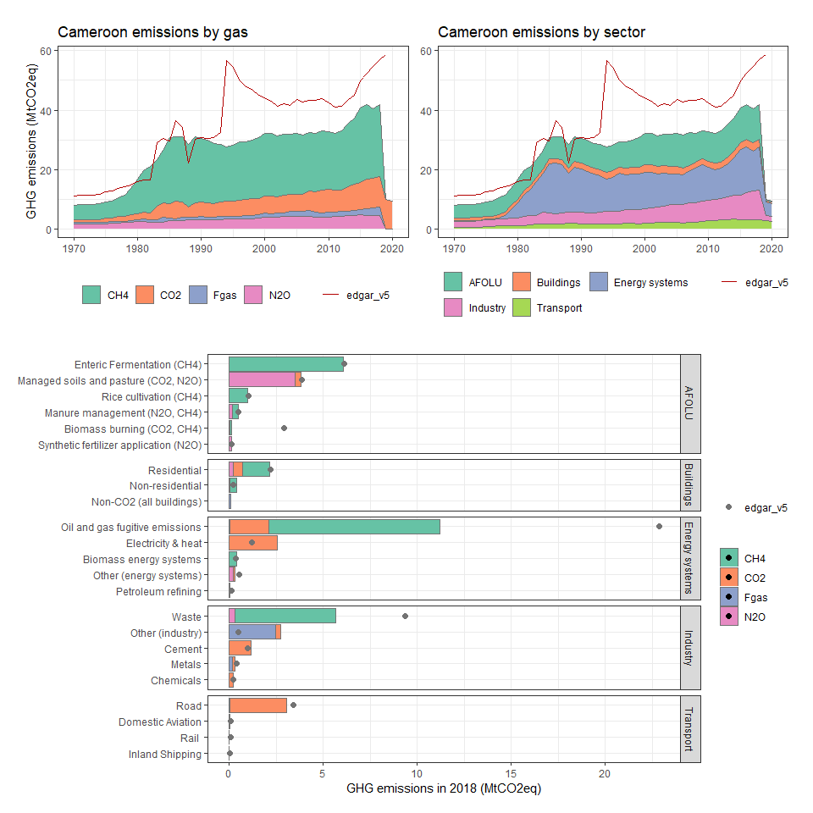

### Canada

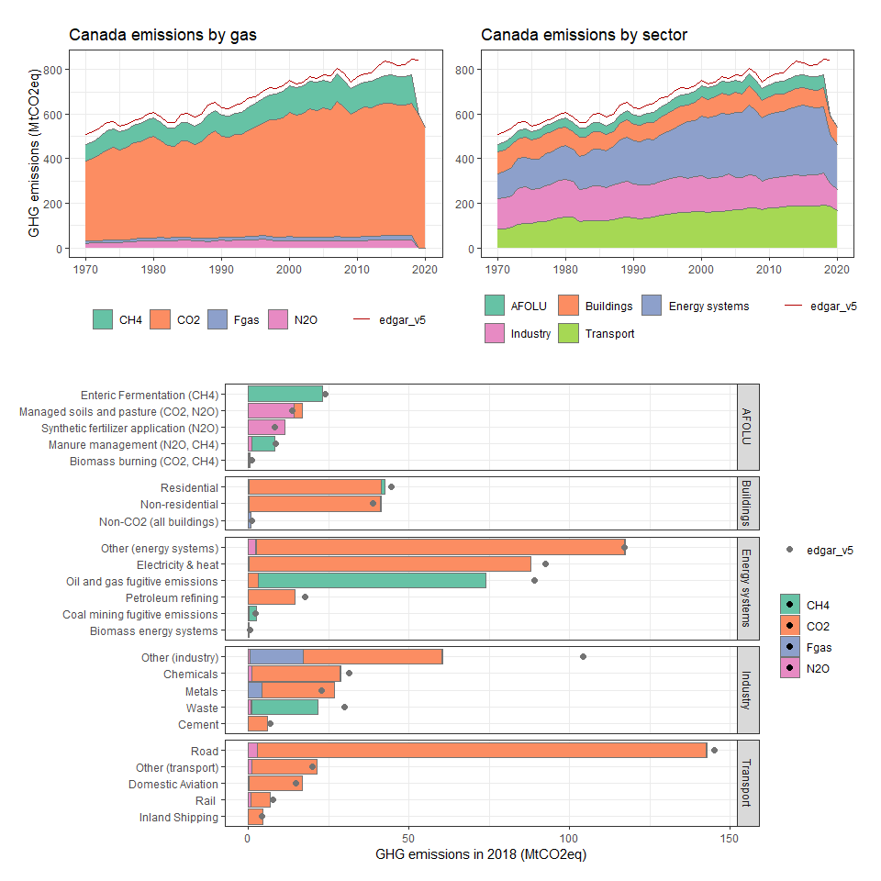

### Cayman Islands

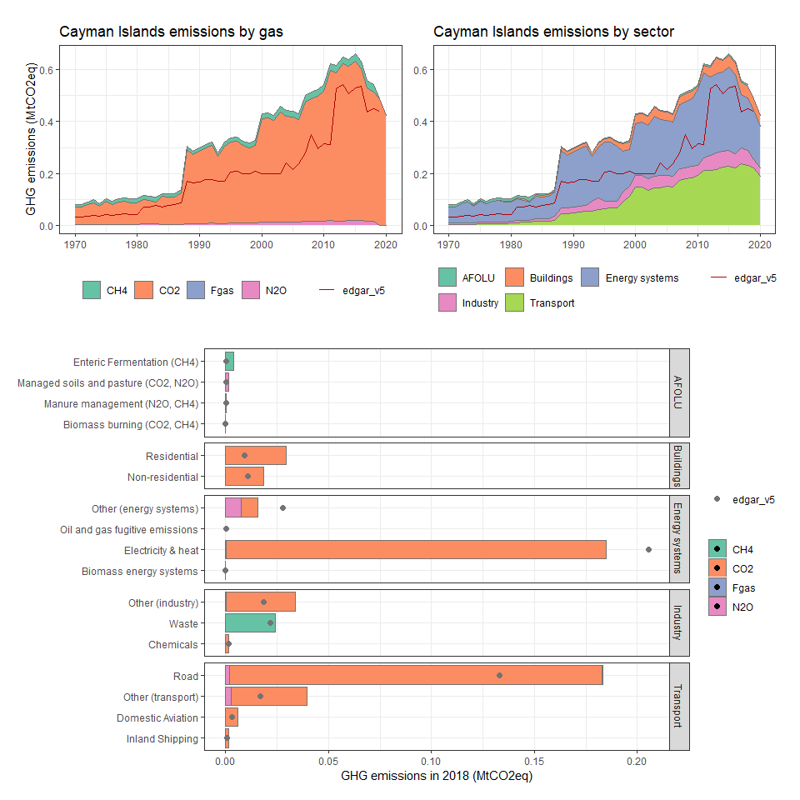

### Central African Republic

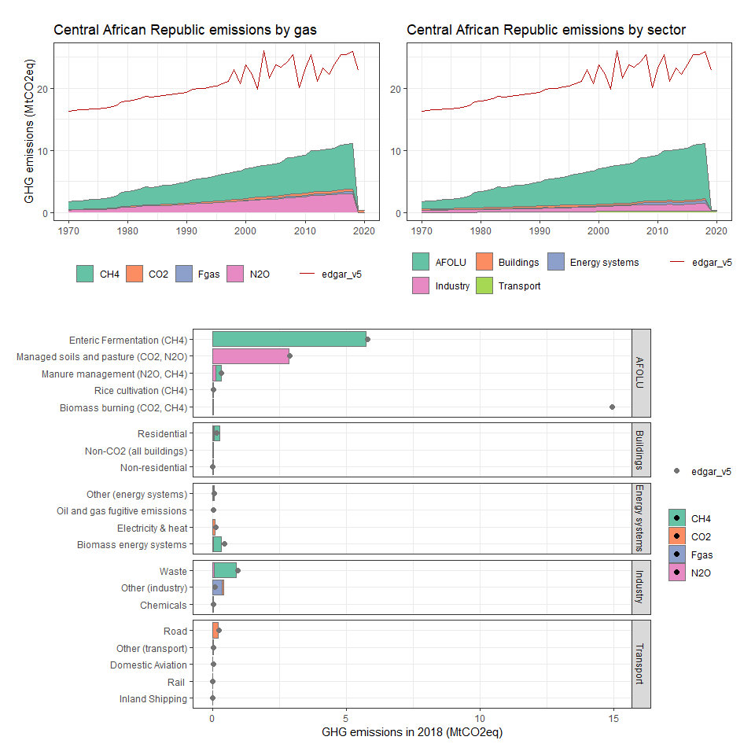

### Chad

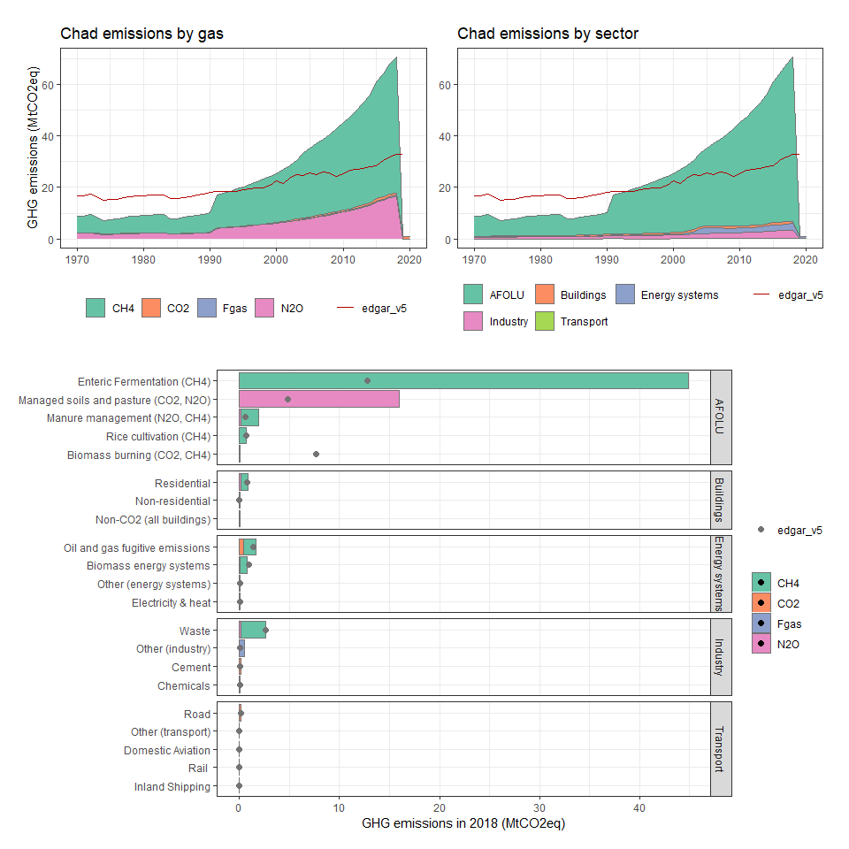

### Chile

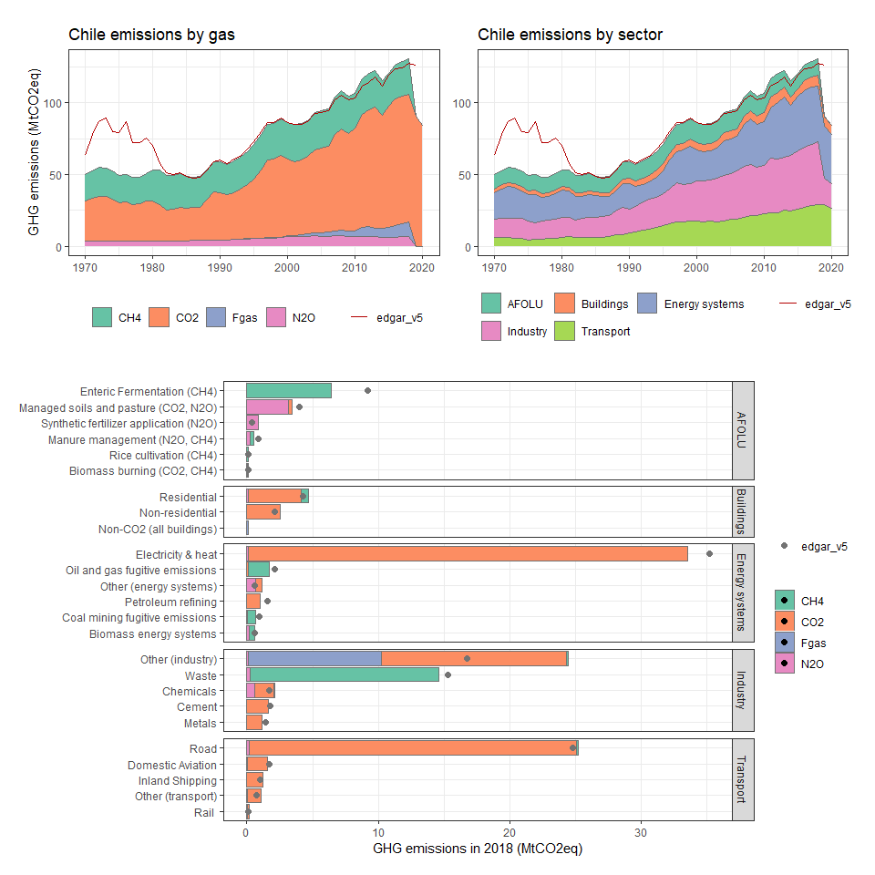

### China

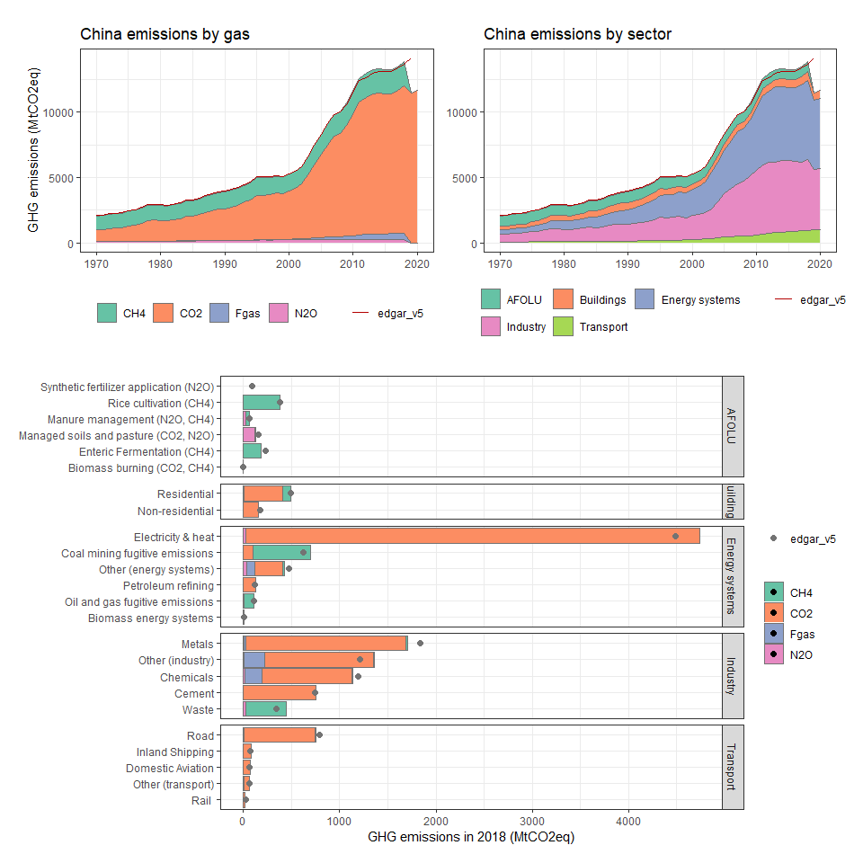

### Christmas Island

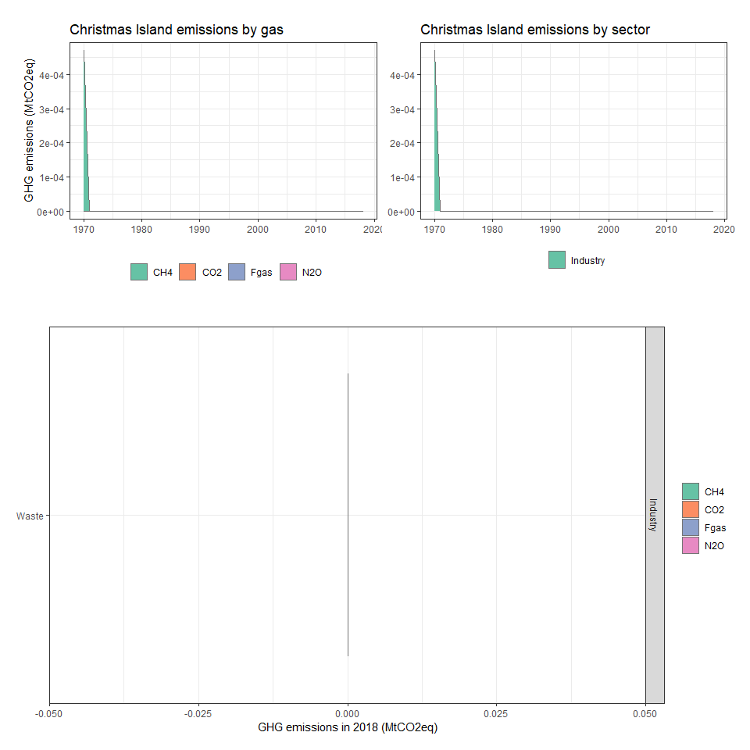

### Cocos (Keeling) Islands

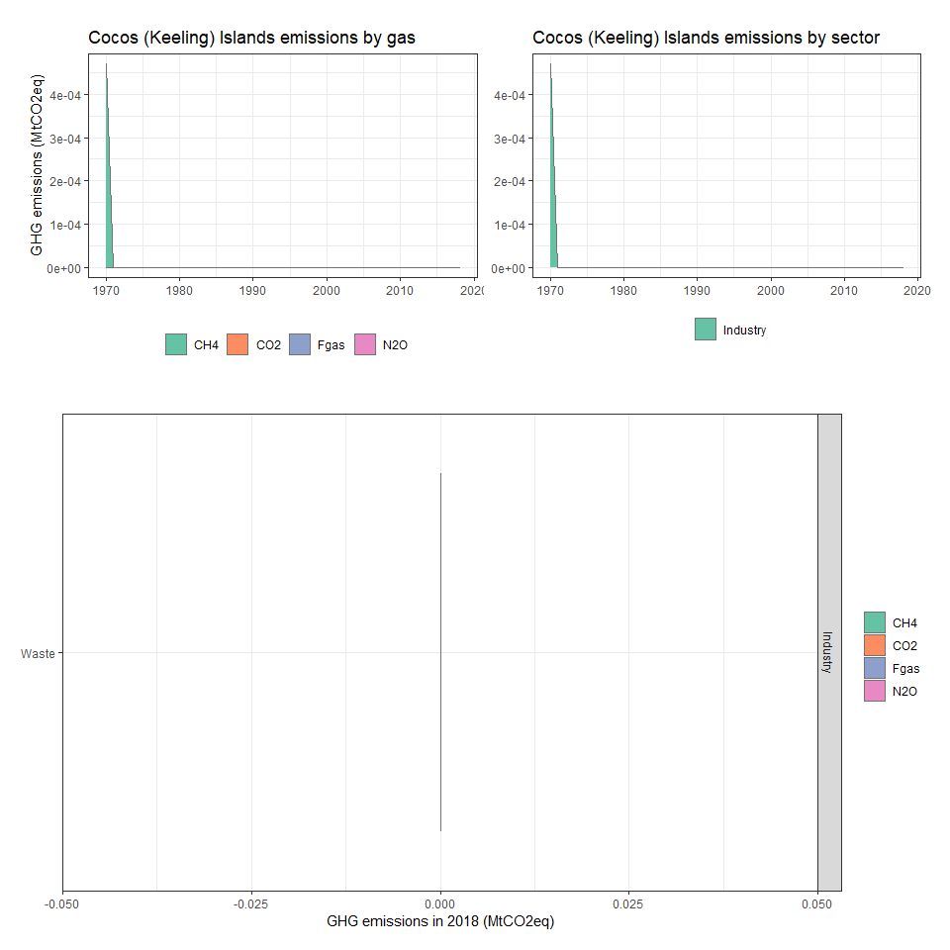

### Colombia

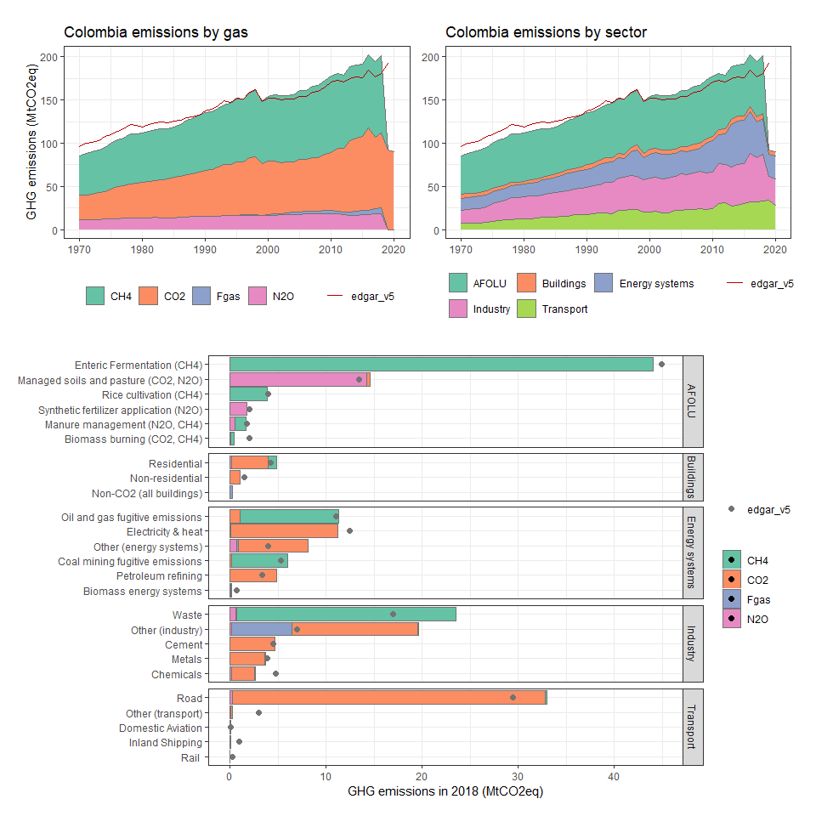

### Comoros

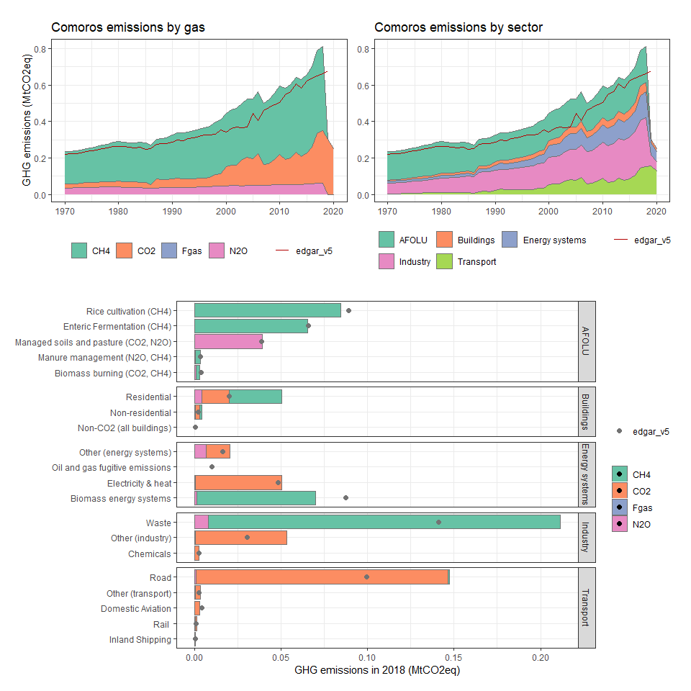

### Congo, Dem. Rep.

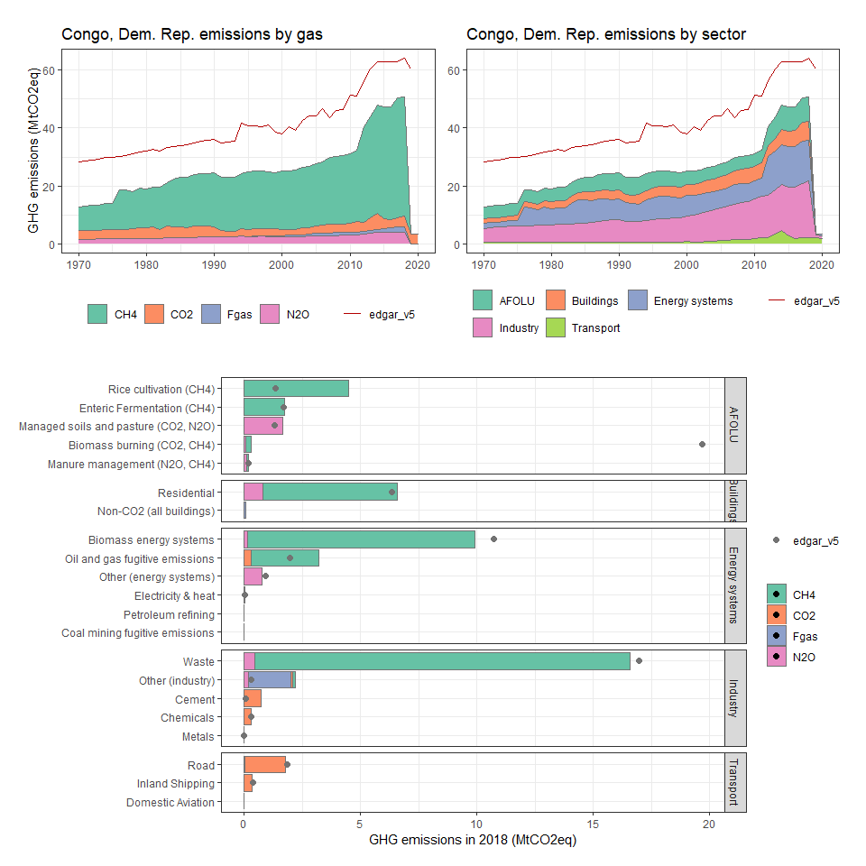

### Congo, Rep.

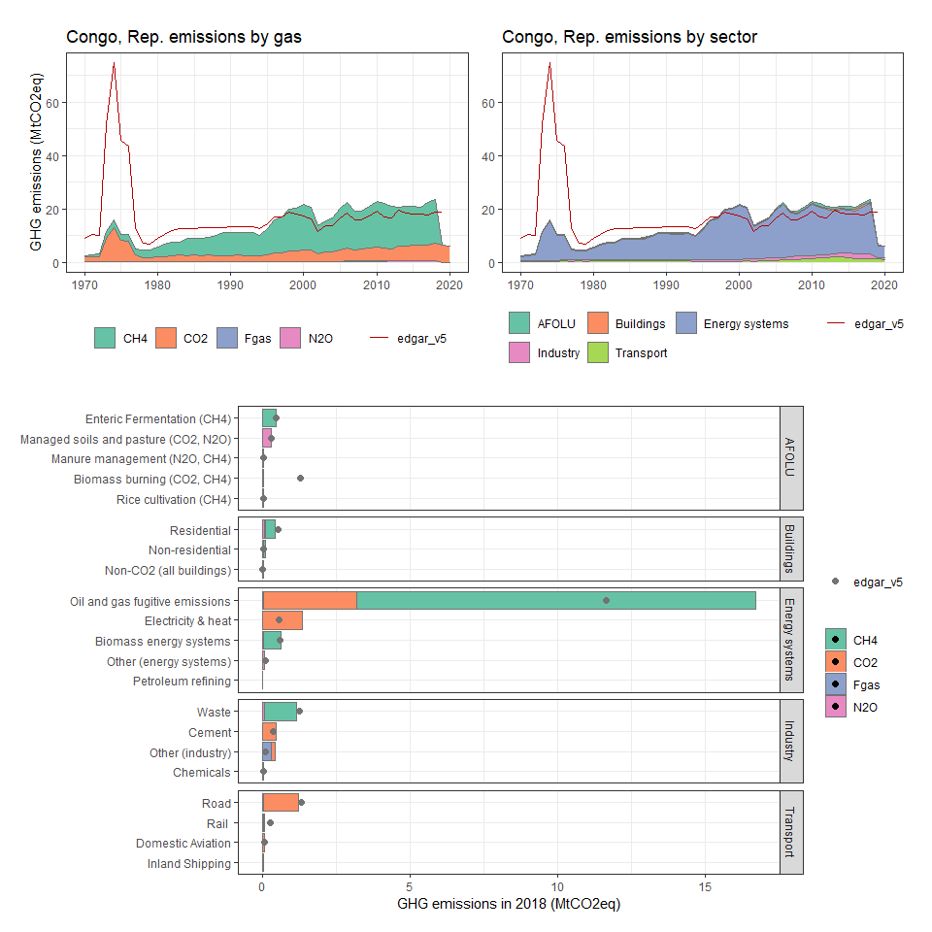

### Cook Islands

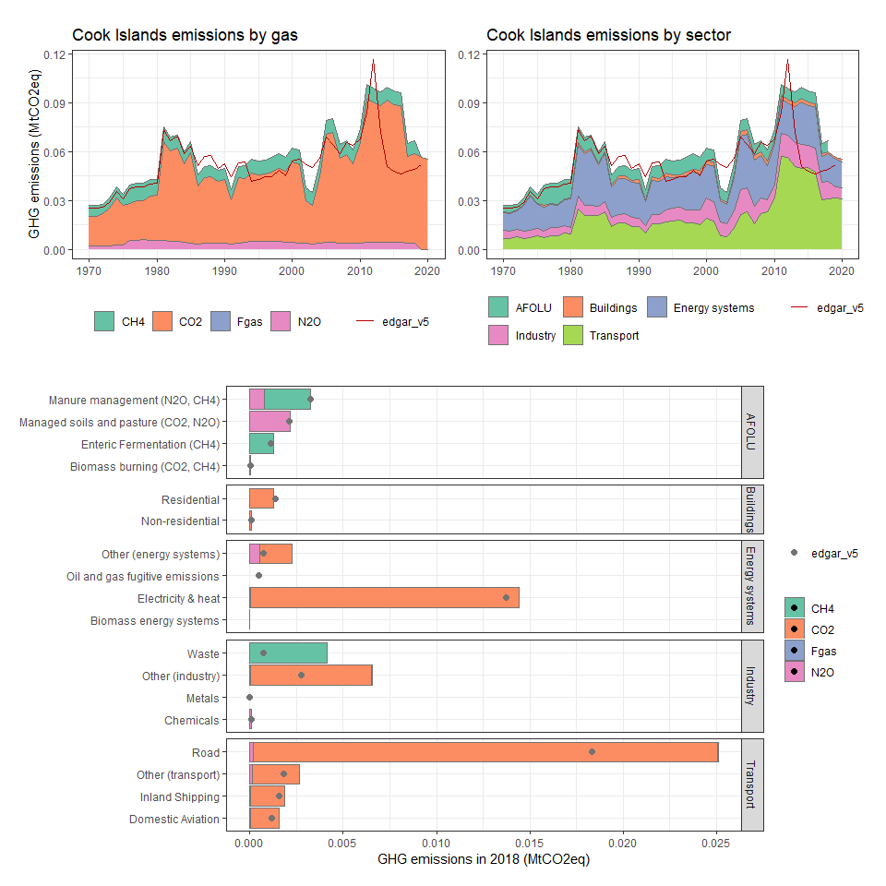

### Costa Rica

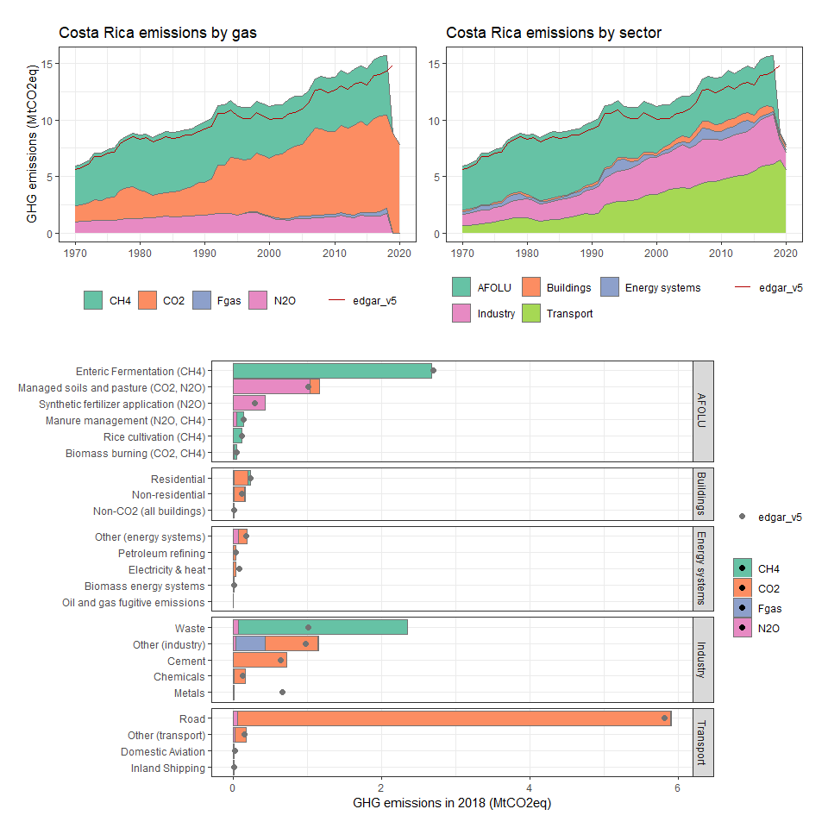

### Côte d’Ivoire

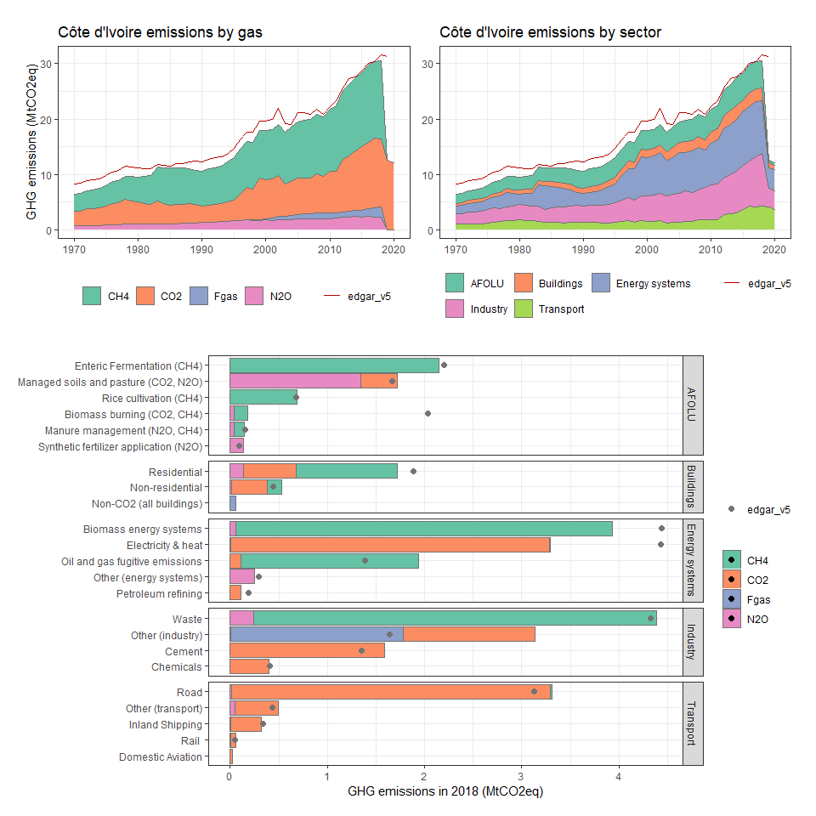

### Croatia

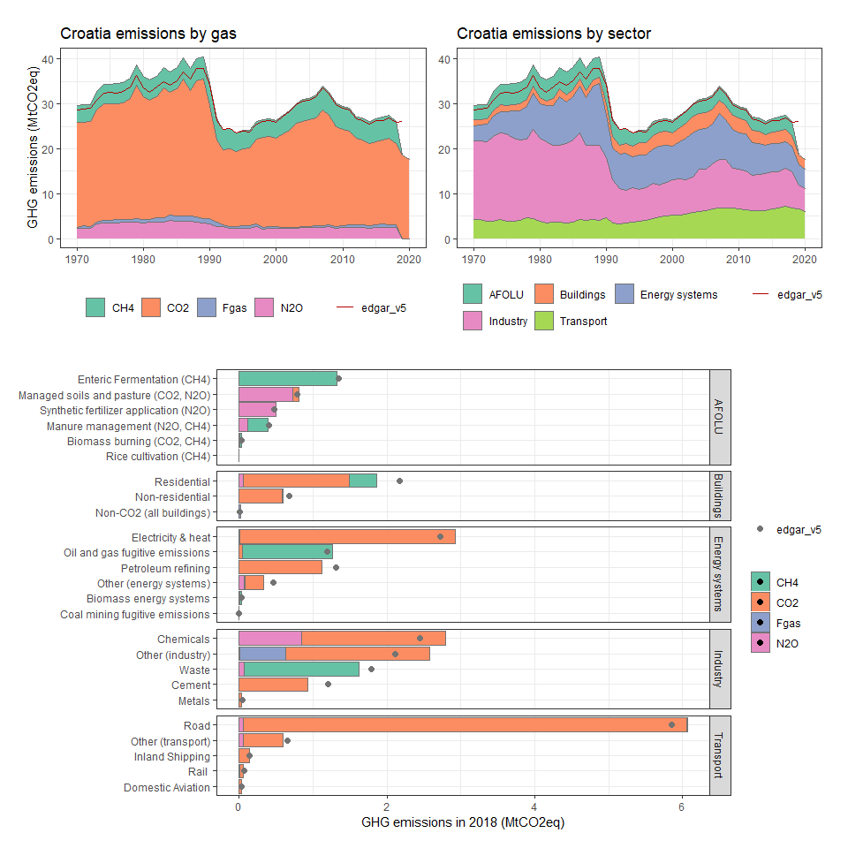

### Cuba

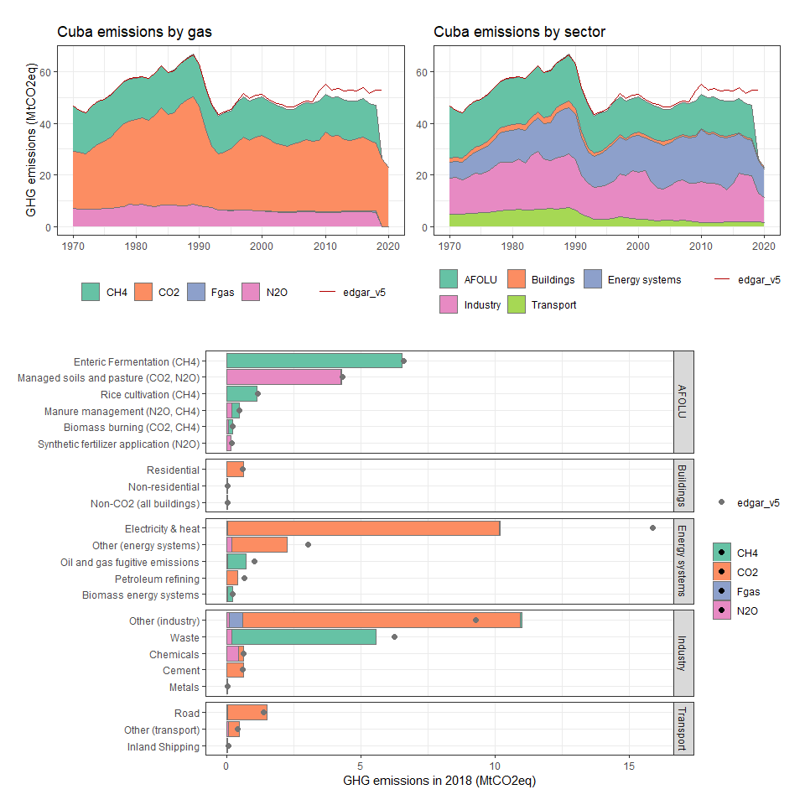

### Cyprus

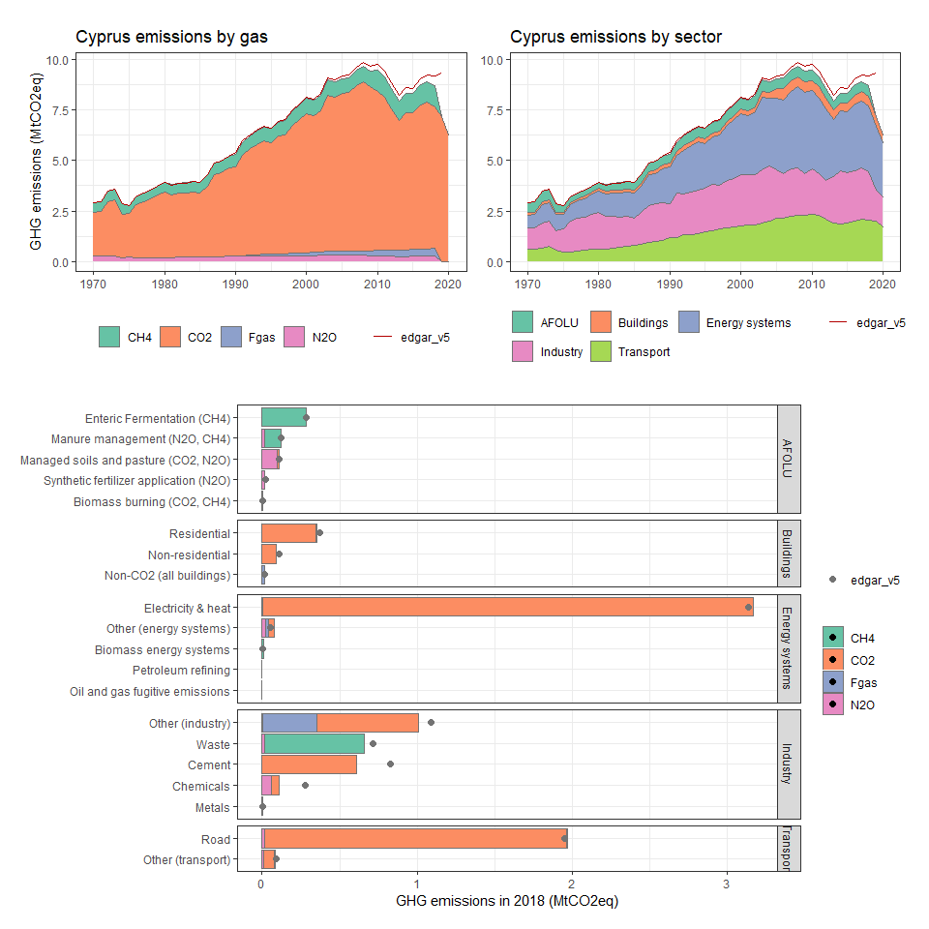

### Czech Republic

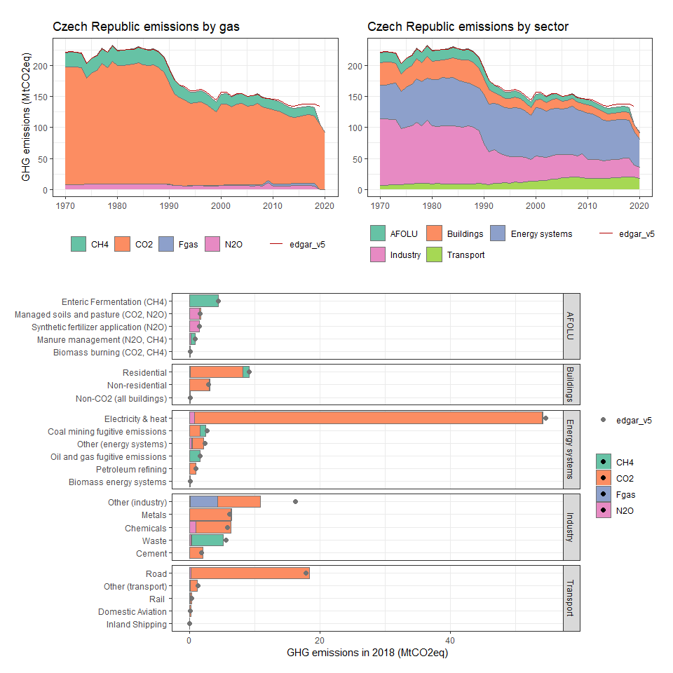

### Denmark

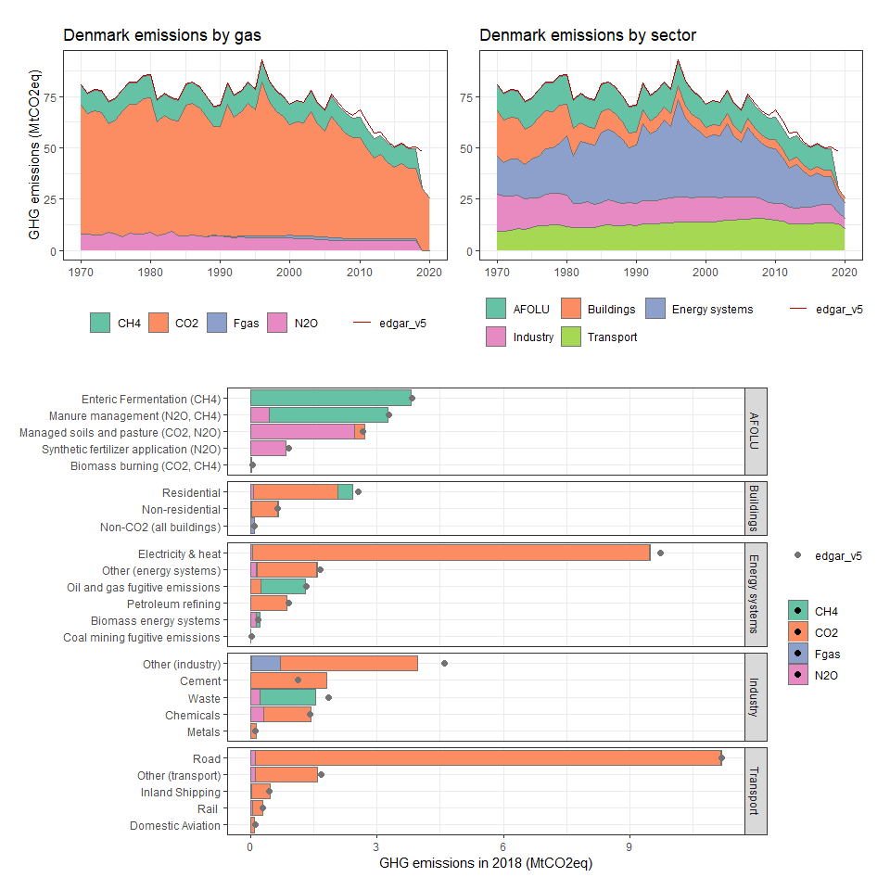

### Djibouti

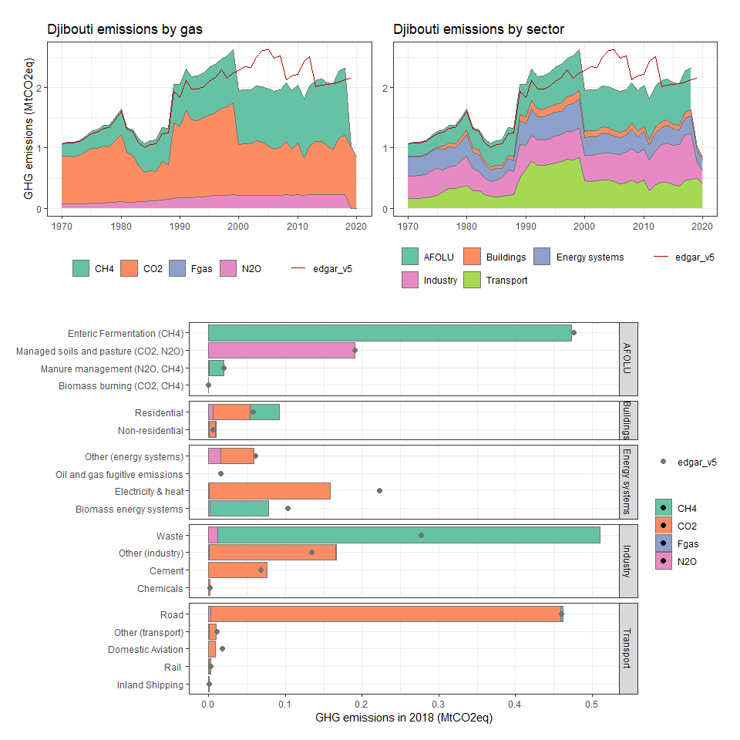

### Dominica

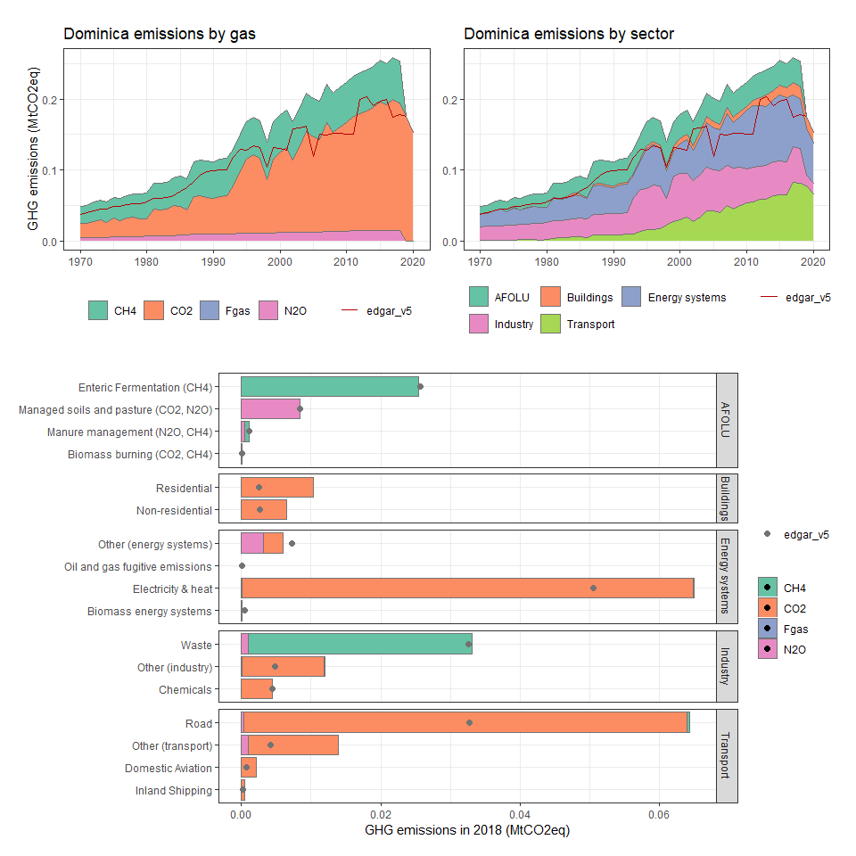

### Dominican Republic

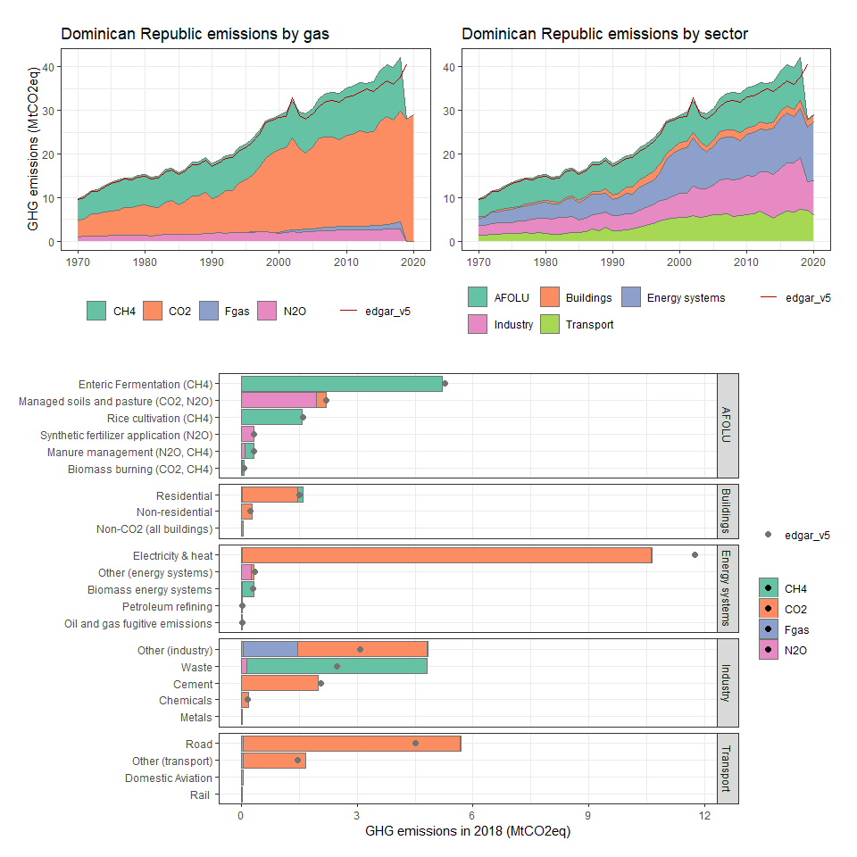

### Ecuador

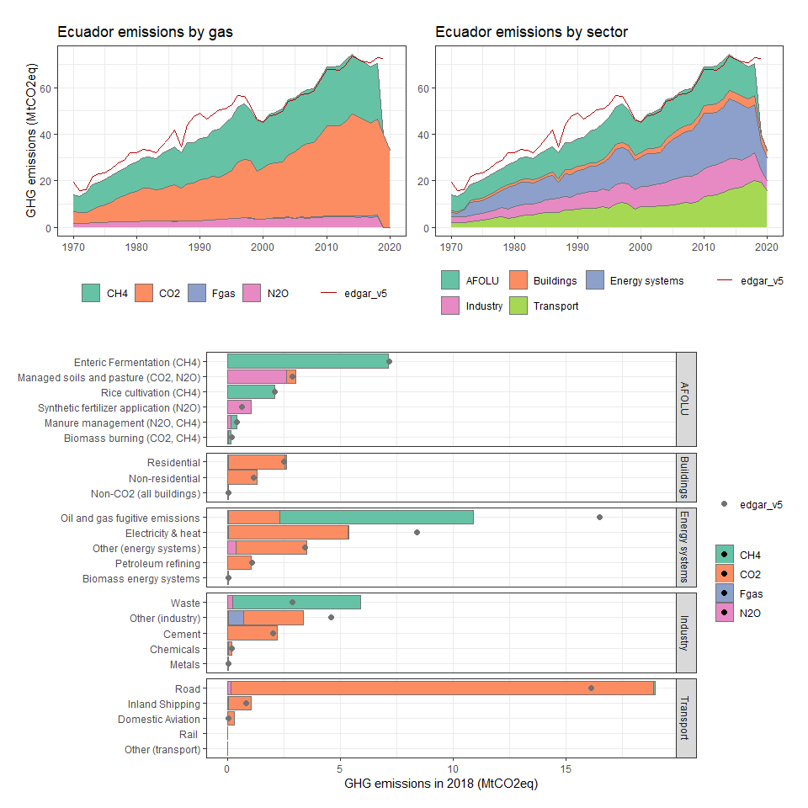

### Egypt, Arab Rep.

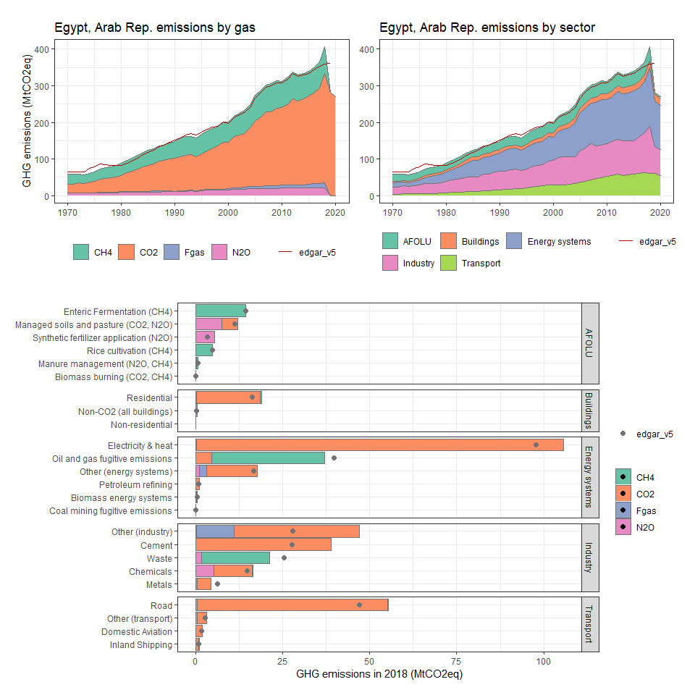

### El Salvador

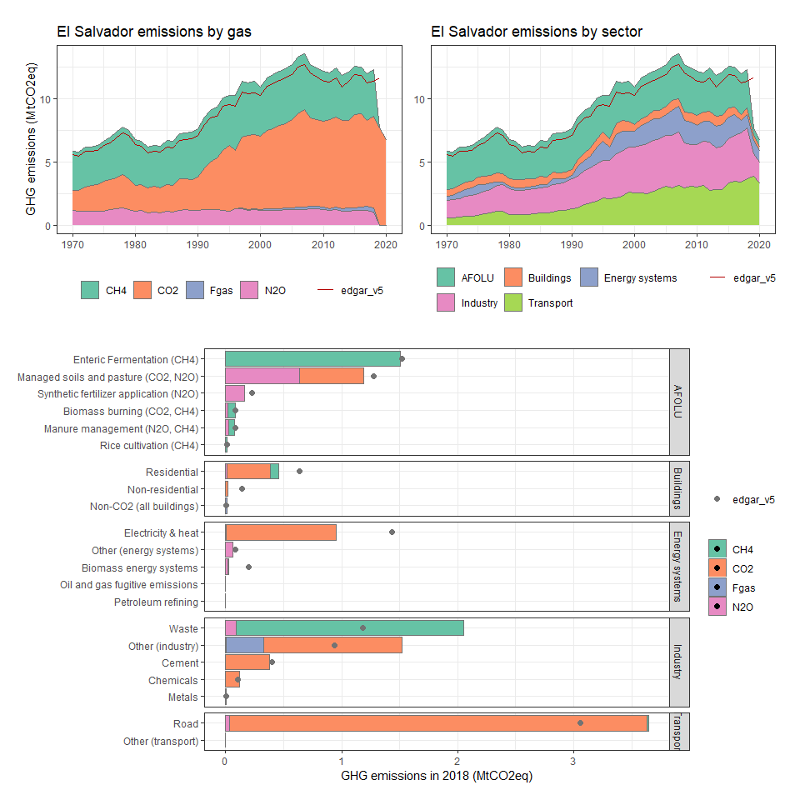

### Equatorial Guinea

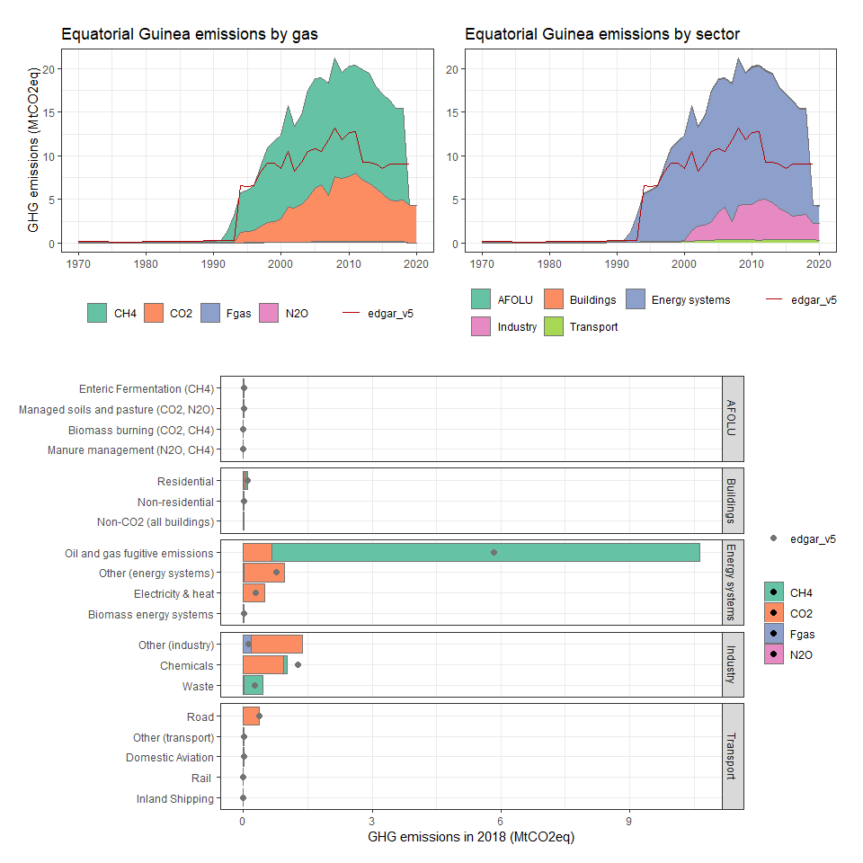

### Eritrea

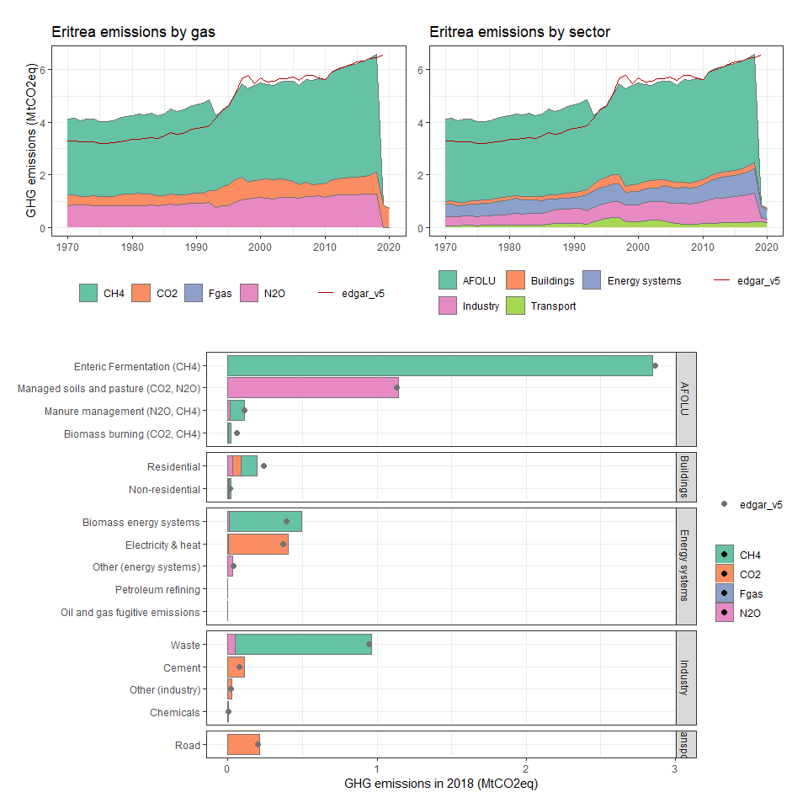

### Estonia

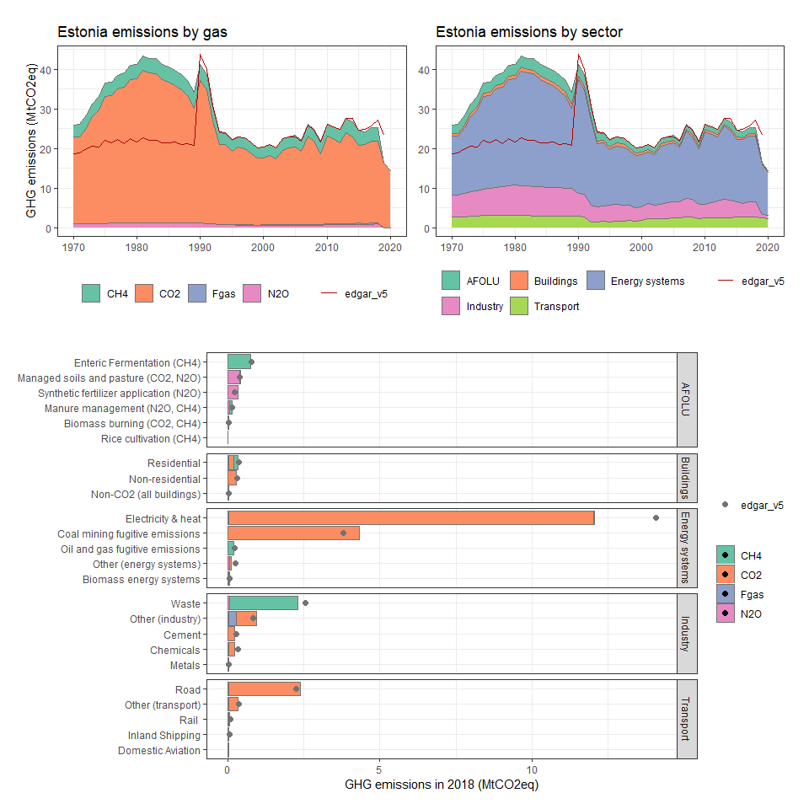

### Ethiopia

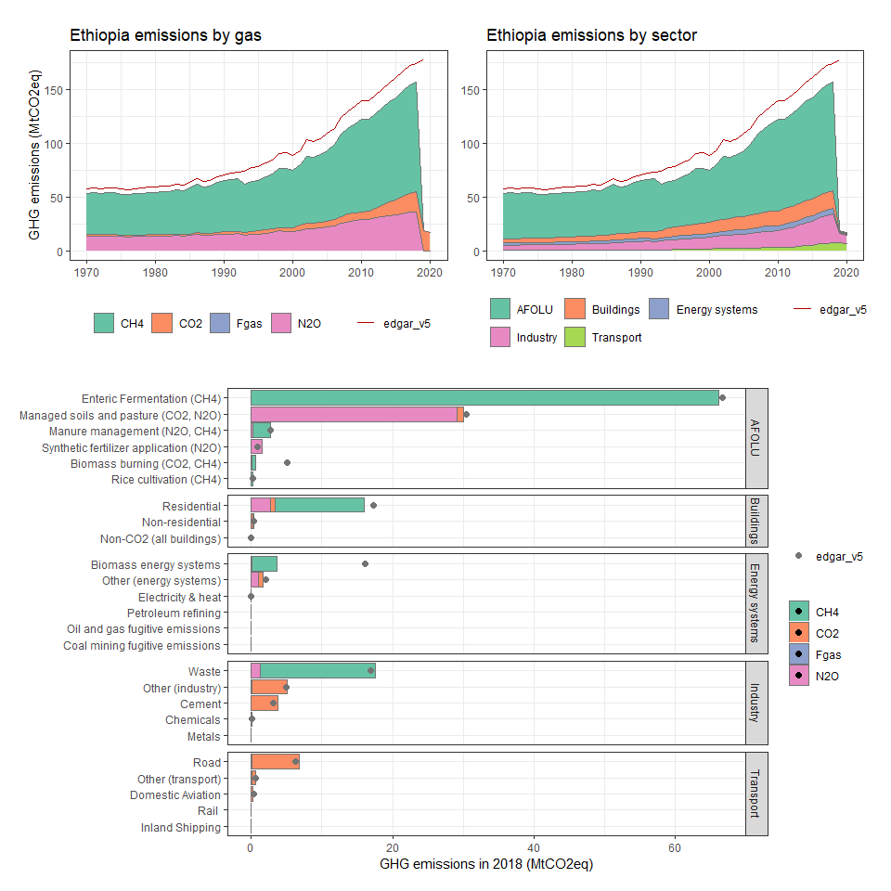

### Falkland Islands (Malvinas)

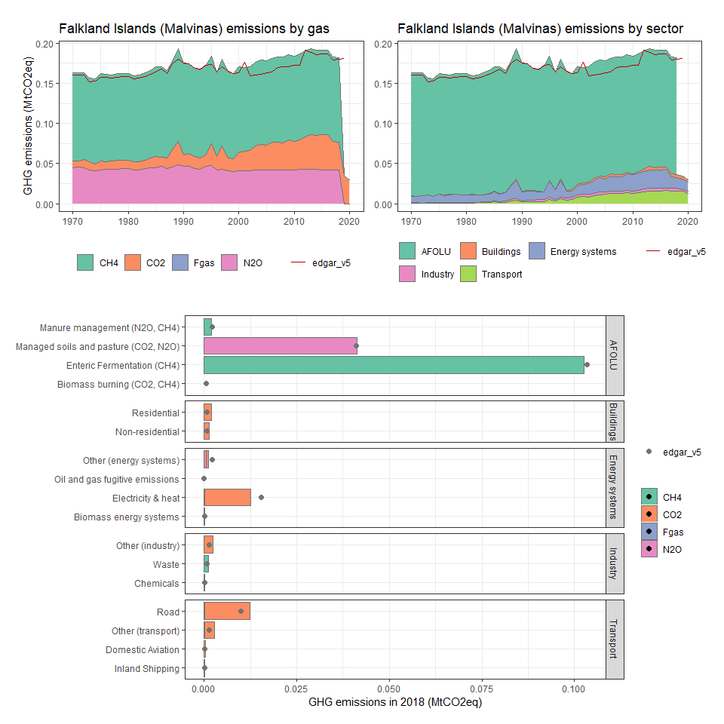

### Faroe Islands

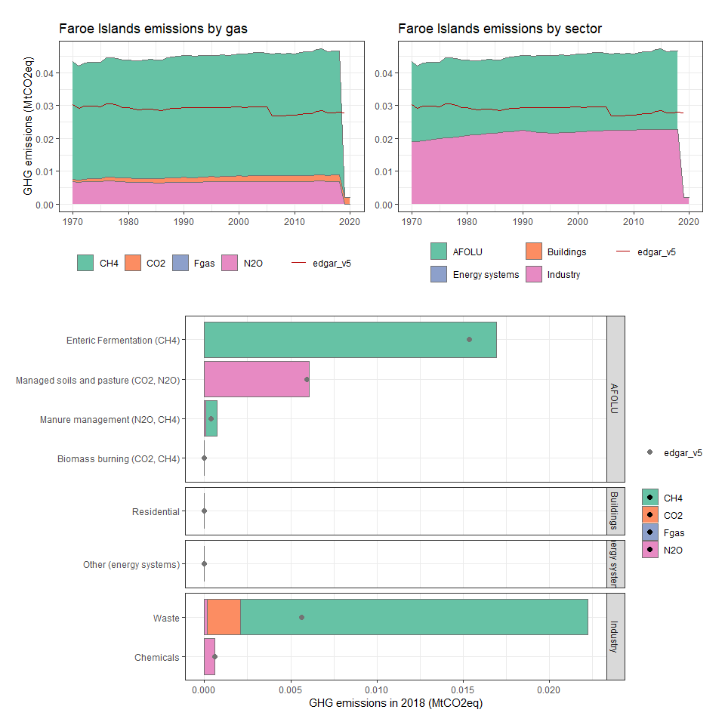

### Fiji

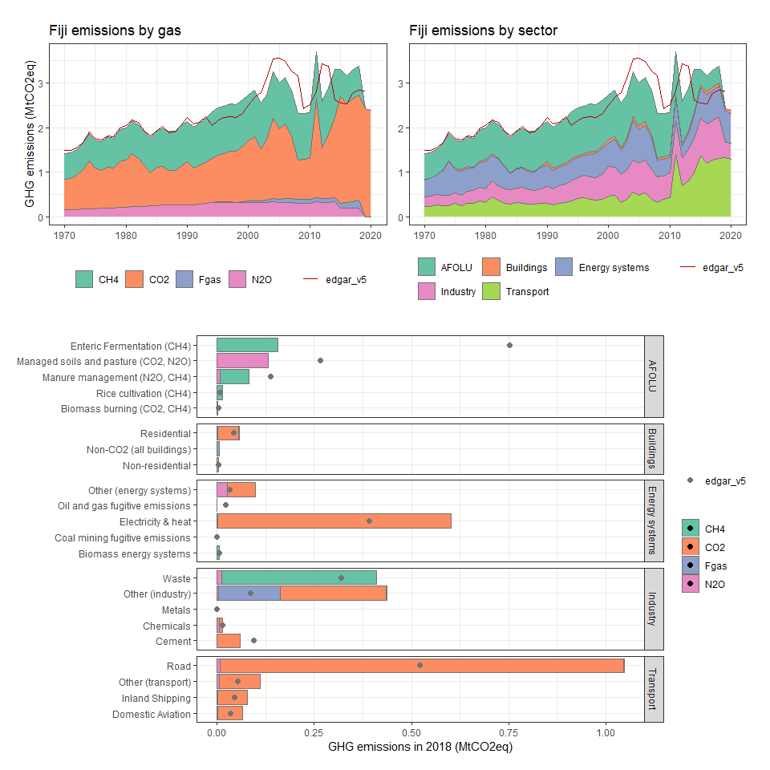

### Finland

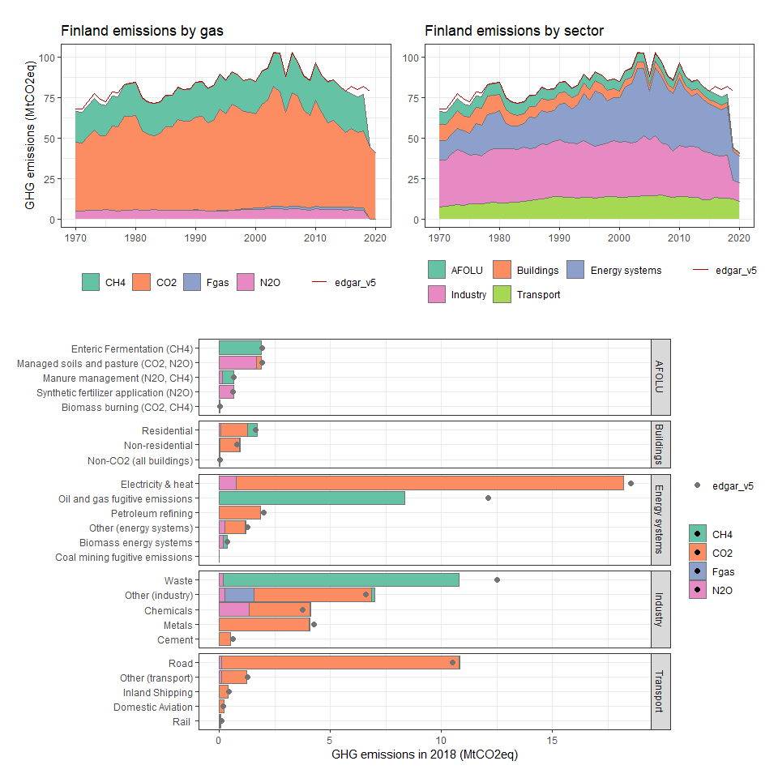

### France

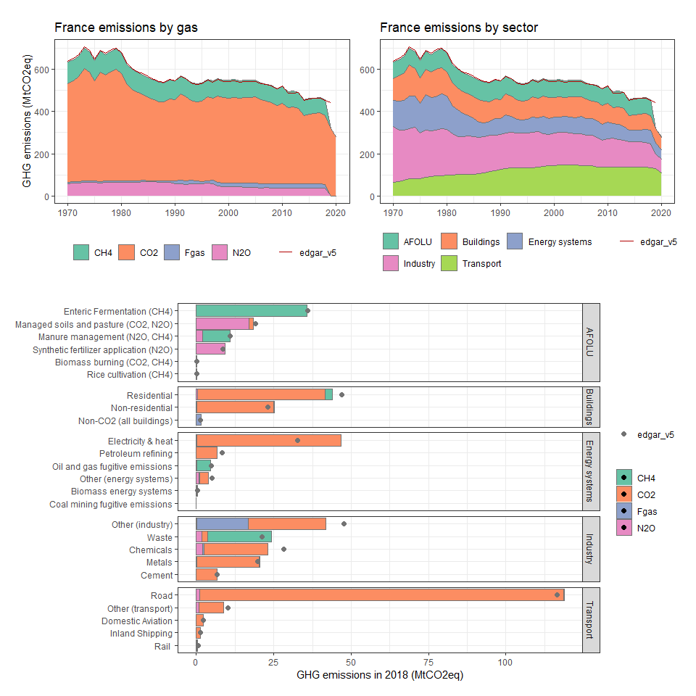

### French Guiana

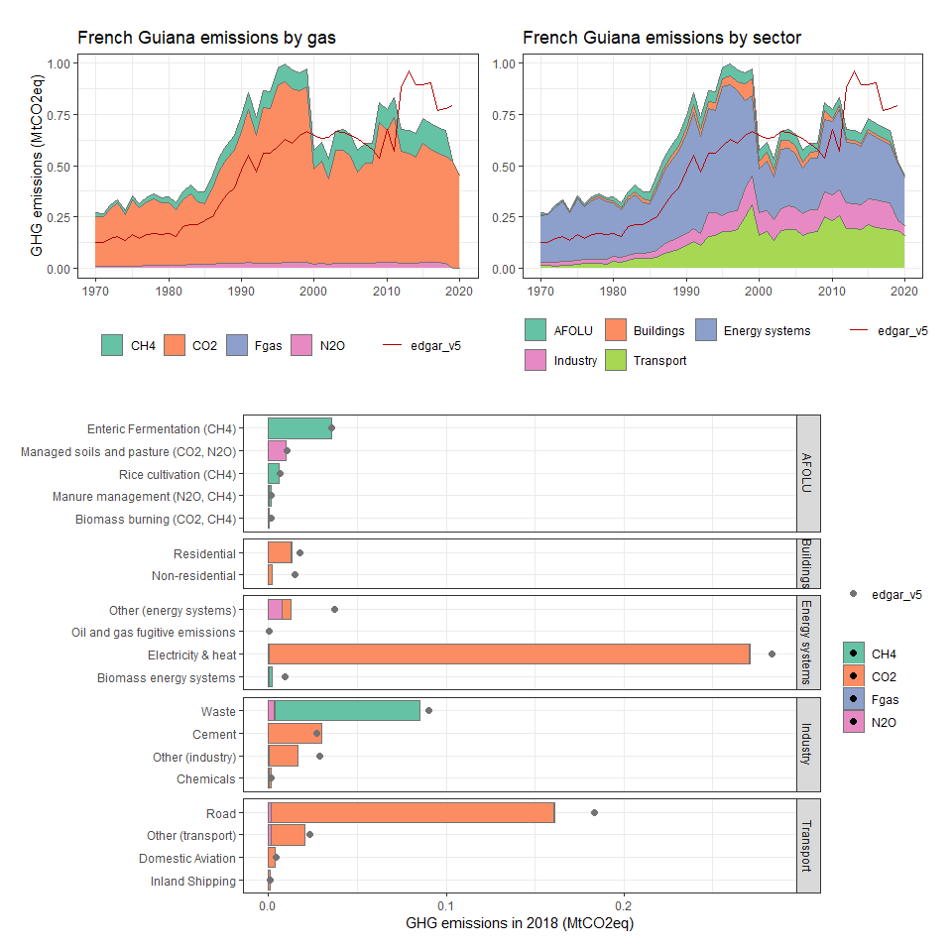

### French Polynesia

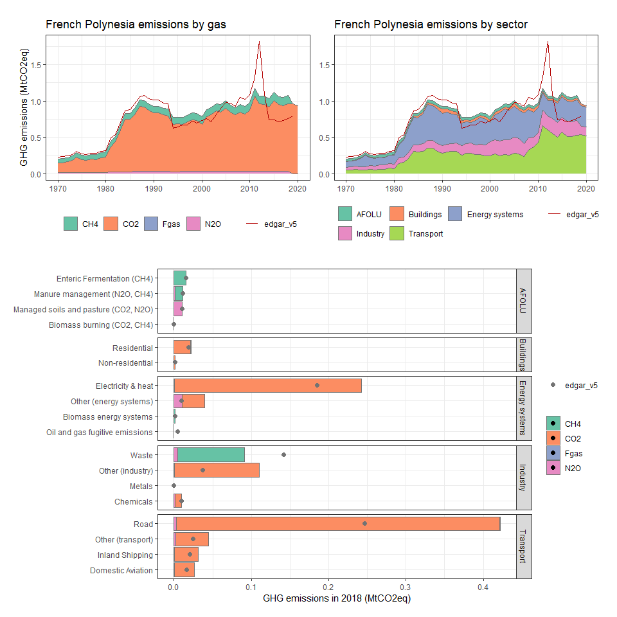

### French Southern Territories

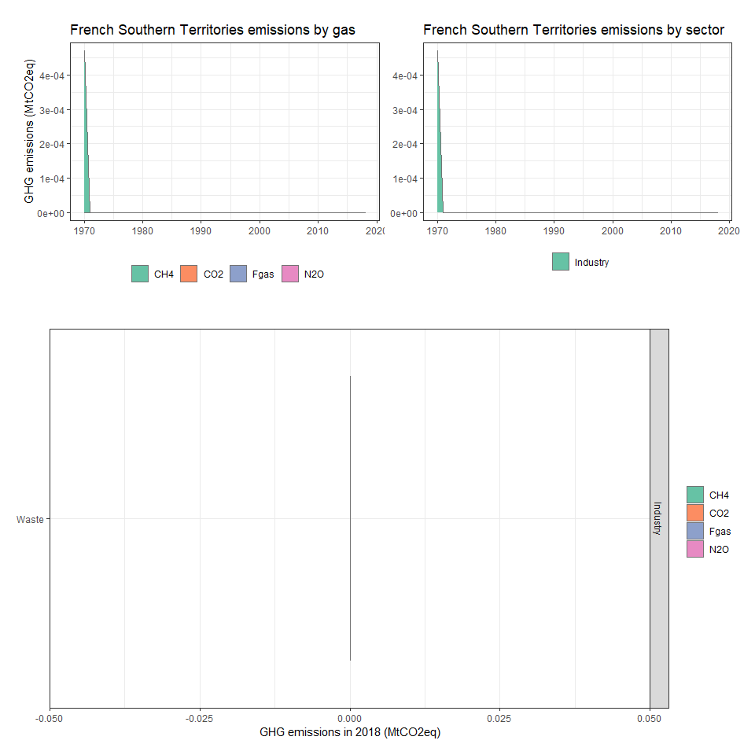

### Gabon

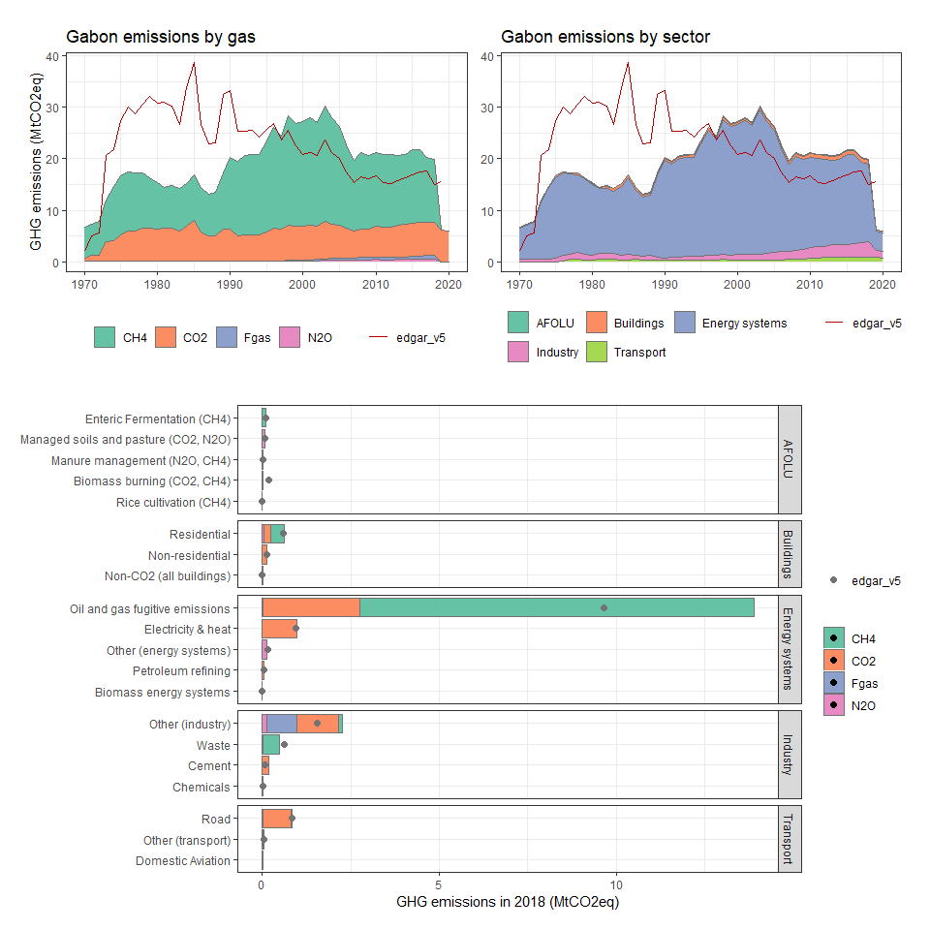

### Gambia, The

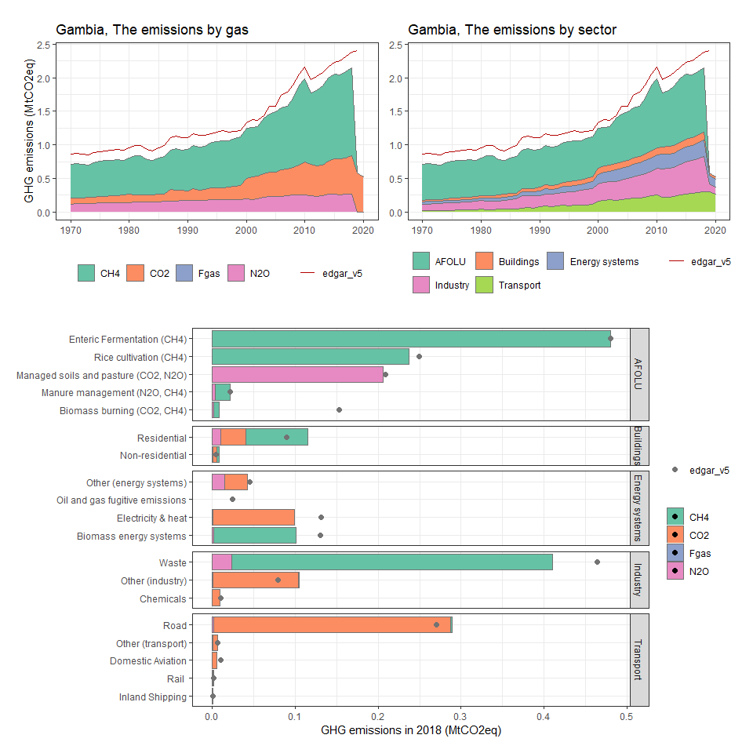

### Georgia

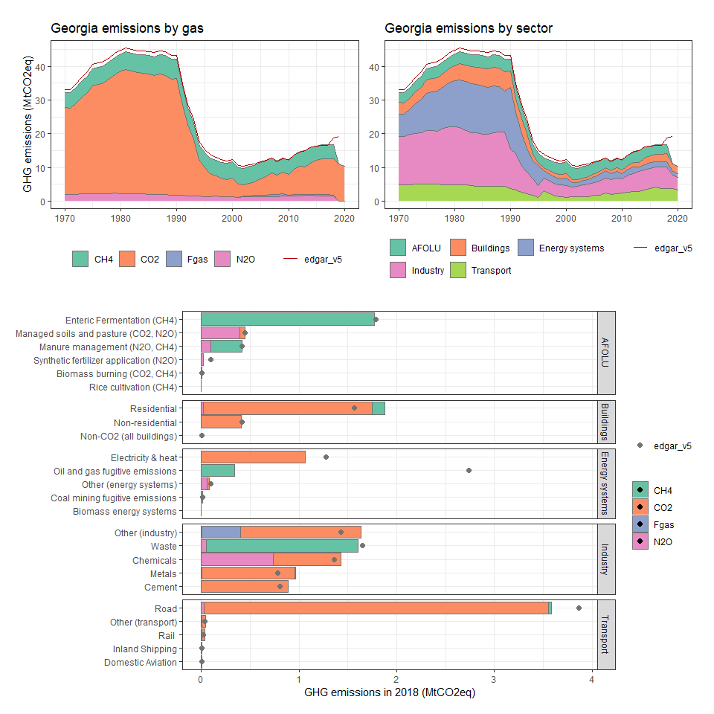

### Germany

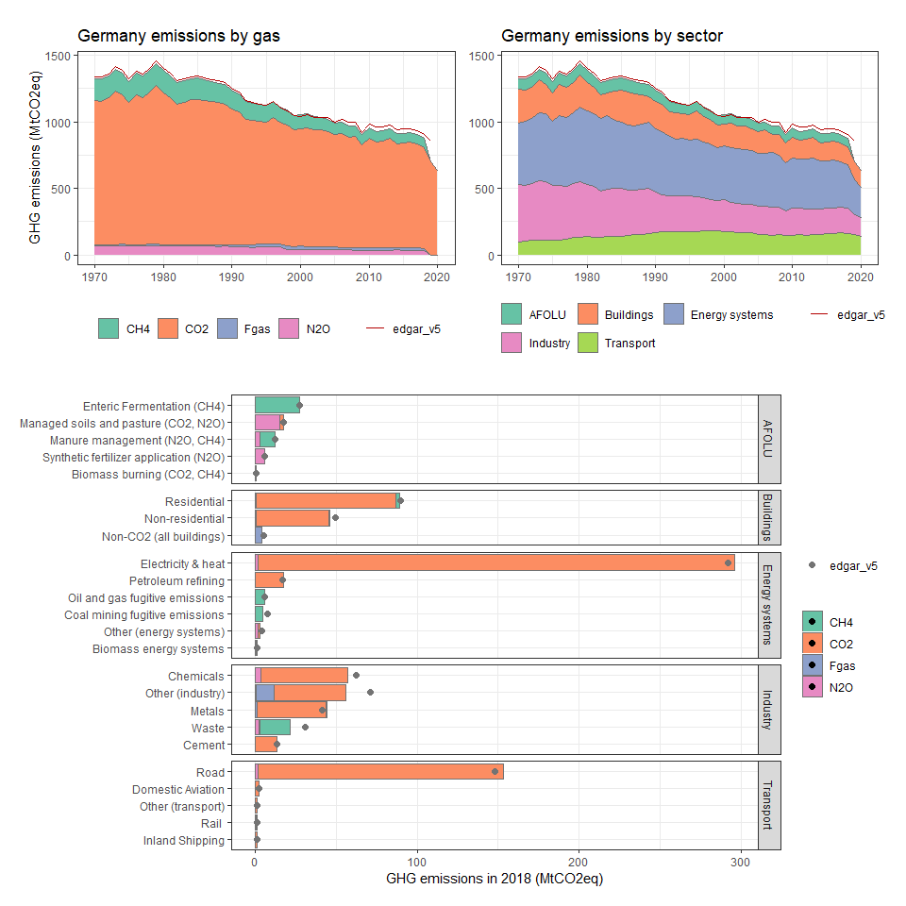

### Ghana

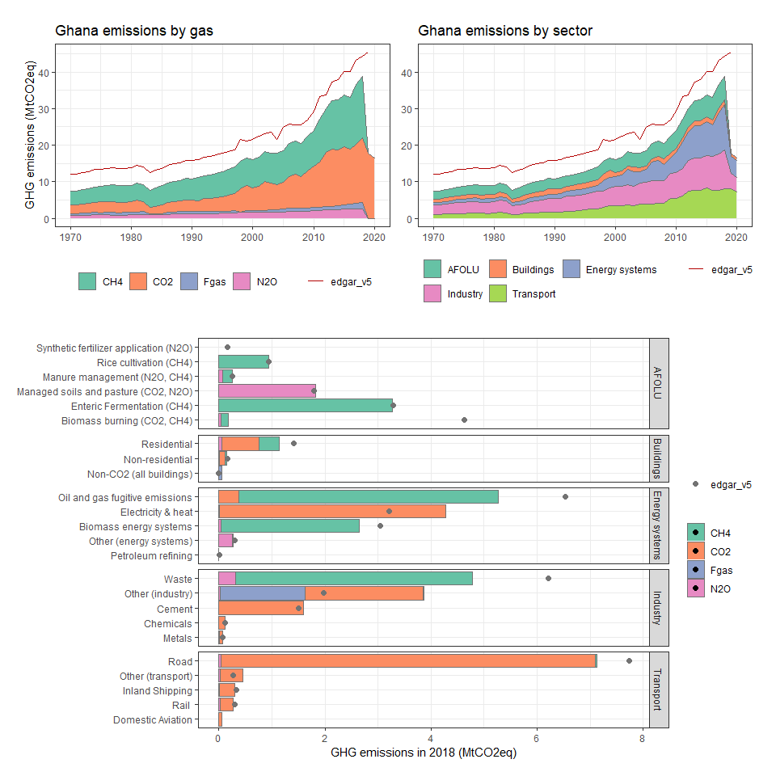

### Gibraltar

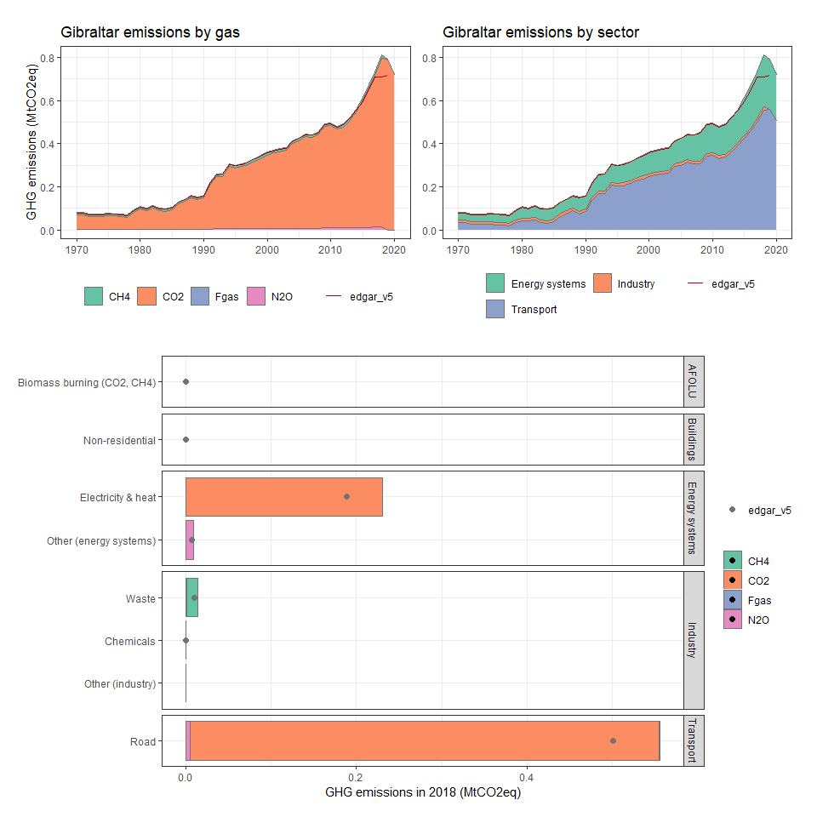

### Greece

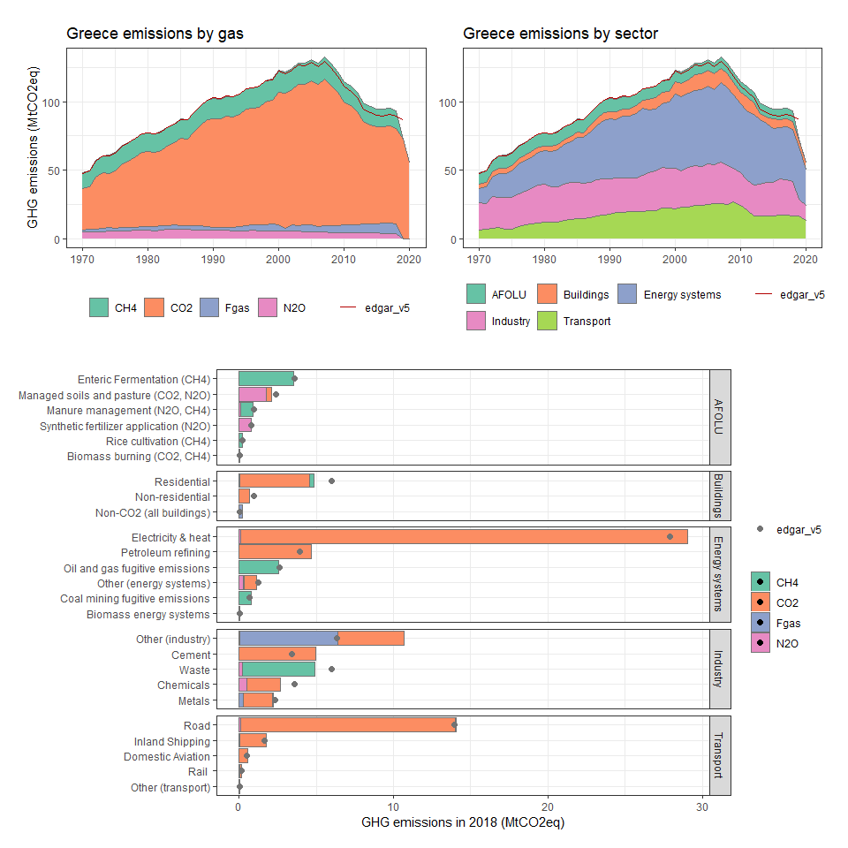

### Greenland

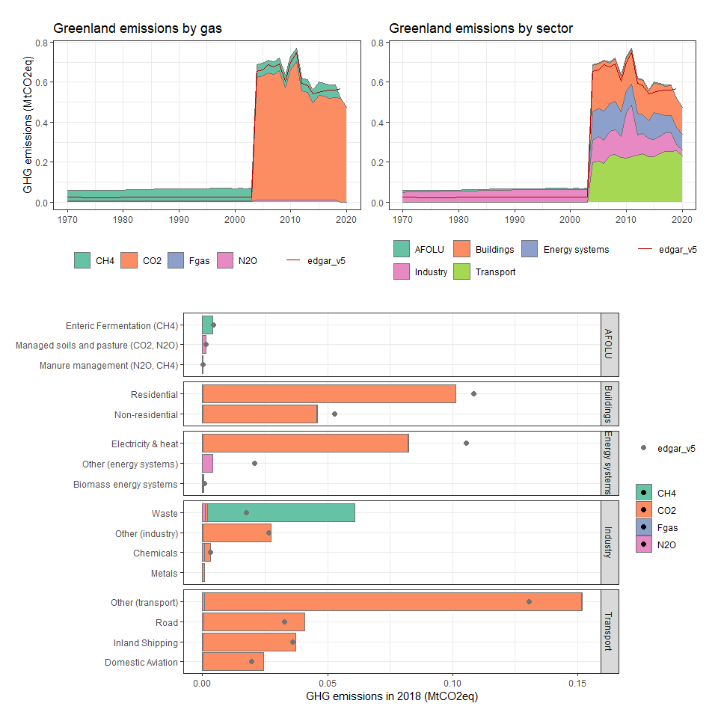

### Grenada

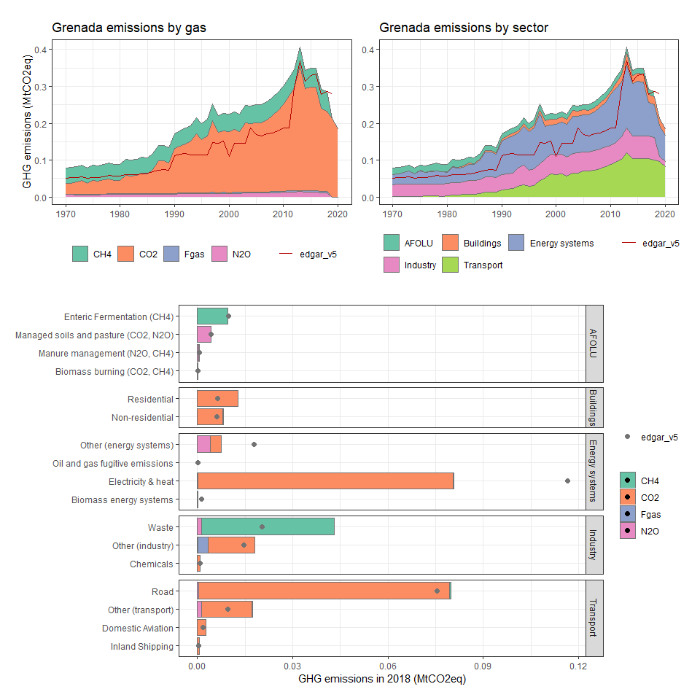

### Guadeloupe

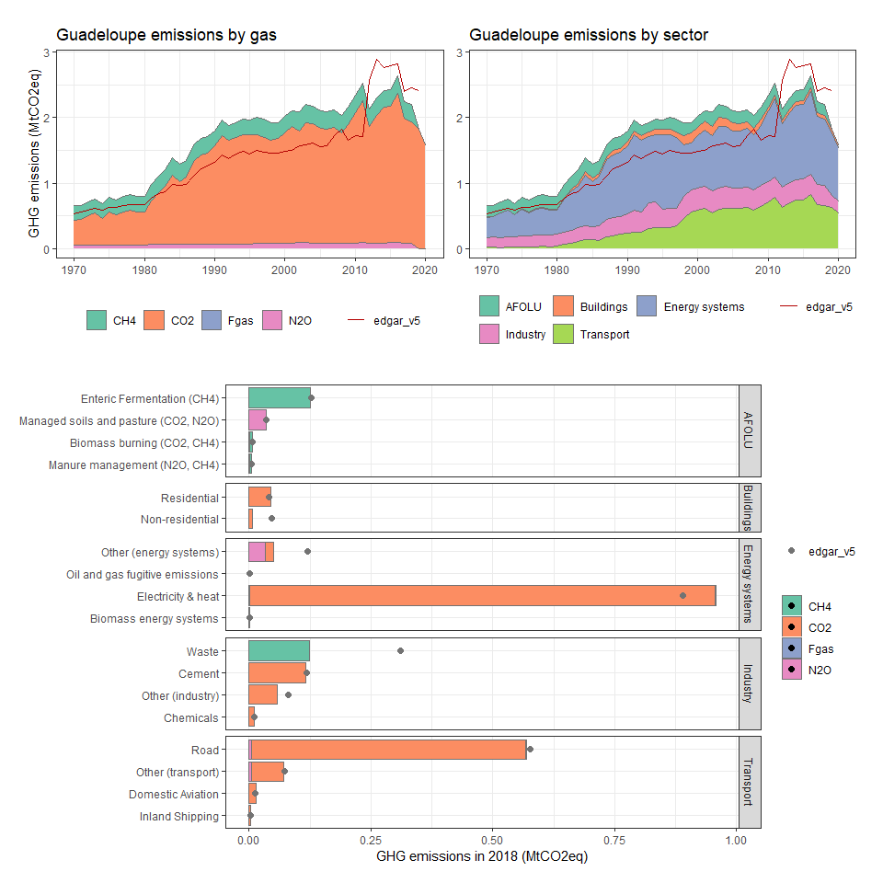

### Guam

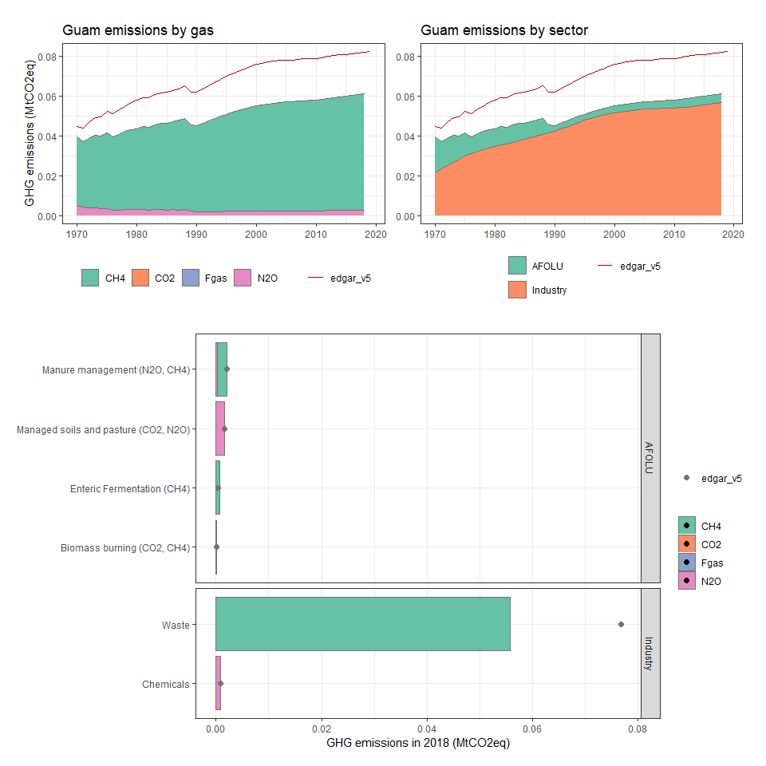

### Guatemala

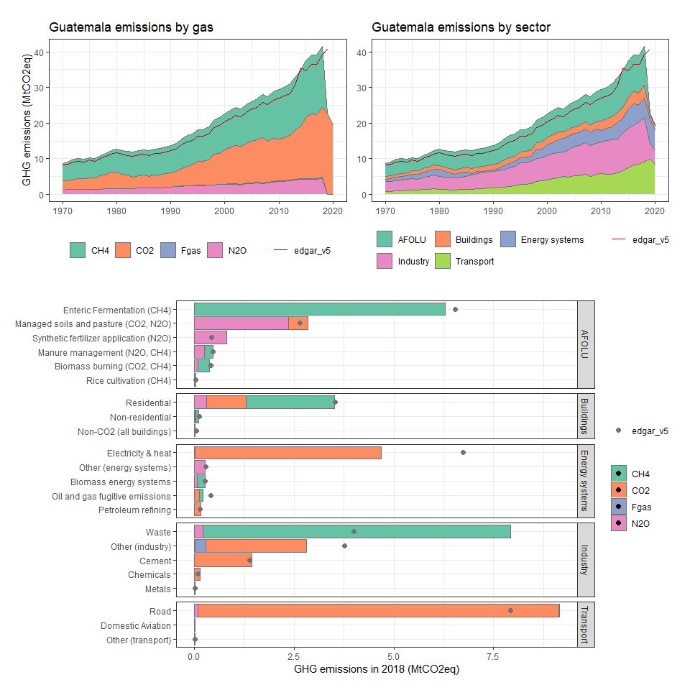

### Guinea

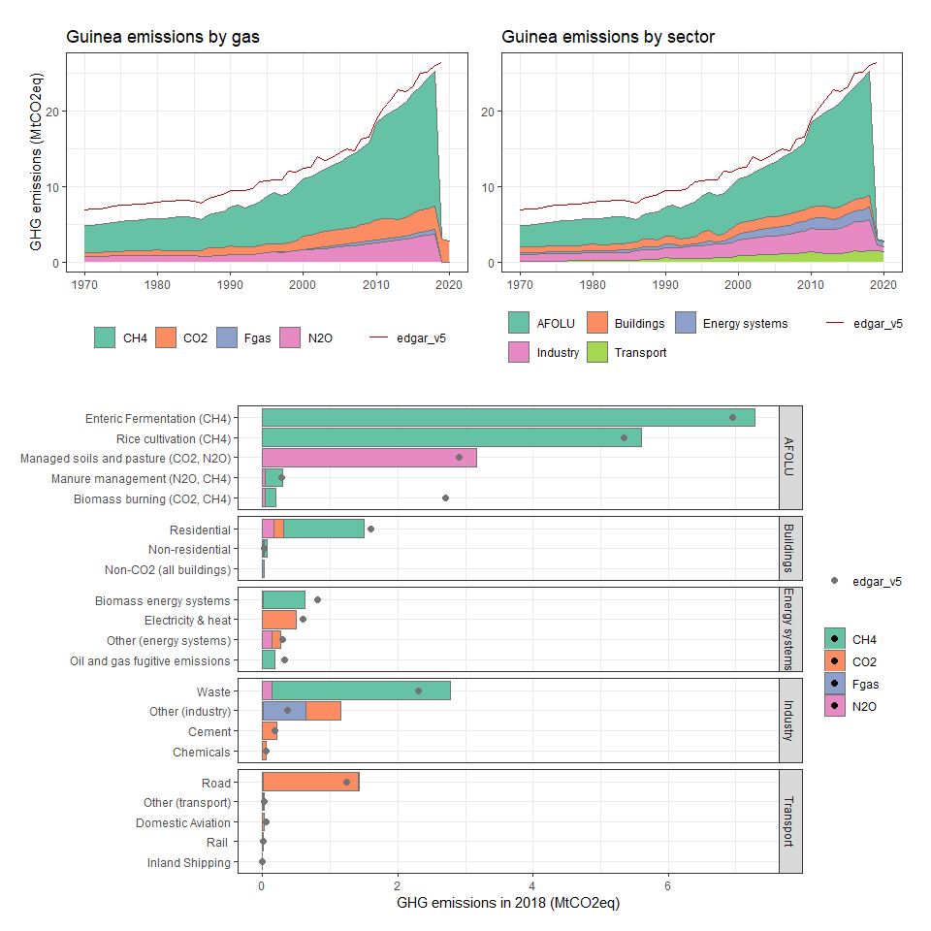

### Guinea-Bissau

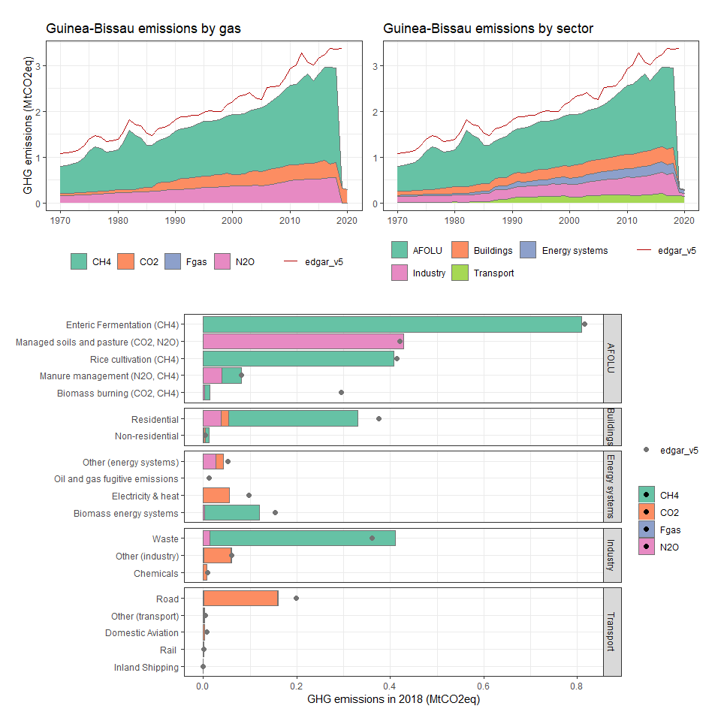

### Guyana

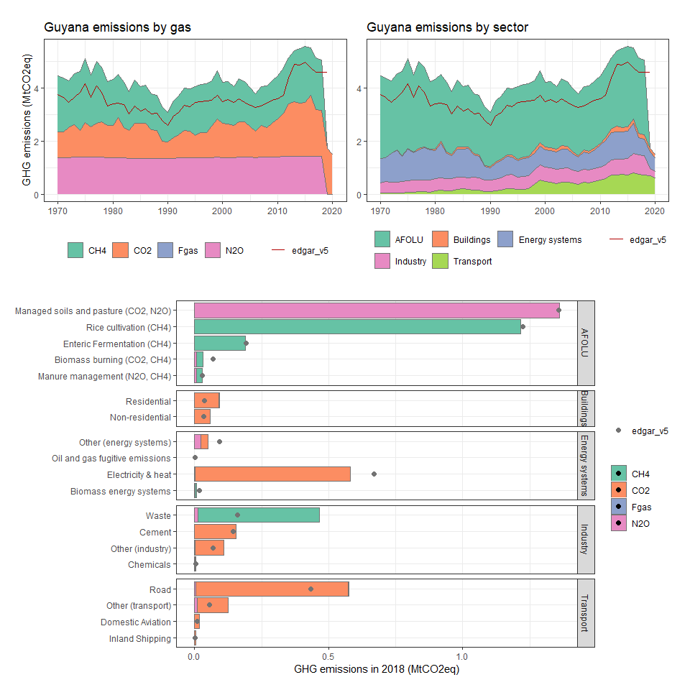

### Haiti

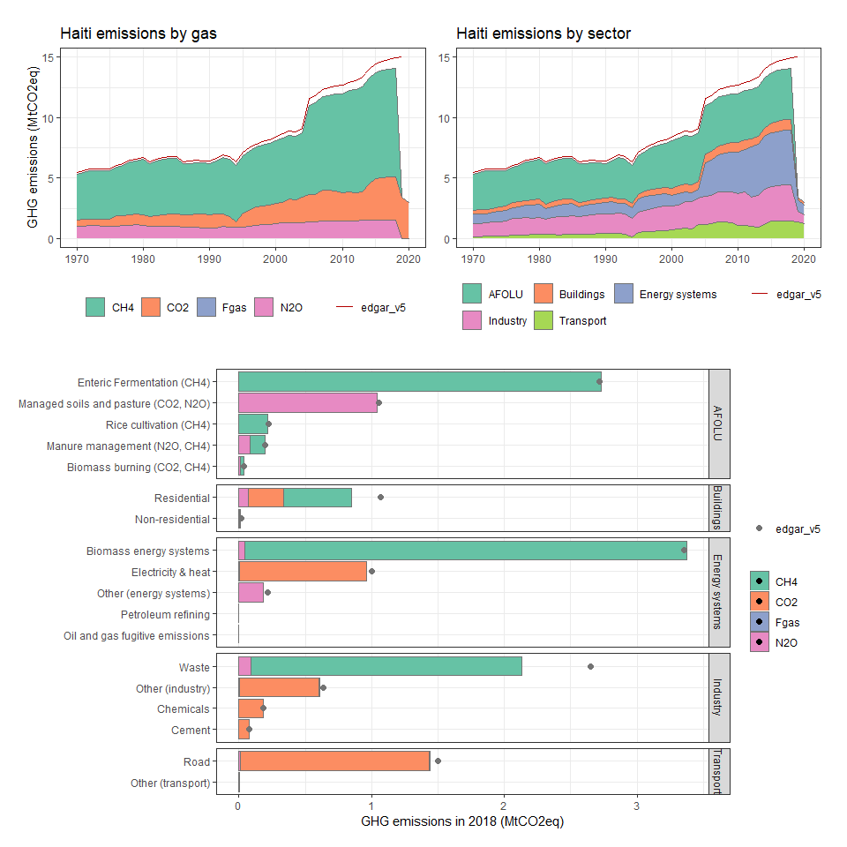

### Heard Island and McDonald Islands

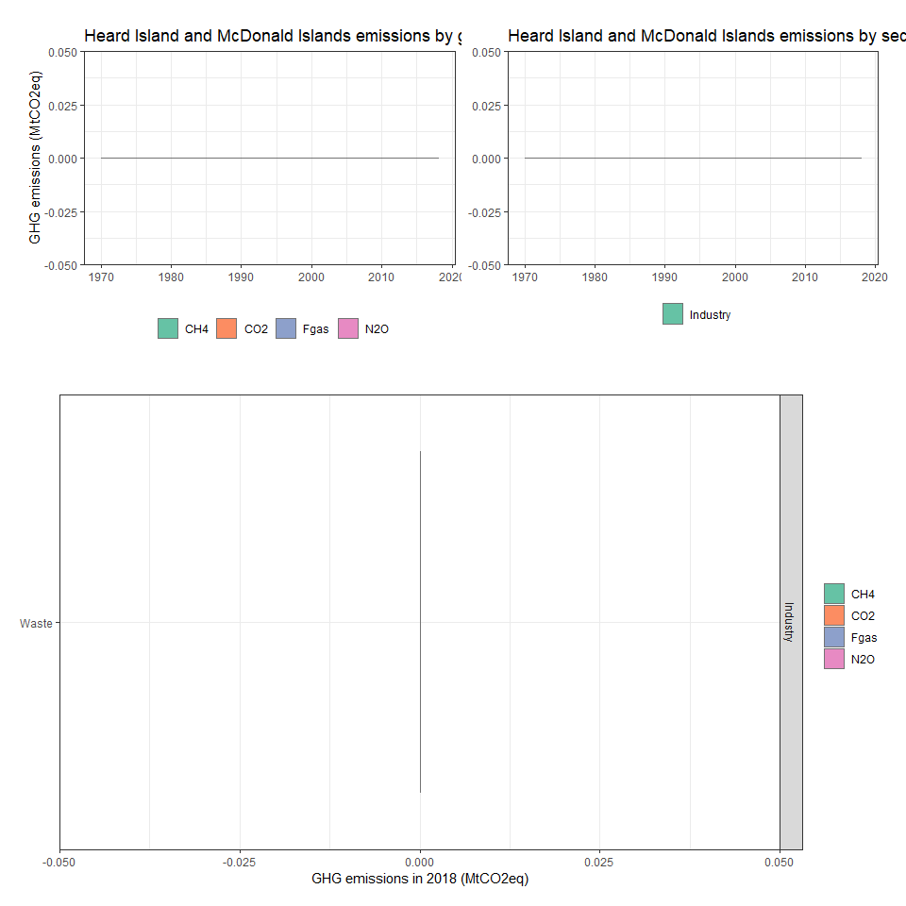

### Honduras

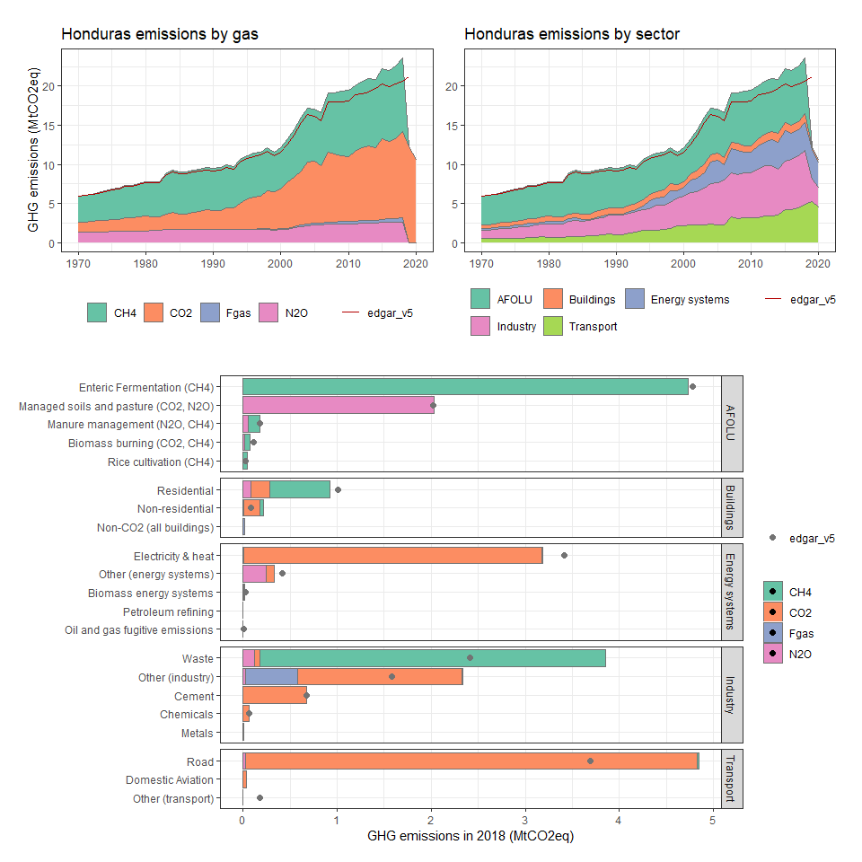

### Hong Kong SAR, China

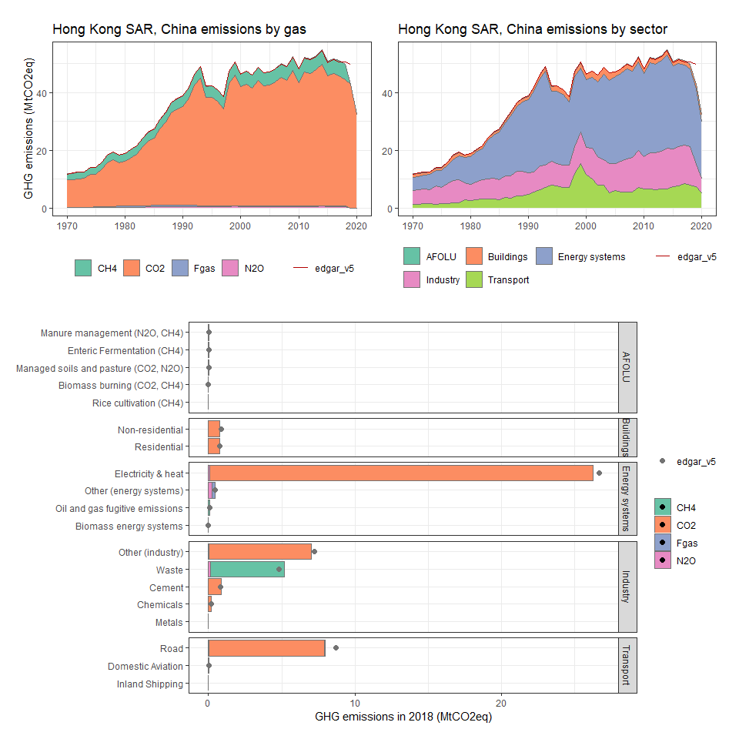

### Hungary

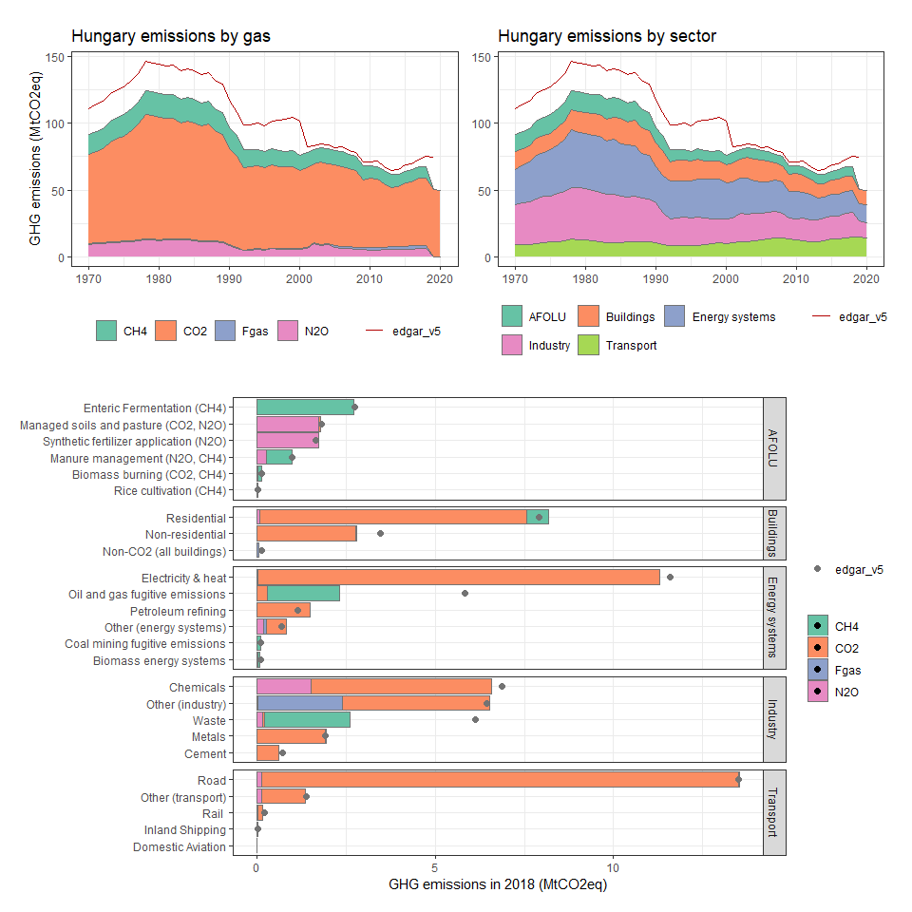

### Iceland

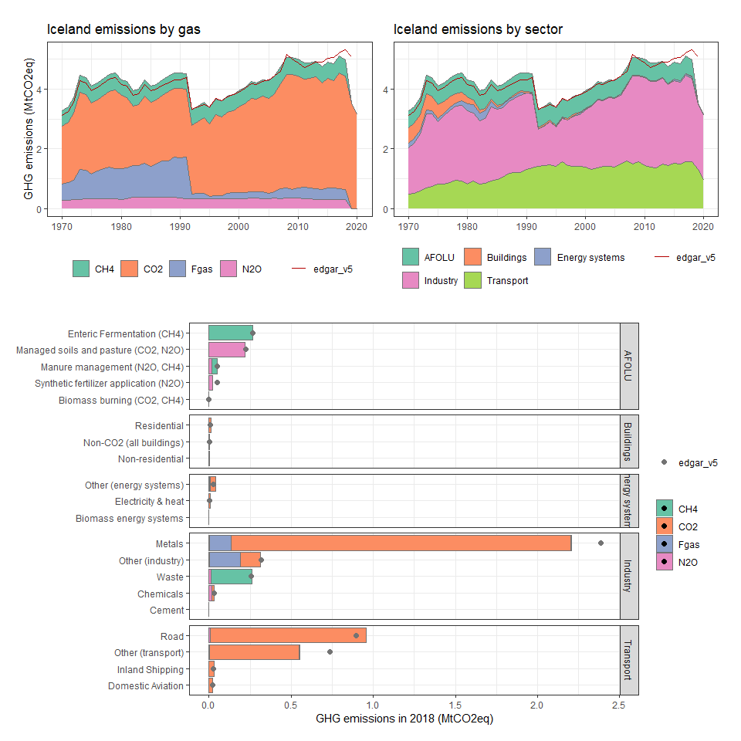

### India

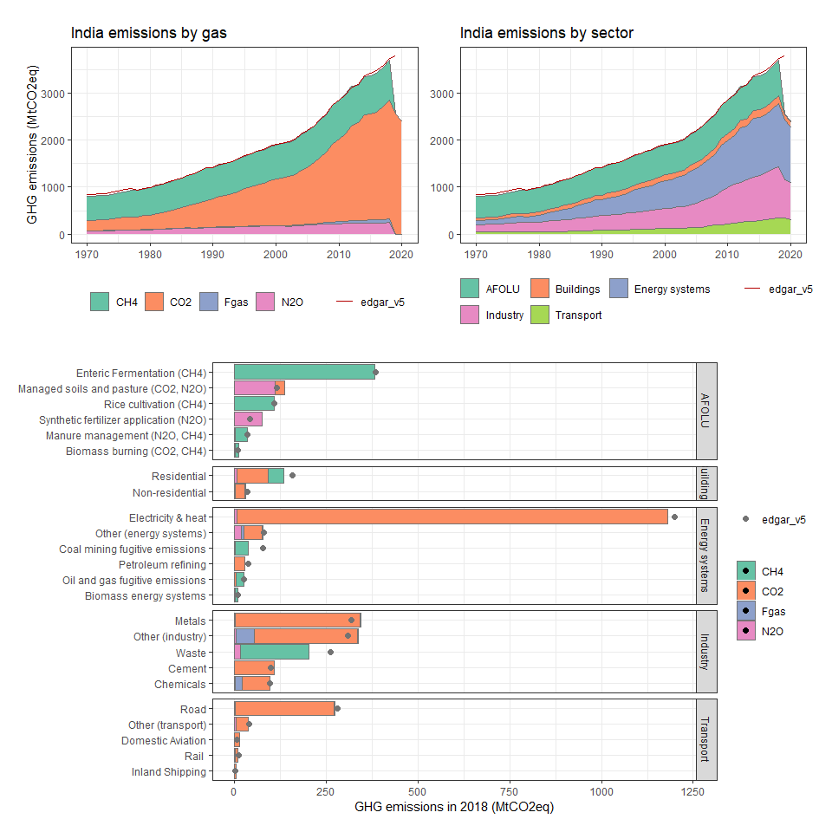

### Indonesia

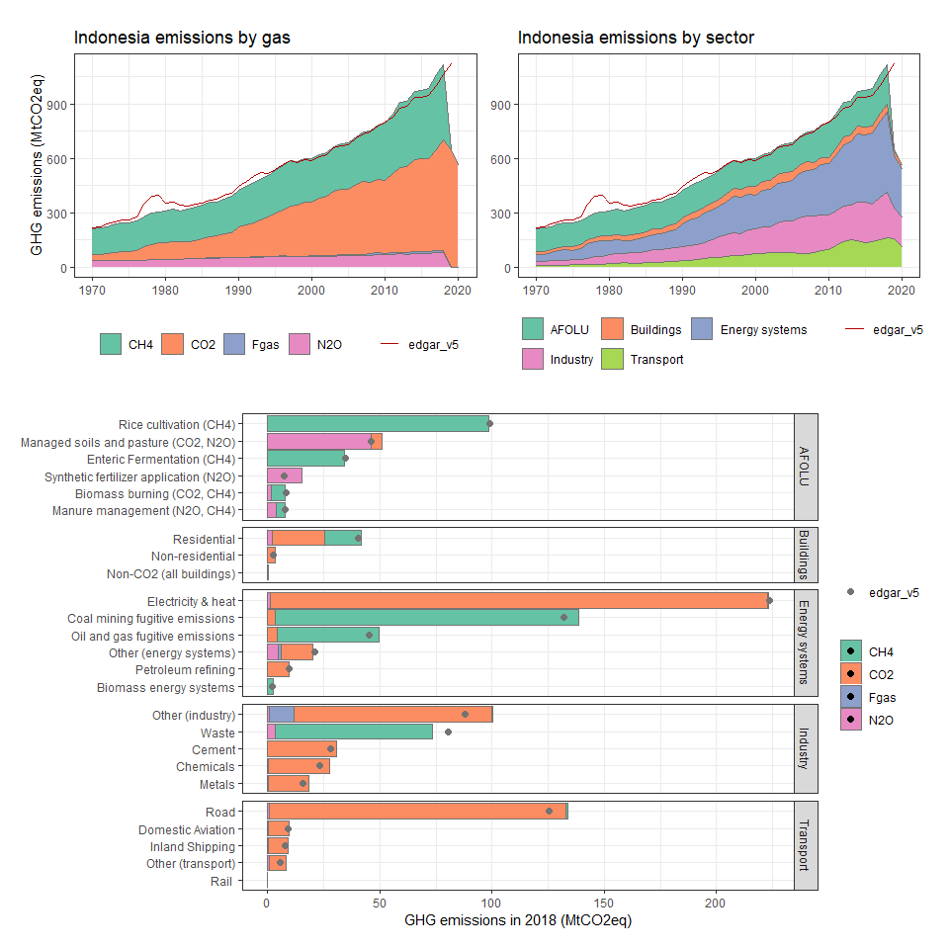

### Int. Aviation

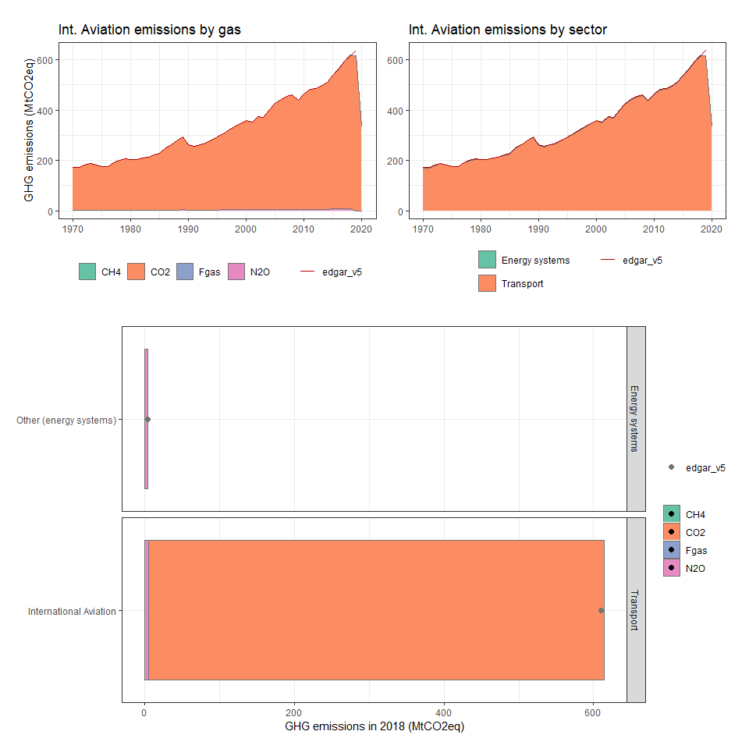

### Int. Shipping

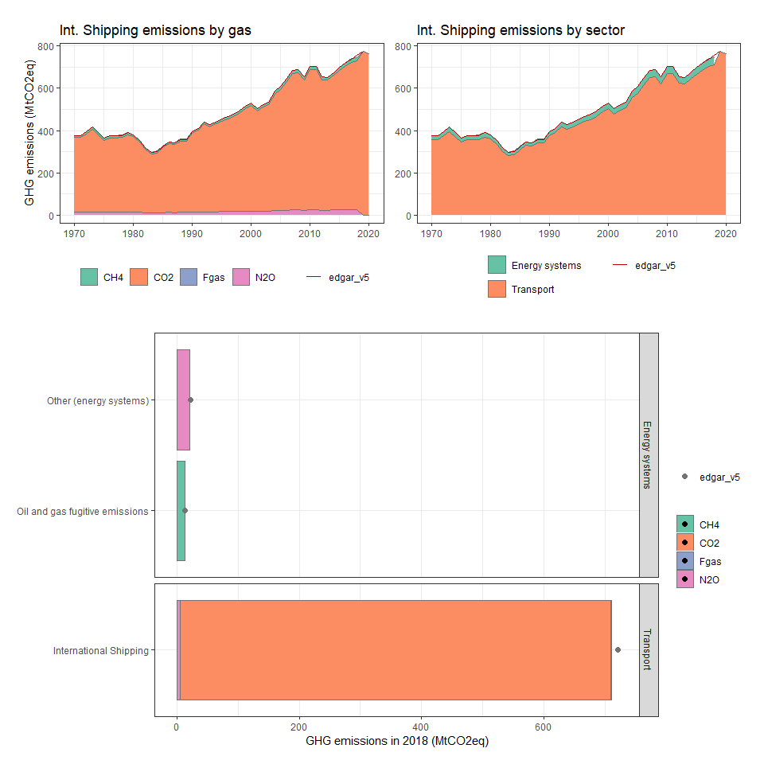

### Iran, Islamic Rep.

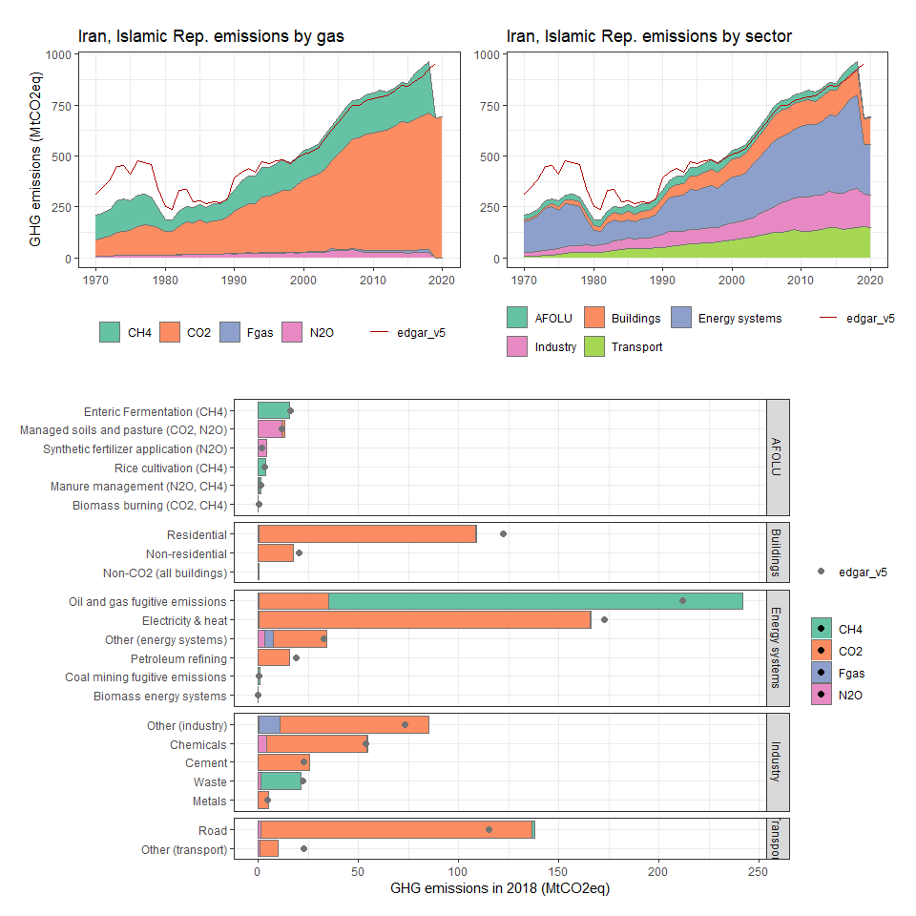

### Iraq

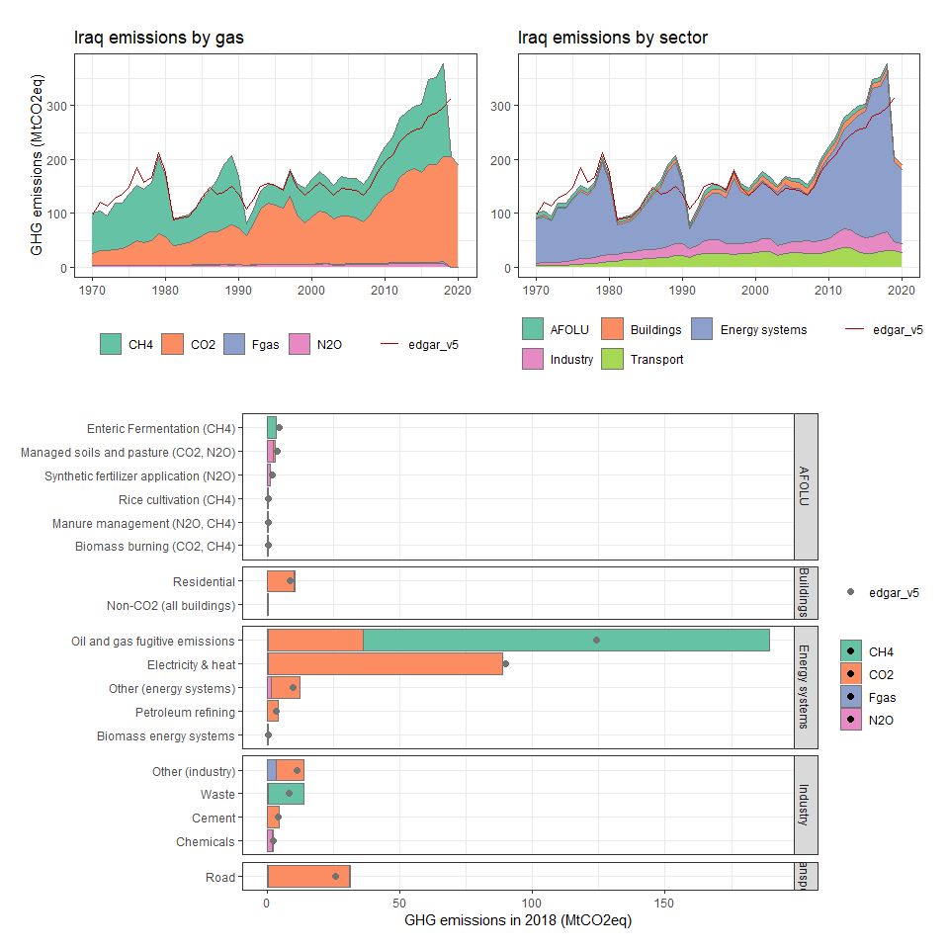

### Ireland

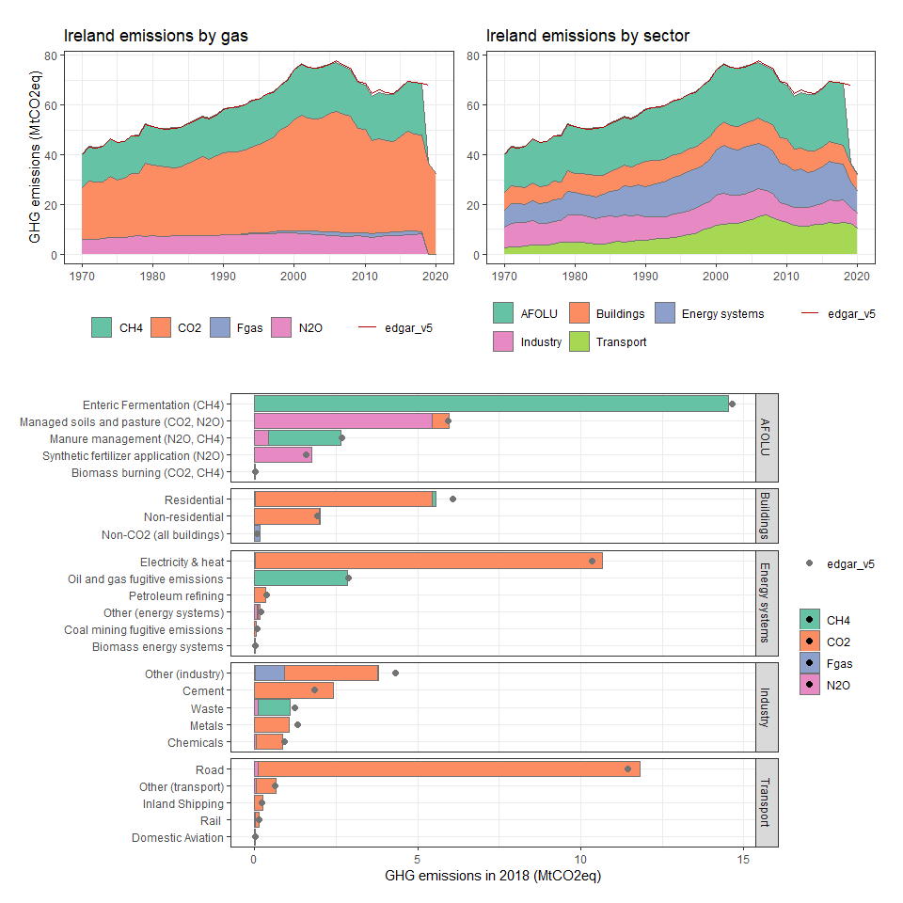

### Israel

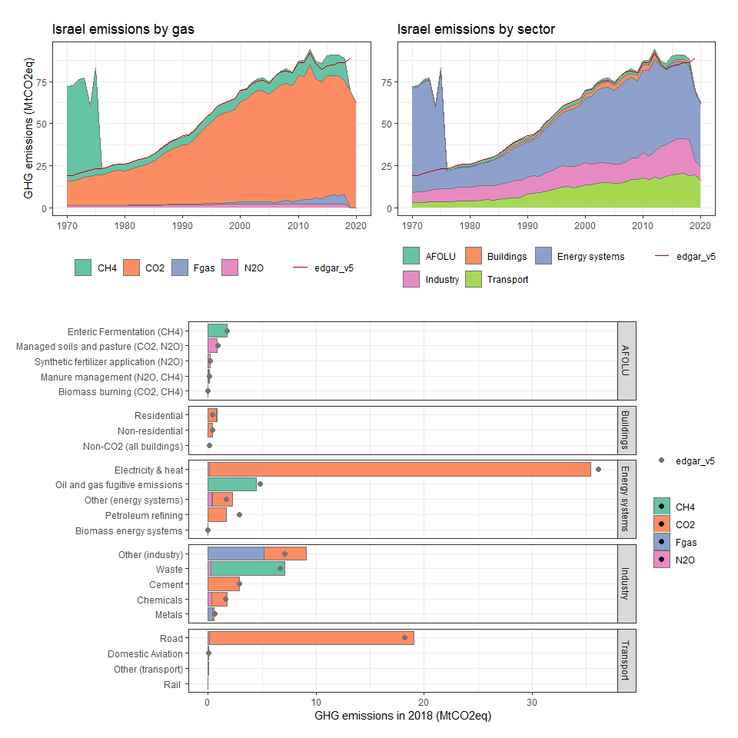

### Italy

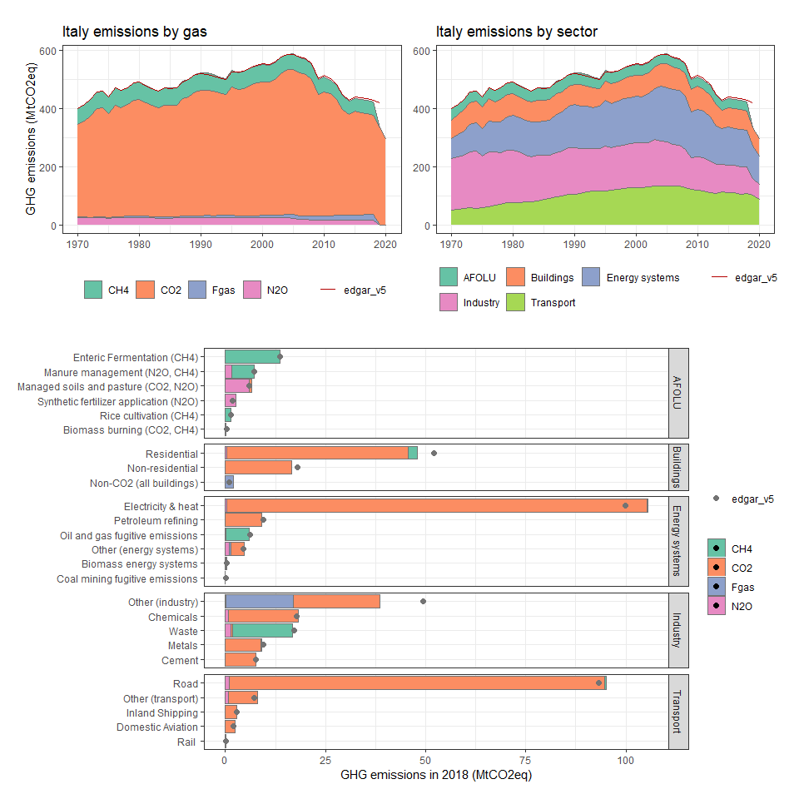

### Jamaica

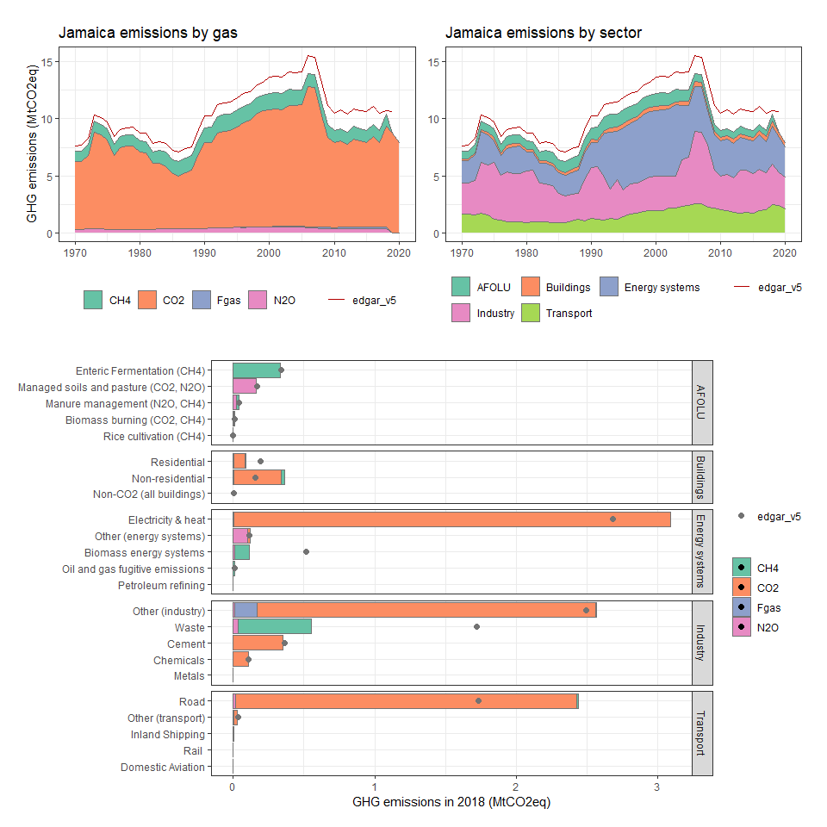

### Japan

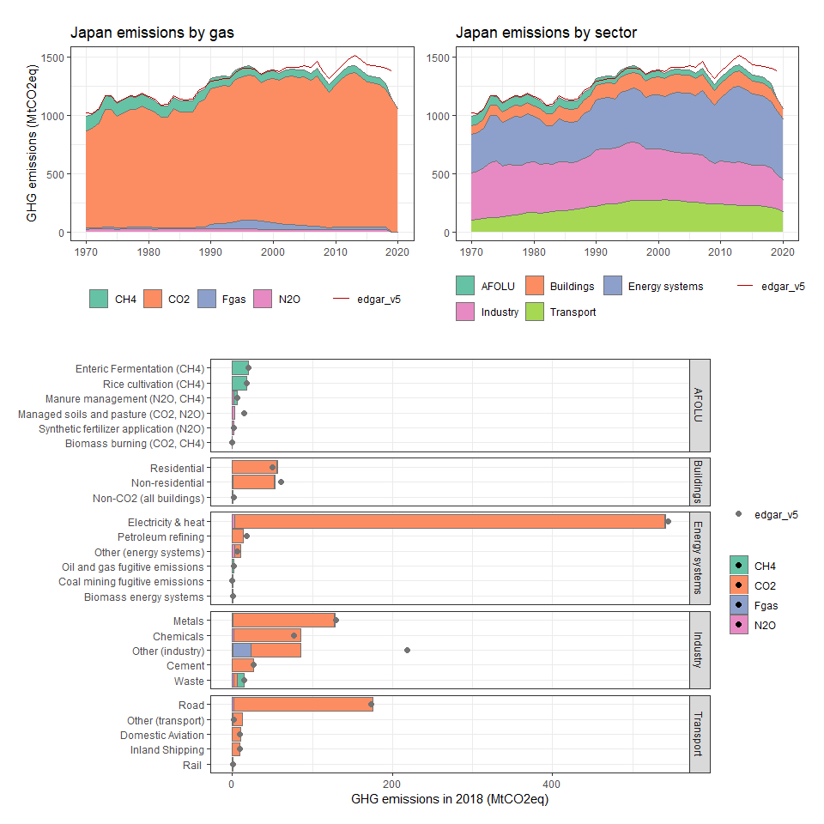

### Jordan

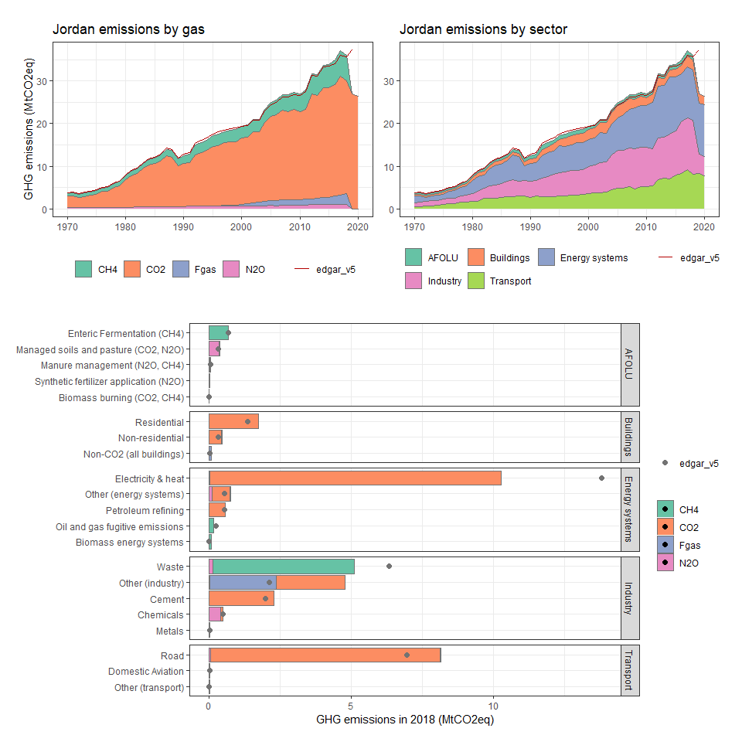

### Kazakhstan

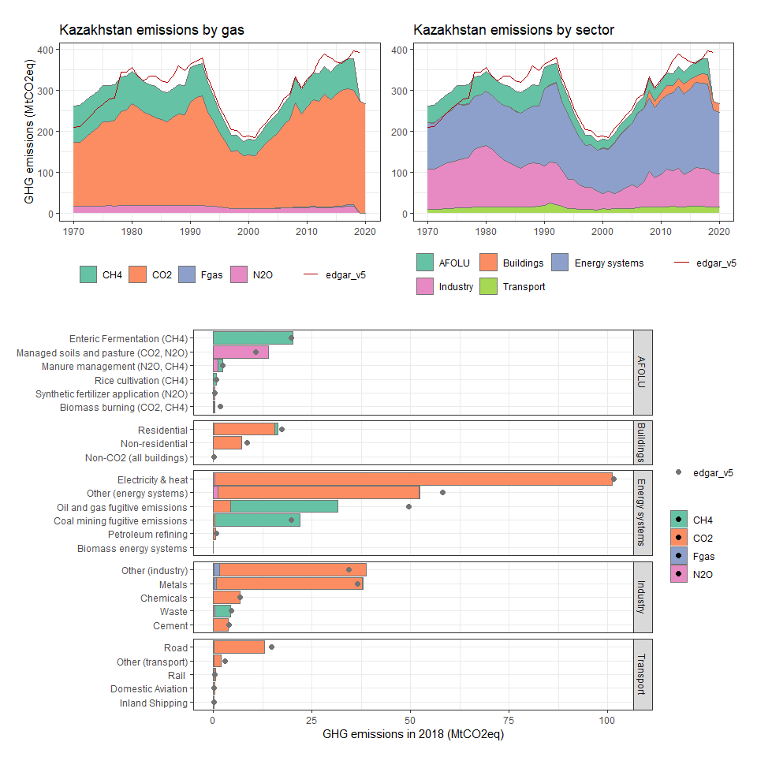

### Kenya

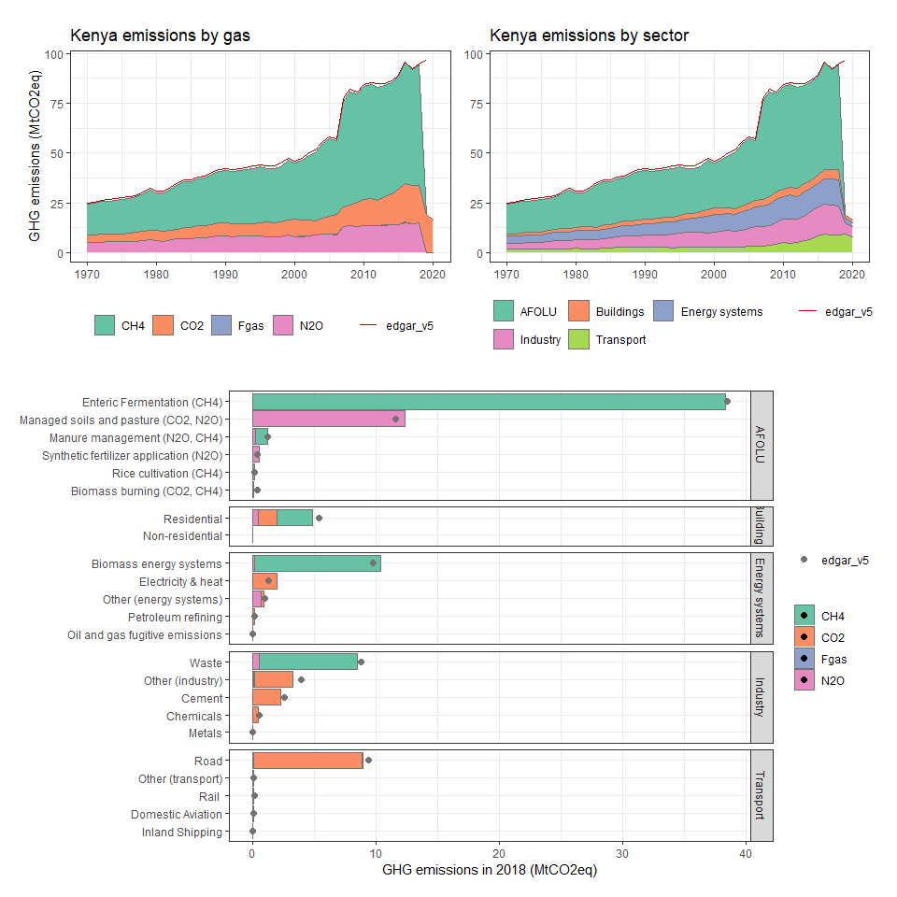

### Kiribati

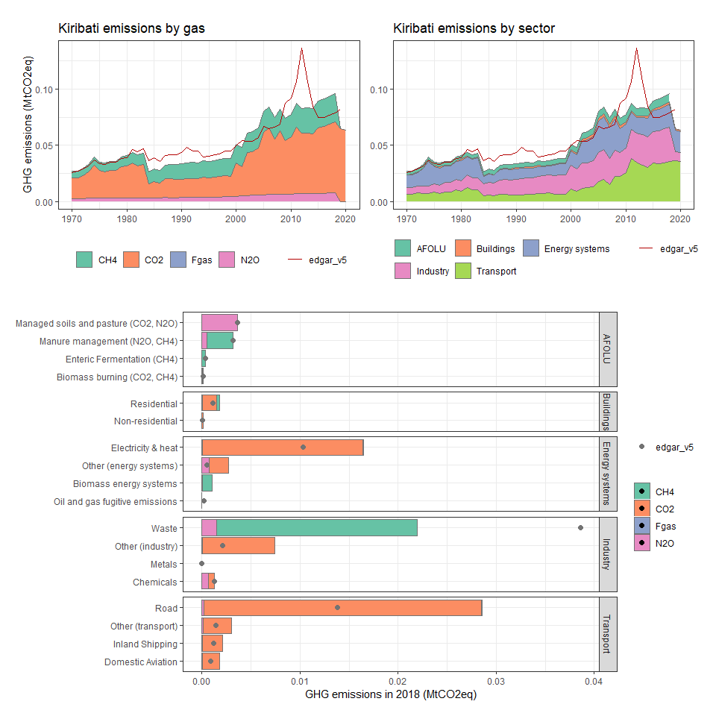

### Korea, Dem. People’s Rep.

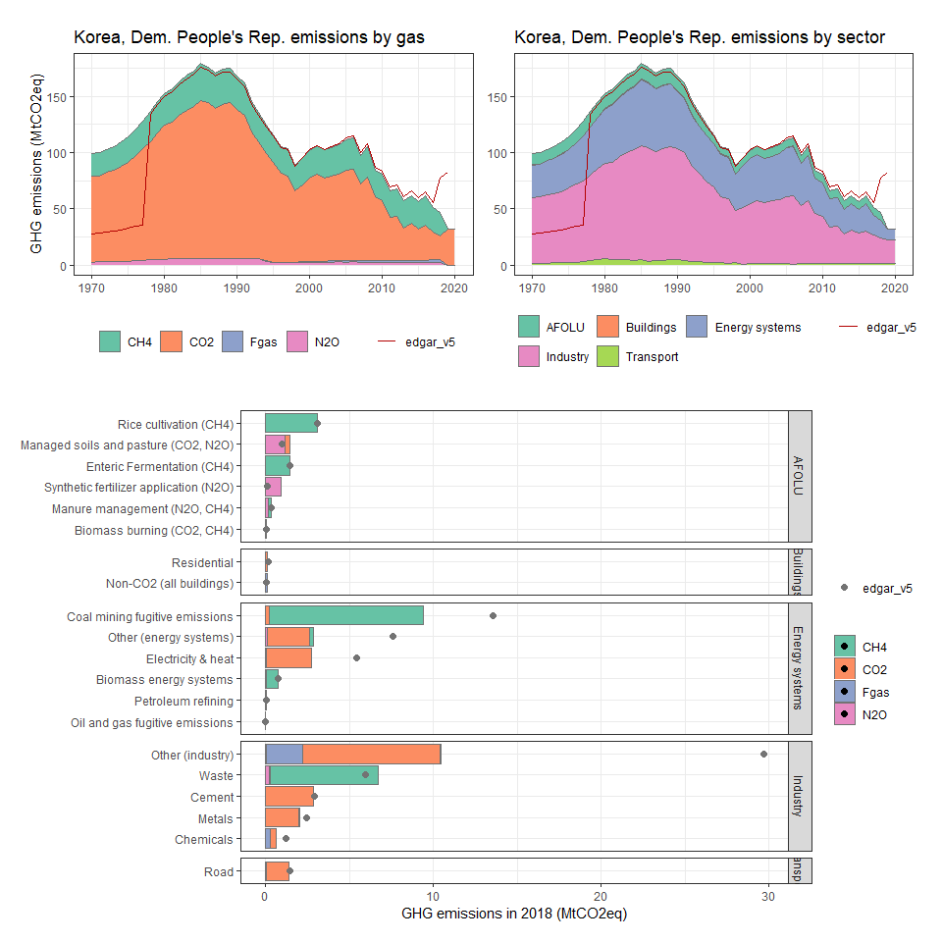

### Korea, Rep.

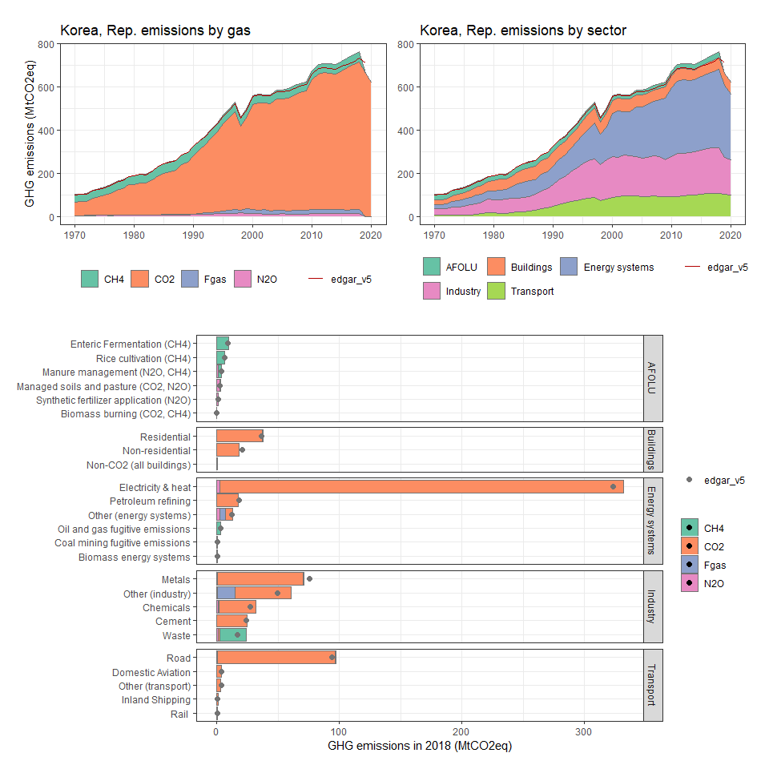

### Kuwait

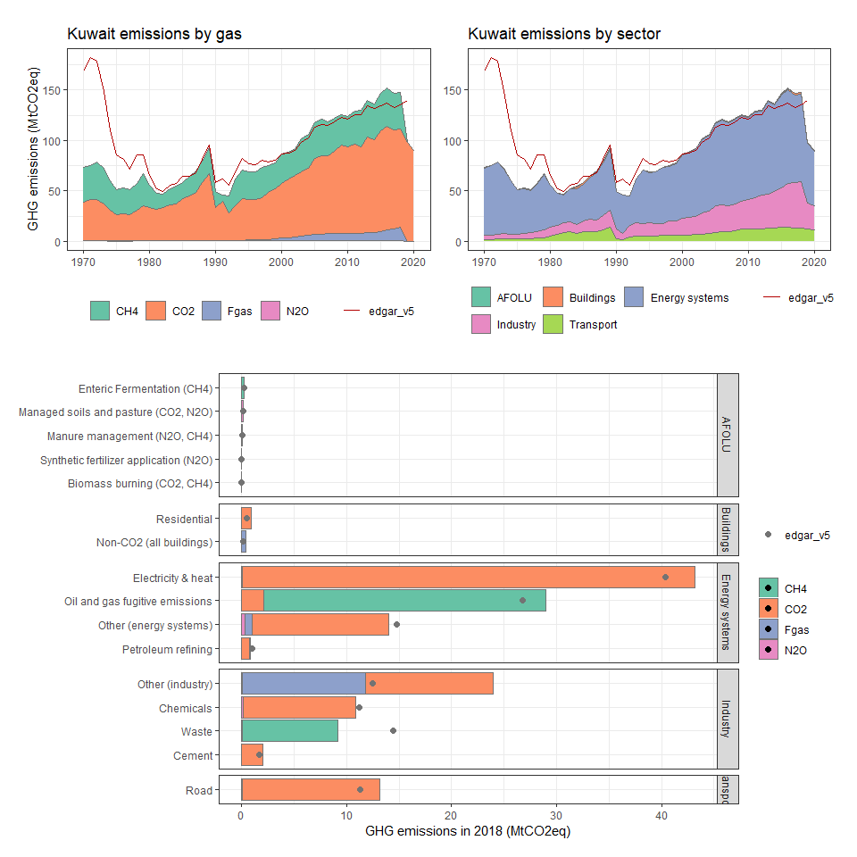

### Kyrgyz Republic

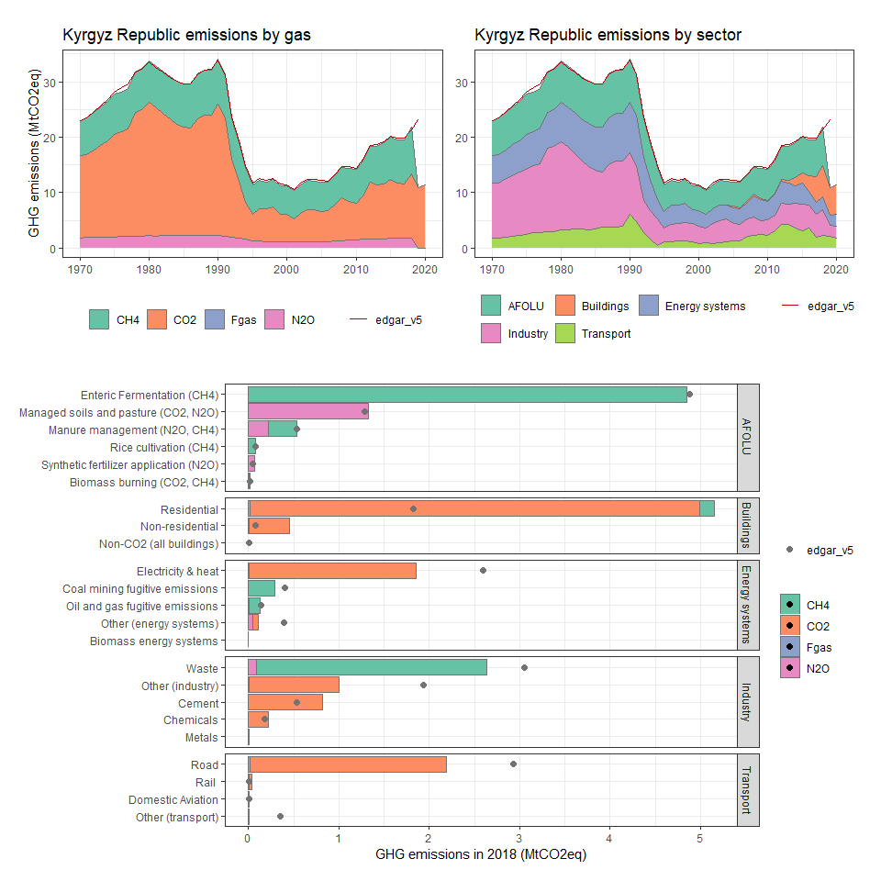

### Lao PDR

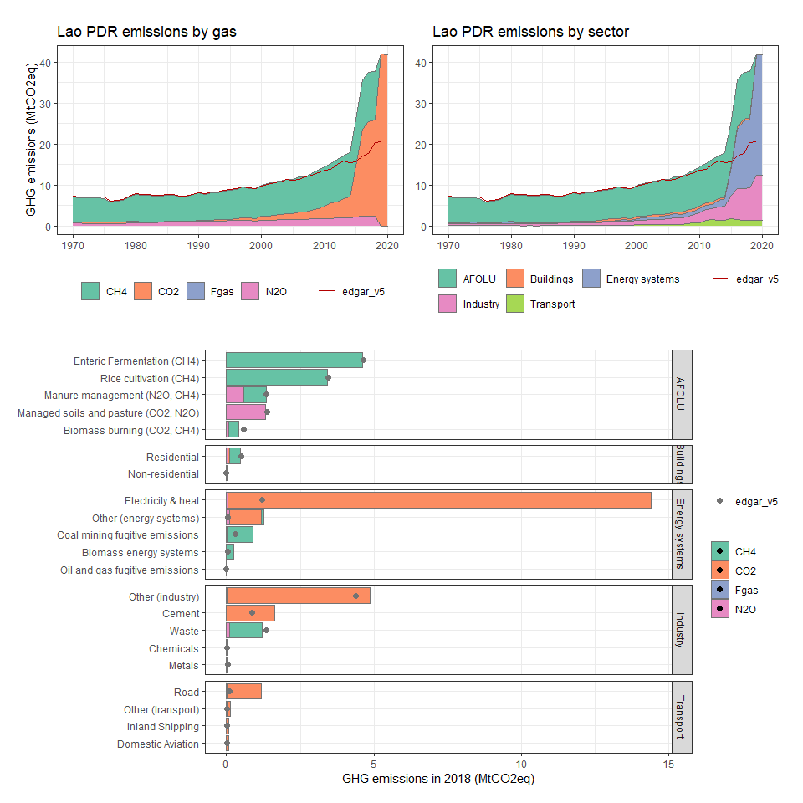

### Latvia

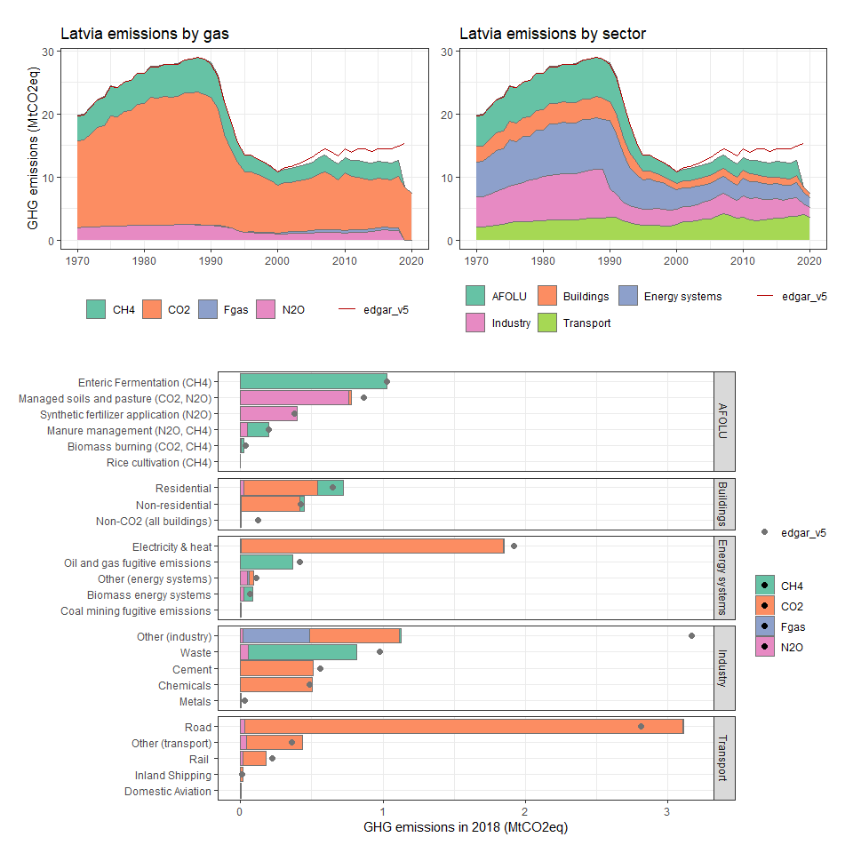

### Lebanon

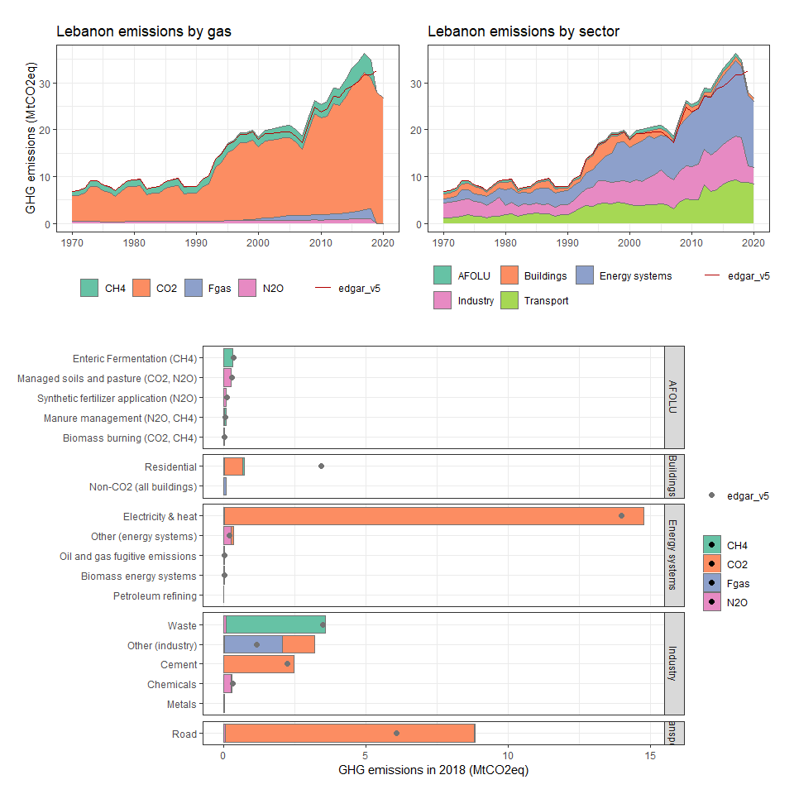

### Lesotho

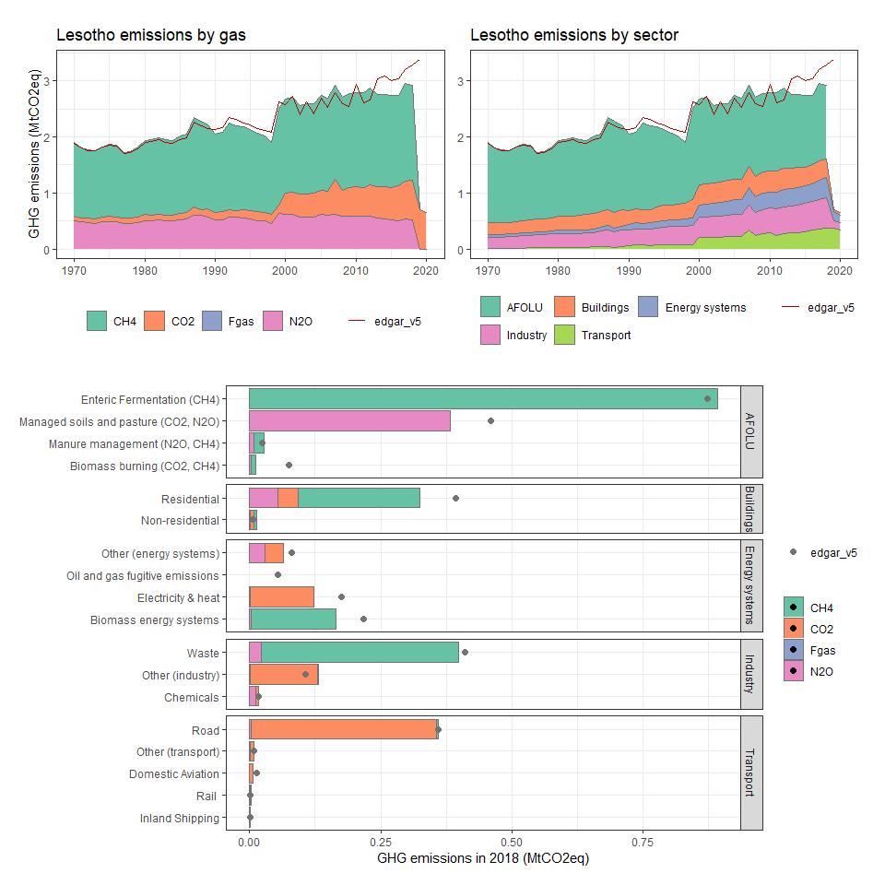

### Liberia

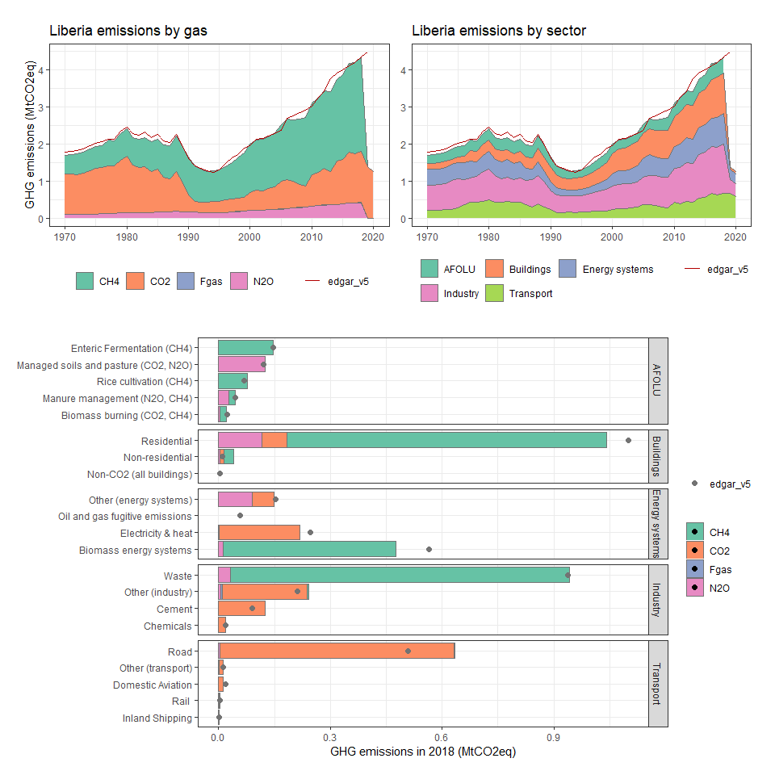

### Libya

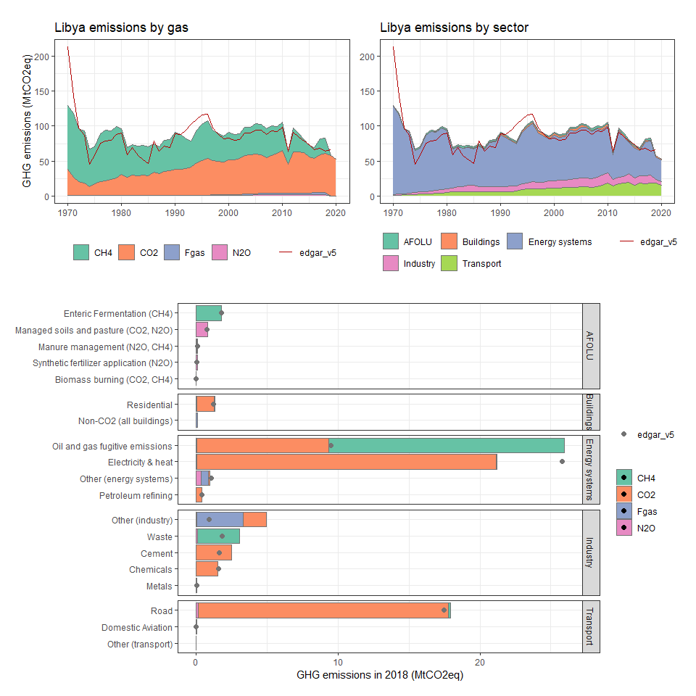

### Lithuania

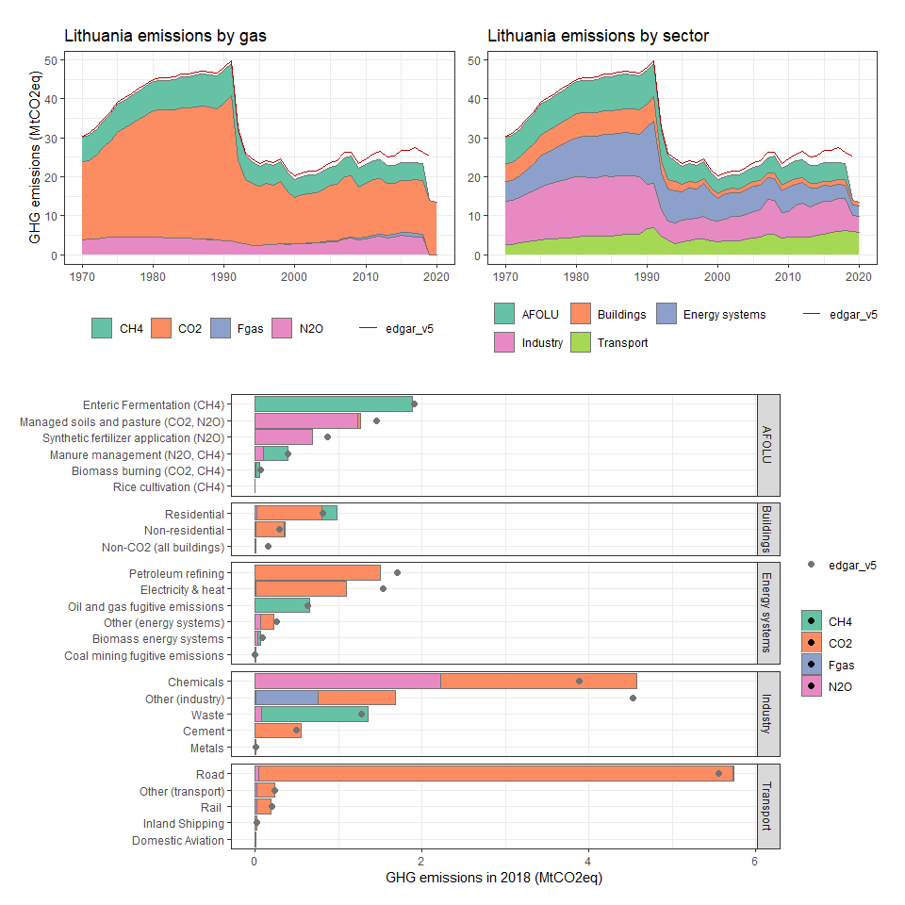

### Luxembourg

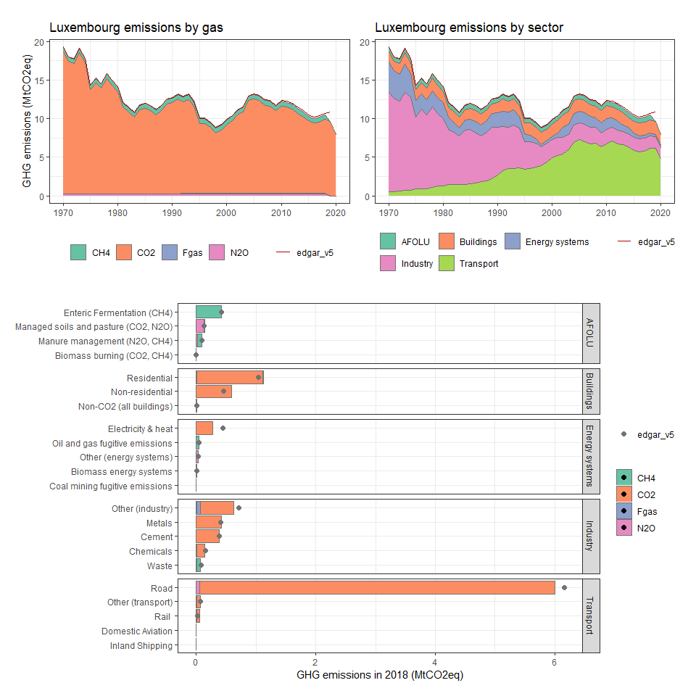

### Macao SAR, China

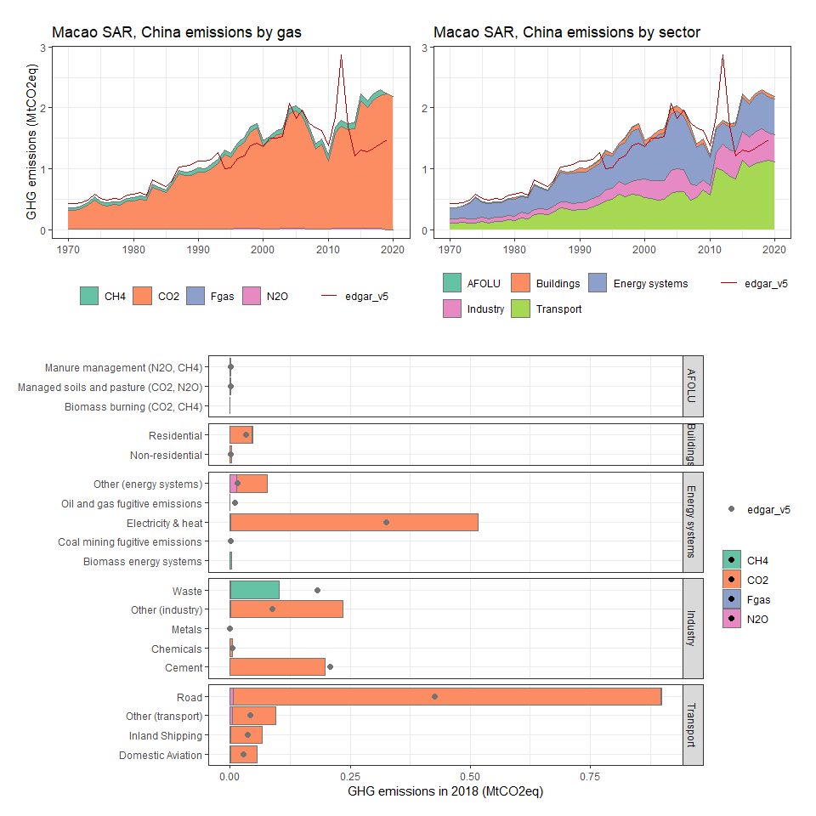

### Macedonia, FYR

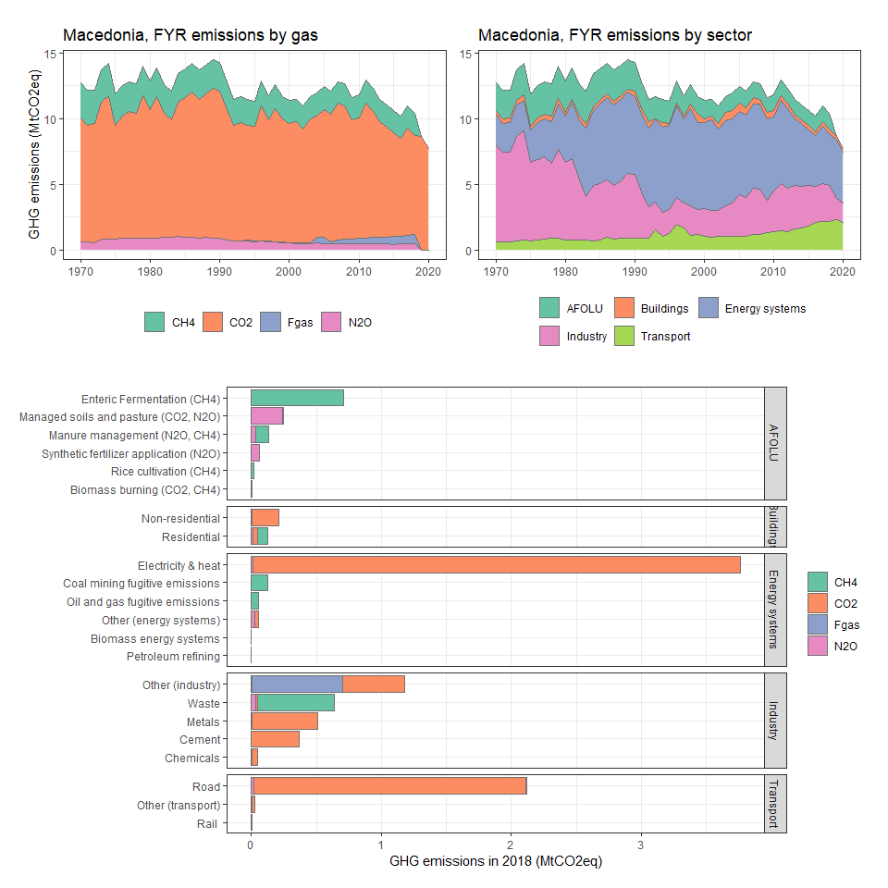

### Madagascar

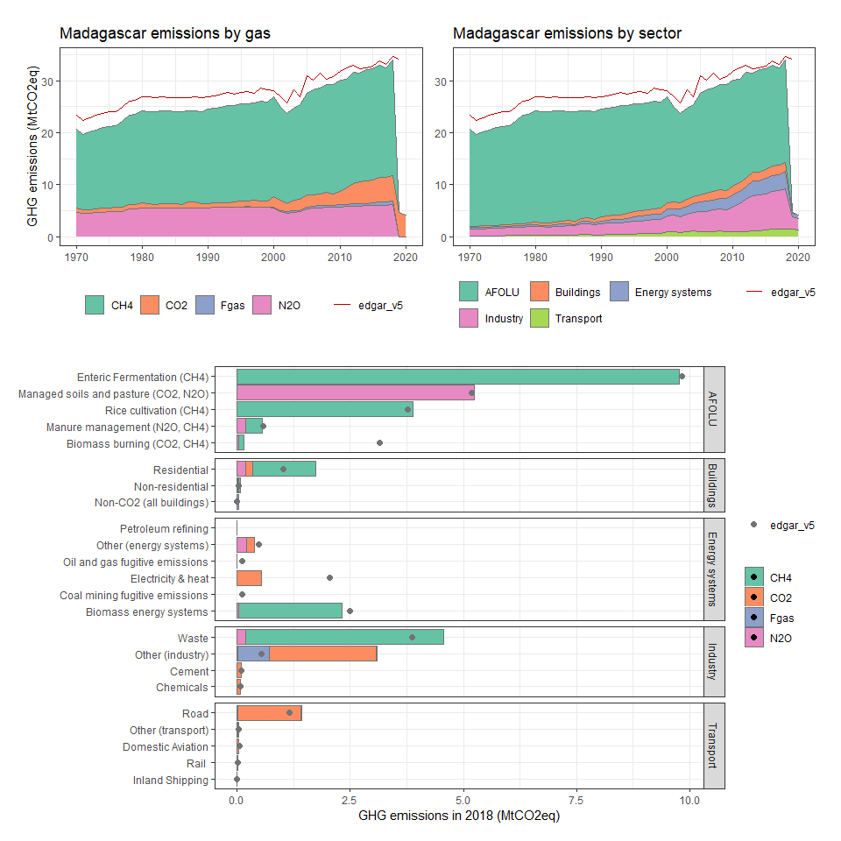

### Malawi

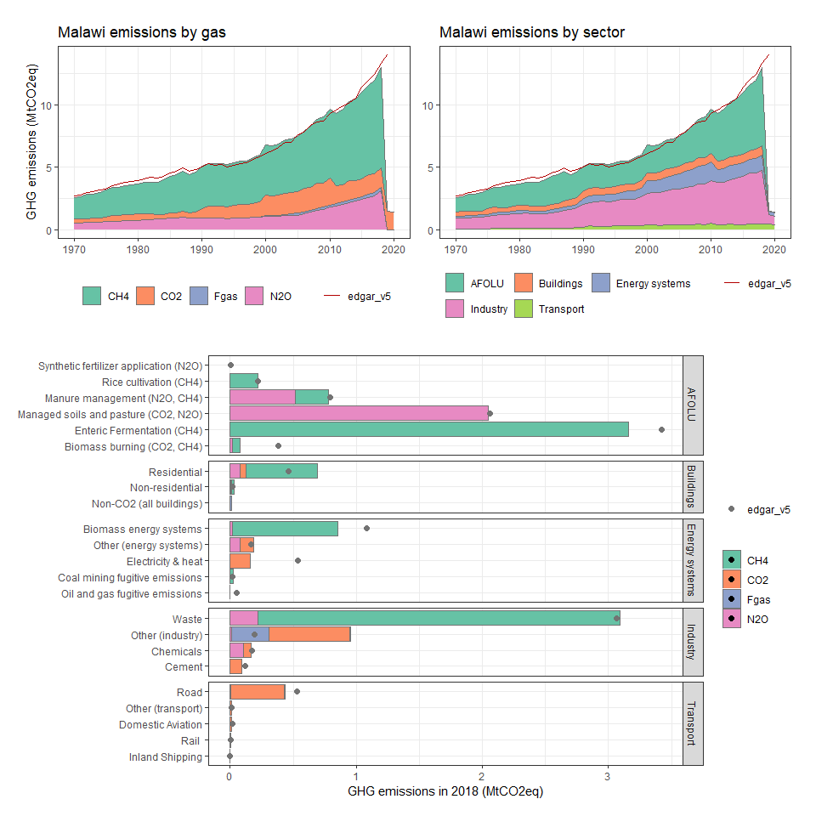

### Malaysia

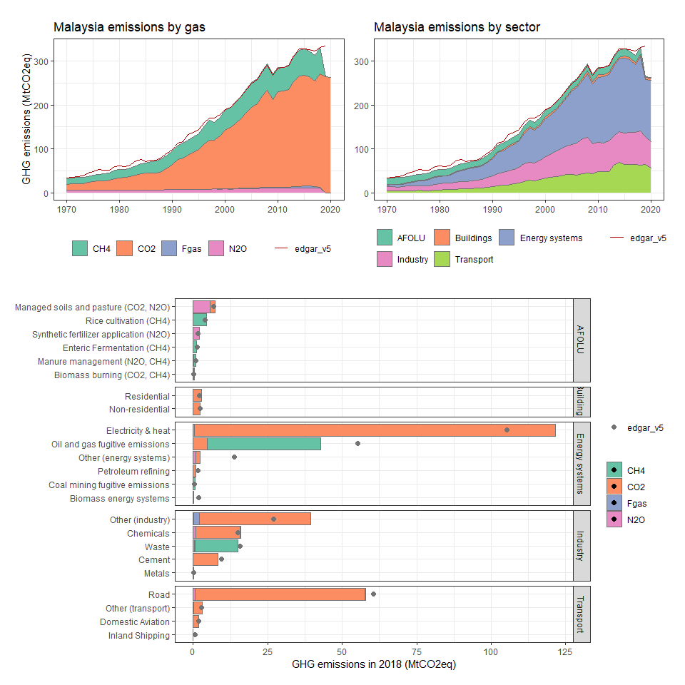

### Maldives

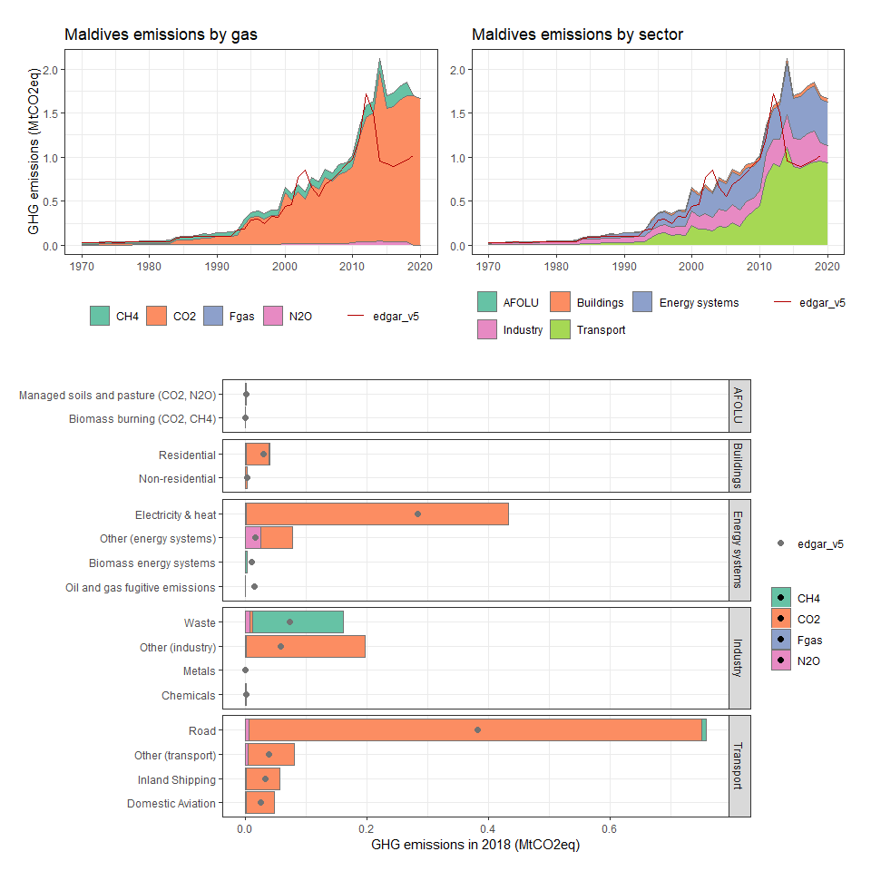

### Mali

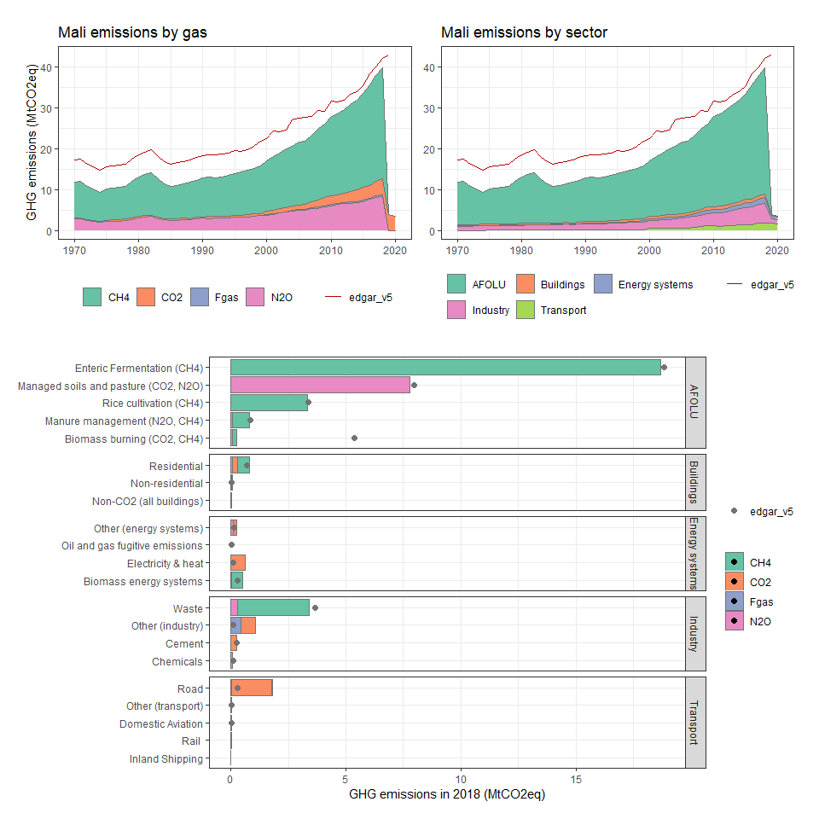

### Malta

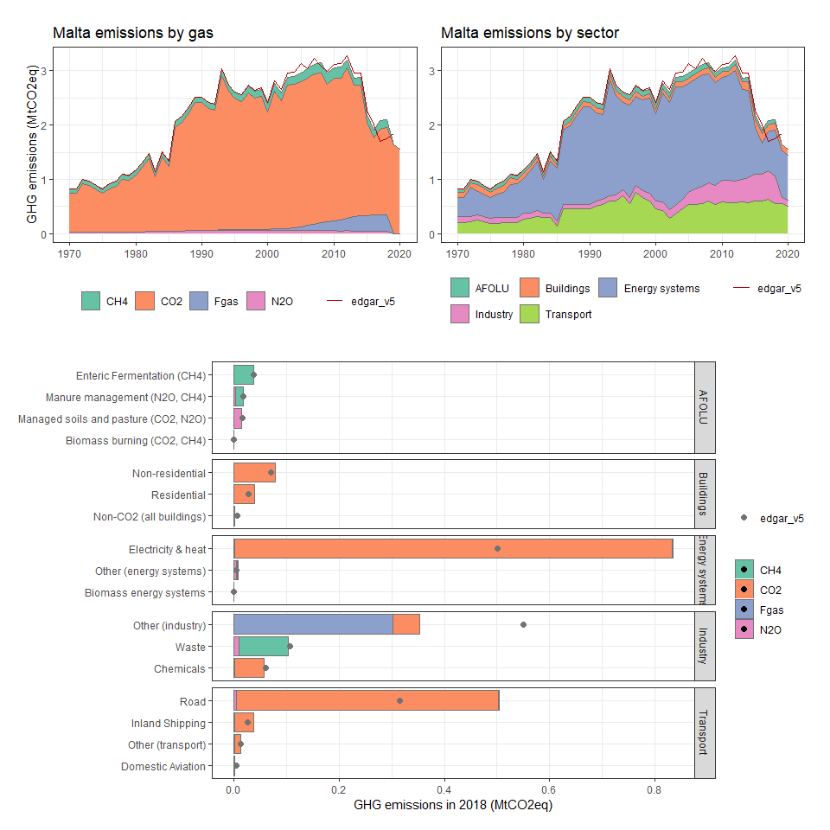

### Marshall Islands

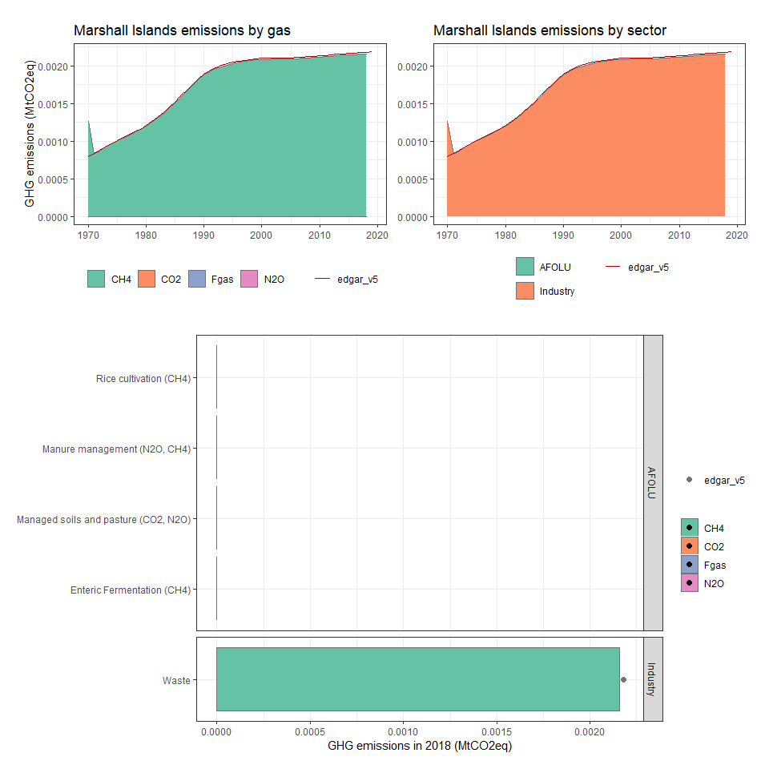

### Martinique

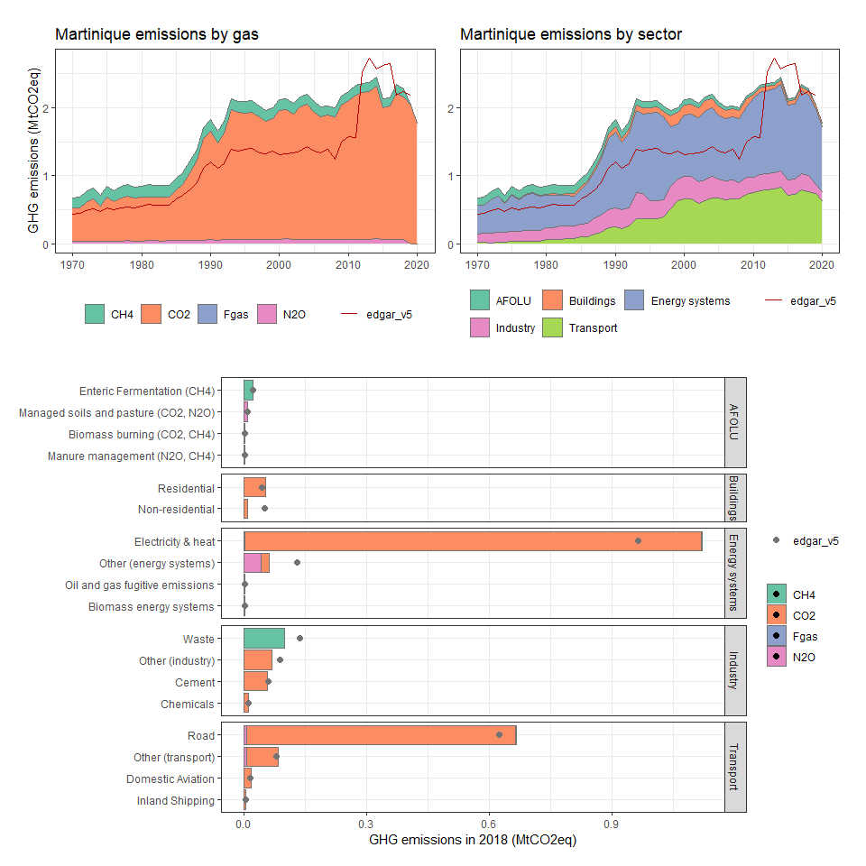

### Mauritania

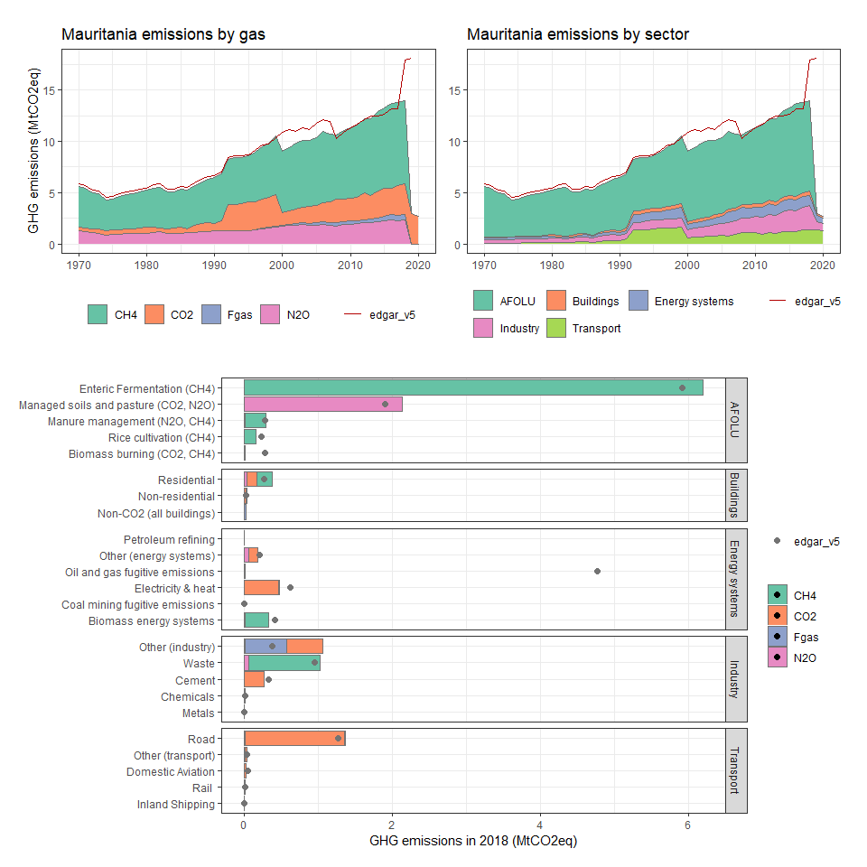

### Mauritius

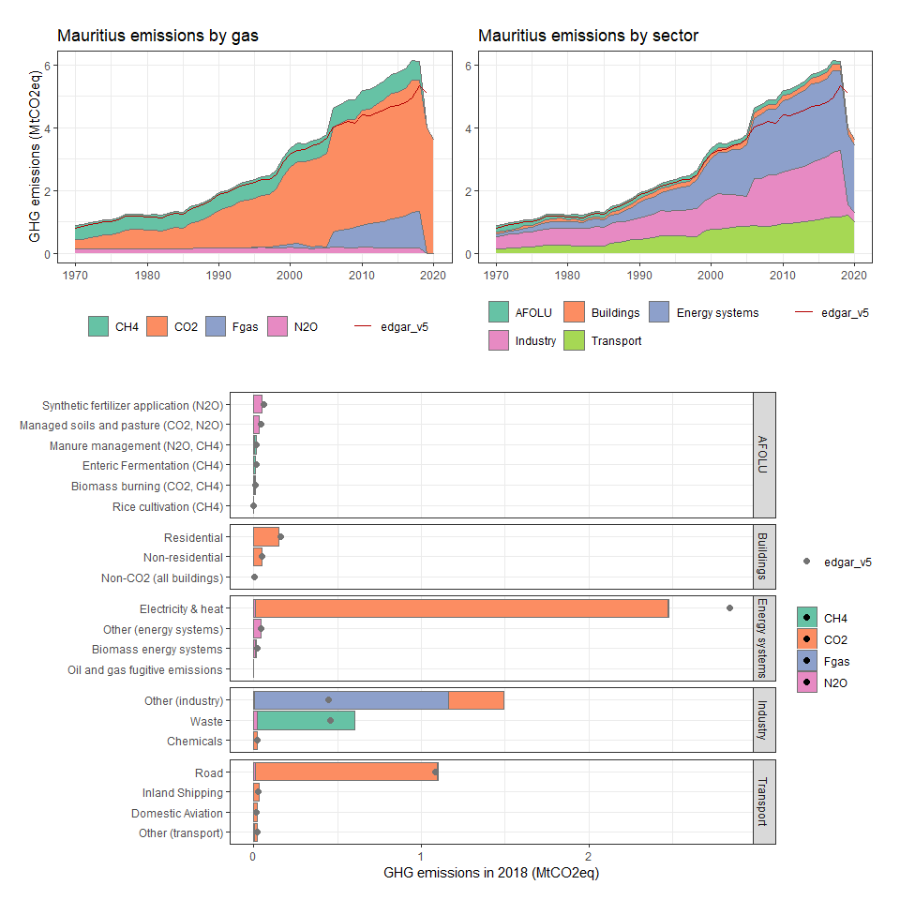

### Mayotte

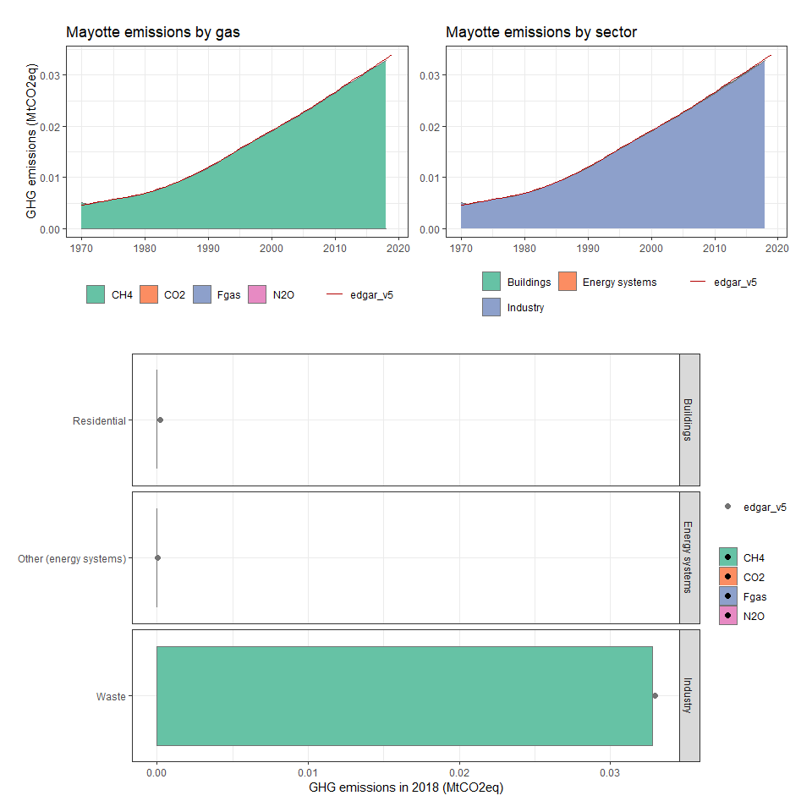

### Mexico

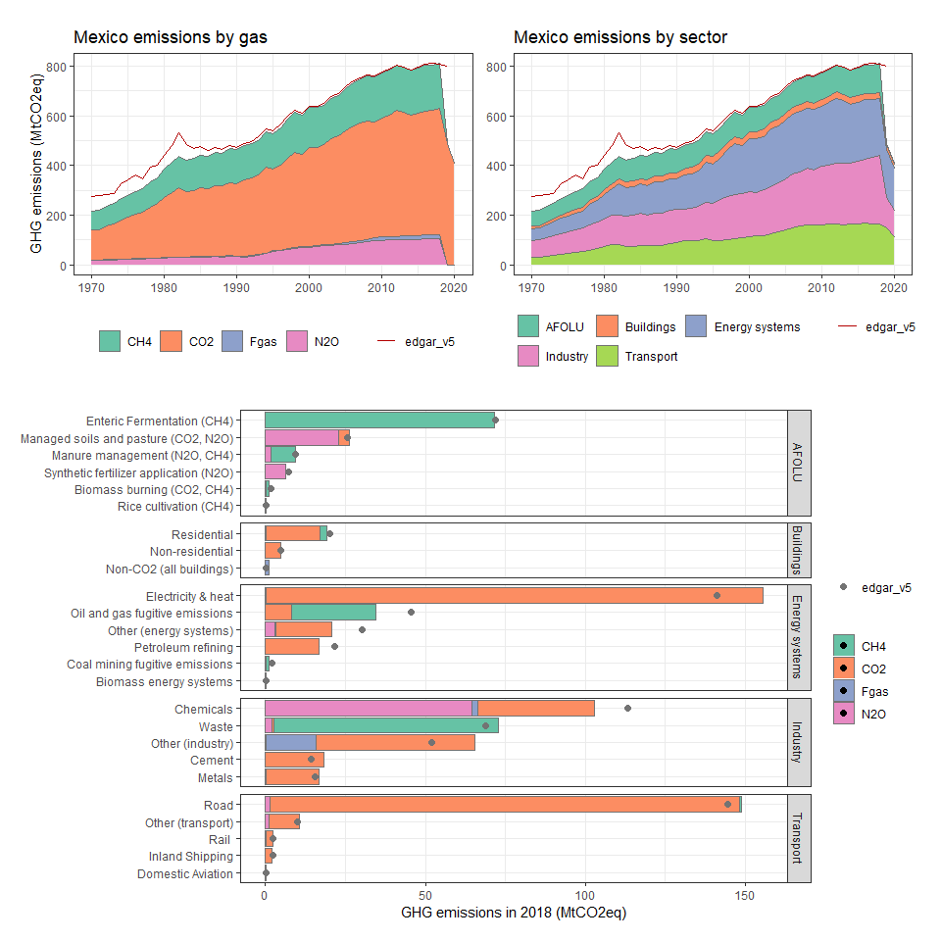

### Micronesia, Fed. Sts.

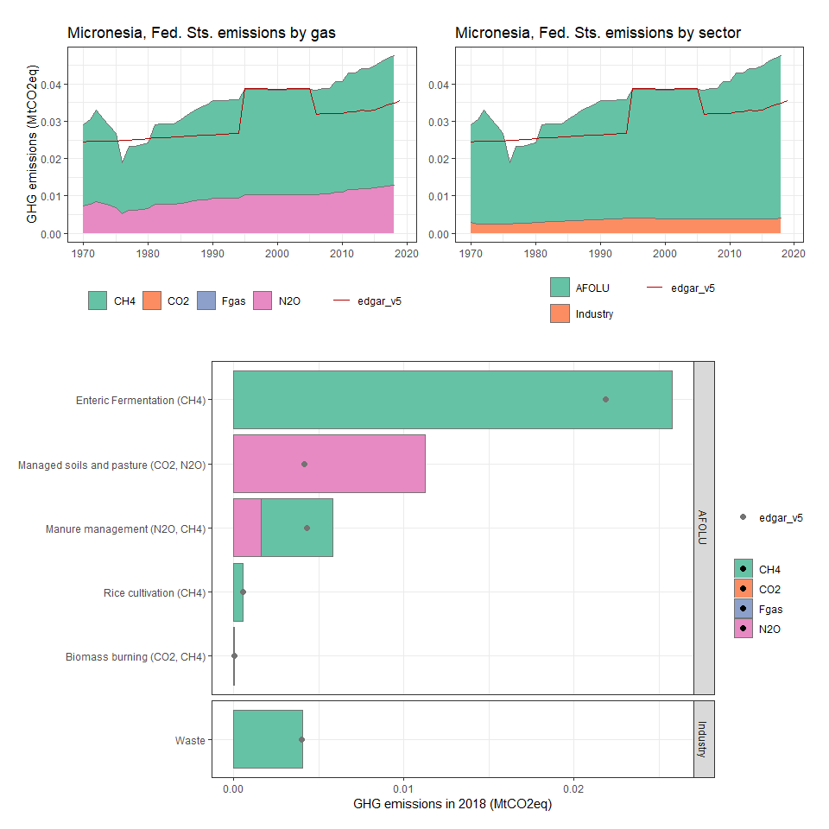

### Moldova

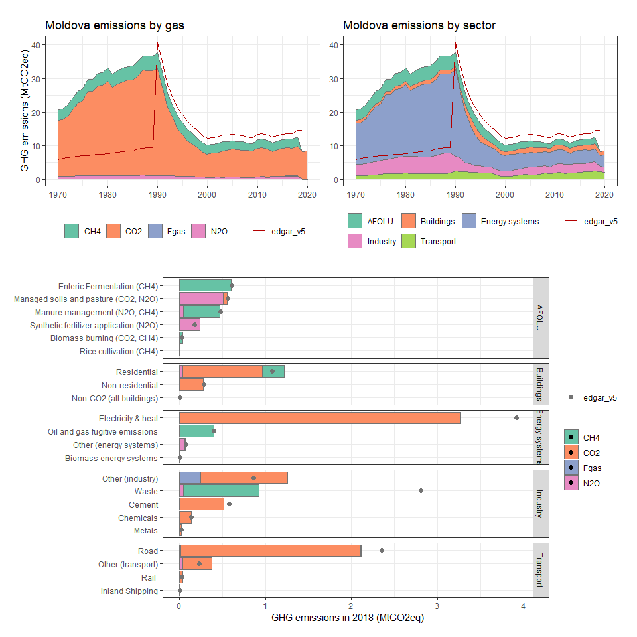

### Mongolia

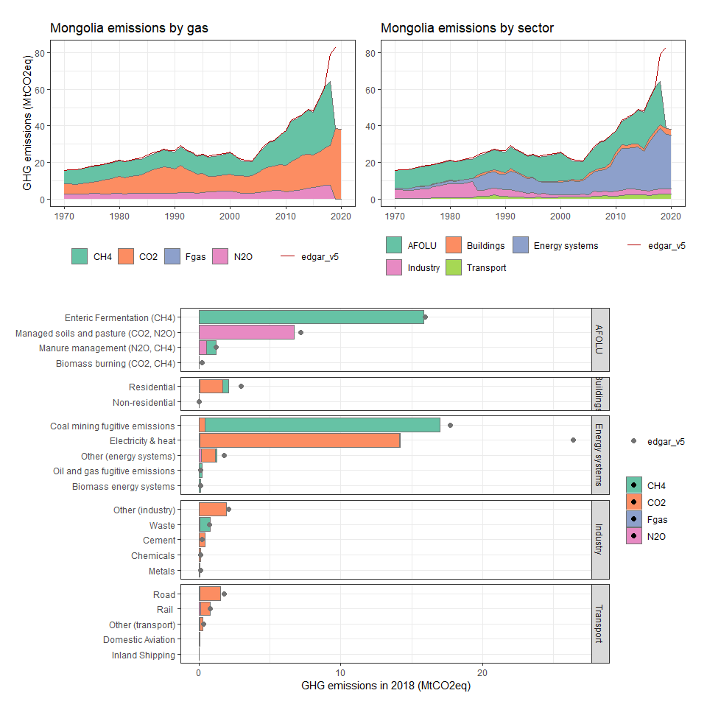

### Montserrat

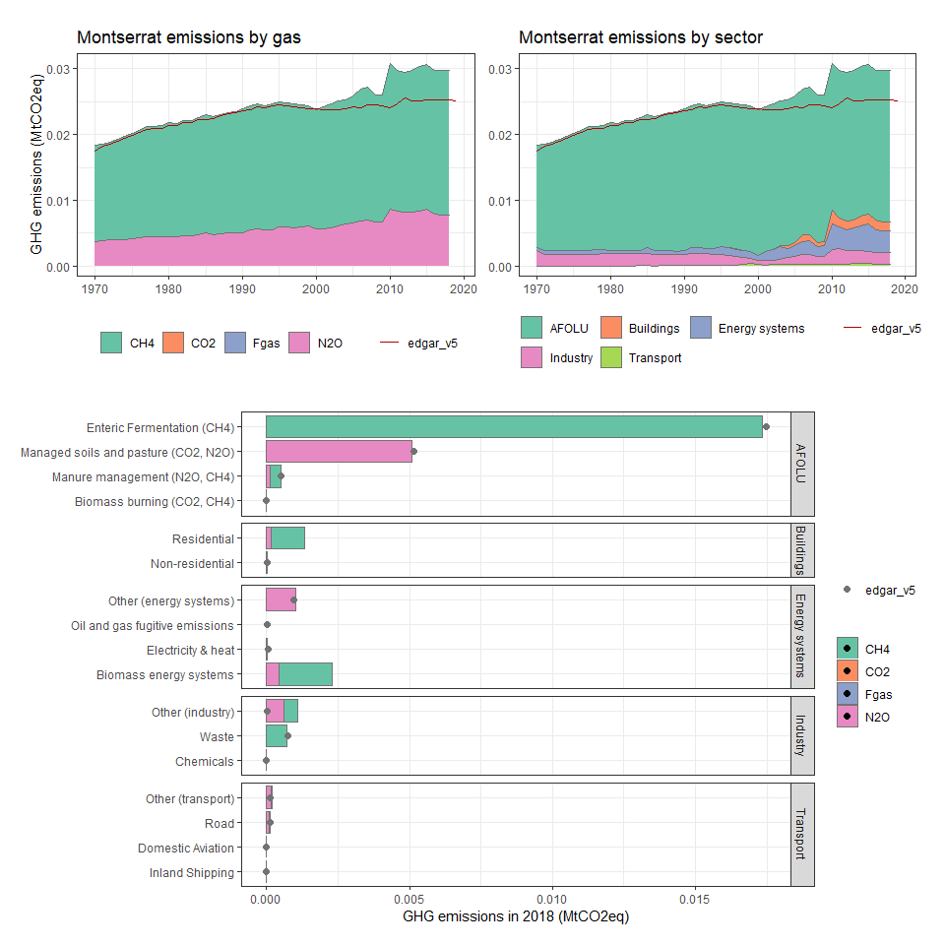

### Morocco

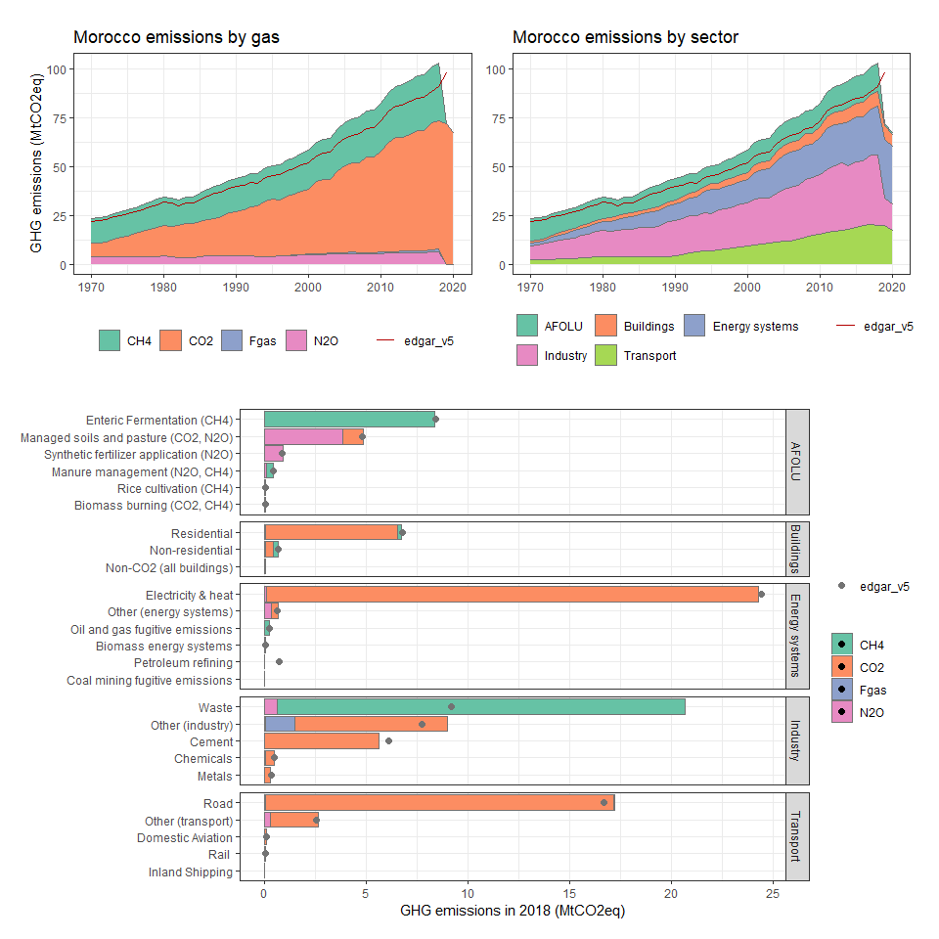

### Mozambique

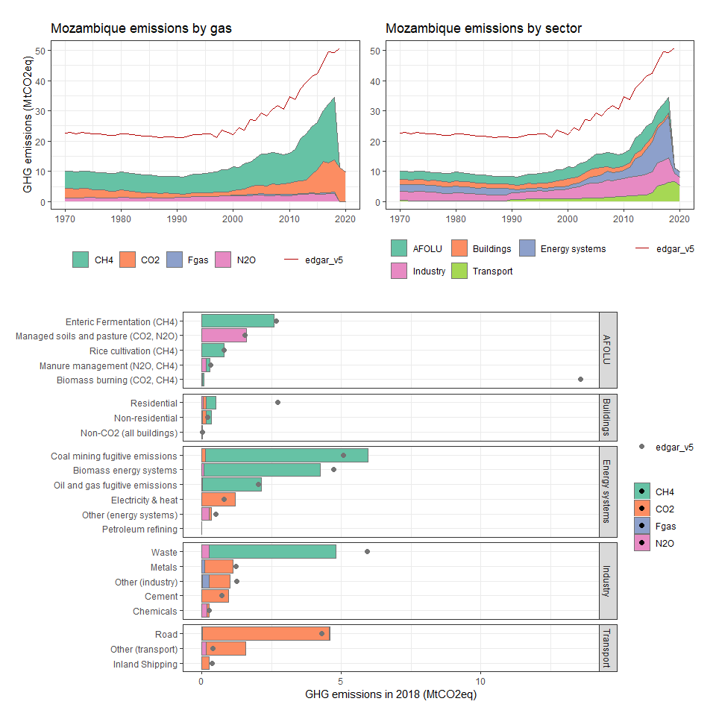

### Myanmar

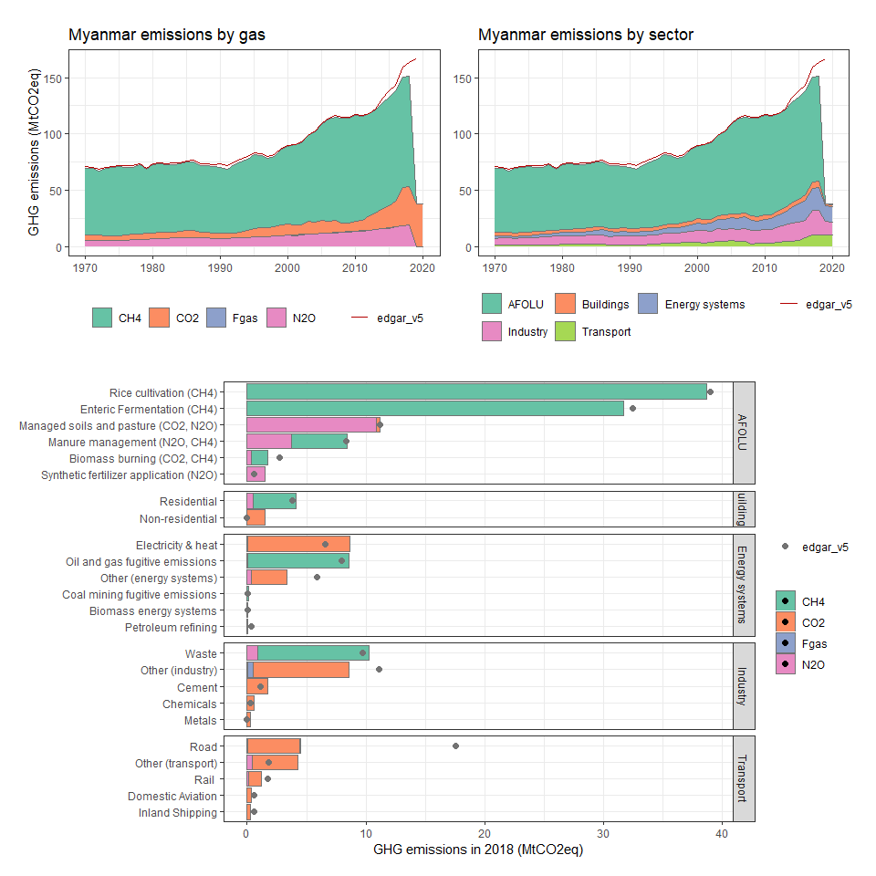

### Namibia

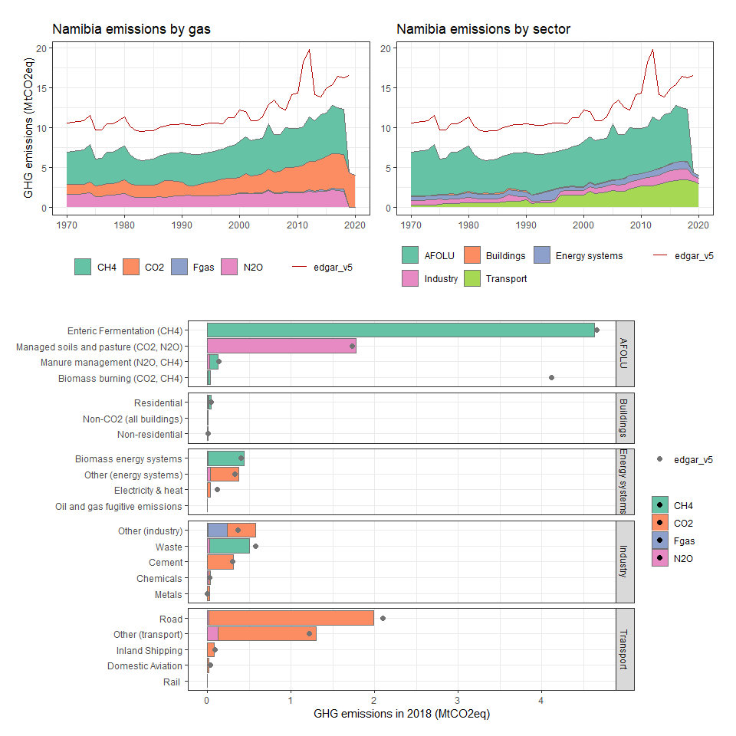

### Nauru

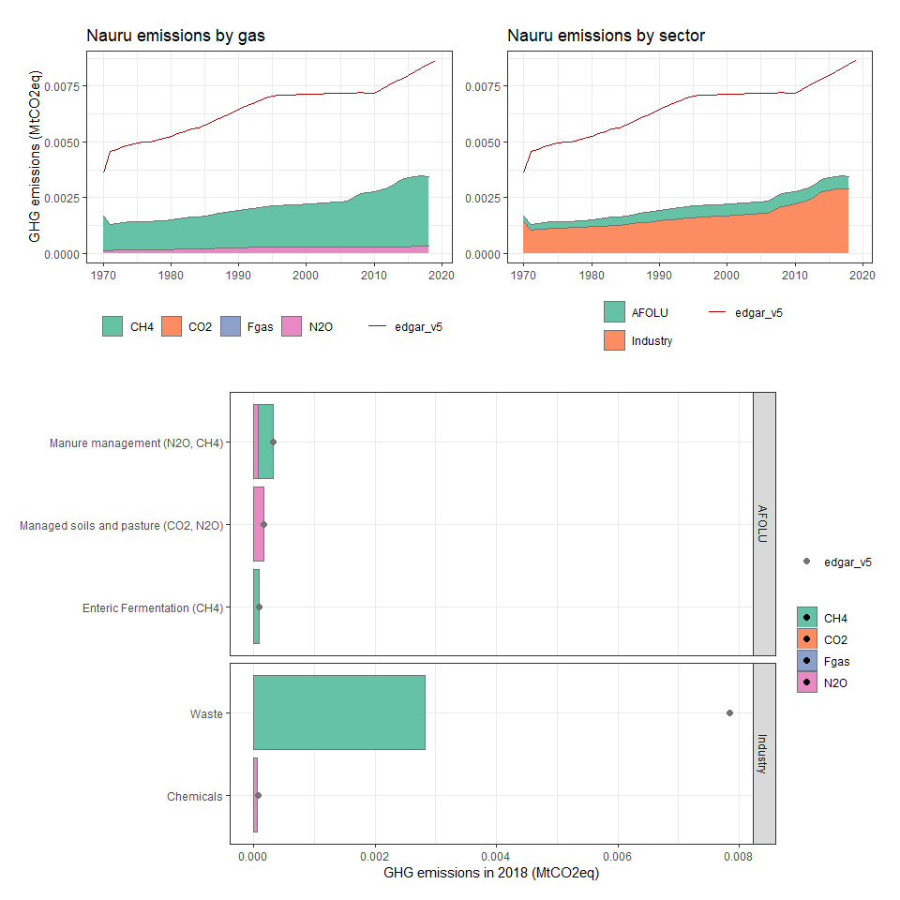

### Nepal

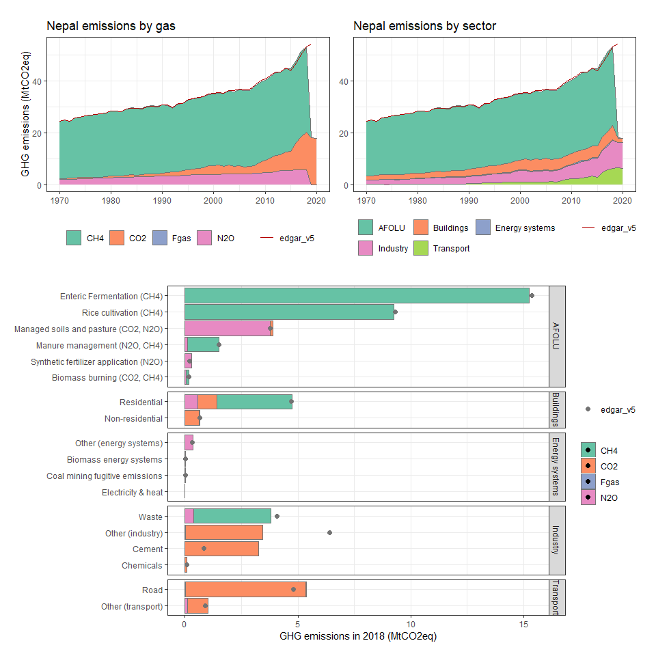

### Netherlands

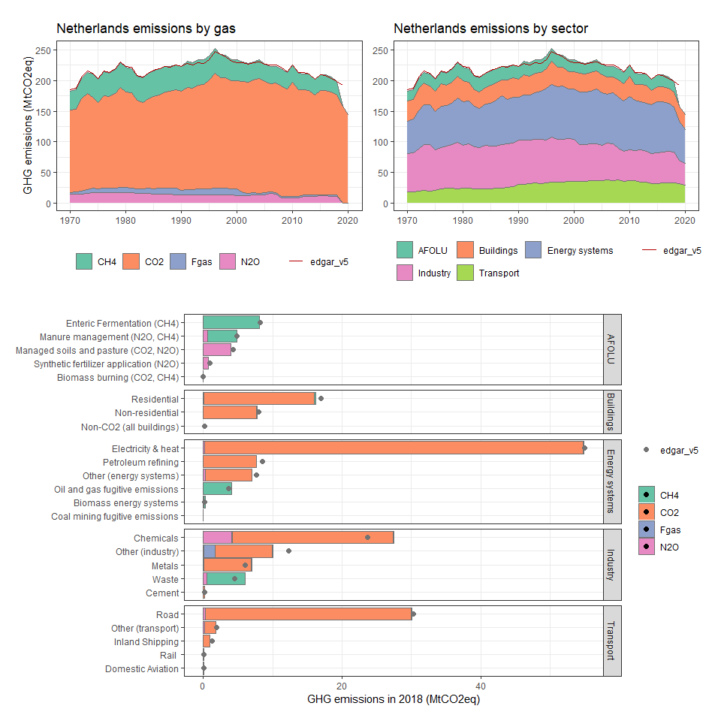

### Netherlands Antilles

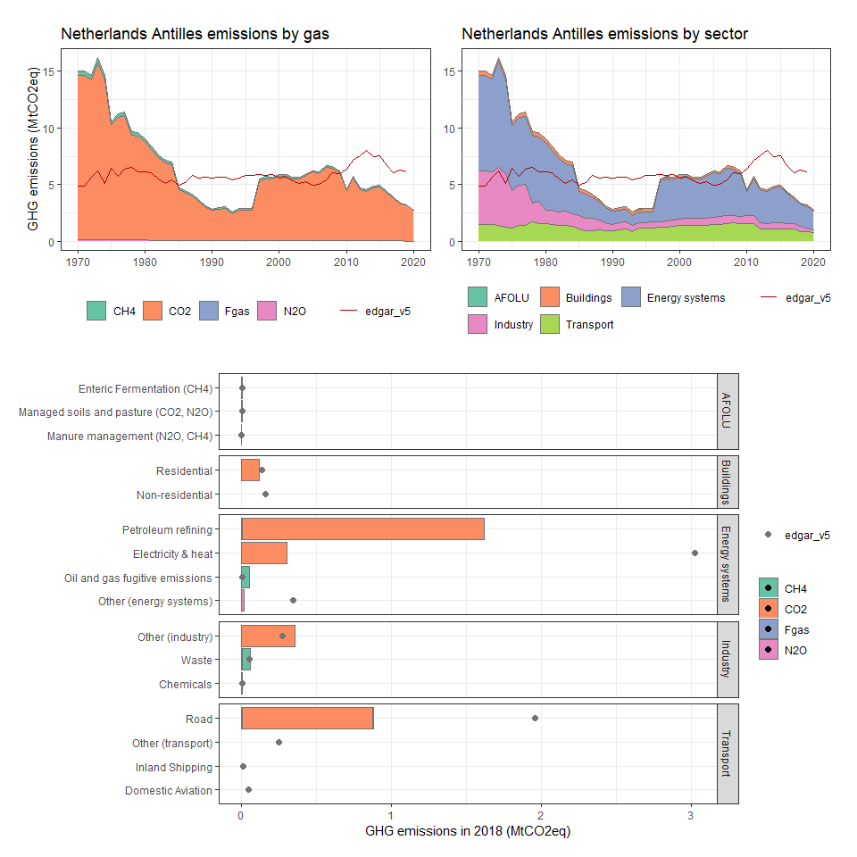

### New Caledonia

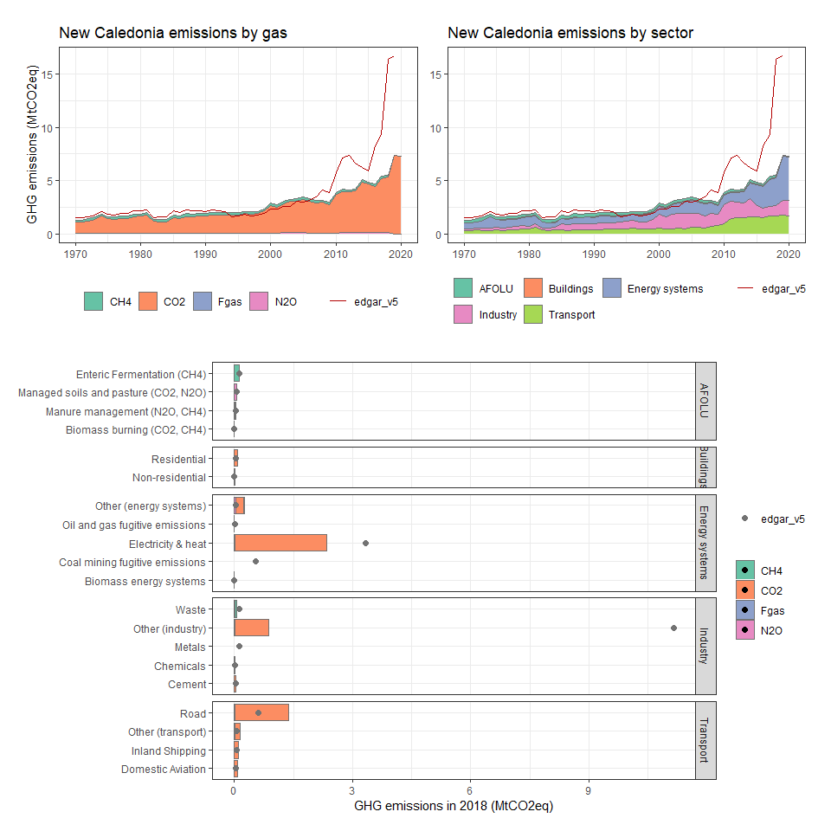

### New Zealand

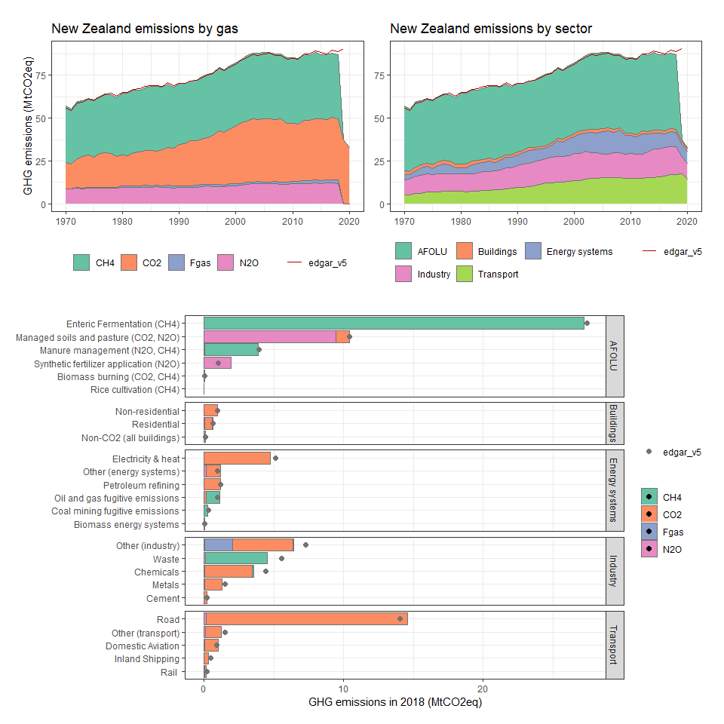

### Nicaragua

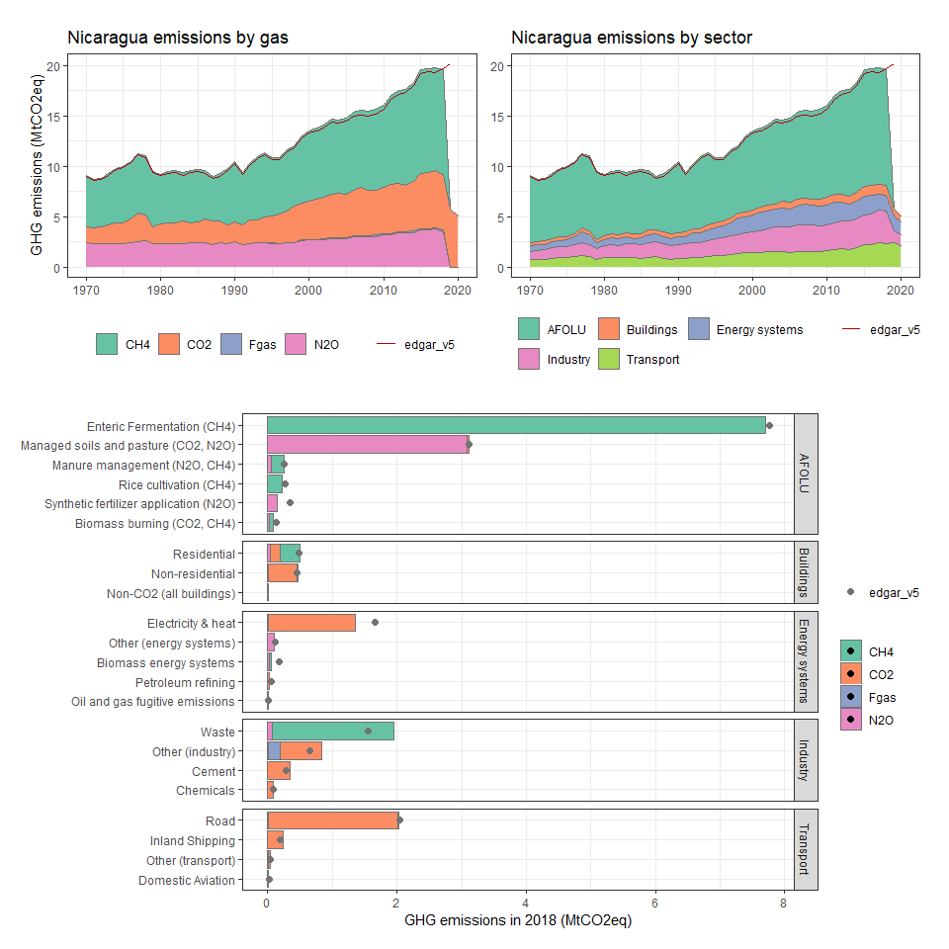

### Niger

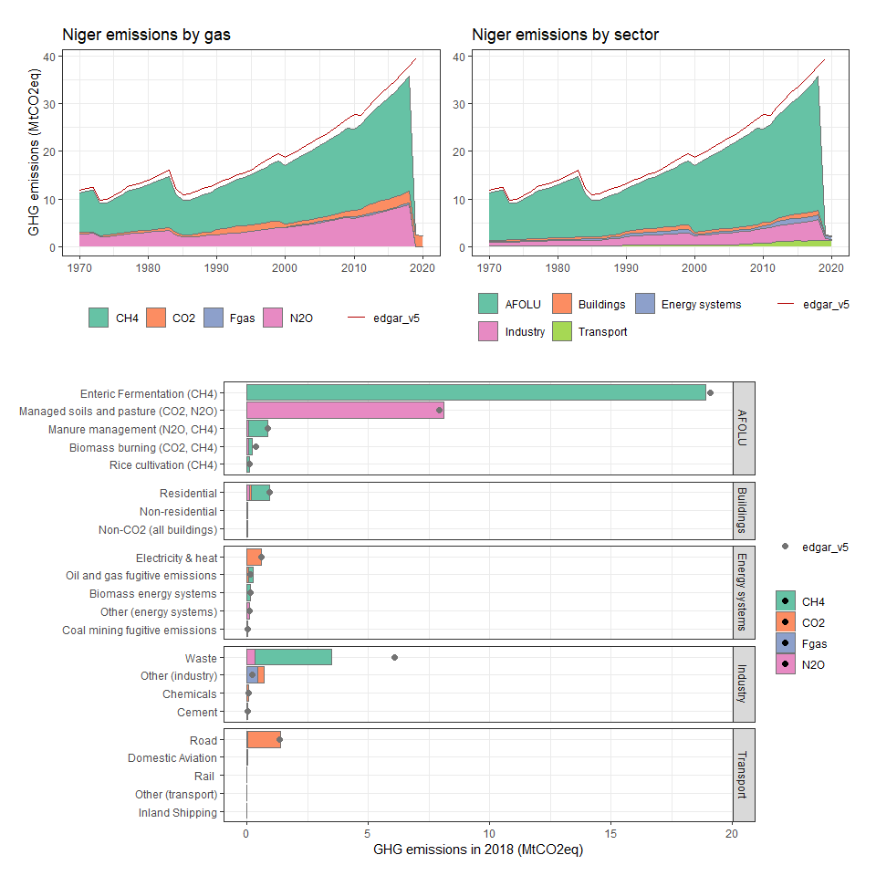

### Nigeria

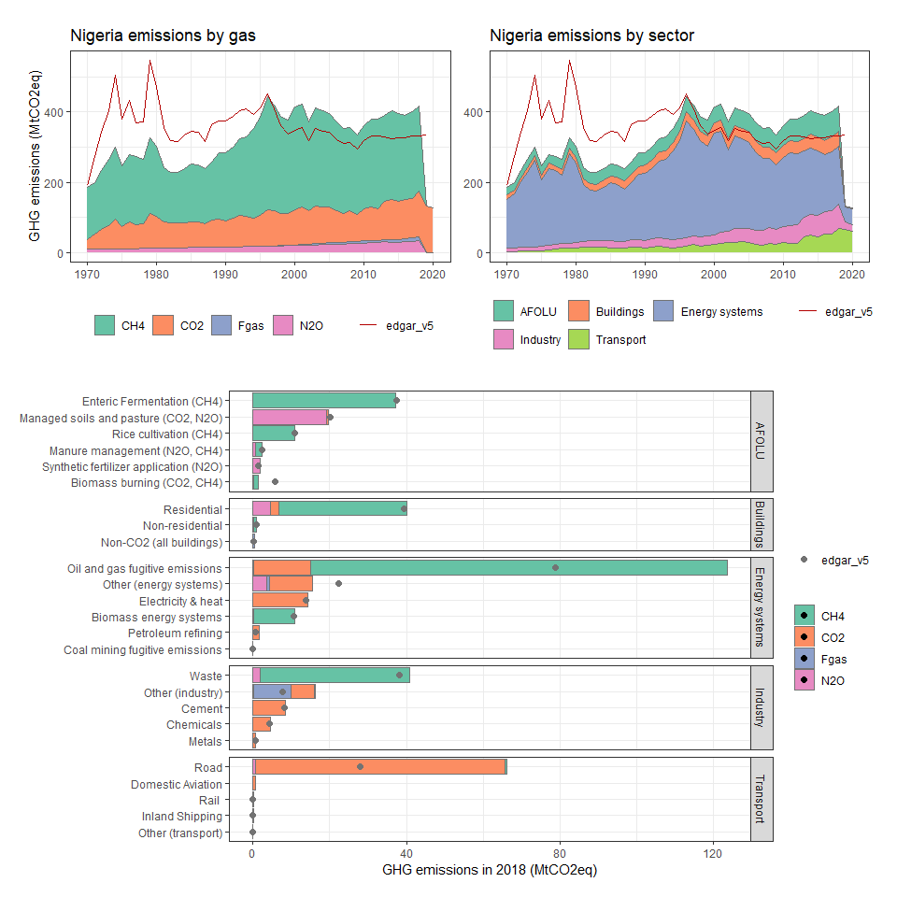

### Niue

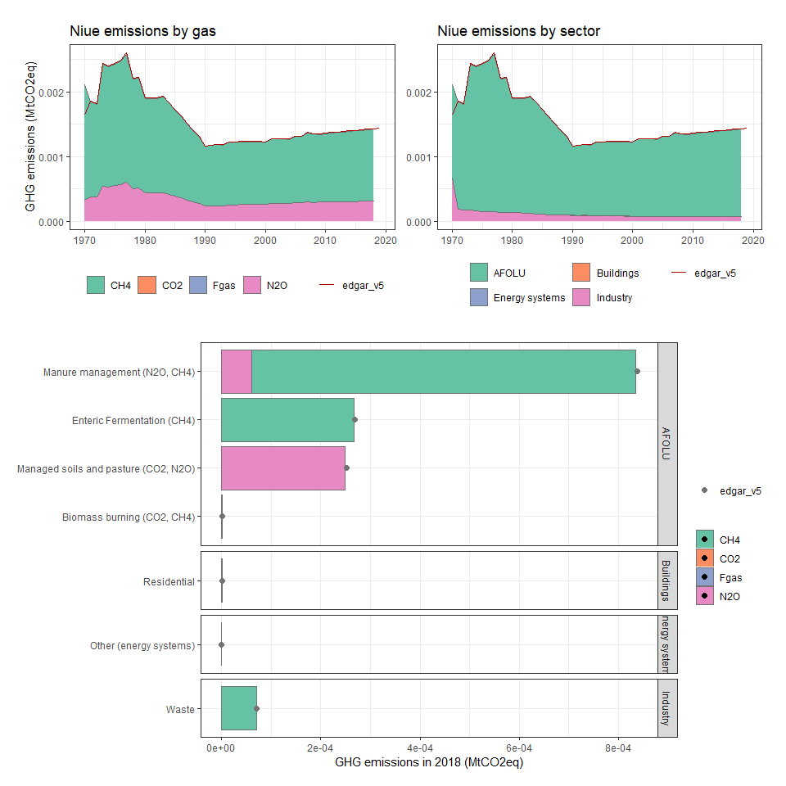

### Norfolk Island

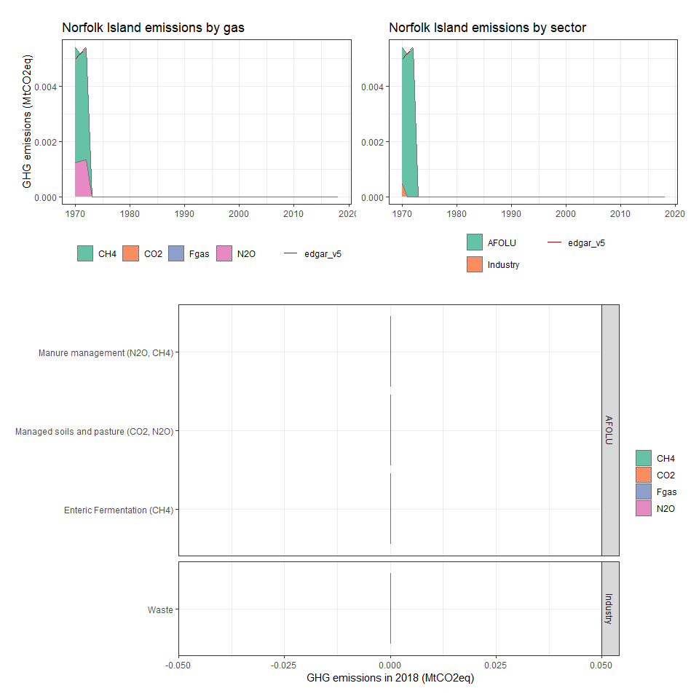

### Northern Mariana Islands

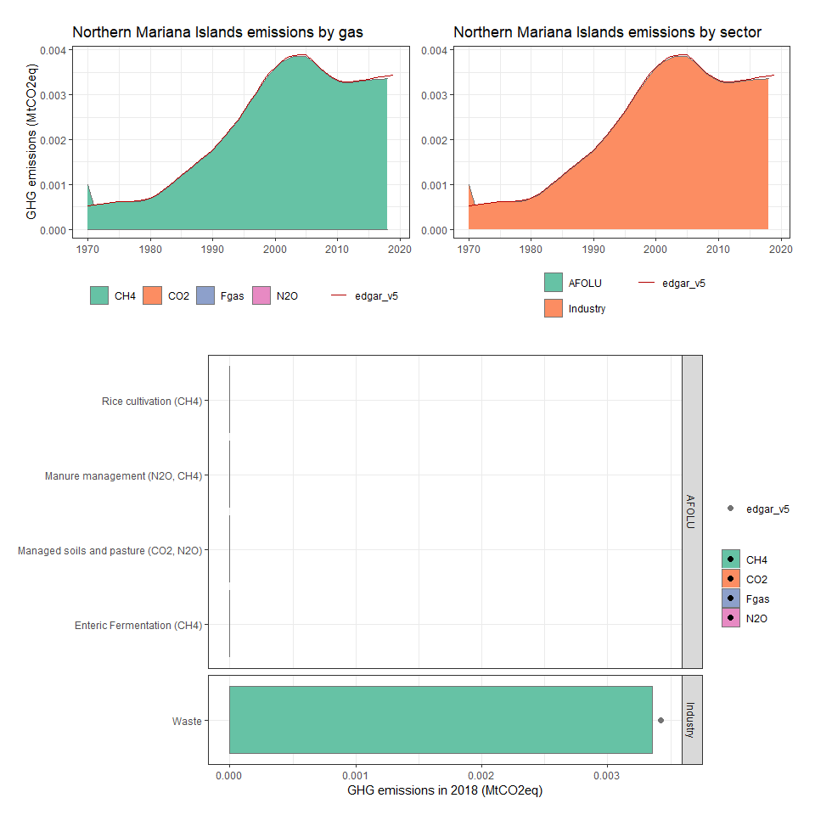

### Norway

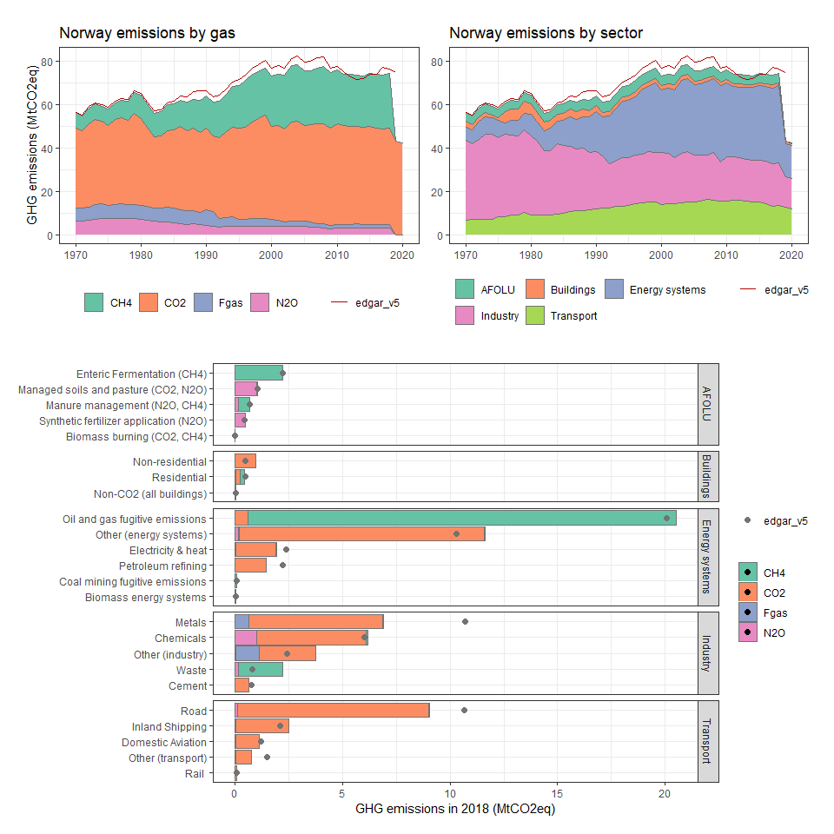

### Oman

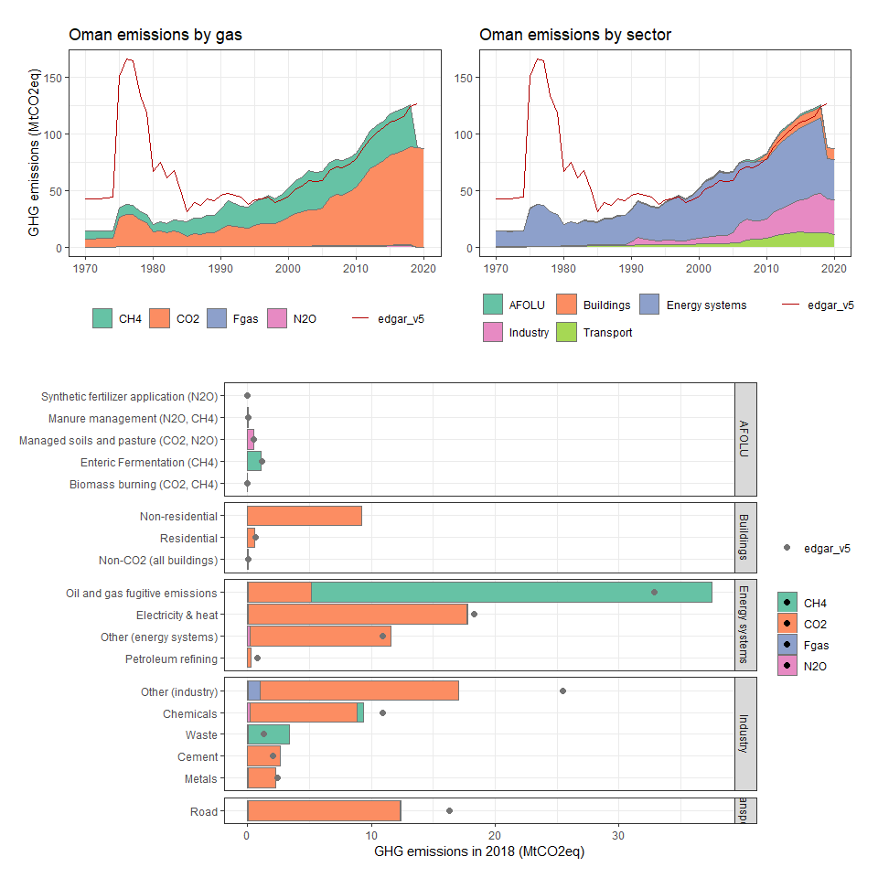

### Pakistan

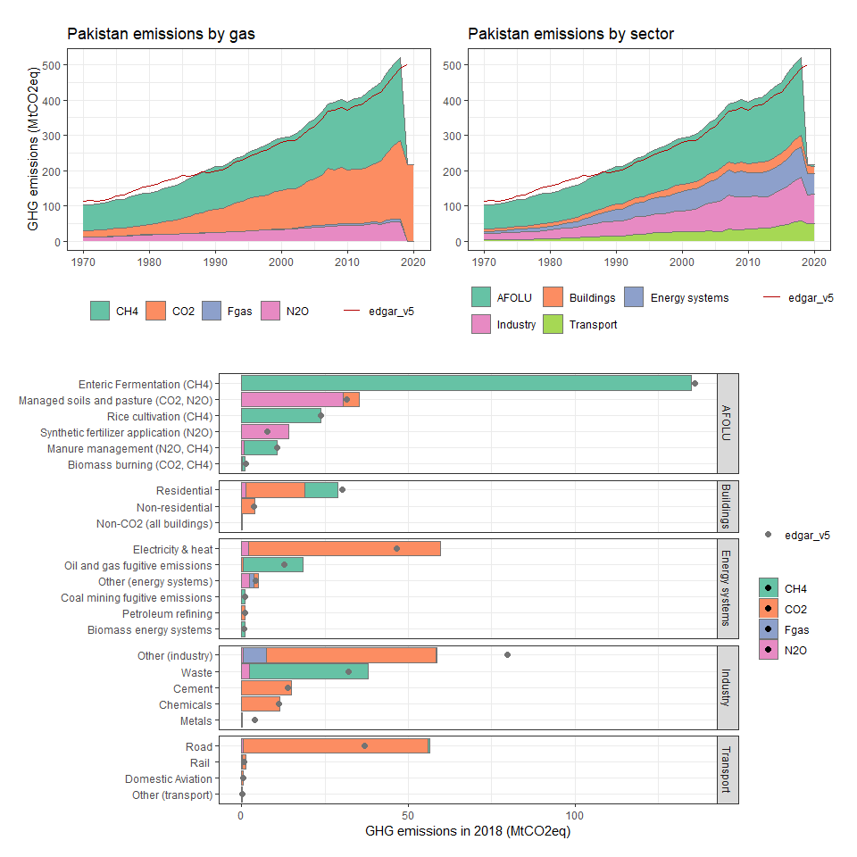

### Palau

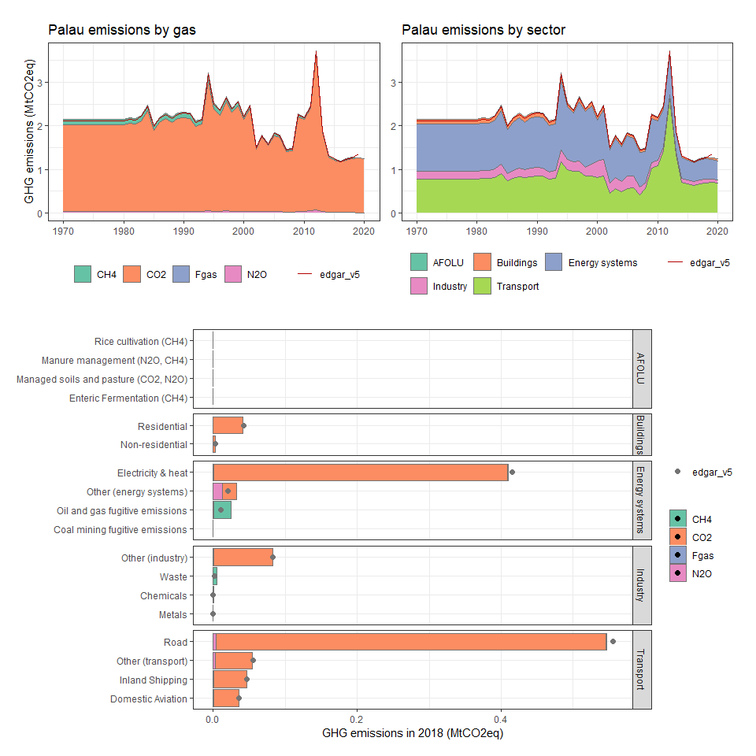

### Panama

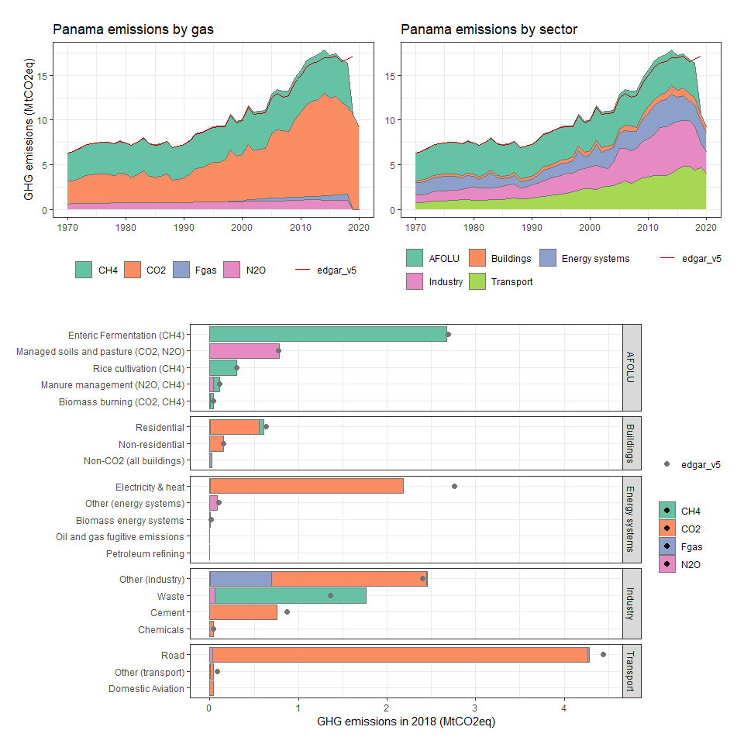

### Papua New Guinea

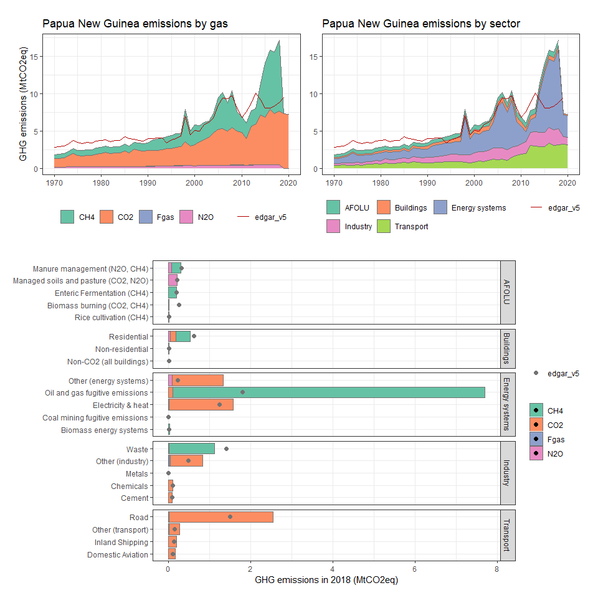

### Paraguay

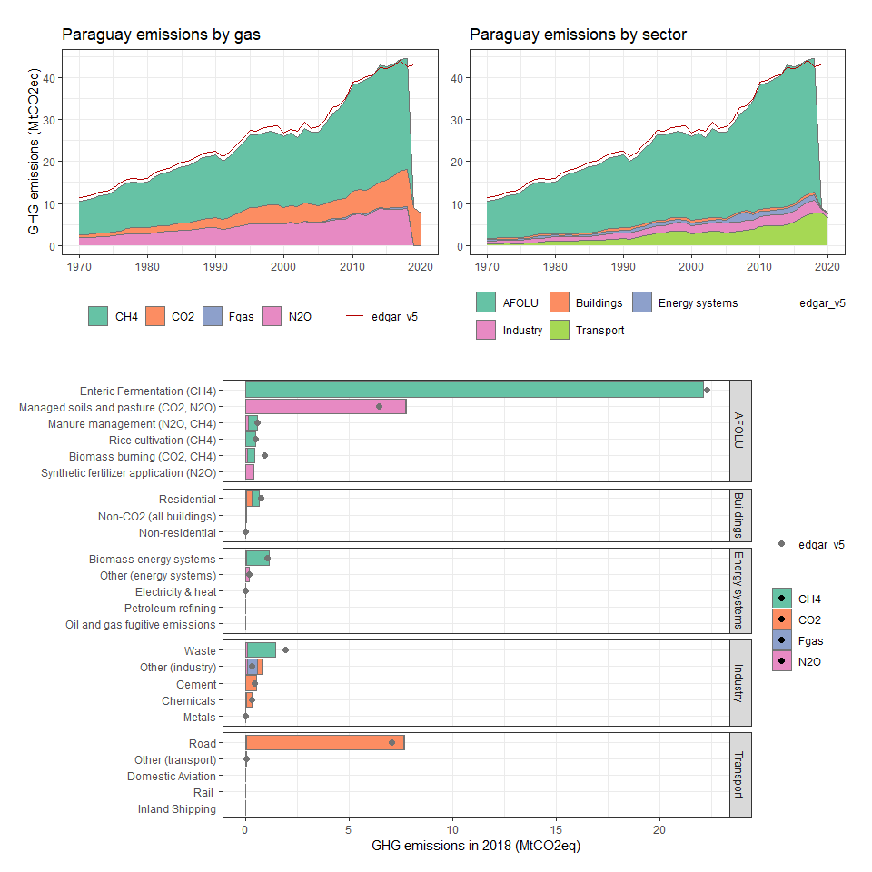

### Peru

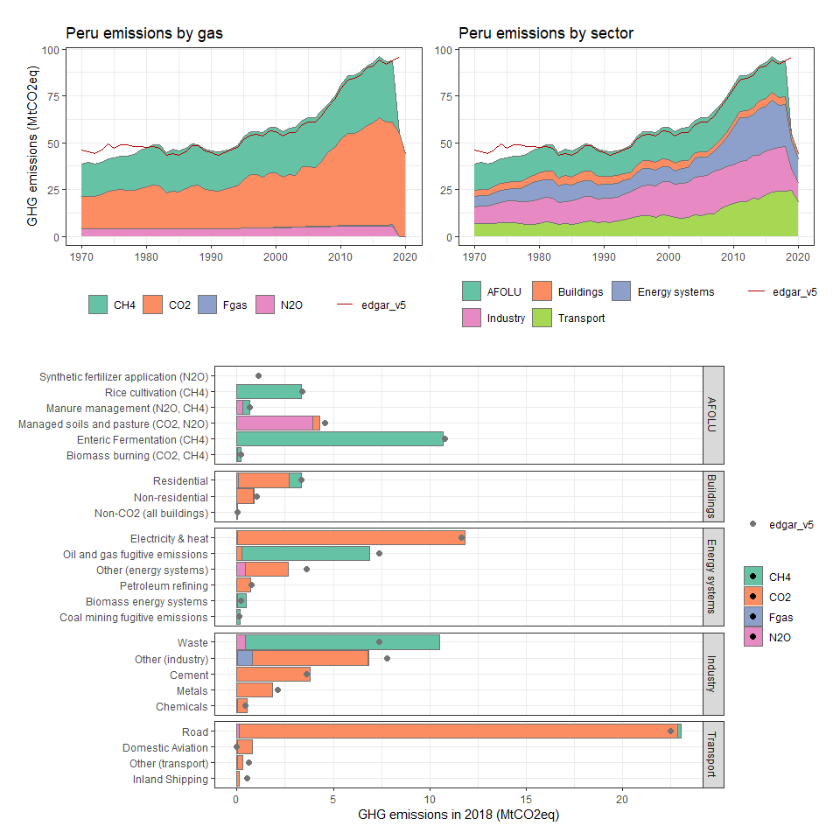

### Philippines

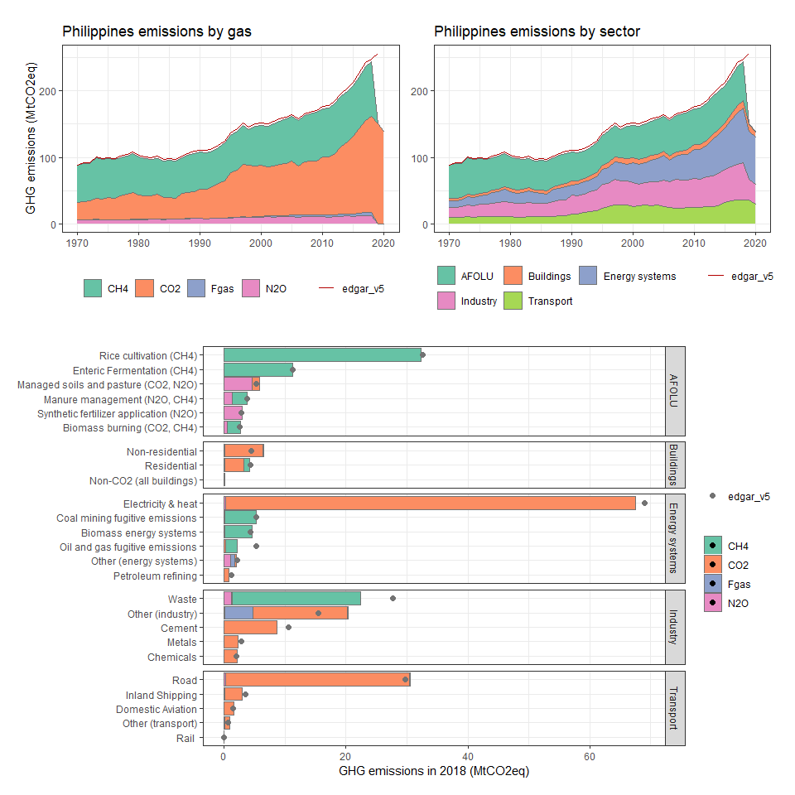

### Pitcairn

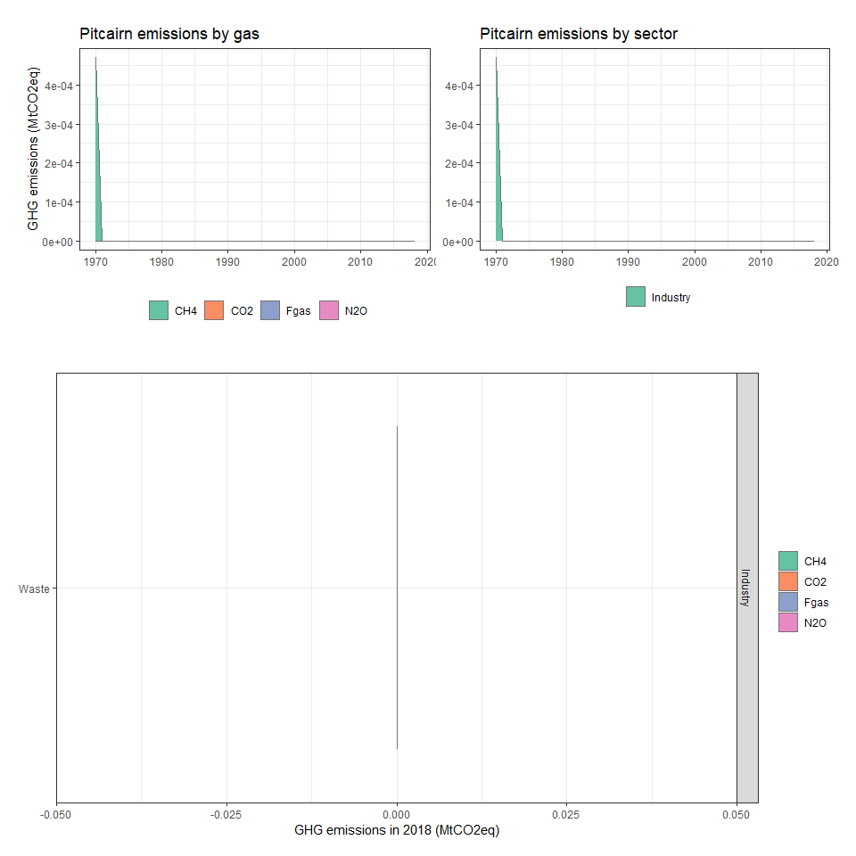

### Poland

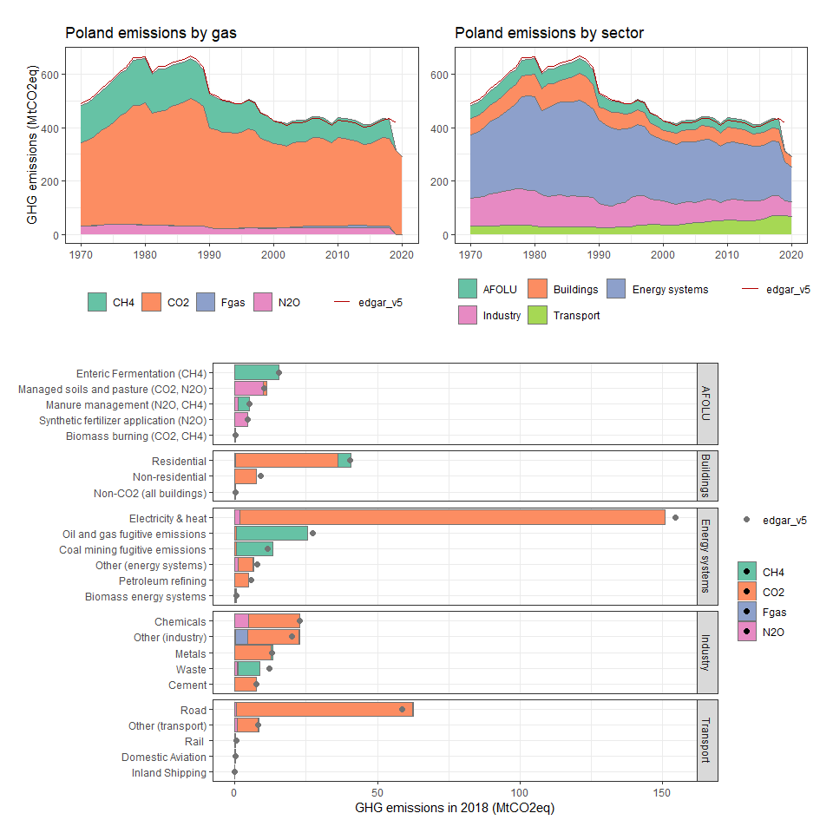

### Portugal

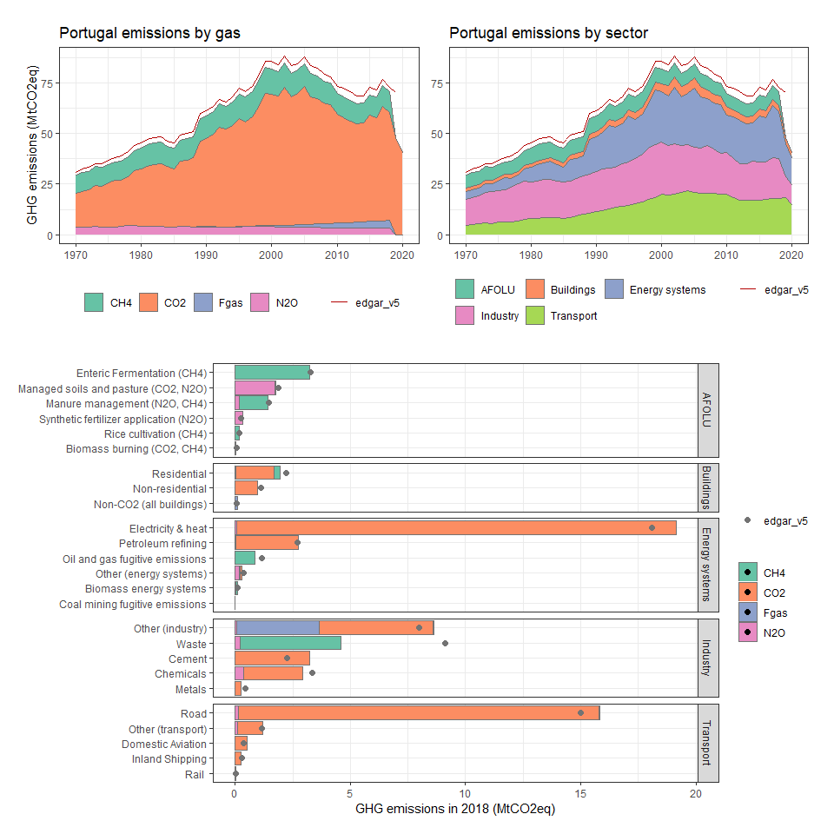

### Puerto Rico

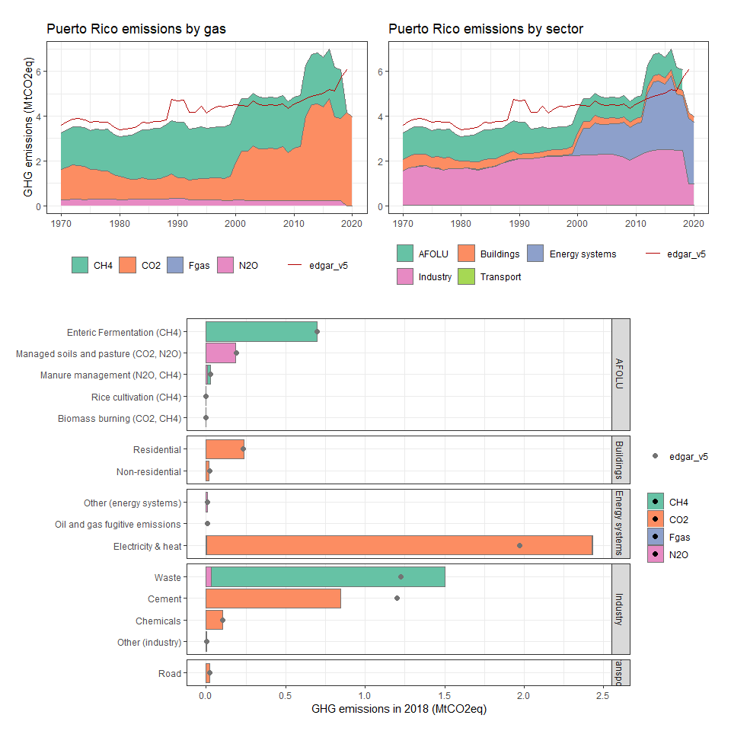

### Qatar

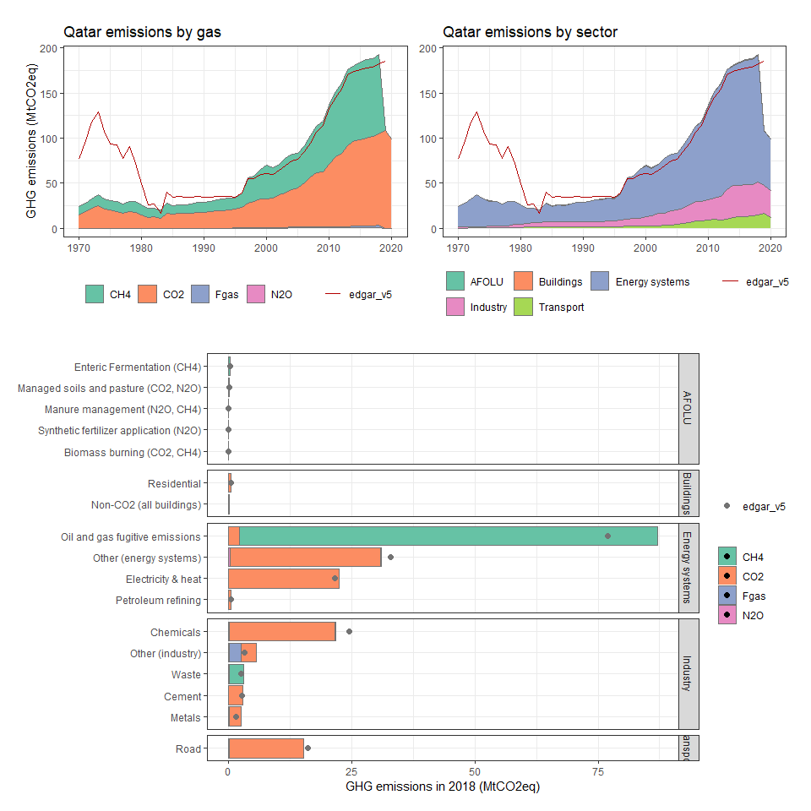

### Réunion

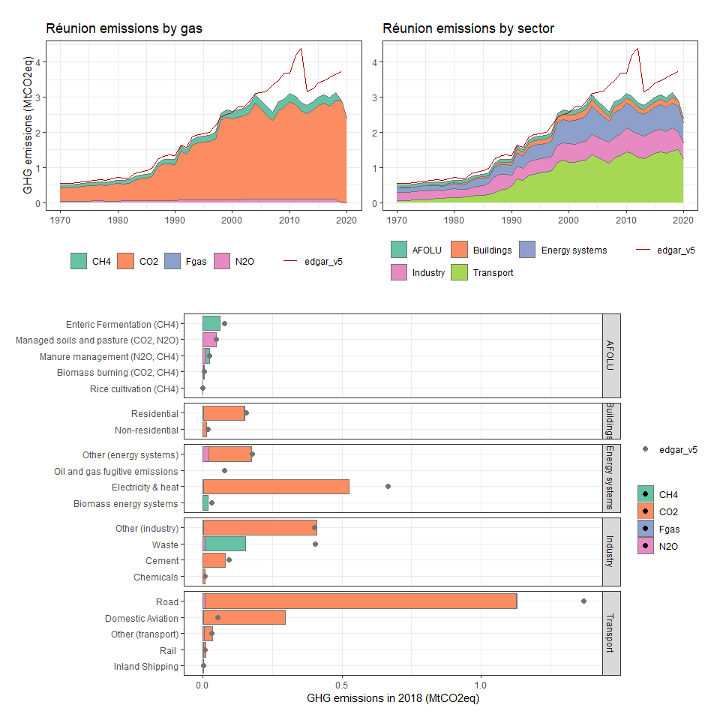

### Romania

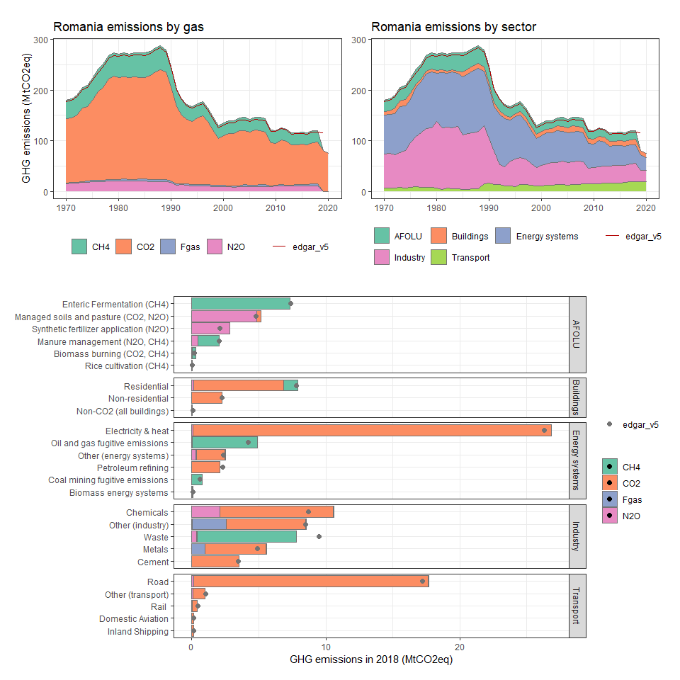

### Russian Federation

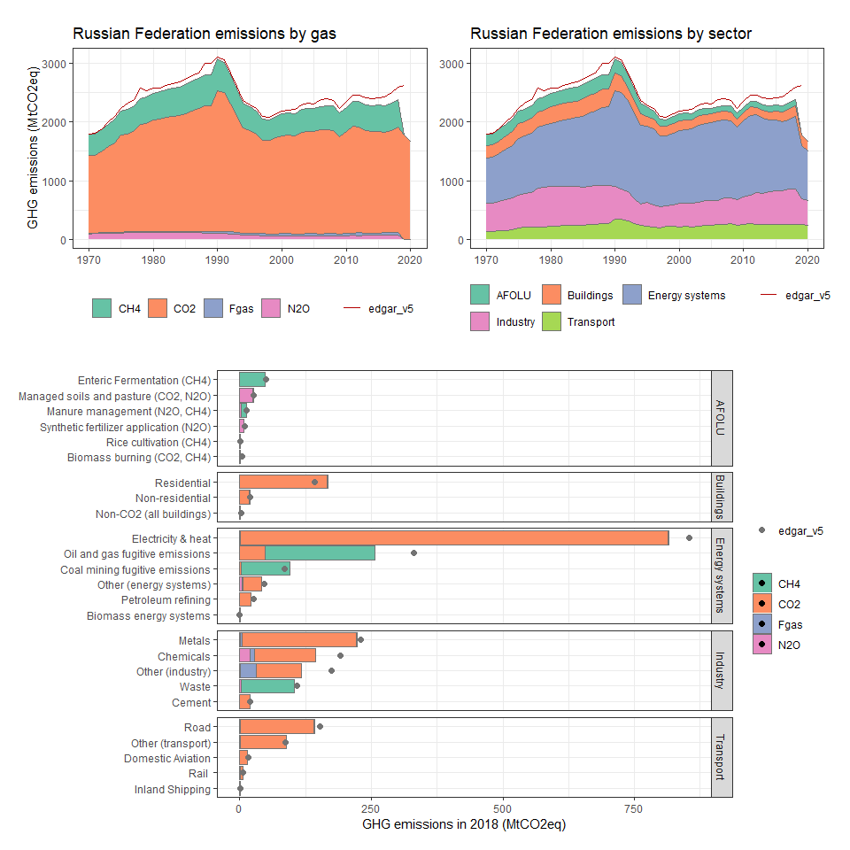

### Rwanda

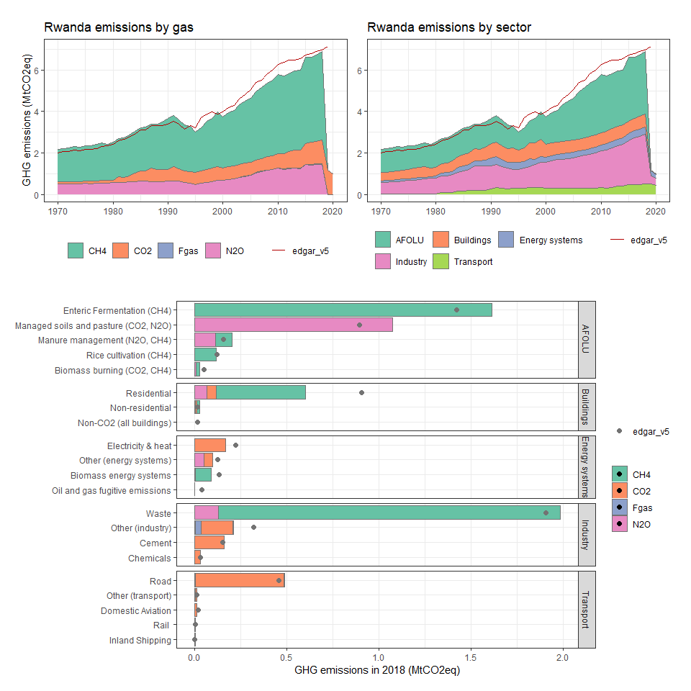

### Saint Helena, Ascension and Tristan da Cunha

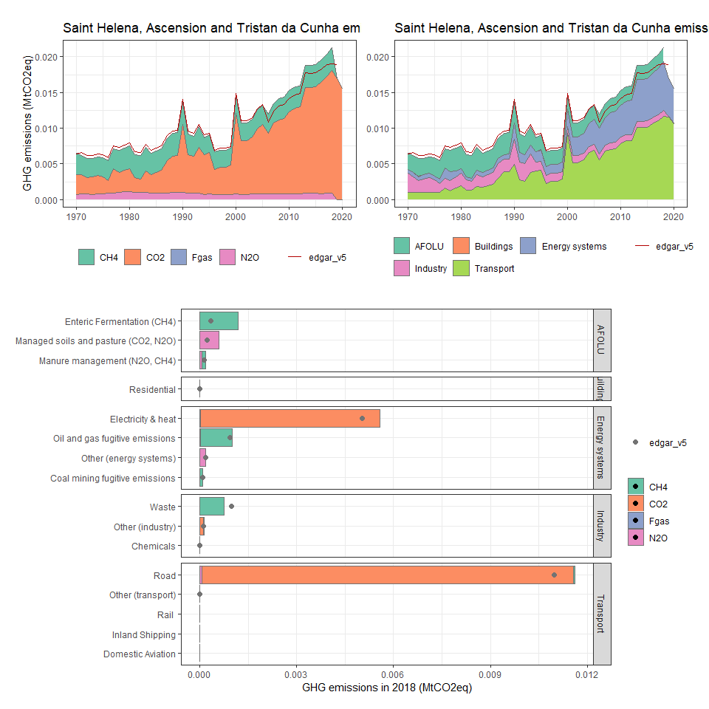

### Saint Pierre and Miquelon

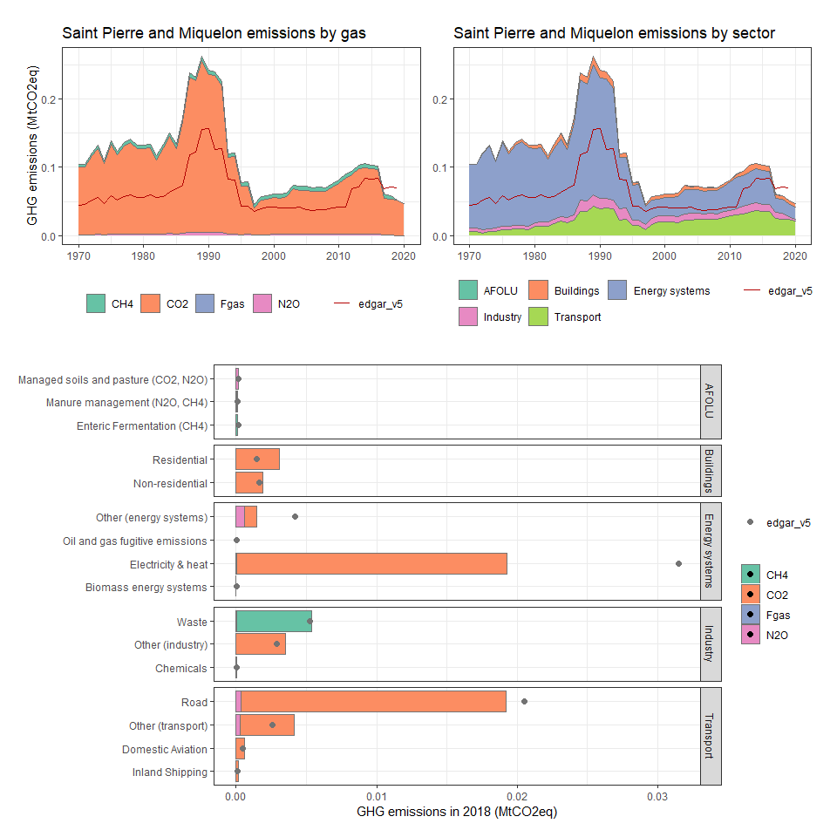

### Samoa

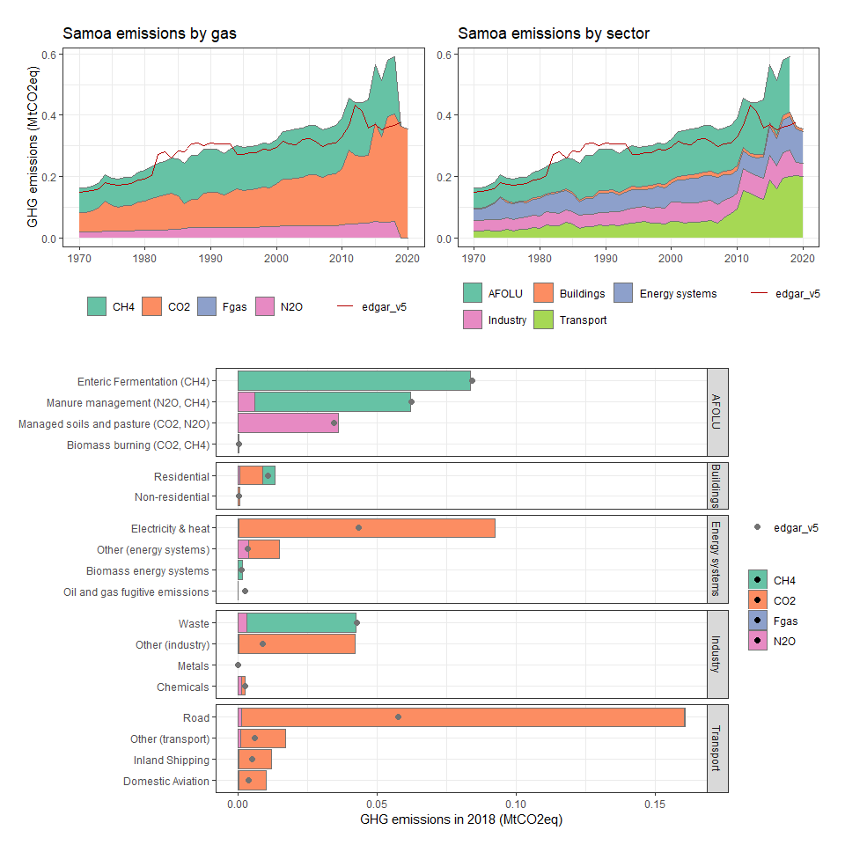

### São Tomé and Principe

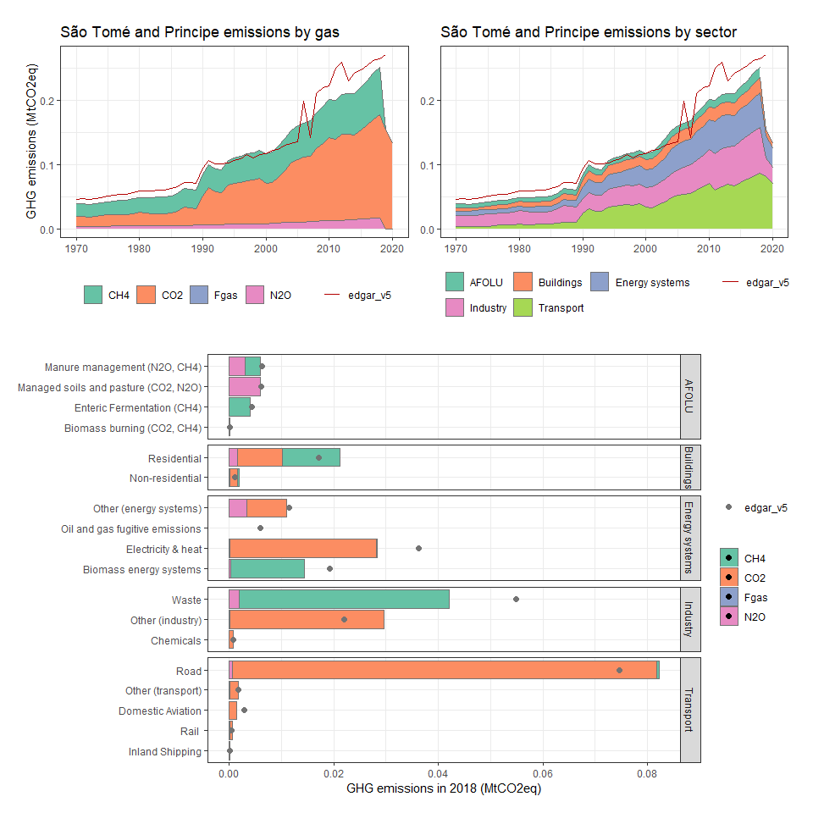

### Saudi Arabia

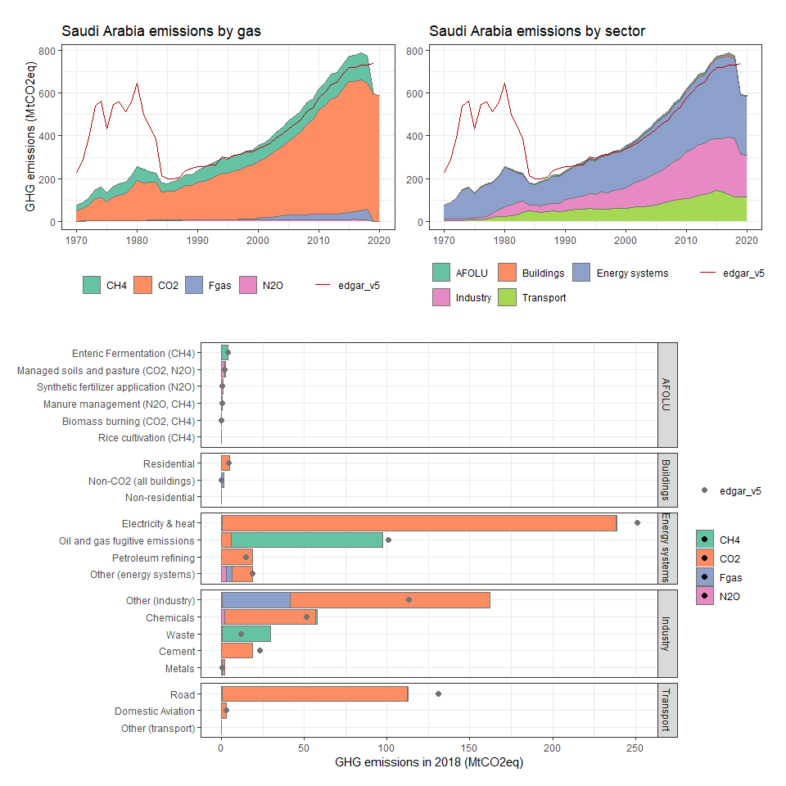

### Senegal

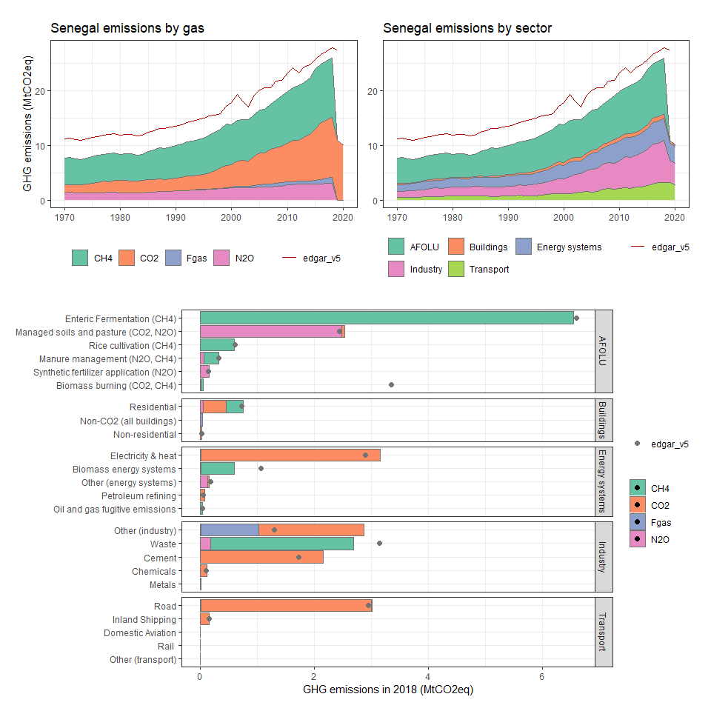

### Serbia and Montenegro

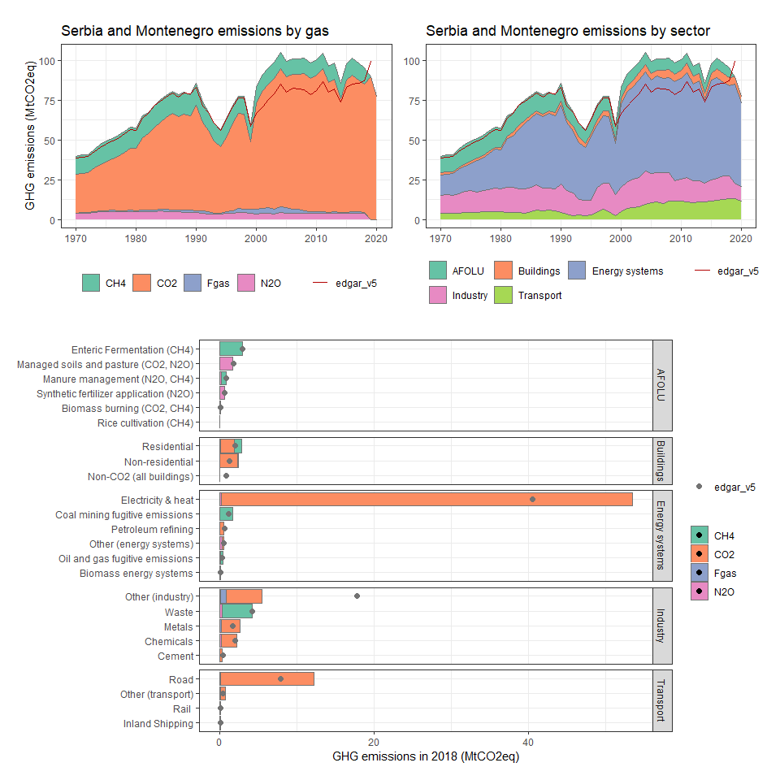

### Seychelles

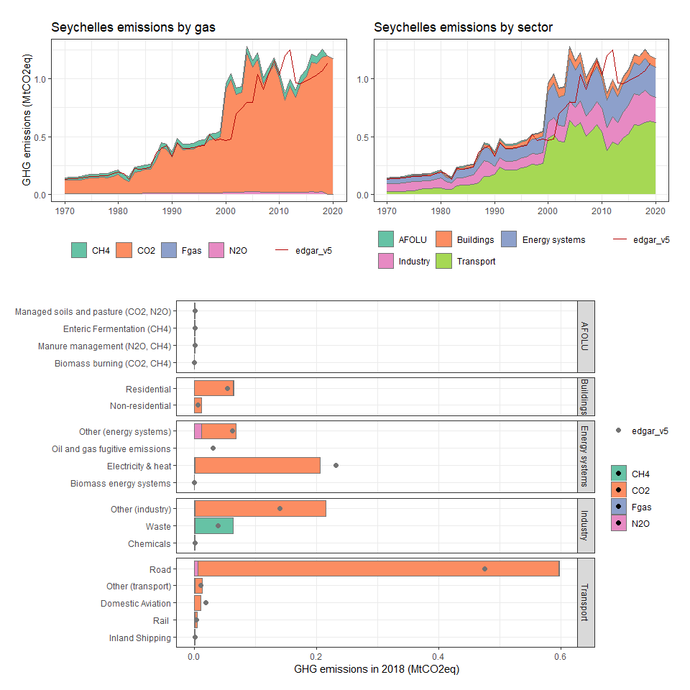

### Sierra Leone

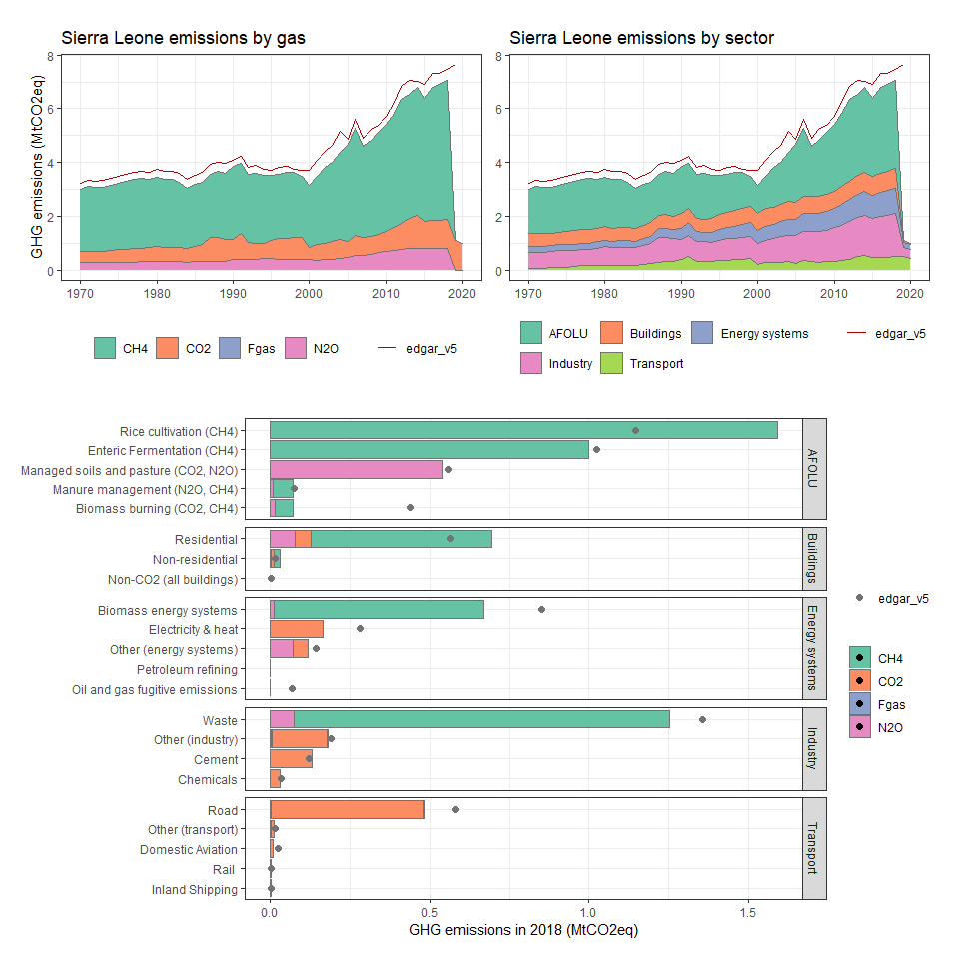

### Singapore

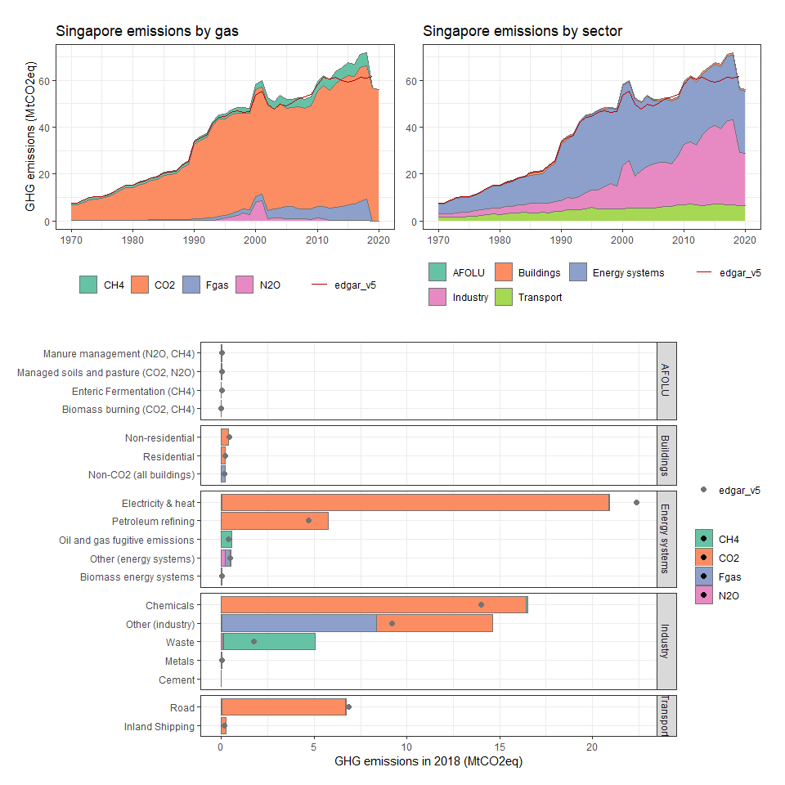

### Slovak Republic

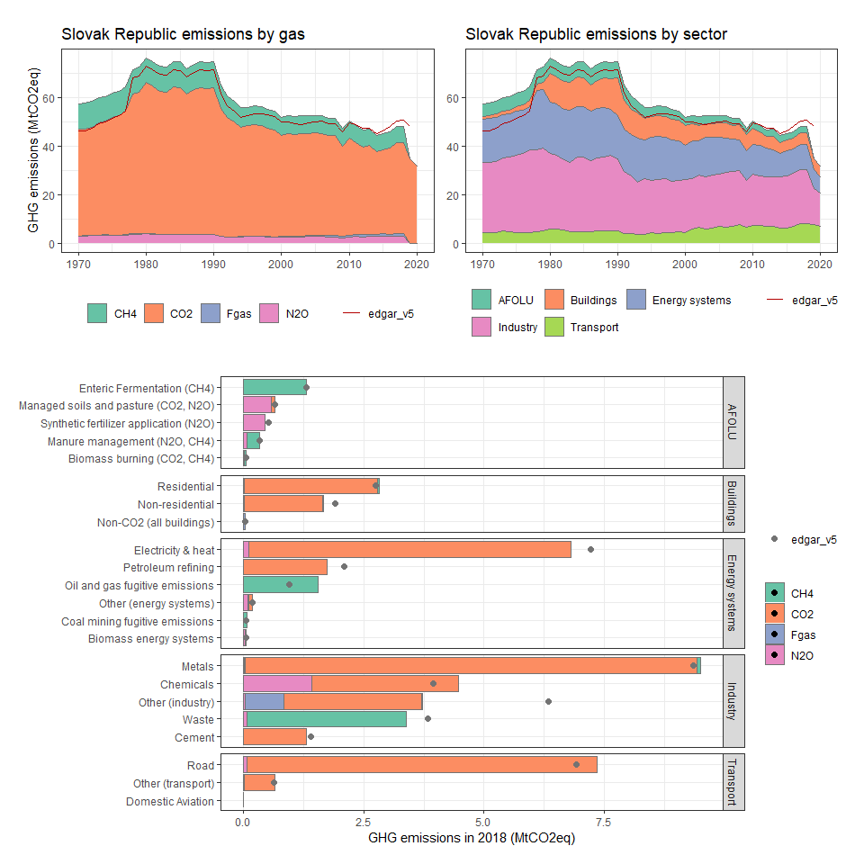

### Slovenia

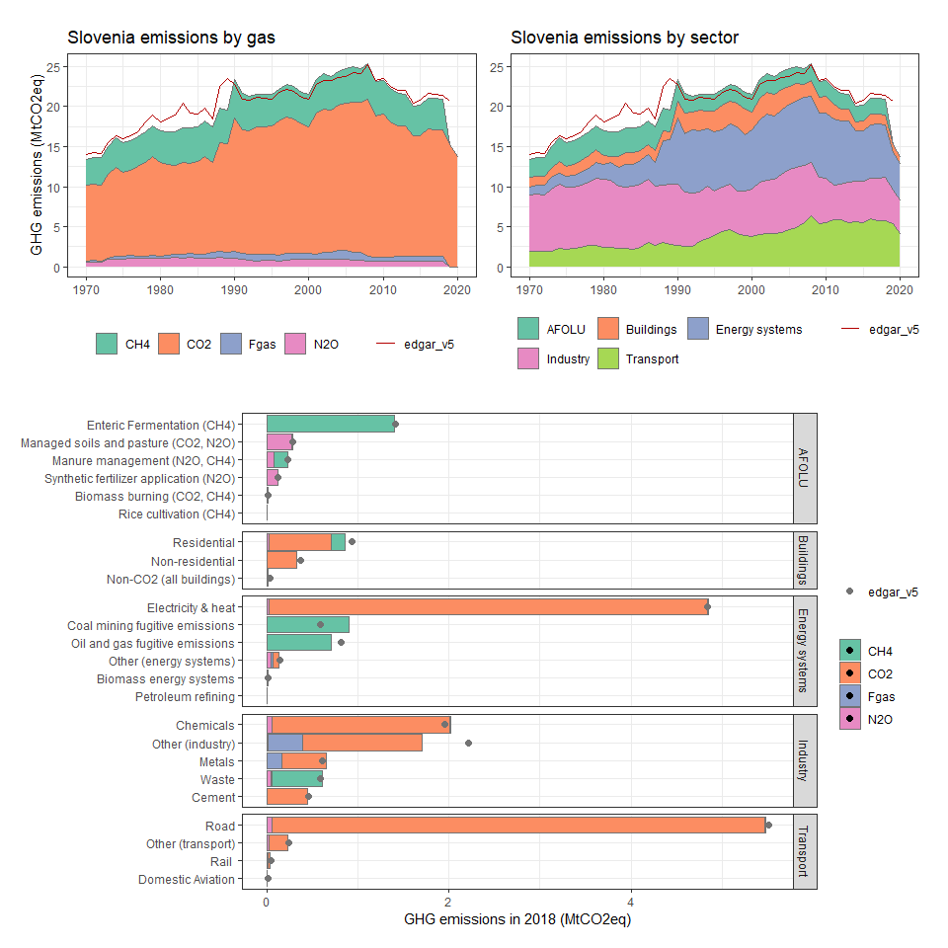

### Solomon Islands

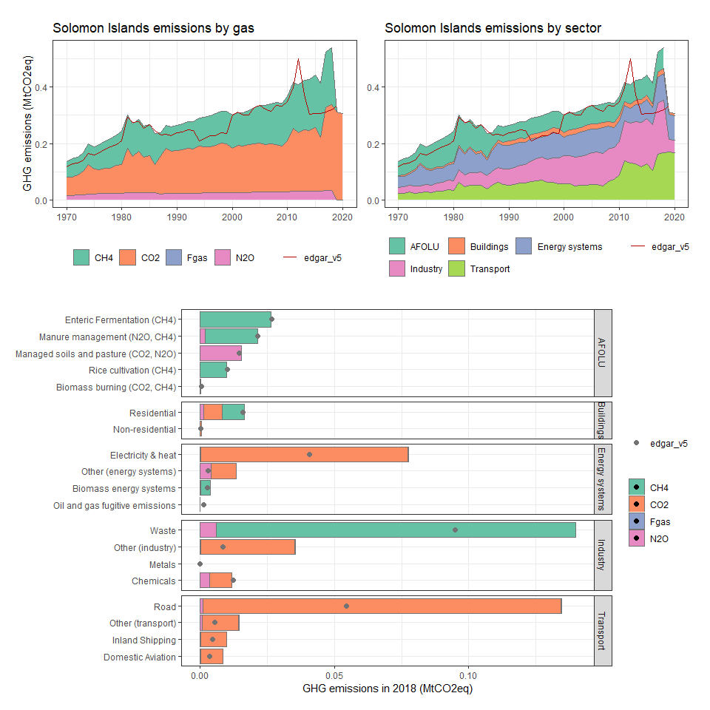

### Somalia

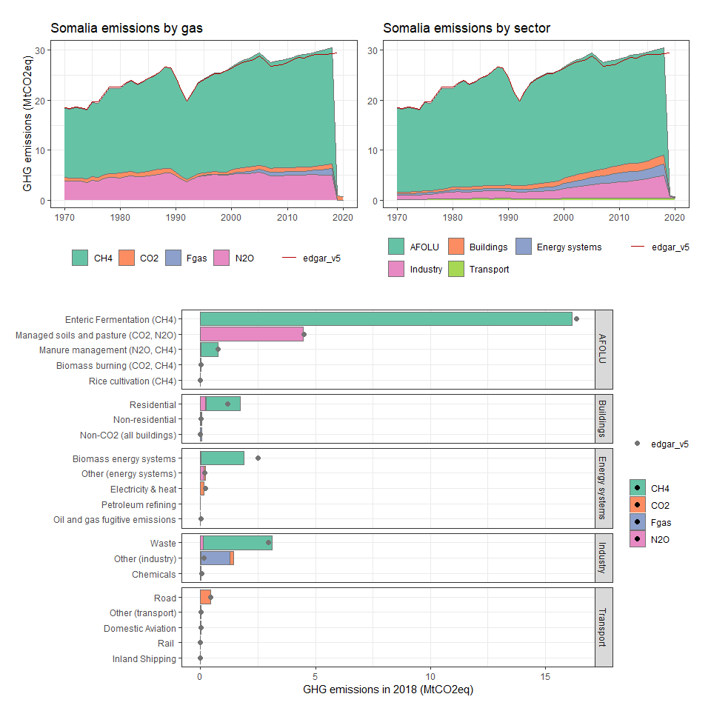

### South Africa

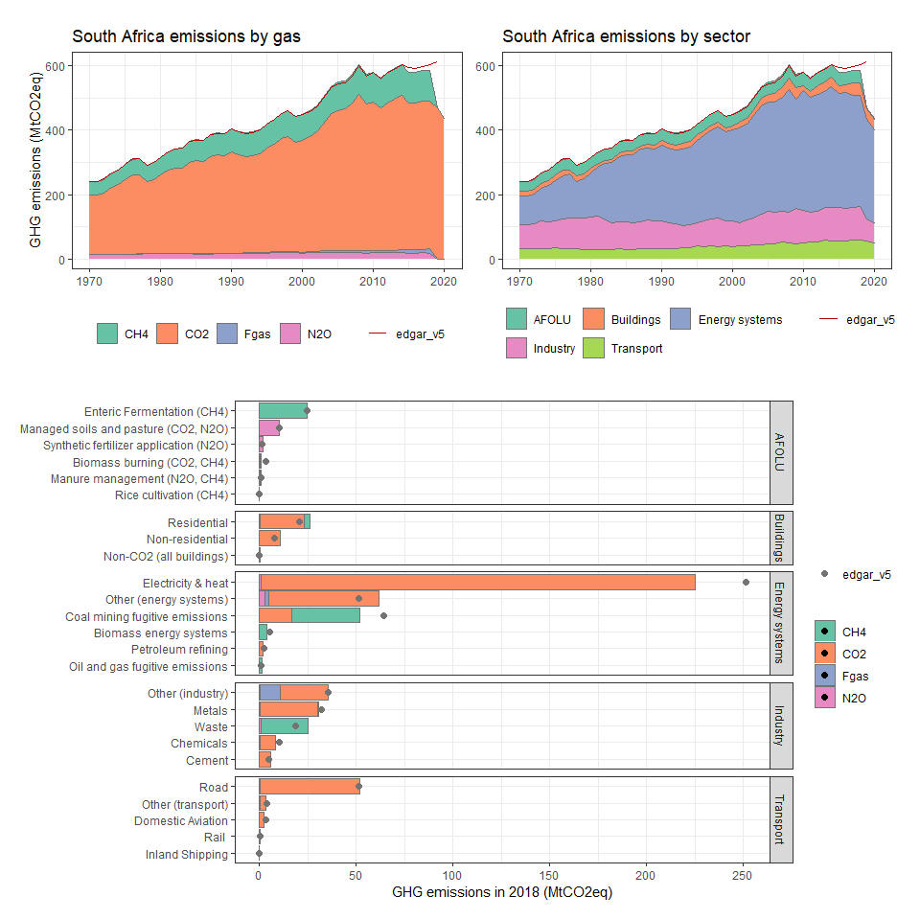

### South Georgia and the South Sandwich Islands

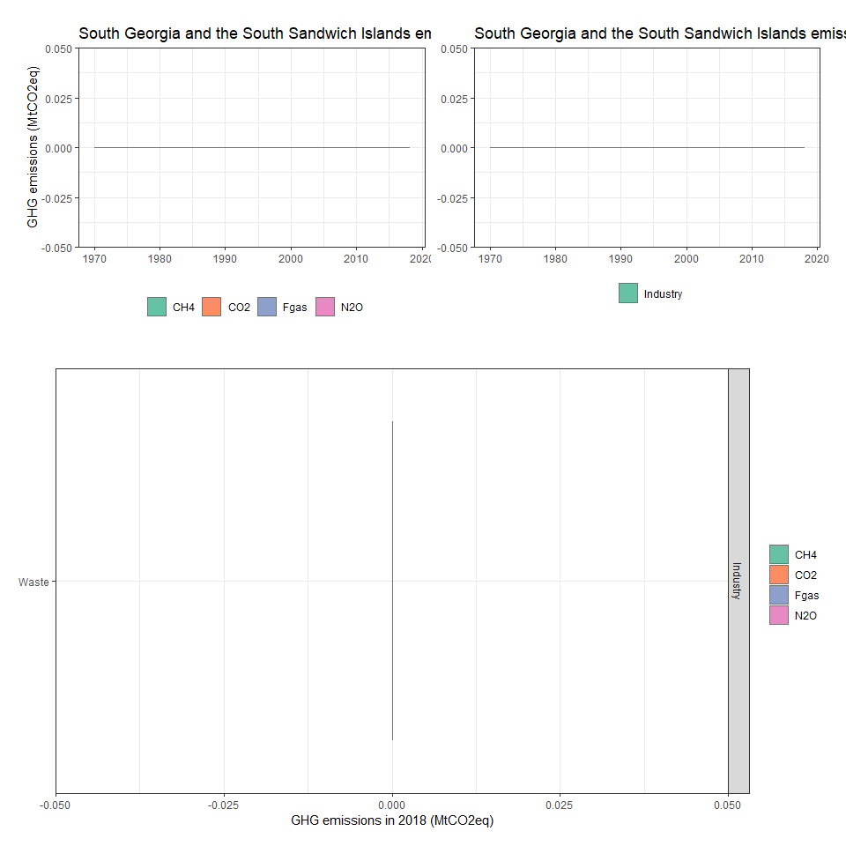

### Spain

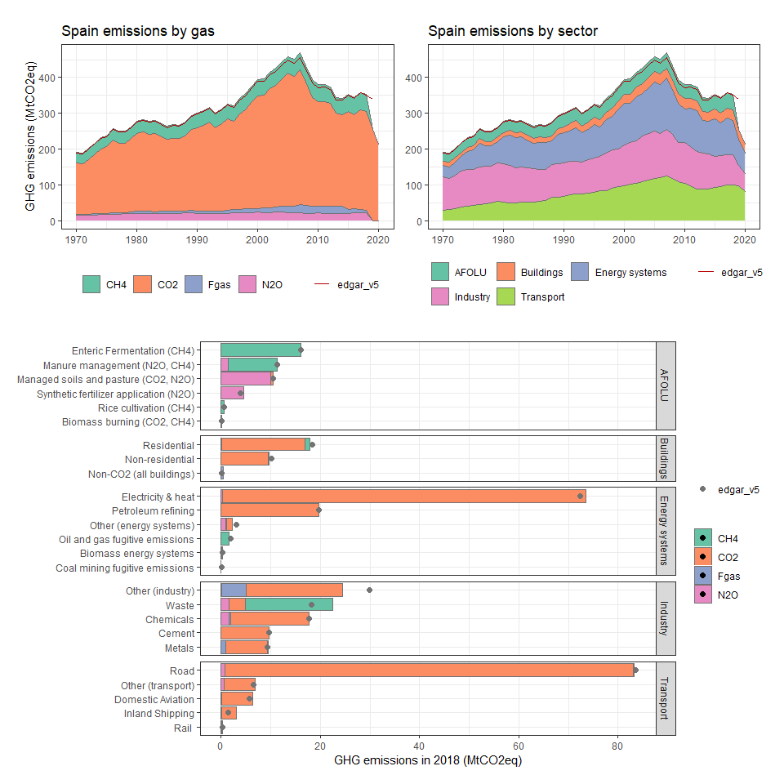

### Sri Lanka

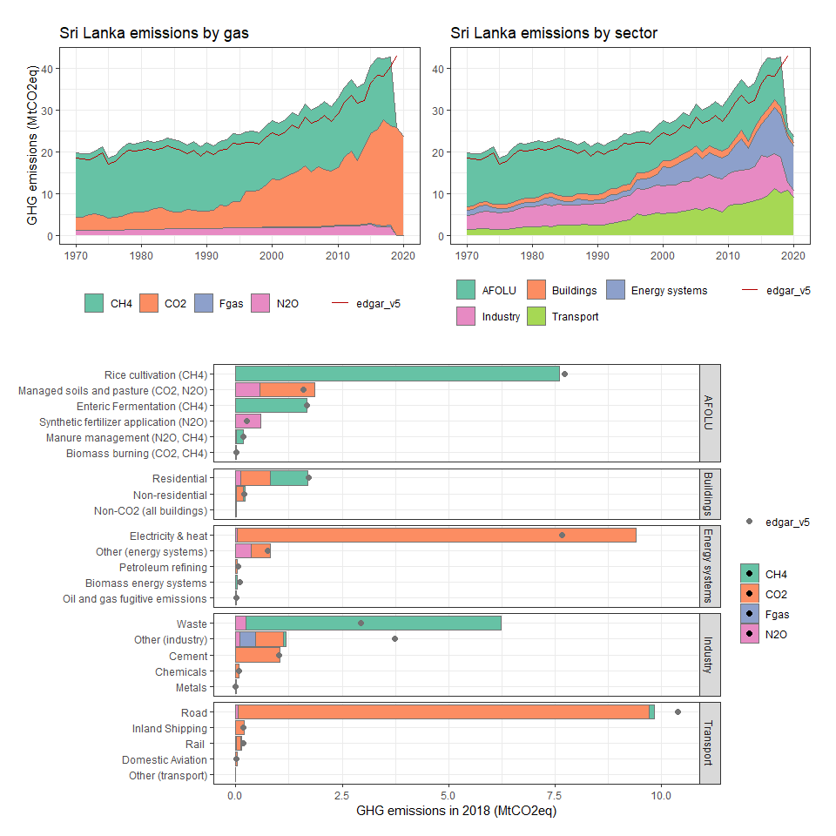

### St. Kitts and Nevis

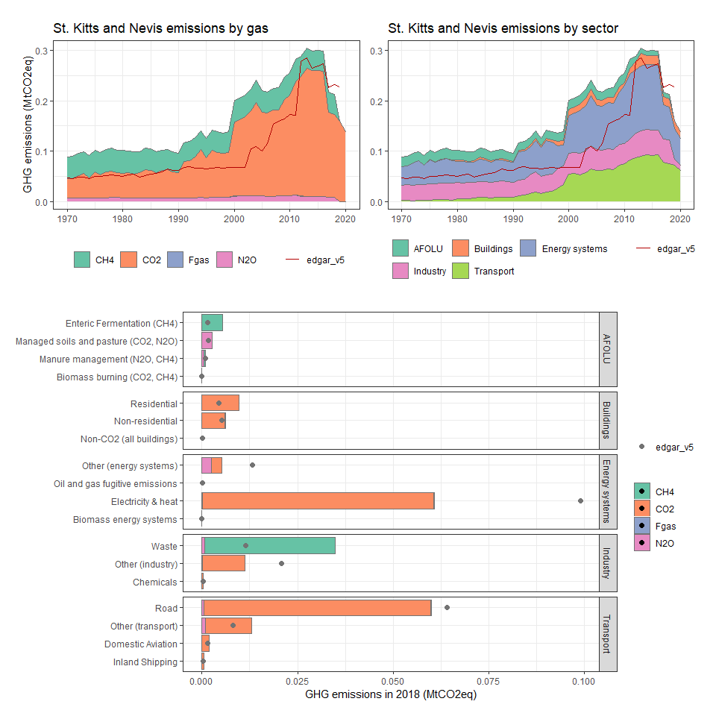

### St. Lucia

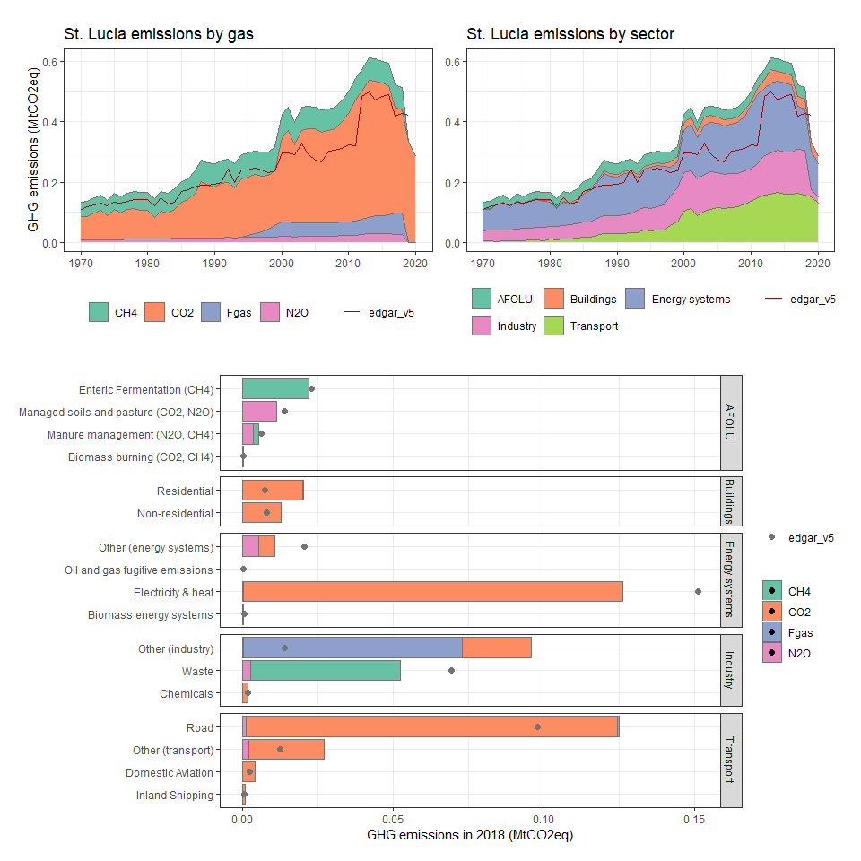

### St. Vincent and the Grenadines

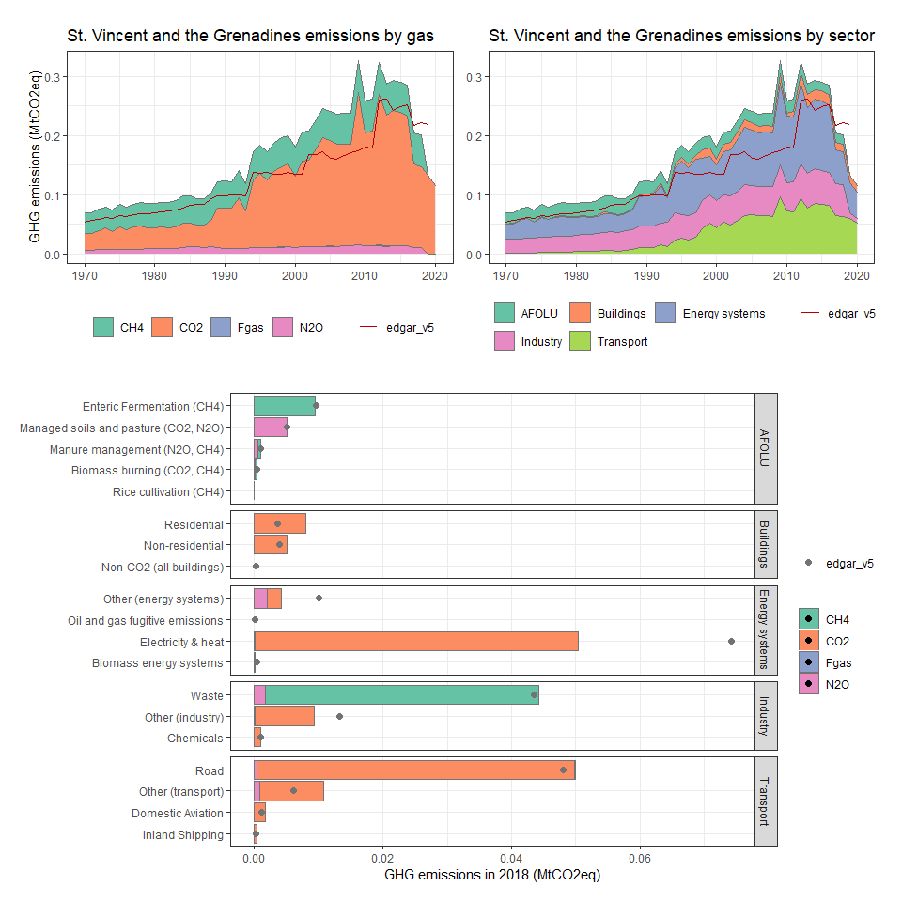

### Sudan

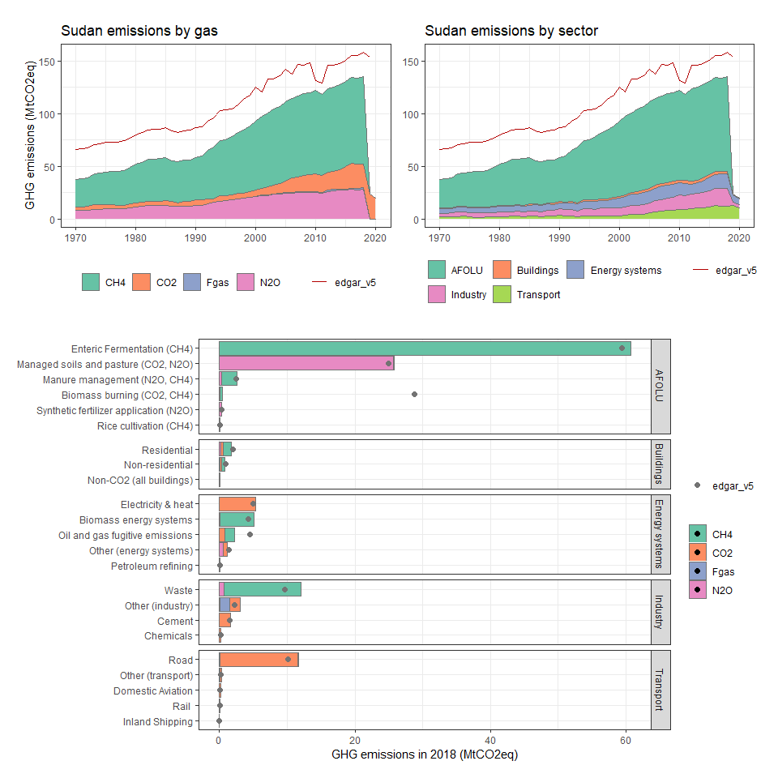

### Suriname

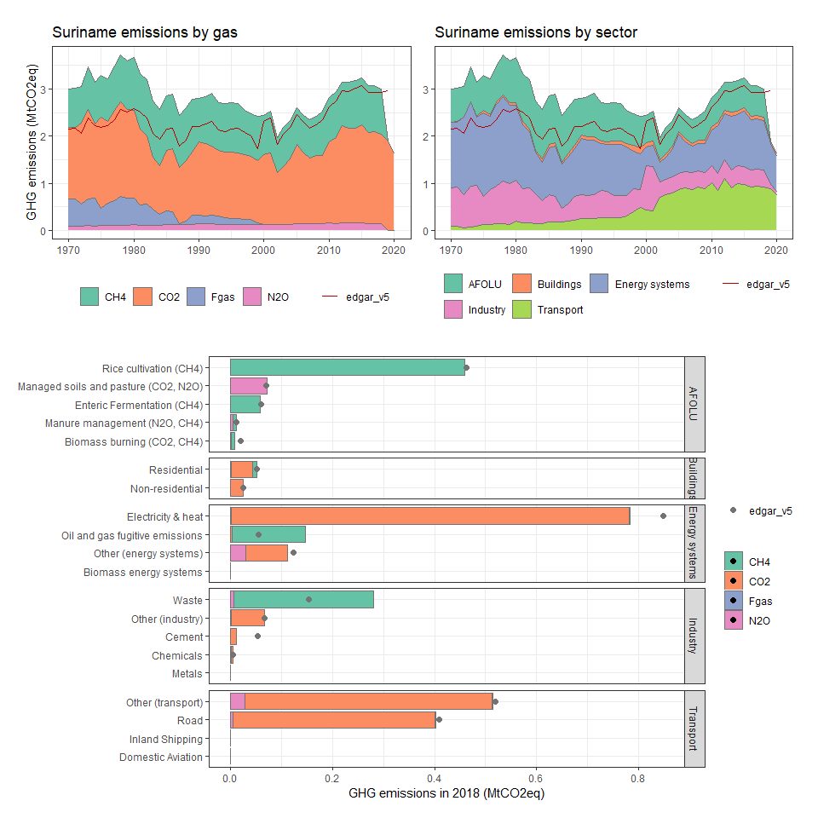

### Swaziland

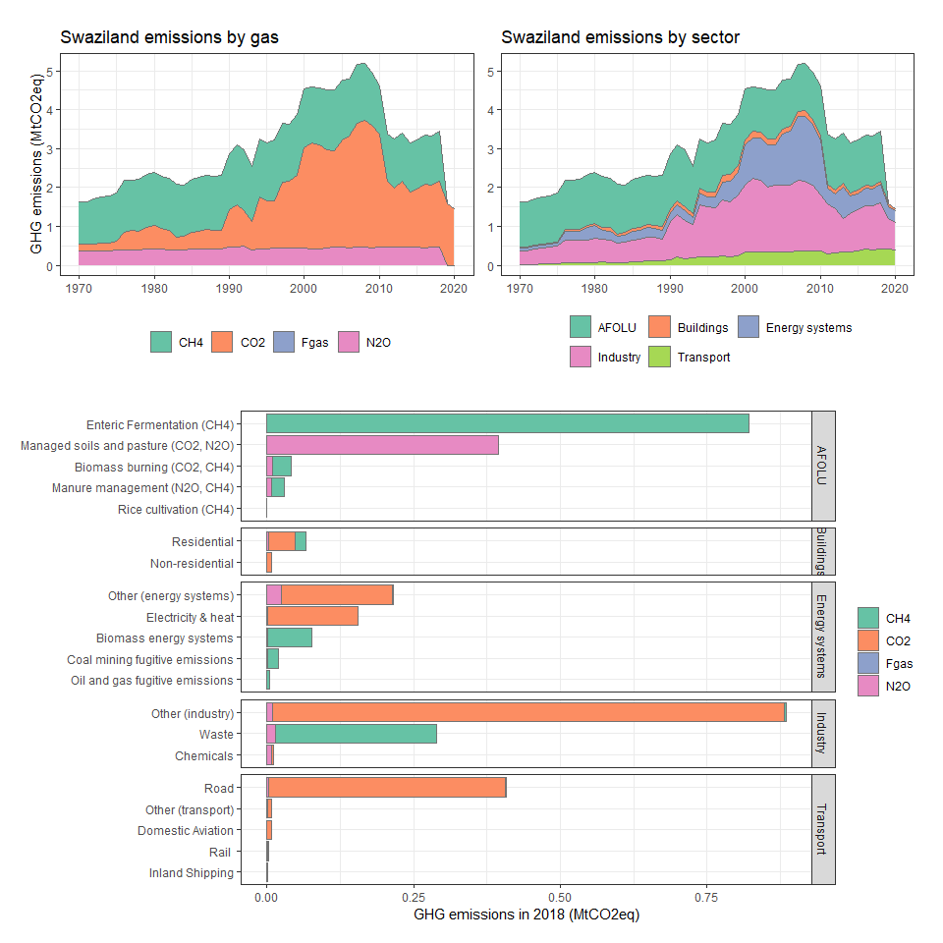

### Sweden

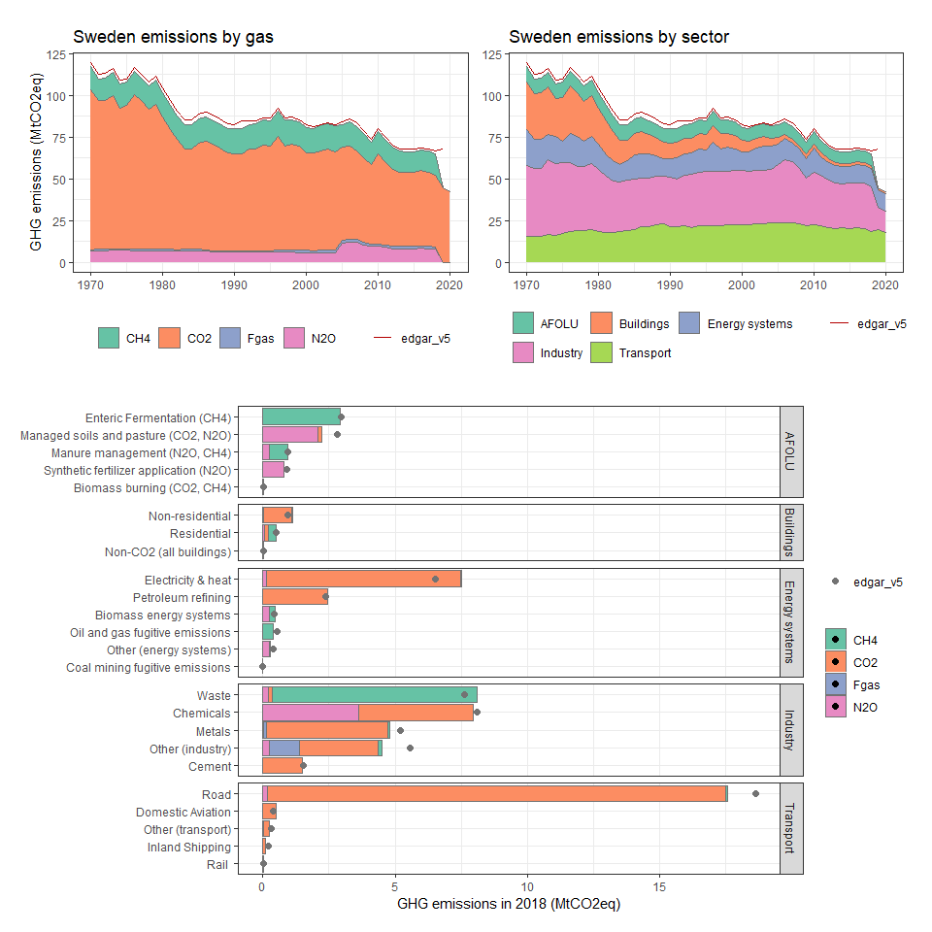

### Switzerland

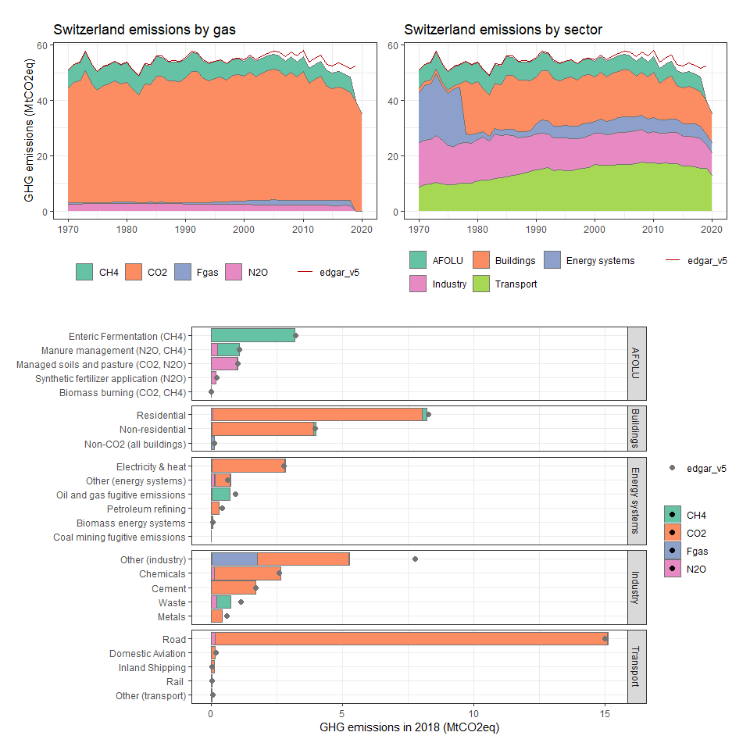

### Syrian Arab Republic

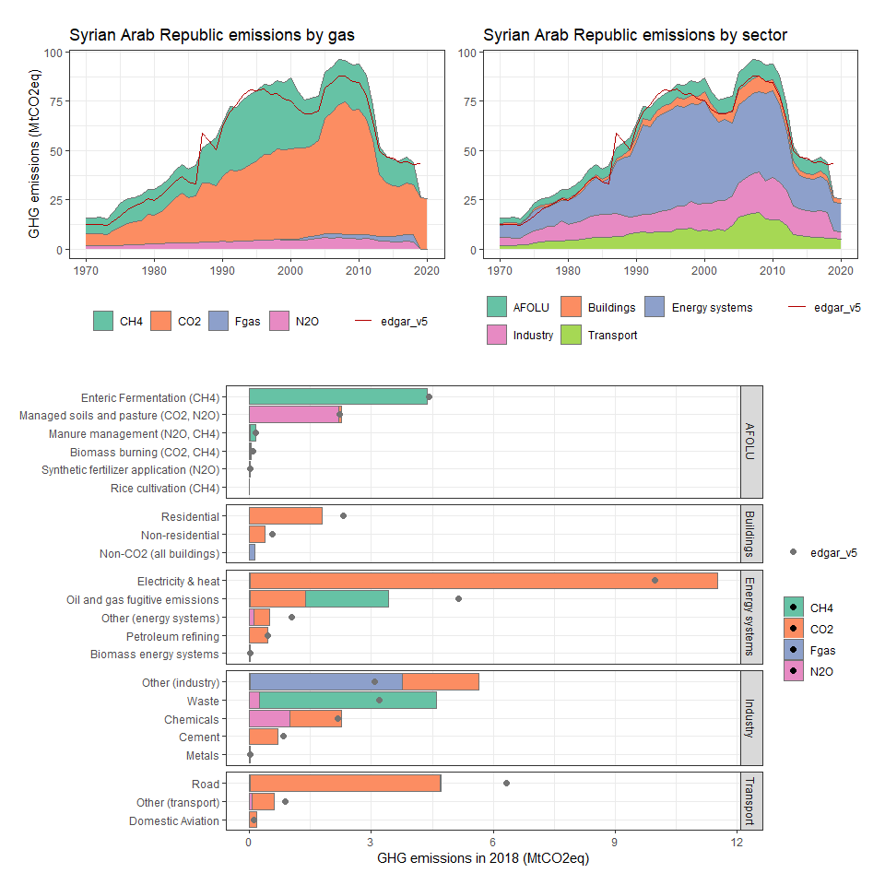

### Taiwan, China

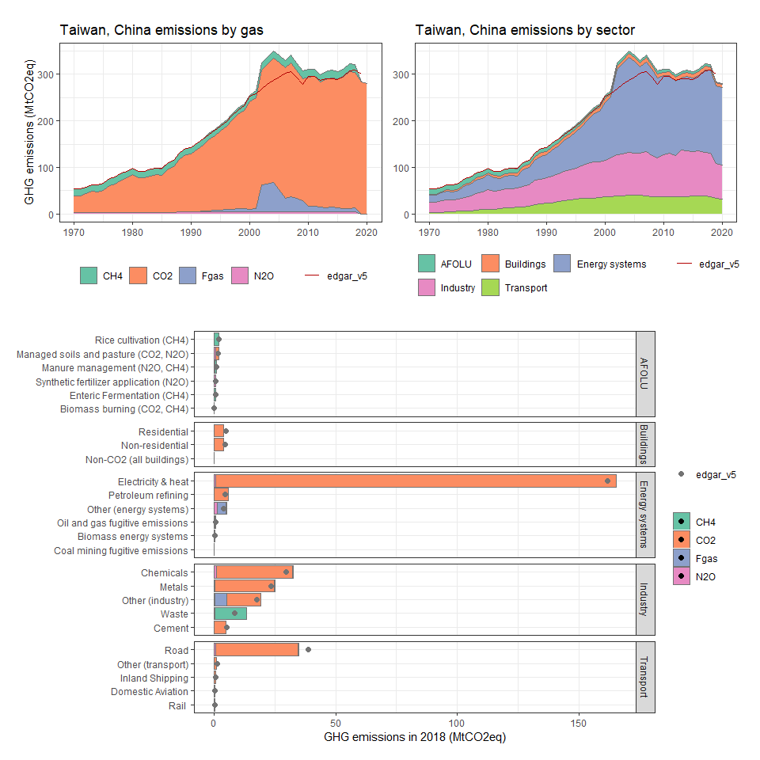

### Tajikistan

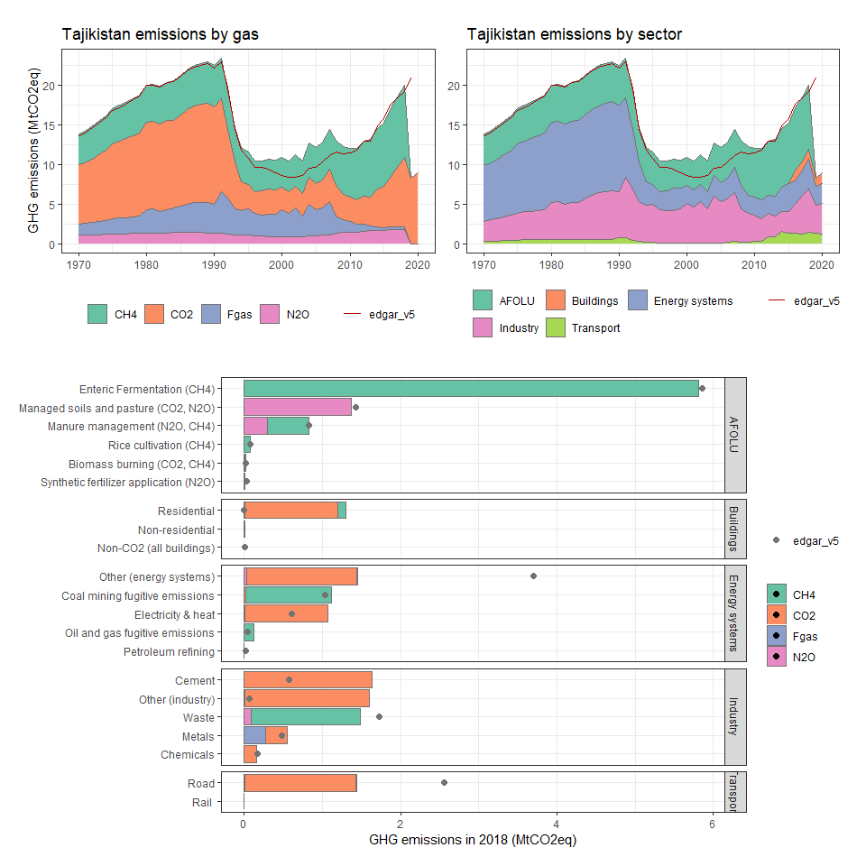

### Tanzania

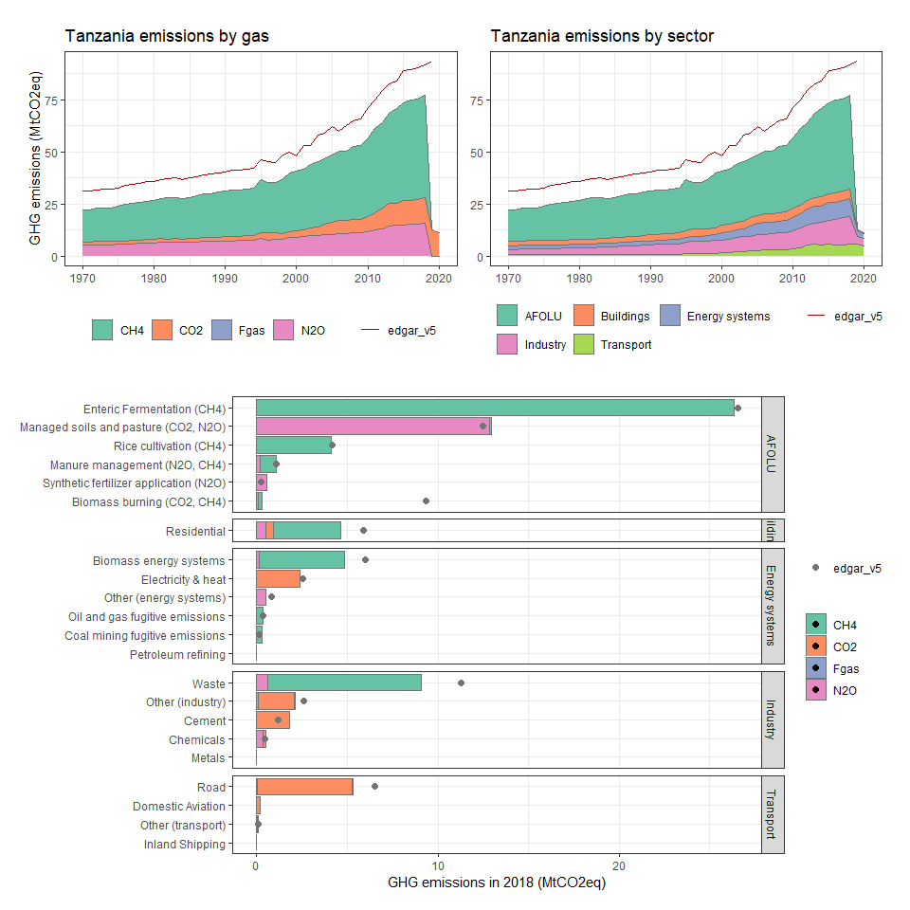

### Thailand

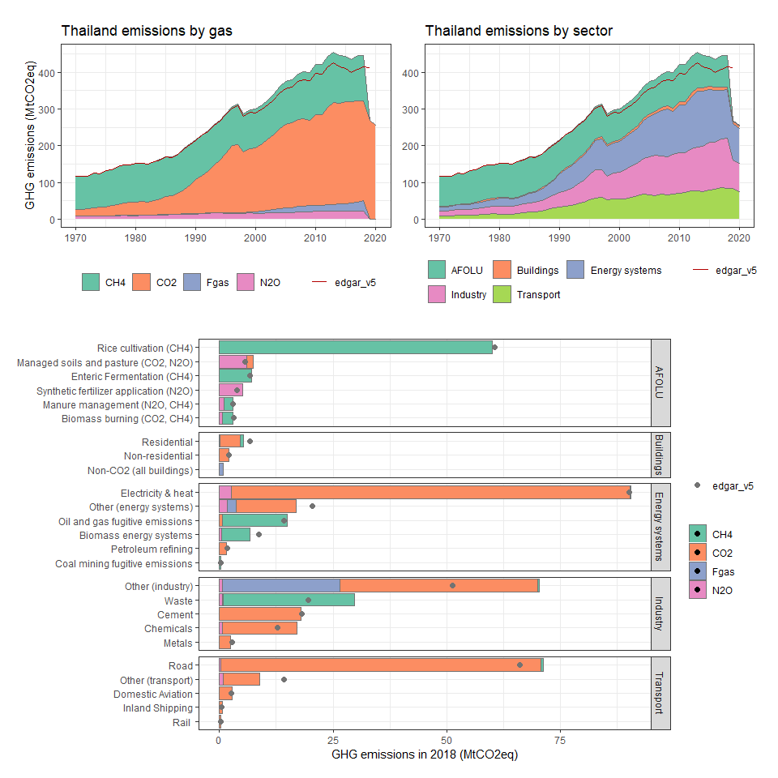

### Timor-Leste

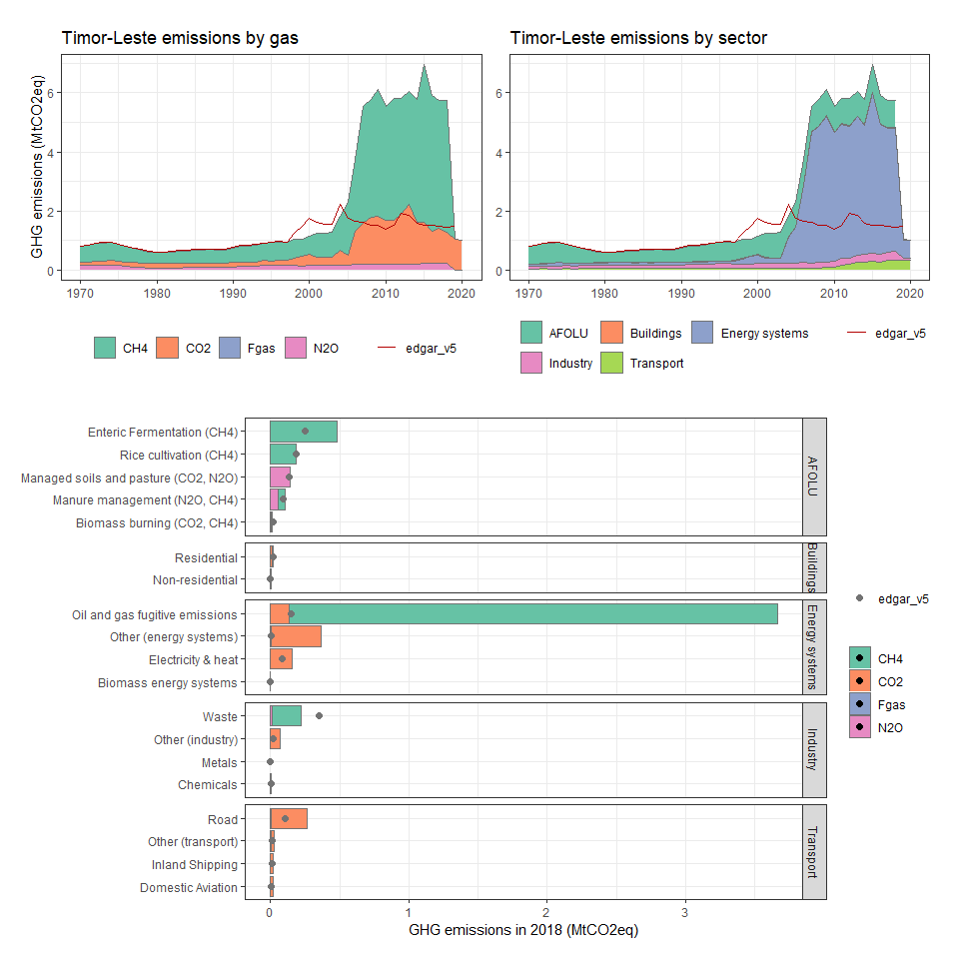

### Togo

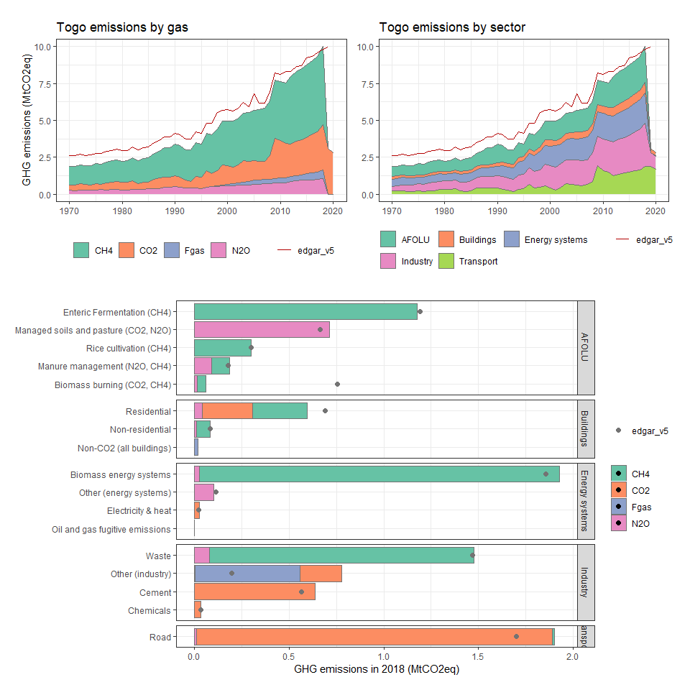

### Tokelau

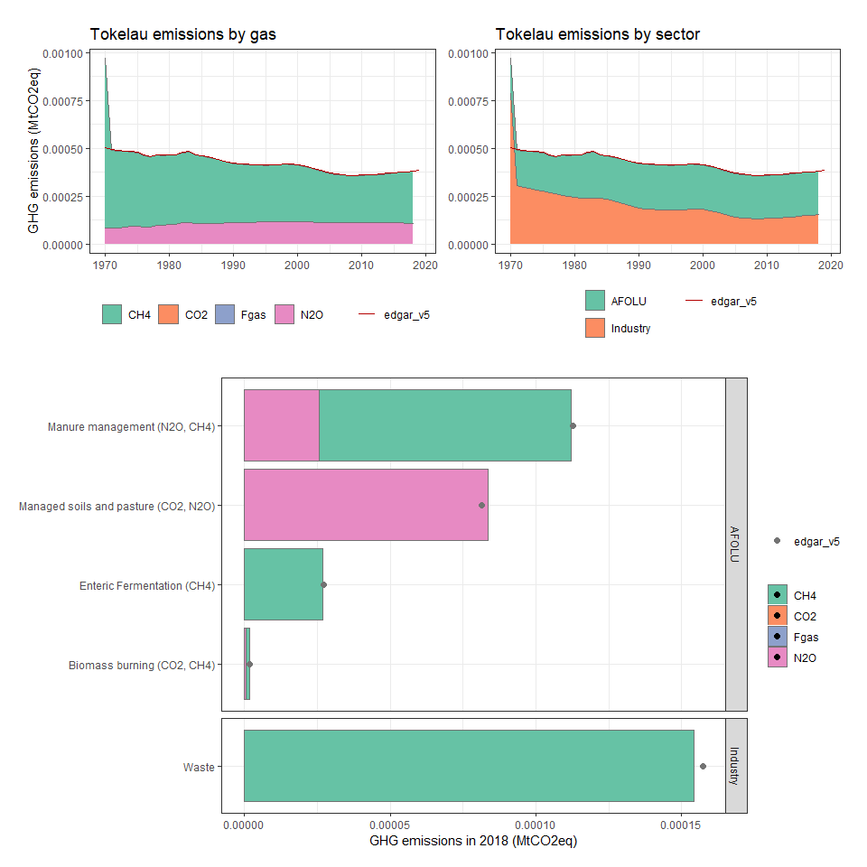

### Tonga

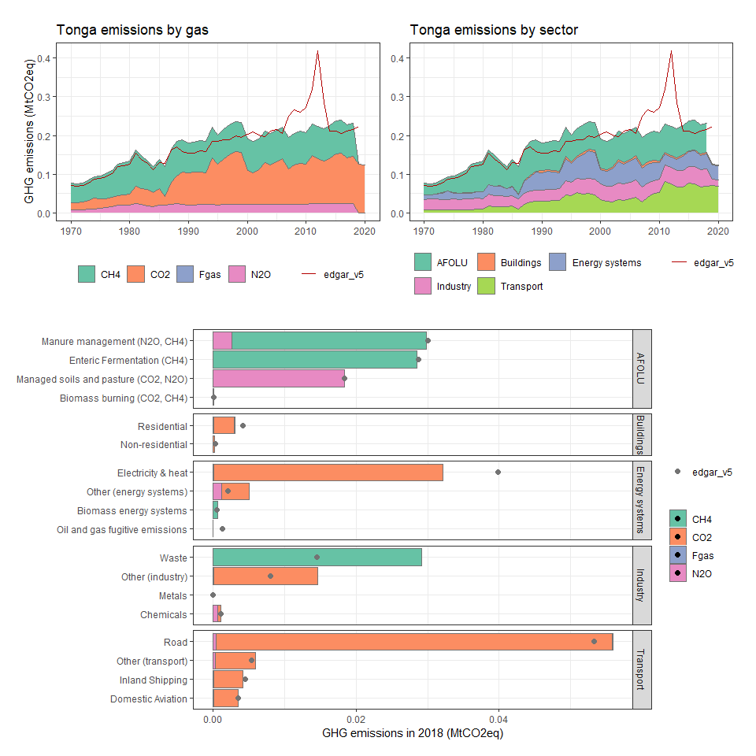

### Trinidad and Tobago

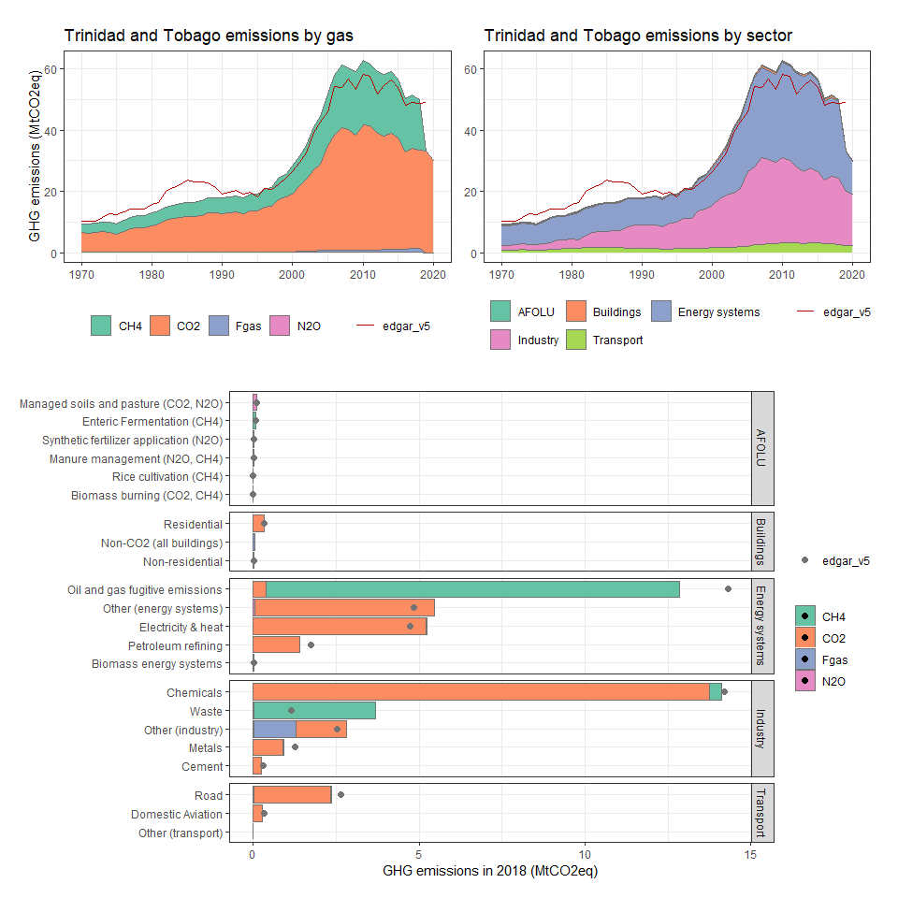

### Tunisia

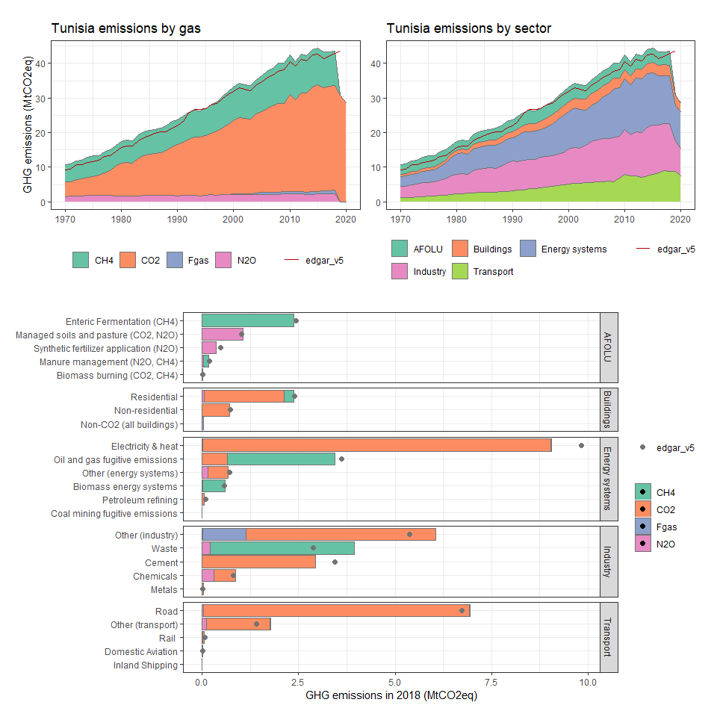

### Turkey

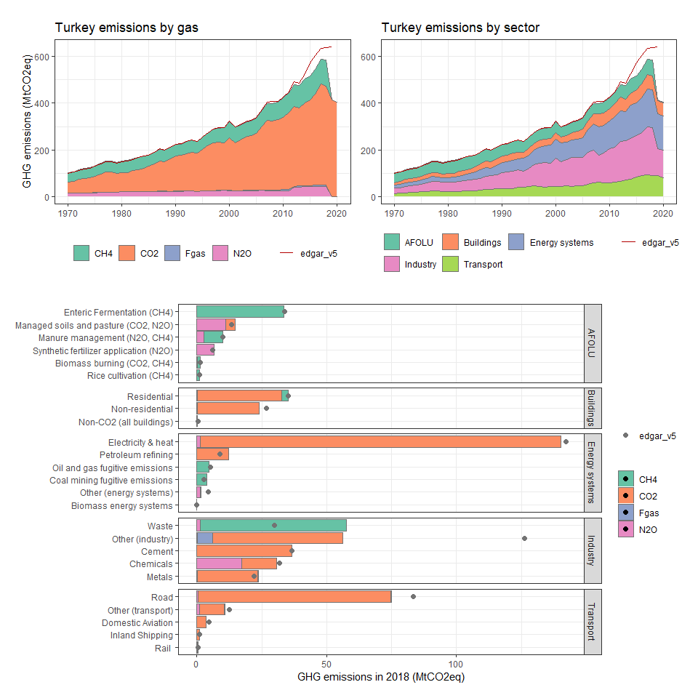

### Turkmenistan

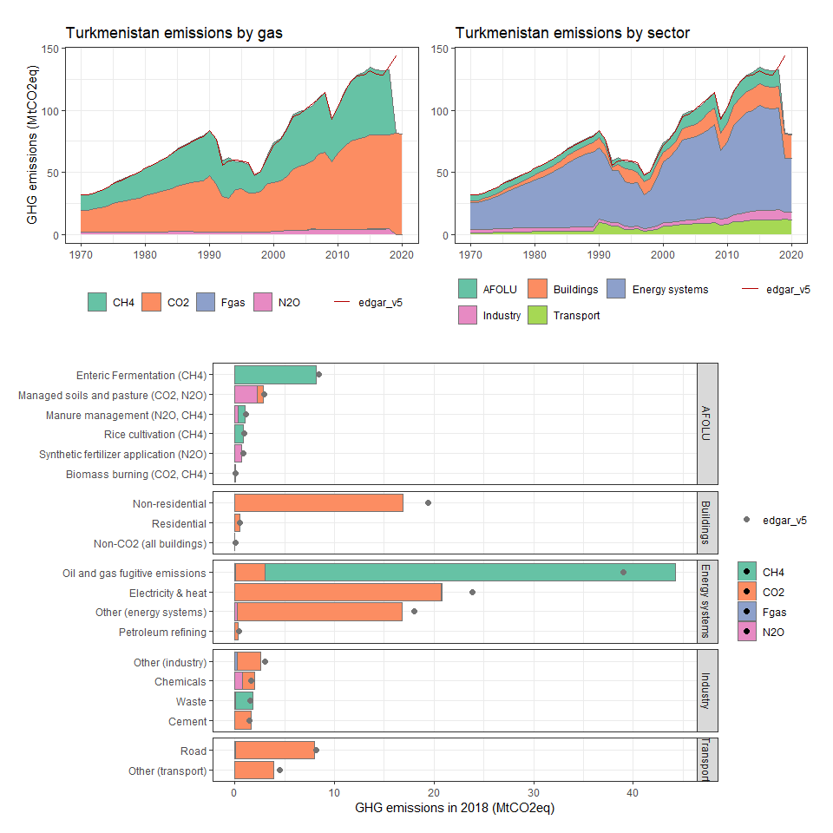

### Turks and Caicos Islands

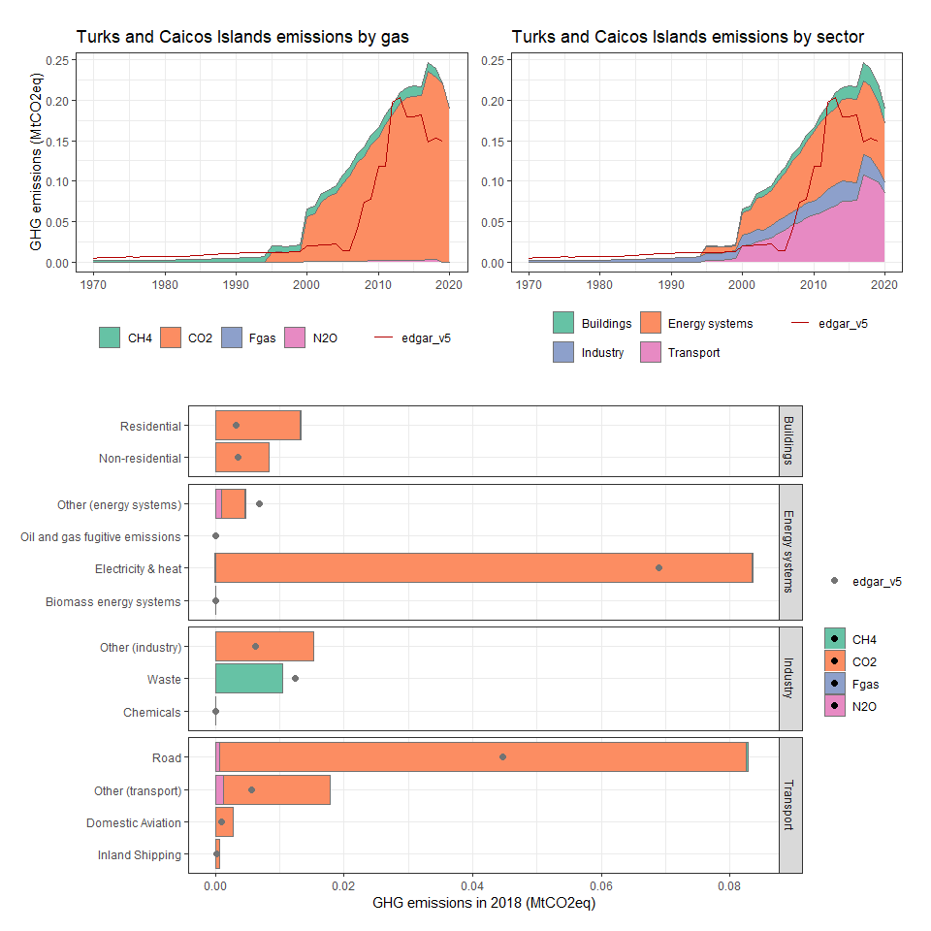

### Tuvalu

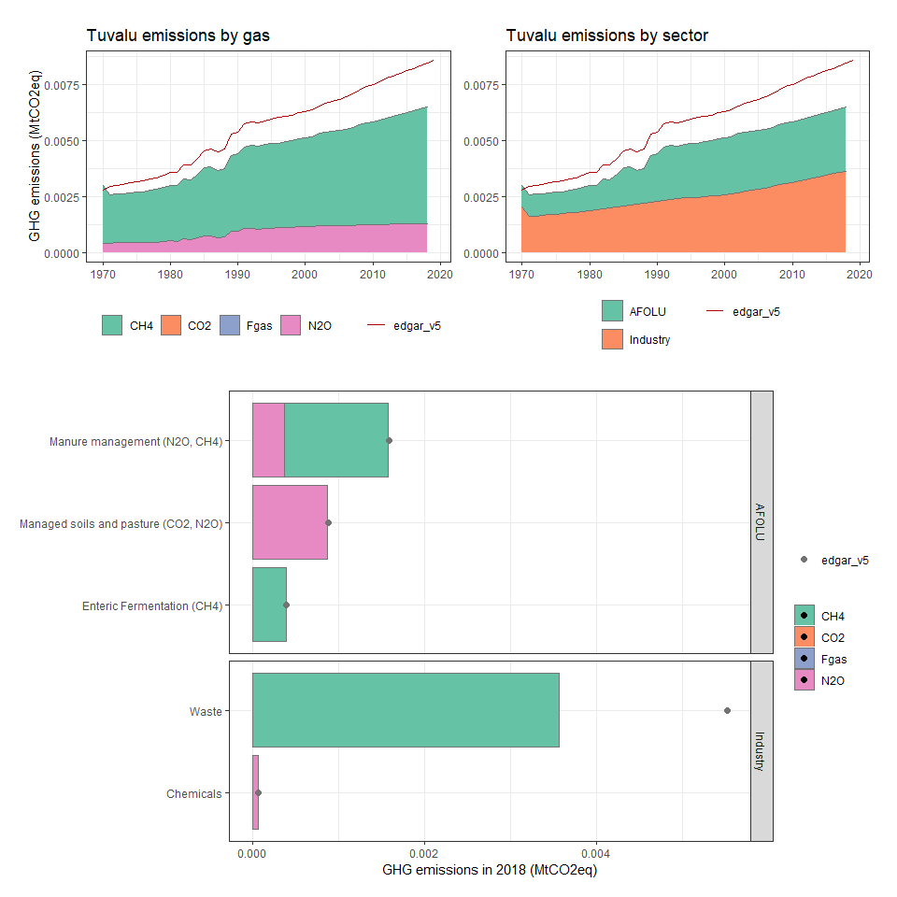

### Uganda

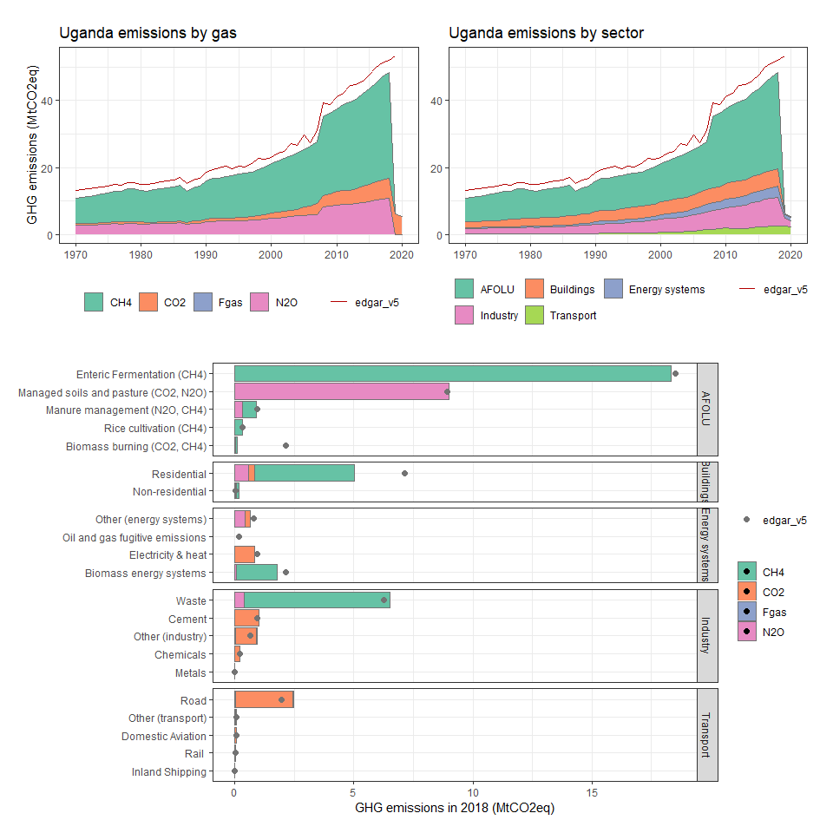

### Ukraine

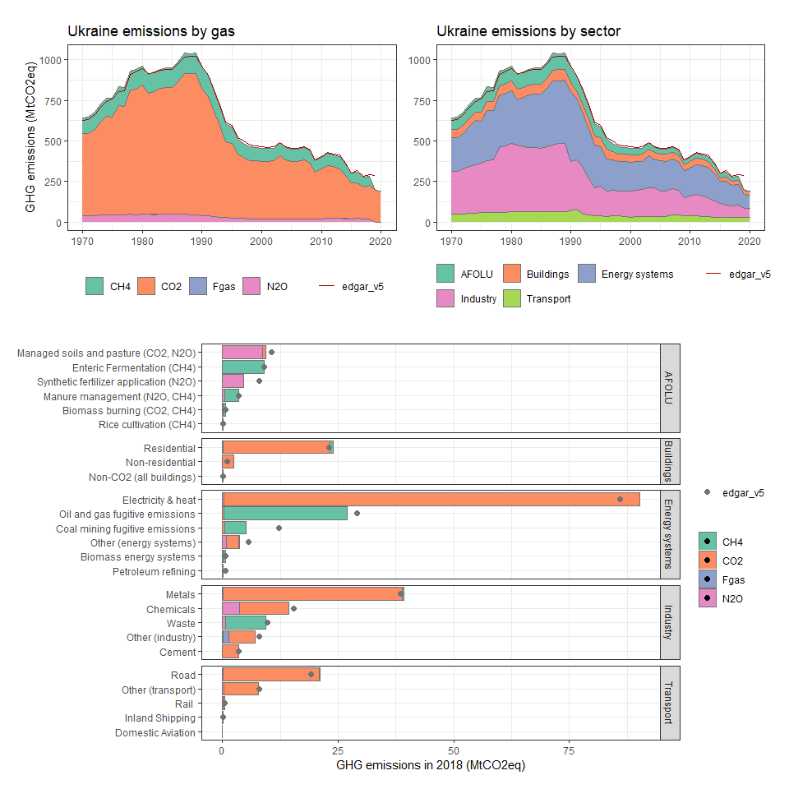

### United Arab Emirates

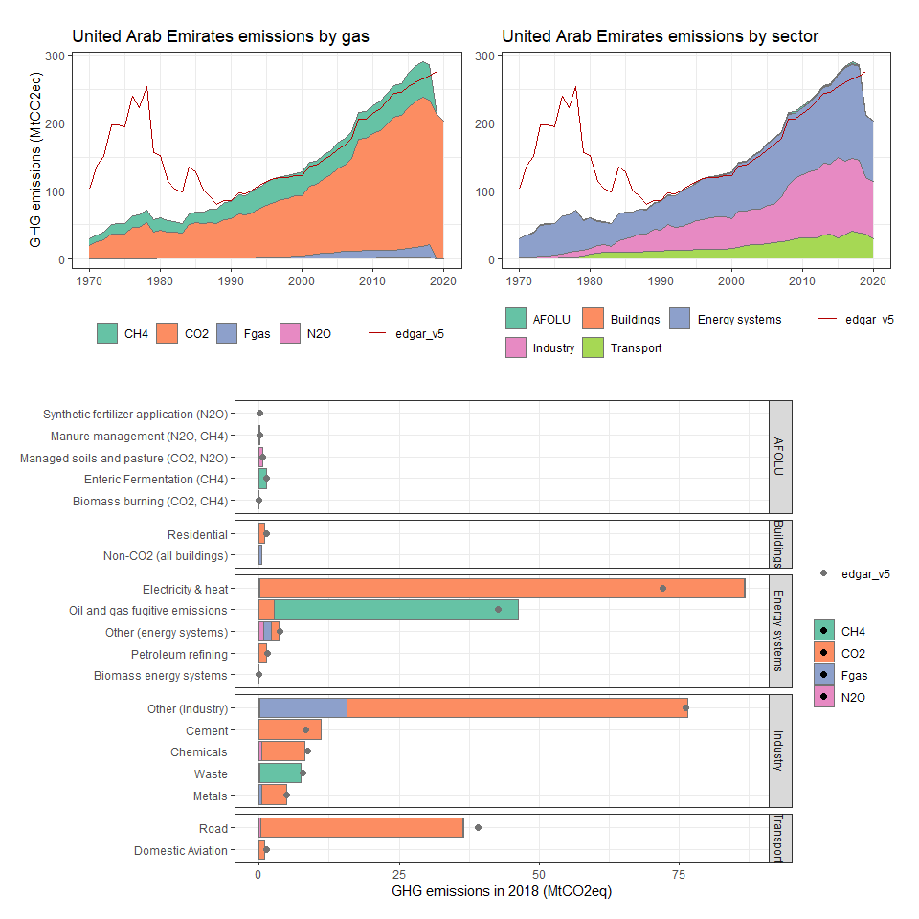

### United Kingdom

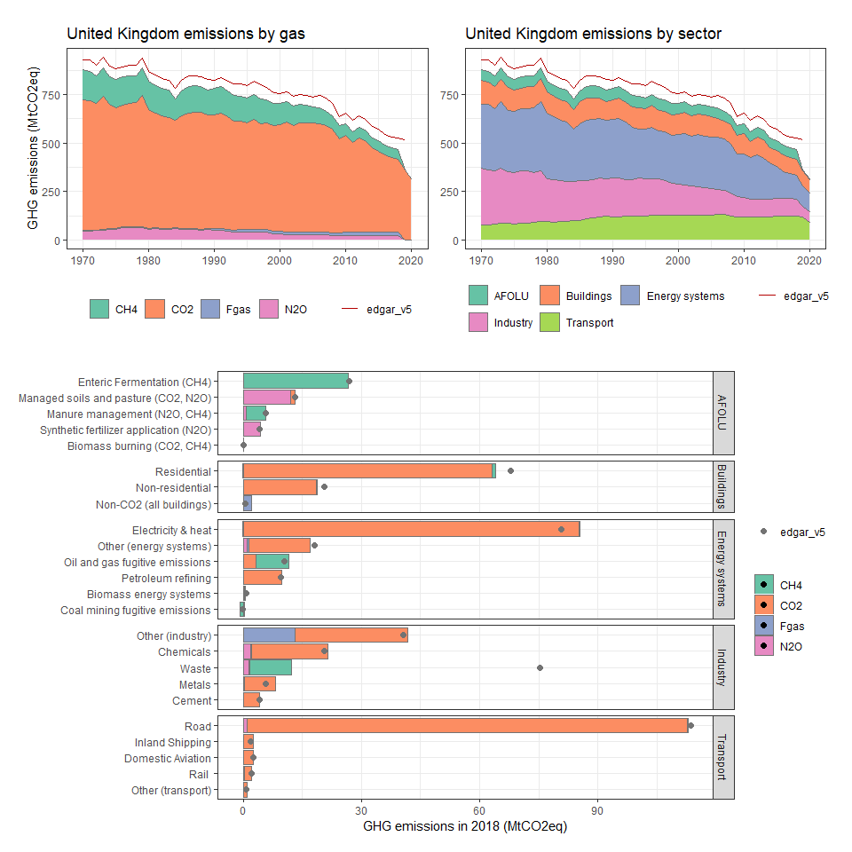

### United States

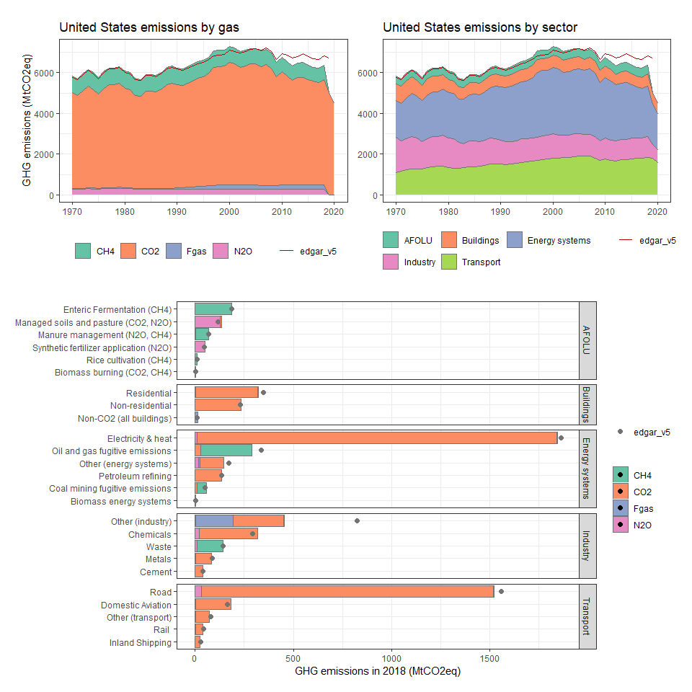

### United States Minor Outlying Islands

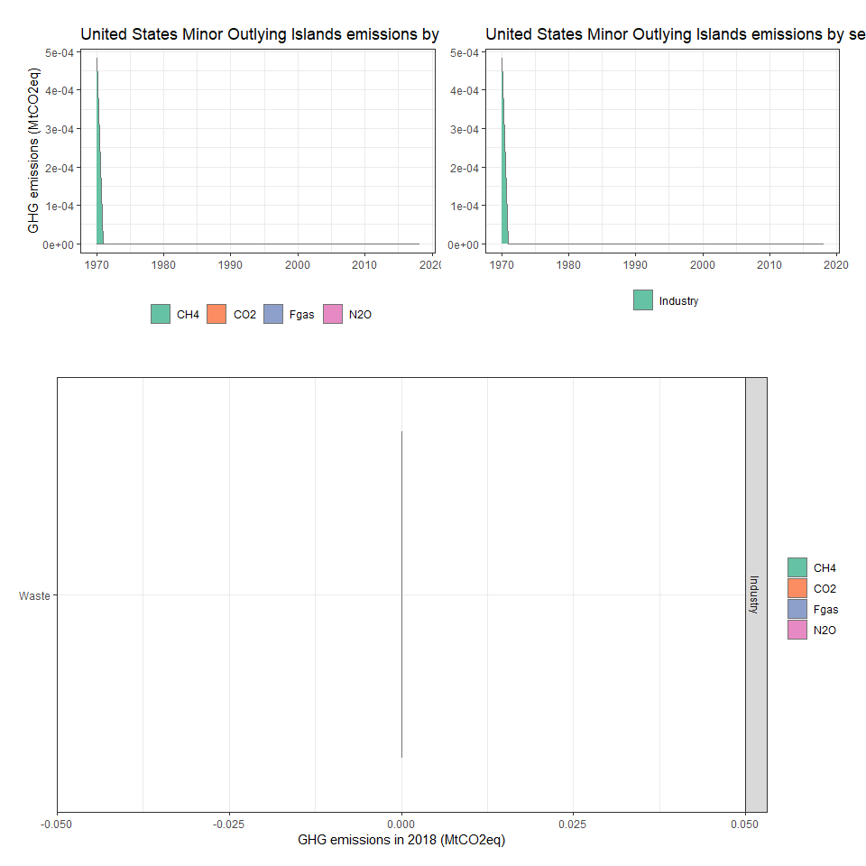

### Uruguay

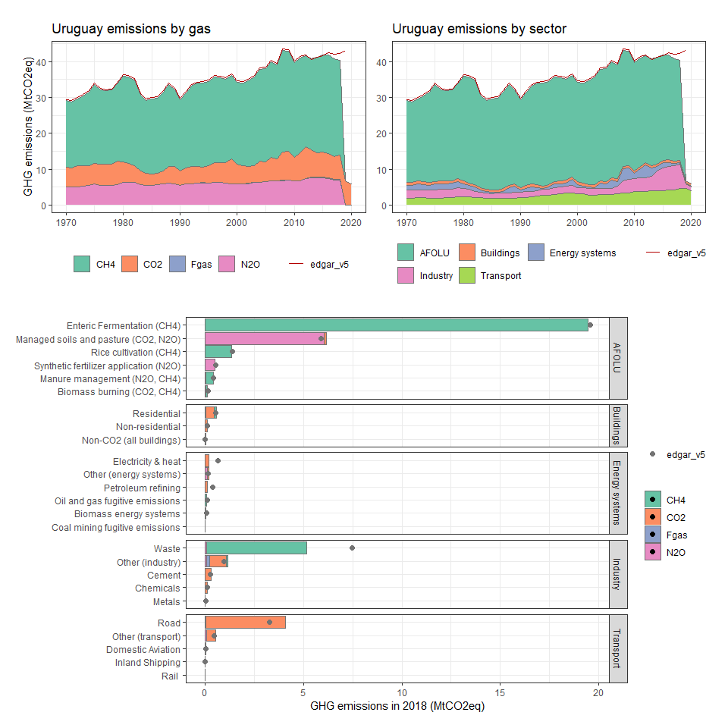

### Uzbekistan

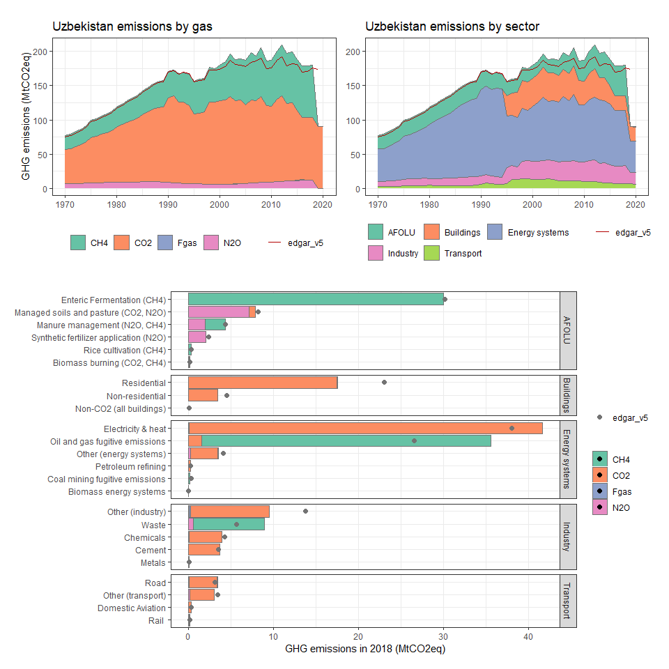

### Vanuatu

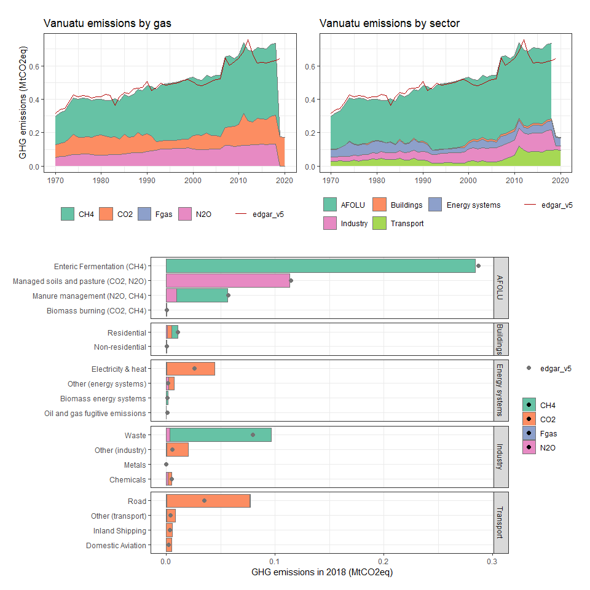

### Venezuela, RB

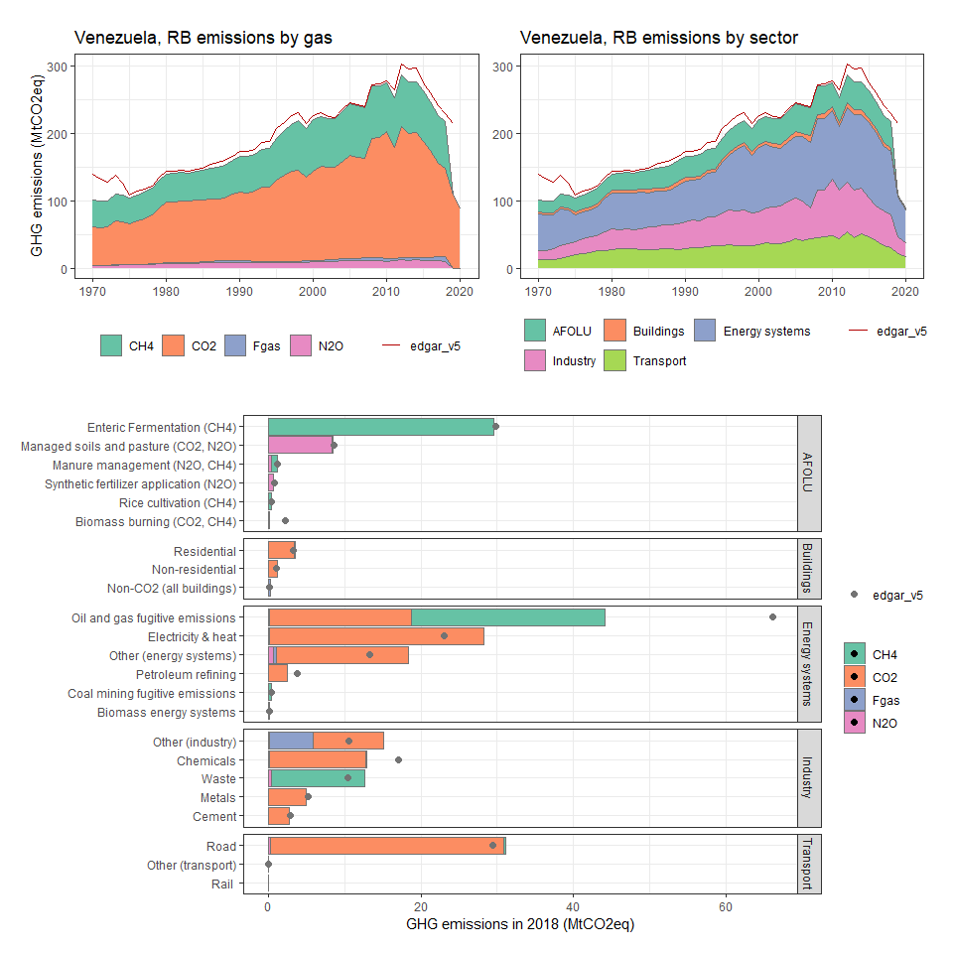

### Vietnam

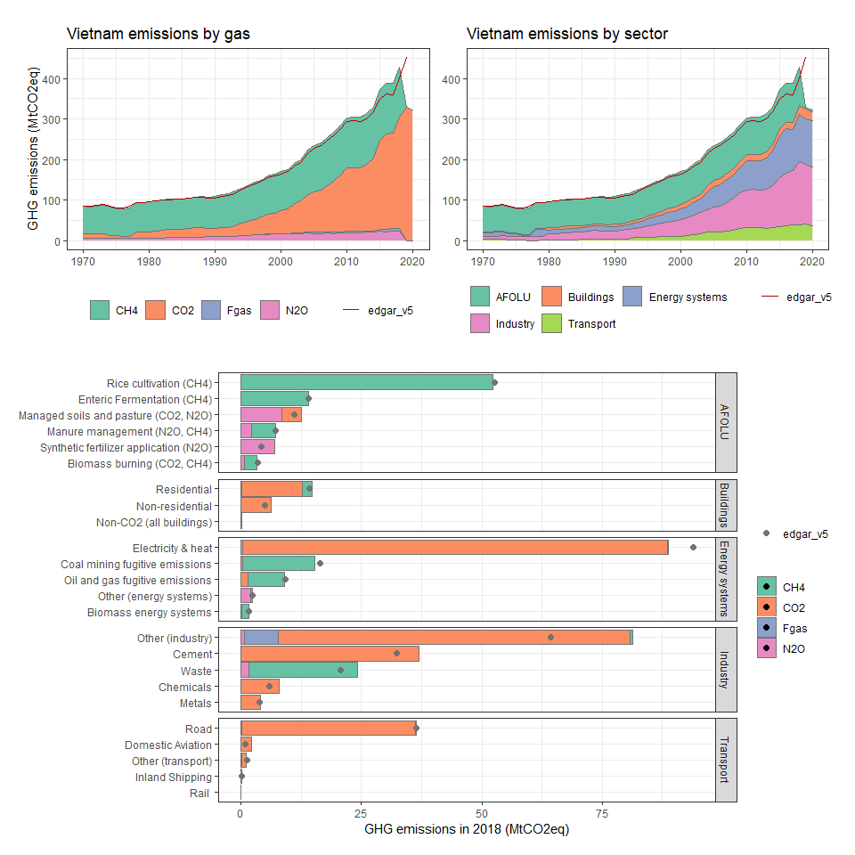

### Virgin Islands (U.S.)

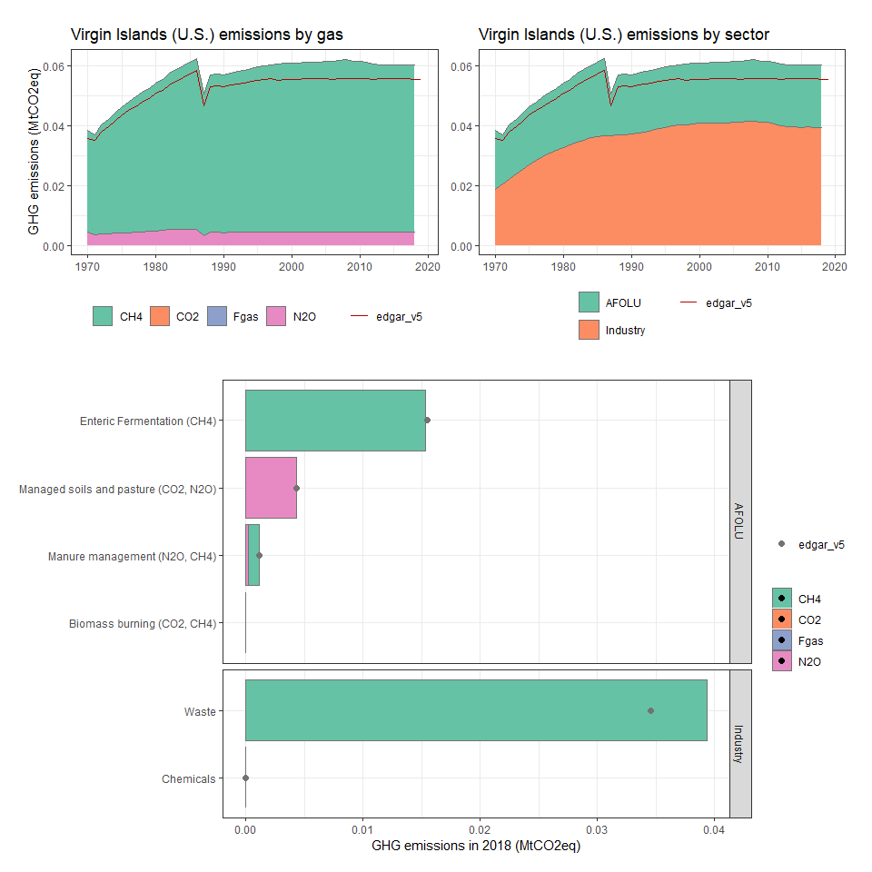

### Wallis and Futuna

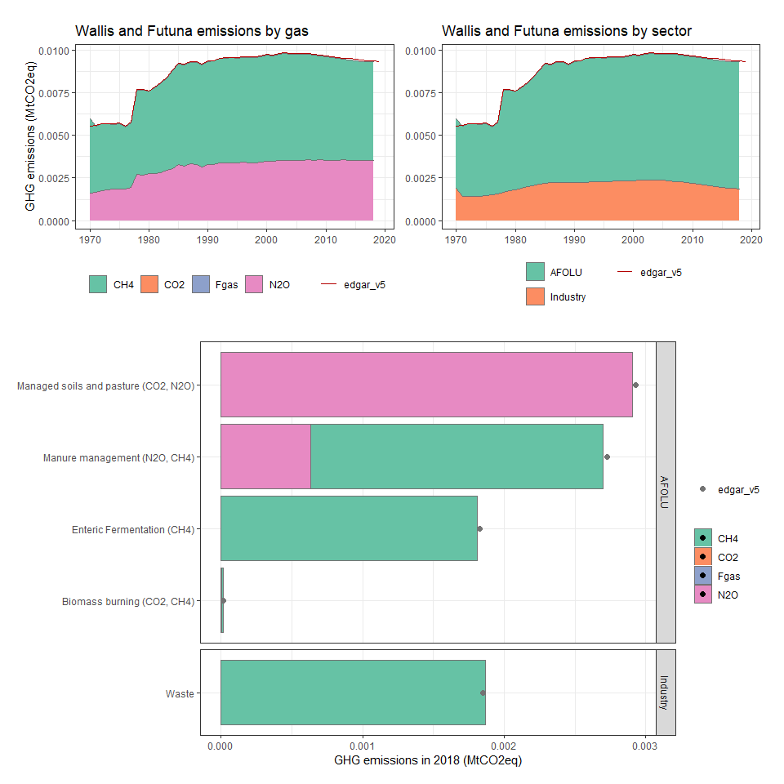

### Western Sahara

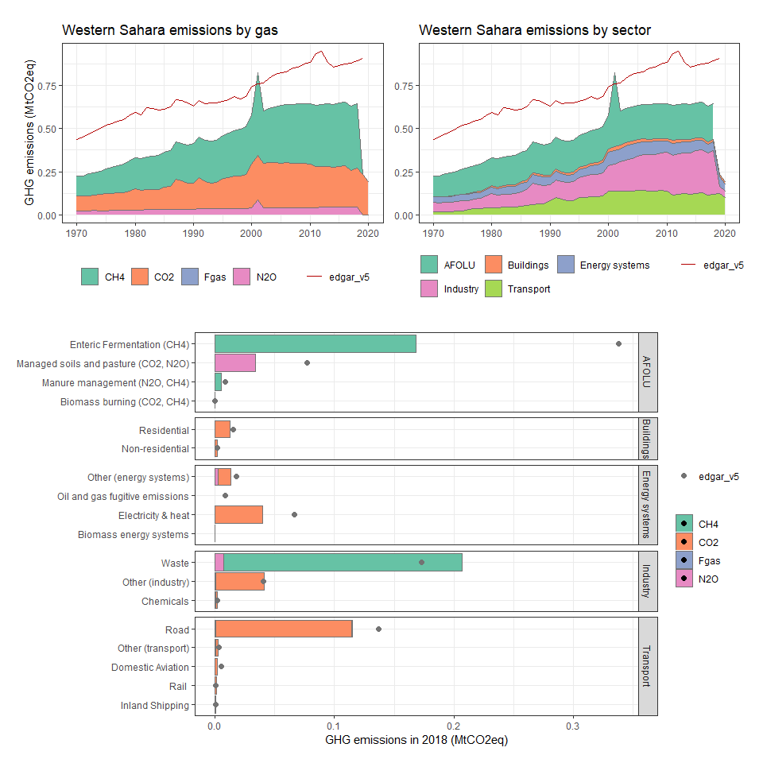

### Yemen, Rep.

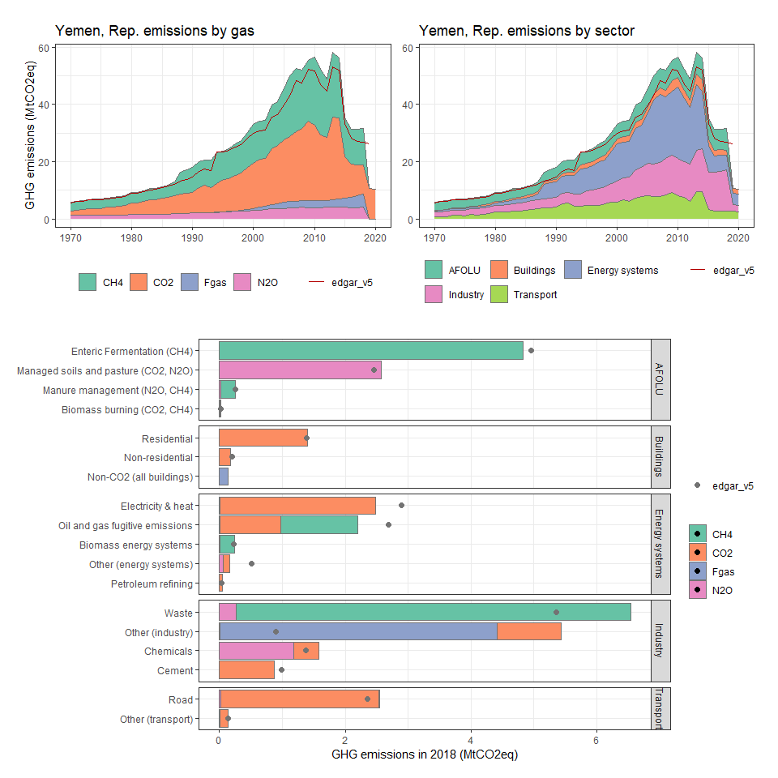

### Zambia

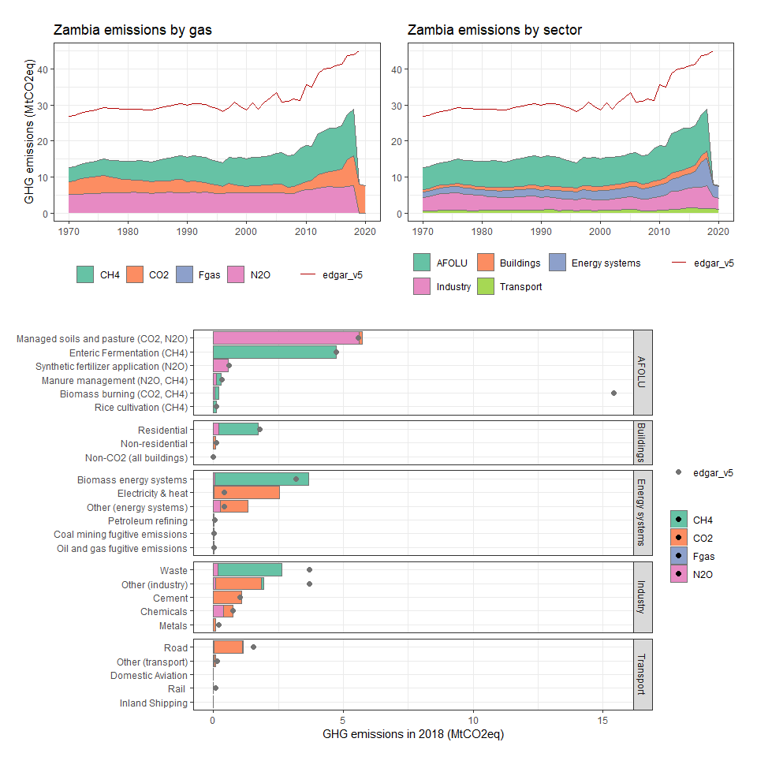

### Zimbabwe

